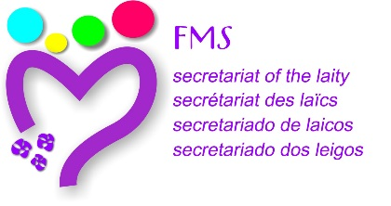

Rome, November 2015

TO THE MEMBERS OF THE CONTINENTAL COMMISSIONS

The last meeting of the enlarged Secretariat allowed us to concretize the process of preparation for the meeting of the Continental Commissions, foreseen for October 2016, in L’Hermitage. The objective of this first letter is to invite you to share a path of prayer and reflection until the celebration of the encounter.

We feel the call to be the echo of the processes lived during the past years in the Institute, regarding the “new relationship” and to offer proposals to the General Chapter that contain the experience of those processes, and in this way promote a greater vitality of the Marist Charism in a future of communion. It would be the occasion to favor “together a new beginning”.

The design or program of the preparation as well as that of the celebration of that international encounter has taken into account the observations received after the Project was sent out to each Continental Commission. Once again we are enclosing the Project. In it you can see the objectives, possible contents, participants… It is good to remember the dates: 3 - 8 October 2016 (arrive on the 2nd and travel on October 9). With the presence of 40 to 45 participants

We stress the importance of the preparation. This is going to demand prayer, discernment and dialogue. From the Secretariat we want to create the best possible conditions for this. In December and in May you will receive a subsidy or help to reflect on some of the contents of the encounter. It is a personal exercise but it may be shared with the Provincial commission or another group. Afterwards in each Region the Continental Commission will draw up a synthesis of everything that it has received, to send it to the Secretariat. This synthesis will be formed into a video-conference with the members of the Continental Commission. The suggestions of the Continental Commissions would then be integrated in a one only document which would serve as a working instrument for the encounter in L’Hermitage. This document would be sent in September, one month before the encounter.
In a synthesis frame the process is thought as follows:

November 2015 | Motivation letter | Tasks
December 2015 | First subsidy for reflection | Personal reflection  Dialogue with the group of Province  Possibility: Regional Video-conference  Synthesis of the Commission  Send to the Secretariat
May 2016 | Second subsidy for reflection | Personal reflection  Dialogue with the group of Province  Possibility: Regional Video-conference  Synthesis of the Commission  Send to the Secretariat (July)
August 2016 | Drawing up of the instrument of work | Secretariat
September 2016 | Sending out the instrument of work | Secretariat
October 2016 | Celebration of the Encounter

May Mary, guide and companion on the journey, be our inspiration and strength on this journey that we are going to begin.

Secretariat of the Laity

