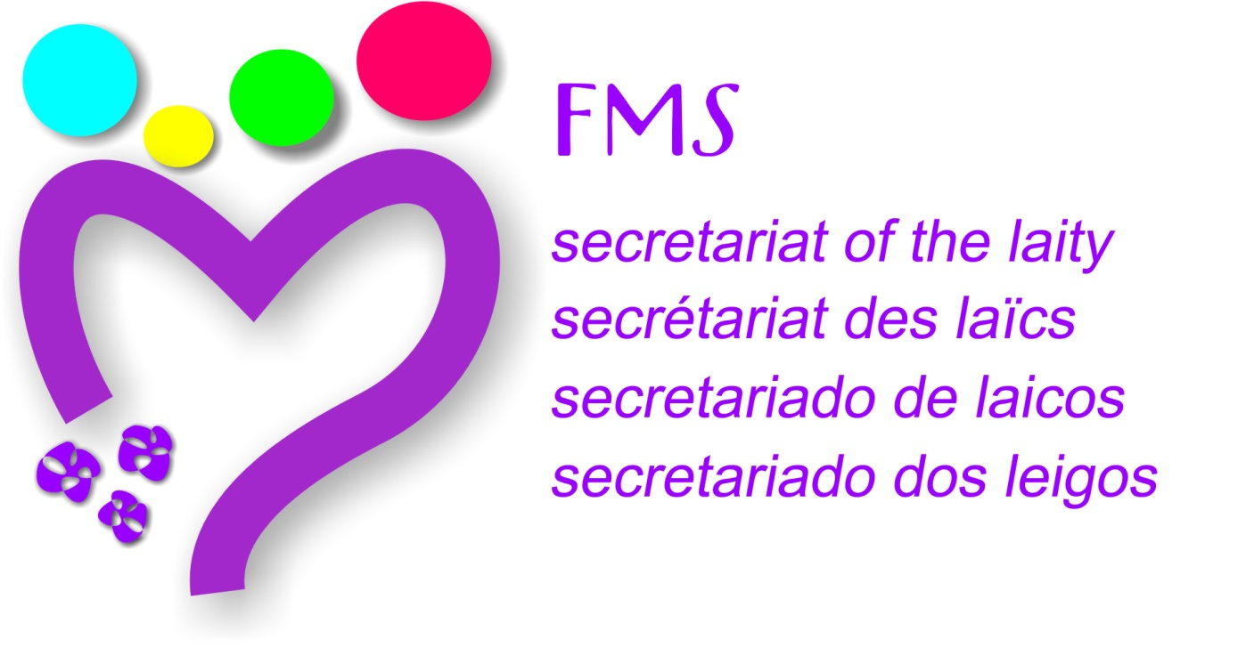 Rome, September 17, 2016

TO THE PARTICIPANTS OF THE CONTINENTAL COMMISSIONS MEETING

Fifteen days before we start our meeting at the Hermitage I allow myself to send these lines accompanying the Work Document which provides a summary of the contributions received from the Committees regarding the proposed topics for our reflection and discernment.
It has been a journey of more than two years. In the last year with a proposal for insight into various aspects of the lay process at the Institute. This road has assumed a first reflection of the Secretariat of Laity, then the invitation to each participant to deepening the themes, the possibility of dialogue with others about your own process, and finally agree on a synthesis exercise with members of the Continental Commission. The working document that you are receiving includes the synthesis of the contributions of the 6 Commissions
The meeting at the Hermitage brings us on the way to the beginning of the Third Centenary, in the spirit of the XXII General Chapter, in the search for new references to the Constitutions of the Brothers, at the end of the update process of the Champagnat Movement, in the establishment of new management models, in discerning a solid proposal to the lay Marist identity, in the invitation to build together a new beginning.
Next to the places that remind us of Champagnat and the first brothers, we have the opportunity to live a strong experience of communion imagining new ways, recreating what we have, breaking fears, assuming to be the co-creators of a common future. And this co-creation is referred to Laity and Brothers, diversity of Marist cultures and sensibilities, to the different rhythms and situations in our Marist universe. The collected contributions are sample of this rich diversity. The experience that we will live wants to be an expression of a common path that we can glimpse from the identity of our provinces and regions.
I invite you to spend maybe an hour a day in these fifteen preparatory days to the meeting, to read the texts, pray with them and discern possible proposals that we would like to offer the next General Chapter. With these proposals that we can conclude, we already become a co-creators of a common Marist future.
From now on, welcome to this celebration of Marist vitality around the places that hosted the first intuitions of Champagnat.
Fraternally,
Br. Javier
Secretariat of the Laity

