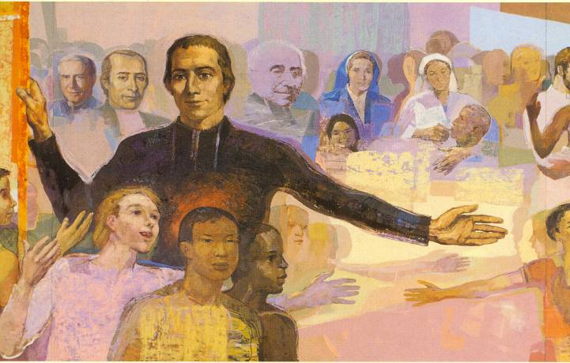

To live the Marist charism with others
is to live an experience of communion.

Living the Marist charism with others

If in times gone by we used to seek out prophets to rouse us from lethargy, today we believe there is a need to look to diverse forms and expressions of community life, able to reveal new paths leading us to new expressions of our Marist charism.

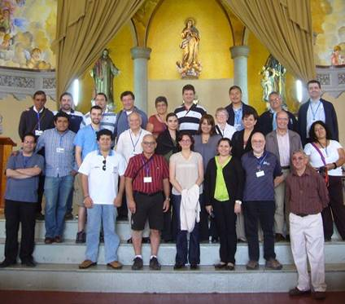
The renewal of our Institute will only result from personal conversion tied in with the process of forming communities, wherein new styles of life and mission, new dynamics for creating relationships and new expressions of our Marist charism will come about from communion between lay people and brothers.

As the XXI General Chapter points out to us, one way to understand this new relationship is to live the Marist charism with others. We believe it is the Spirit who is inviting us to create new and different ways to live communion in the Church, thus leading religious and lay men and women to mutually enrich their lives. When all is said and done, these expressions of community life clearly demonstrate a new approach to living as Church.
Brothers and Lay Marists
Arco Norte

- LIVING WITH OTHERS: THE MEANING OF PERSON
A person is a-being in-a-relationship of Communion. Human beings attain fulfillment in so far as they enter into relationships of communion. Arising from a Christian view of the world, the four categories of beings with which men and women form relationships are: nature, the individual self, others, and God. How well we communicate with these four categories has a direct bearing on the quality of who we are and how we live. In this sense, closing ourselves off from communion amounts to being devoid of life. We need each other.

People are social beings who develop their potential when they live related to others. Friendship, like love, is indispensible for a person to achieve a life of fullness and self-realization. Without true friendship one cannot reach fullness of life. By communicating with others we encounter our selves, and when we maintain authentic communication with our selves we encounter others.

The “other” calls me into existence. I come to see others as giving meaning to my life. I appreciate the differences among us and how we complement one another. I give of my essence, because one can only possess what he or she gives. There’s nothing substantive about human life without love. Love is what makes us citizens of the little planet we share. Out of love arises our common commitment to make creation and history more human and fraternal. It commits us to making the world a nicer home for all.
- LIVING THE FAITH WITH OTHERS: A GOSPEL IMPERITIVE
As people having the same vocation in life, we feel united with all men and women throughout our world. We feel that the vocation to enhance life as the means to attain every person’s human potential is one that every human being has in common. God’s plan calls for people to live together, relate to one another, dialog, communicate and respect differences and the freedom of each individual, in an atmosphere of forgiveness and mutual reconciliation. It is a plan that calls for respecting creation, our earth, in harmony with all beings and living things, in a cosmic, all-inclusive fraternity. It is a plan calling for solidarity with all people everywhere, especially those overlooked, forgotten and cast aside.

Sharing the same faith strengthens our belief that God is calling-us-as-one. It gives us the feeling that we have been sent into the world to build the Kingdom of universal communion, that we are signs of God’s communion with us. To live our faith with others is to live in a world where love reigns supreme. “In the evening of our lives, we will be examined on the extent of our love.” For a Christian, to love is not about an ethical code of conduct but rather a vivid experience of being loved by God himself. Love means living in Communion, since it is life itself, and life is communion, communion with God and with men and women. There are not two loves, that of God and of neighbor, but one Spirit that unites heaven and earth in the heart of God.

No one can follow Jesus by living in isolation. Having faith means drawing strength and support from the faith of our brothers and sisters, and in like manner supporting them with our own. Community is necessary for us to live out our life of faith. This is not, however, simply a need based on theology, but also on sociology. To live the Christian life with integrity today, in these turbulent times, it is increasingly necessary to truly be a member of a community. Those of us who come together in the Eucharist don’t do so simply to be neighborhood friends but brothers and sisters for each other.

- LIVING WITH OTHERS IN COMMUNITY
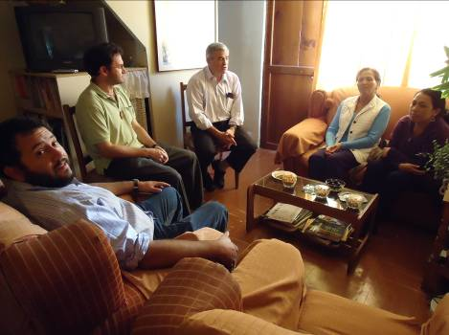
Community is the place where people come together in communion. Community engenders people and people engender community. You can’t have one without the other. Some form of community is essential for all forms of human life. One author writes, “Based on the most clearheaded anthropology and the most elementary vision of life in the Gospels, it must be said that the quality of living together is an essential condition for cultivating a high quality of life, on both a human and Gospel level. To possess such a quality of life we human beings need a balanced and wholesome community, a harmonious life in that setting, communication that rescues us from the “uninhabited” solitary spaces in our lives.

The Assembly in Mendes affirmed this clearly: We are called to work together in progressive ways to proclaim the Kingdom of God to all children and young people, especially the poorest, creating opportunities for sharing our lives in developing different forms of community life, and creating vibrant Marist communities that in very visible and meaningful ways will evangelize by their family spirit and commitment to the mission. (Cfr. Mission)
La Serena – Chile
Extended comunity.

The “genetic code” for every Christian community is clearly laid out in the New Testament, especially in the Acts of the Apostles. Its distinguishing characteristics go back to the earliest communities. They are vividly aware that the Spirit is present in them. Gathering to listen to and celebrate the Word, the Eucharist and common prayer is an indispensable feature of the blueprint for their lives. They display a lively sense of fraternity in virtue of which they wholeheartedly put their belongings at the service of the community; eagerly seek to edify one another and do away with social and cultural barriers among their members. They also rule out domineering and violent relationships. They see themselves as distinct from the rest of society yet belonging to it and contributing to the common good. Notwithstanding, whenever there’s a question of faithfulness to the Gospel, they adopt an attitude of resistance. Their presence prompts surprise, admiration and strong feelings. They are not sinless communities; ambition, campaigns and rivalries continue to exist. But they possess a power that induces them to preserve their identity, live as an alternative community and offer their witness to society.

- LIVING THE MARIST CHARISM WITH OTHERS
We brothers and lay people share our Marist vocation. This commitment with God is taken up by other Marists, companions on our journey. The gift of our Marist charism leads us to enter into a covenant, both with God and those who share this same gift.
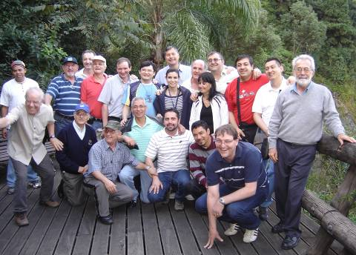
To live the Marist charism with others is to live an experience of communion. And this is where the dimension of community life comes into play, as an association of people interweaving fraternal bonds emanating from one and the same experience: God’s having lured them into following Jesus in accord with the spirit of Champagnat. This communitarian dimension is at the heart of how we experience the charism, enabling us to personally synthesize key elements of our vocation, such as spirituality, mission and Marist fraternity.
Living the Marist charism with others does not permit us to limit the way we experience community to only the people with whom we share our house, whether it’s a family home or the residence for a brothers’ community. To live the Marist charism today means to open our lives to others, as in concentric circles, to all who are who are reaching to share in our Marist spirit.

When we live the Marist charism we discover community, as it is experienced in its many forms and styles: theological realms, where we can attain union with God; humanizing places, where we sense our uniqueness as persons; settings where as prophets of fraternity, we offer witness to the world.
Brothers and Lay Marists

Mary’s style of life is what defines the style of a Marist community: being attentive to details, down-to-earth and approachable, fostering family spirit, replete with smiles and freshly-baked bread, open and welcoming.

- DIVERSE EXPRESSIONS OF COMMUNITY

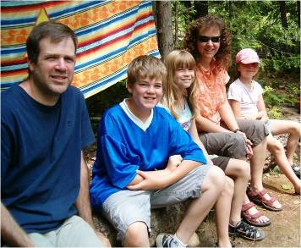
- THE FAMILY
For a great number of the laity marriage is a fundamental part of their vocation. In their mutual commitment as husband and wife, married couples reveal God’s ever faithful love in the midst of the world. The family is the first place for practicing communion, the essence of any and all communities. Within a family’s communion people grow as persons and followers of Jesus. Along with facing the normal challenges and conflicts that arise in the lives of families, couples also grow in mutual understanding for each other, in self-sacrifice in caring for their children, elders and those who may be infirm and in the way they accept each other’s differences. Their unity enables all to live in dignity and find their proper place, nurtures fidelity and security in knowing that there will always be a place at the table set for anyone away from home.
Marist Family in Canada

As “Gathered around the same table” §73 states, lay Marists, whatever their circumstances, form their family into a Christian home, where love and understanding are at the center of relationships. On that basis they join and participate in the community of the Church, and there they bring Marist fraternity to life.

- A COMMUNITY OF RELIGIOUS
Brothers feel called-to-be-together. God calls them to be with others. Their personal surrender to God fashions them into the heart of a community. And so the community becomes a place of interchange and growth. In the community brothers are welcomed as different and complementary. Each one takes an interest in the life and work of the others. The community becomes a setting of friendship and interchange, in which each one’s human qualities and spiritual gifts unfold and grow.
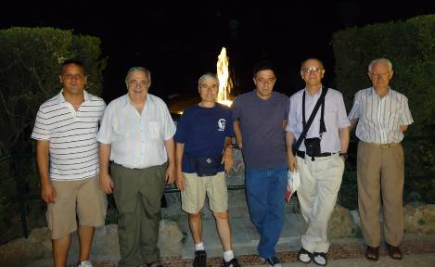

For brothers community is a grace from the Holy Spirit. They form a community without having chosen one another and mutually welcome each other as a gift of the Lord. Through their unceasing efforts of reconciliation and communion, they desire to be signs of unity for all who witness their lives.
The best antidote to a world marked by consumerism and discriminatory, exploitative and selfish relationships is provided by the gratuitous relationships based on equality, a desire to serve and be in solidarity that are practiced in a community and through its interaction with other groups. Brothers’ communities can serve as laboratories for other Marist groups and all of society in demonstrating how to live together in a spirit of honesty and fraternity.
Community in Rome

- A MIXED COMMUNITY
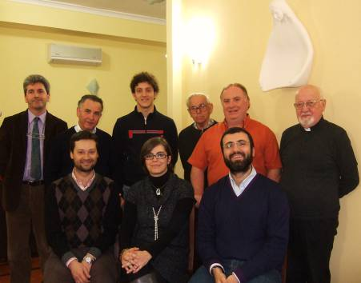
In this experience lay people and brothers live in the same residence. Examples would be the communities at Mulhouse and the Hermitage in France and Giugliano in Italy. This project places emphasis the day to day living of the Marist charism based on complementary vocations. Coordinating their schedules, members share their work, prayer and reflection. They stress maintaining open lines of communication, dialogue and listening, and live the challenge of welcoming pluralism and building togetherness.

In mixed communities the brothers contribute the gift of a religious vocation, the charism embedded in their spiritual journey plus their own experience in community. At the same time the lay women and men offer their domestic and family way of doing things and involve themselves in the wider world. Whether married or single, they demonstrate a different way of living the charism that without a doubt enriches the brothers.
Mixed community in Giugliano, Italia

Having equal standing, the brothers, lay people and priests in a mixed community outline the spiritual path of the experience, the way they live community, share their goods and animate one another, acting with autonomy and developing their own identity as lay people, brothers and priests, the mission, and their relationship to other communities and the Church.

Referring to the mixed community at the Hermitage, Brother Séan said this: if this new community truly aspires to become a group of people united in one single heart and the same spirit, which was Marcellin’s dream for his brothers, it will be necessary for its members to adopt the methods he proposed to achieve this goal, viz., showing mutual respect, praying and practicing forgiveness and simplicity of life. Ultimately, the efficacy of the Hermitage Project will depend upon this new community’s capacity to live Marist spirit in all its richness and to know how to communicate to others exactly what that means.

Séan himself points to the power behind the mission for this community: Whenever visitors and pilgrims leave the Hermitage, they should carry in their hearts the conviction that they have spent time living in a Christian community that is Marist in name and in its actions. Nowadays this is expressed by a community that cares for a diversity of nationalities, races, cultures and styles of life. This also means that its members are passionate about the mission. The experience of living at the Hermitage must lead us to this: to set out from there with a heart on fire with the desire to bring the Good News of God to children and young people in need, wherever we live and work. In stating this with all simplicity, it must stimulate us to draw near to children, as Marcellin did, to tell them how much Jesus loves them.

- A COMMUNITY OF LAY PEOPLE
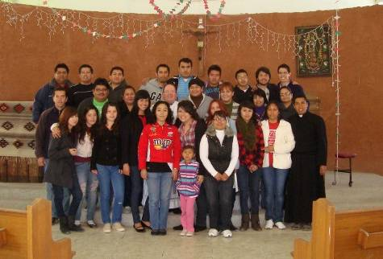
More and more frequently small groups of believers are coming together, supported and encouraged by a parish or one or another movement. As members of the Church they feel less than satisfied to simply go through life deepening their personal thoughts and beliefs; they desire to do so in the context of community life, to be and to live as communities. These are communities of lay people, usually without a particular dwelling place but with a firm desire to have their faith grow and mature in relation to others, and to project this dimension of faith in their plans for mission. And so we read in Gathered around the same table, §93: “The Lay shared life, encouraged by the Spirit, is growing and will better acquire new forms of expression in the future. If we are open to learning from each other, we will strengthen, together, the Marist mission and spirituality.”

Groups of this kind in the Institute would include the Marist Missionaries in Ciudad Juárez, México, the lay men and women of the Marist Movement in Québec (MMQ) and mission groups in Australia…

The Marist Missionaries started out as a small group of students at a Marist high school. Now they consist of graduates, teachers and others who have united without having any contact with a Marist establishment. They feel that the Spirit of God has gifted them with a desire to live Marist spirituality, based on their lay vocation. Their dream is to be able to tell everyone that God loves them very much, especially the children and young people that they meet in rural areas and at ring roads around the city; doing this by means of giving witness to Marist virtues: family spirit, a love of work, simplicity, a loving presence, and above all, devotion to our Good Mother, Mary most holy.
Marist Missionary of Ciudad Juárez, México

The mission groups in Australia consist of teachers who want to deepen their Marist identity through meetings that promote the dimension of community and the deepening of spirituality. They have discovered that in order to live their Marist charism more fully they need to share it with others.
- A COMMUNITY OPEN TO THE LAITY AND BROTHERS IN MISSION PROJECTS
Gathered around the same table §92 sums up this kind of community: “In quite a number of places, Lay people experience community life in different structures and works of the Institute (communities in schools and social works, provincial commissions, animation teams) and in other Marist groups contributing their own color to the rainbow of expressions of the charism.”

The XX General Chapter encouraged the development of greater co-responsibility and reciprocity between the Brothers and Lay people in existing educational centers and new establishments. It maintained that we need to involve the Laity more in decision-making, including participating in some structures of government. Where conditions are favorable, we encourage the creation of communities open to the membership and presence of Lay people, to work with young people, especially those most abandoned and neglected. And thus communities have sprung into being with the presence of the Laity, for the purpose of answering the needs of youth, especially the most abandoned.

The Province of Cruz del Sur talks about extended communities, in which a religious community of brothers, together with Lay men and women most committed to the history of a Marist educational center at a given location, carry out the mission in a co-responsible manner. At the same time they mutually support each other in their specific vocations through prayer and joint reflection. With their particular features, these extended communities now exist in Nueva Pompeya and Fraile Pintado. The Provincial Council has agreed to promote them in Neuquén, Merlo, La Inmaculada (in the Federal Capital), La Boca and Pando, and on the Animating Team for the Province’s Youth Ministry.
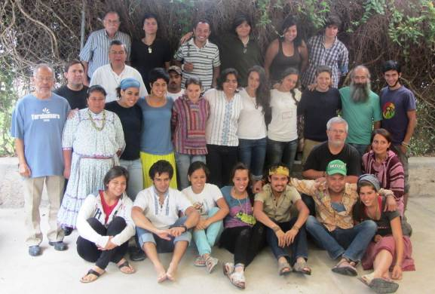
The mission is what determines the form of community life in which the brothers and laity take part. The common plan of the mission explains the processes of reflection, prayer times and the witness of communion at the core of their evangelizing activity and apostolic presence among children and young people. This is the profile for missionary communities. At some educational centers they are called “Marist reference communities.” Some high school mission teams opt for this form of community.
Brothers and marist volunteers in Tarahumara, México.

The community at Fraile Pintado, Argentina describes itself this way: A Marist community with a strong family spirit; a mixed community, formed by brothers and lay people who, though living in different homes, have common times and places for prayer, recreation and mission; a community close to the poor, that inserts itself into simple surroundings, taking on the rhythm of the ordinary life of hardworking and openhearted people; a community that places a strong emphasis on being missionaries among the young.

- A FRATERNITY OF THE CHAMPAGNAT MOVEMENT
The basic unit of the Champagnat Movement is the fraternity, composed of lay people who have chosen to live their vocation according to the spirituality of Marcellin Champagnat.

La idea behind fraternities of the Champagnat Movement has to do with working together as a community. Their Life Plan brings to mind multiple possibilities. See how they love another is a calling to practice the virtues of love and unity in the fraternity; to be open and joyfully welcome all who ask to become members. It’s also an invitation to promote communion in their own families, where they work and in society. This style of family is essentially laical in nature. The possibility of having a brother in the fraternity is meant to enrich the fraternal experience, but without altering its lay character.
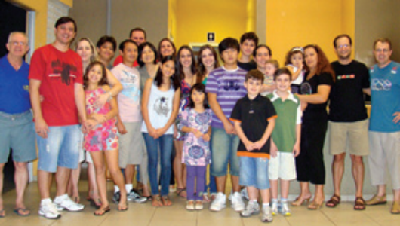
The Movement makes a concerted effort to exemplify family spirit as it was practiced at Nazareth and La Valla. As with the first Christian communities (Acts, 2), fraternity members share their human and spiritual gifts, including, when the Lord invites them to do so, their material goods.

In a fraternity, family spirit manifests itself not only in joyful times, when things are going well for everyone, but also and especially when sickness and trials appear. Sometimes a fraternity may go through hard times. In such circumstances each member strives to be an instrument of support and communion. Likewise a fraternity becomes a privileged sphere of activity where the mission is carried out.
A Fraternity in Maringá, Brazil

- THE MEANING OF AN ANIMATING GROUP IN A COMMUNITY SETTING
The dimension of community life can become obvious in the vibrancy of a team, commission or animation group, whether local, regional or province-wide. When it looks upon itself as a community it sees that it is more an organizing or sponsoring entity. In any group that seeks to build a community, discernment, dialogue, listening and communion take center stage. Its members experience beforehand what they intend to promote. They put into practice beforehand what they want to proclaim. They create space for sharing their lives, significant times of prayer and opportunities to demonstrate their mutual care and support.
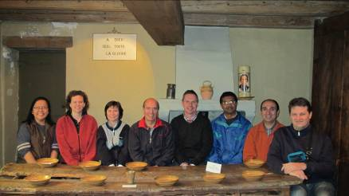
A commission or team that lives as a genuine community promotes what’s essential when it comes to critical times and tasks, extends times for being together in a customary style of life, puts people front and center before programs and creates fraternity. Commissions and teams offer each participating member opportunities for growth. Life comes before tasks to get done.
Secretariat of the Laity, Hermitage

An animating group’s sense of community enables it to overcome any tendency to function as merely a coldhearted organization whose only concern is to do its work efficiently.

- THE SCOPE OF COMMUNITY LIFE AMONG THE LAITY AND BROTHERS
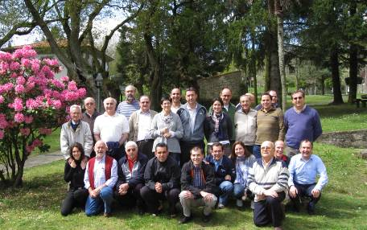
Not to speak of community in a narrow sense, aspects of community life can be developed involving both brothers and lay people, dimensions that indeed take on certain formal and orderly ways of developing. These can be applied to processes of faith, meditative encounters, apostolic experiences… Perhaps IDEM groups in Compostela, the community of brothers at Mulhouse as it relates to the mixed community and some of the new communities in Santa María de los Andes might be included in this category.
IDEM group in Roxos, España

These communities promote encounters where faith is shared, people dialogue about aspects of formation and certain apostolic tasks are accomplished, all this in an atmosphere marked by lots of flexibility, accommodation to the potential of staff members and the absence of rigid structures. Groups living joint experiences in formation could be included in this category.

- A COMMUNITY OF THE LAITY THAT INVITES BROTHERS
This situation doesn’t happen often but the Community in Mulhouse could be considered at this point, for in reality it has ended up as a mixed community; likewise, the Marist Missionaries in Ciudad Juárez, Mexico, who although composed of lay men and women look forward to having a brother join them.
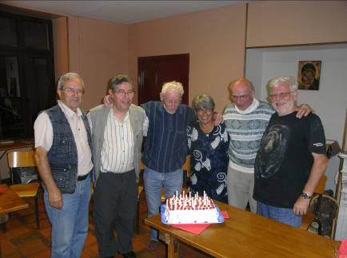
Presumably the role of brothers would be to form community with Lay people, within the parameters of a lay community. The secular nature of this experience would indicate that what needs to take priority are the plans put forth by the lay community, whose identity changes when brothers enter, given their vocation to the religious life, and adjustments are required when carrying out projects common to them and the brothers.

The community in Mulhouse, France is an experience resulting from the initiative of a married couple. They share with the brothers their home and a common outreach to youth. This began 15 years ago. Through fraternity this married couple is nourished by the initiatives of Marist spirituality. With the presence of their three children, the house changes into a meeting place for young people in their parish. Following a period of discernment lay people and brothers place themselves at the service of the Province and establish this community, whose essential mission is to serve the young. It needs to be stressed that the lay people are the first to experience this calling and bring the plan to fruition. It is a married couple that find in this project a way of life for their marriage, and within which their children grow.
The Community in Mulhouse

- A COMMUNITY OF BROTHERS THAT INVITES LAY PEOPLE
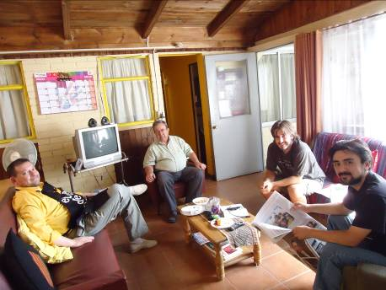
In general, brothers’ communities in urban areas have expanded the practice of welcoming lay volunteers for set periods of time. Usually the aim of having Lay people present is to carry out experiences in mission. The interaction between bothers and laity is usually seen in activities involving welcoming, working in common and enjoying life together. Ordinarily the Lay people are free to participate in times of prayer, community meetings… but usually there isn’t a common Life plan which everyone helps to draw up and observe.

The secular nature of these experiences is such that more significant means for living the charism in all its dimensions are not put forward. The brothers are the ones who invite, or the lay people who offer to help for a while in projects of solidarity, education, etc., while living together under the same roof and following the rhythms of the community.
La Pintana – Chile
Extended comunity

- AN INTERCONGREGATIONAL COMMUNITY
Aiming to support one another and share in the mission, three Sacred Heart Brothers and three Marist Brothers are building a community in Vallée Jeunesse, Québec. This experience began in September 2011. The Brothers from the two Institutes are living in the same house at Valcartier and sharing their fraternal lives, their prayer life and a single mission, one dedicated to evangelizing the young people in Vallée Jeunesse.
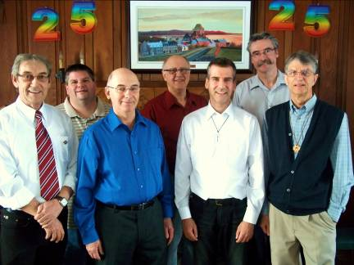
They find the spirit and charism of their two Congregations to be so similar and close that they go about their everyday lives in a very natural way.

The members of this intercongregational community are Brothers Jean-Denis Couture fms, Claude fms, Jasmin Houle sc, Léopold Truchon fms, Charles Gauthier sc, Dalniel Cournoyer fms and Patrice L'Heureux sc.
Community of Marist Brothers and Brothers of the Sacred Heart, in Québec

- FEATURES OF LIVING IN A COMMUNITY
It’s not necessary for all these indicators to be present at the same time, but they do indeed give a good idea of what it means to live in a community.

- Living out an ongoing process in terms of attitude, discernment and moving forward
- Putting dialogue, sharing and communication front and center
- Being attuned to life more than the trappings of an organization and structure
- Honoring times for prayer, discernment and sharing a vibrant faith
- Everyday features: the apostolate, activities, making decisions…
- Being strengthened from sharing life; being committed to helping one another advance in human development and spirituality
- Having reference to a community Life plan that focuses on basic priorities: integration and community relationships, spiritual growth in accord with each one’s vocation and the stage where everyone is at, mission and celebrations
- Having to adapt the sharing of one’s life and mission to each member’s personal traits and not showing favoritism
- Being discreetly attentive to the concerns of each member and the basic needs of the group.
- Establishing evenhanded and fraternal links in the community, therefore necessarily giving evidence of basic qualities such as human and affective maturity and experience in living the Christian life
- Members being communicative and mutually welcoming is fundamental, both a task and goal
- Recognizing, valuing and respecting personal differences and needs
- Experiencing finding myself by giving of myself to my brother/sister.
- Growing in self-identity and personal autonomy as envisioned in a life of sharing.
- Feeling responsible for the community’s manner of contributing to everyone’s welfare

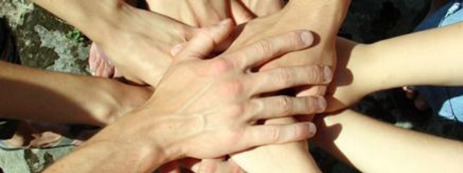

Sharing our experience

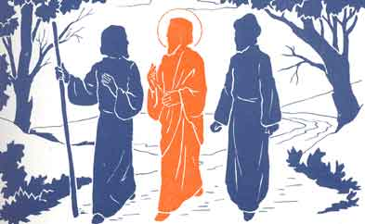

After reading the text, please reflect on and discuss some of these statements:

- “People reach their full potential in so far as they enter into a relationship of communion. The quality of that communication conditions the quality of our existence and the lives we lead. We need one another.”
In light of this, reflect on your experience of communion and please share your thoughts

- The text presents different ways of living in communion and experiencing mutual enrichment among religious and lay men and women.
Are you practicing some of these ways? Please analyze and describe them.

- “Living the Marist charism today means opening up our lives and reaching outward as in concentric circles to everyone who shares our Marist spirit.”
How do you interpret this image? How can it be brought to life in your Marist group?

- The Assembly in Mendes asked us to “create Marist communities of life that evangelize in clear and powerful ways through their family spirit and commitment to the mission.
Think about the “Marist communities of life” that you know and converse about them.

- Many of the Institute’s documents point out our need to be “prophets of fraternity.”
Please share how we can be this kind of prophet for our world and our Church.

