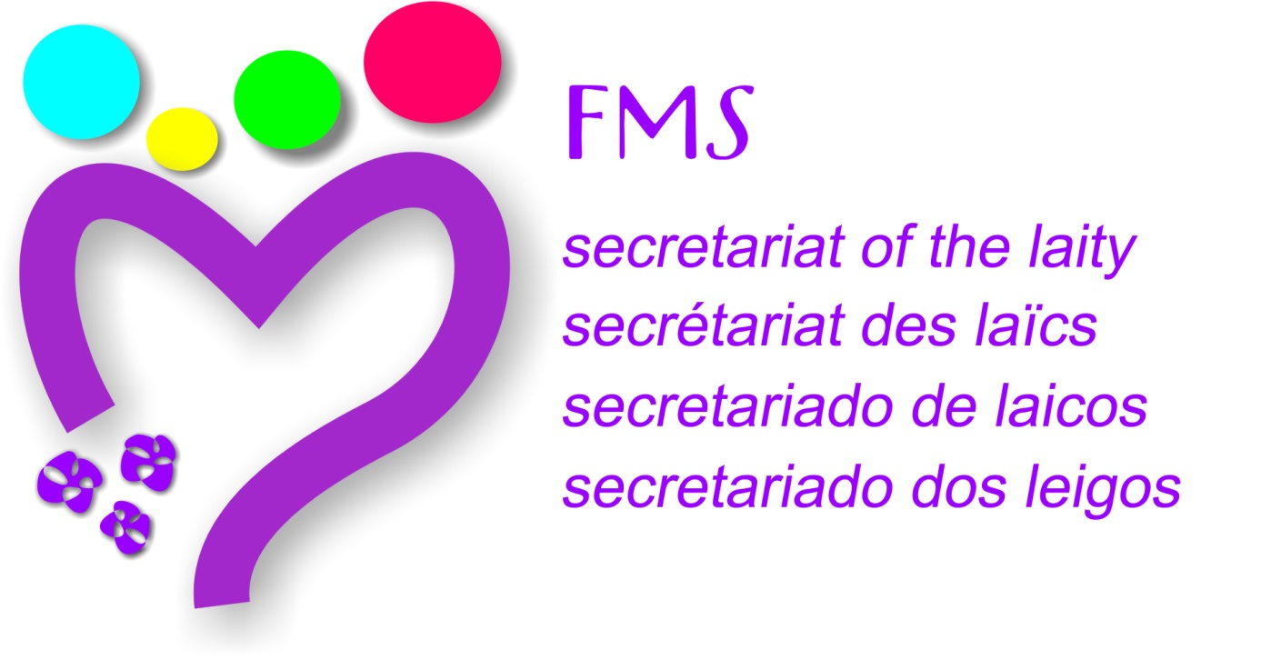

**Brothers, lay man and lay woman**

**in a new spirit of communion .**

**abril 2016**

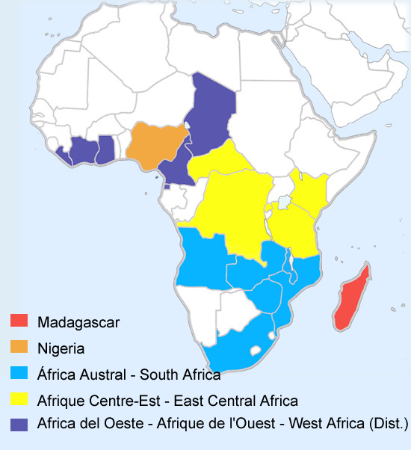

**FORMATION PROCESSES**

**Joint Formation**

**New Horizons workshop**

**LAY MARIST GROUPS**

**Laity of Nigeria**

**Laity**

**Marist Laity Groups on 5 South African Schools**

**ARTICULATION**

**Coordinator Brother**

**Commission and Cordinator Brother**

**Commission and Coordinador Brother**

**Coordinator Brother**

**Coordinator Lay**

**MOVEMENT CHAMPAGNAT**

**Commission:**

**Mr. Mike Greeff**

**h. Sylvain Ramandimbiarisoa**

AFRICA

**MARIST LAY VOCATION PROCESSES**

Sharing our Call

New Horizons workshop

**MIXED COMMUNITIES**

**Masonga, TANZANIA**

**SECRETARIAT OF THE LAITY**

***h. Sylvain Ramandimbiarisoa***

**NIGERIA**

**Prov.** Joachim Ezetulugo[**fmsprovincial@yahoo.com**](mailto:fmsprovincial@yahoo.com)

**Provincial commission:**

Br. Iwu Elias

[**eliodinaka@yahoo.com**](mailto:eliodinaka@yahoo.com)

Br. Donatus Abiaka

Br. Steve Otiode

Br. Christian Obaje

Mrs. Jane Ojukinu

Mr. Mathias Odeme

Br. Iwu Elias

[**eliodinaka@yahoo.com**](mailto:eliodinaka@yahoo.com)

**REGION**

**Commission Afrique- Madagascar:**

Mr. Mike Greeff, Coordinator:

[mikeg@maristsa.co.za](mailto:mikeg@maristsa.co.za)

Fr. Sylvain R. *Secretariat Laity:* [slv@moov.mg](mailto:slv@moov.mg)

Fr. Ernest R**. :** [nestafms@gmail.com](mailto:nestafms@gmail.com)

Br. Iwu Elias: [eliodinaka@yahoo.com](mailto:eliodinaka@yahoo.com)

Fr. Albert Zabonaliba: [nzabonaliba@gmail.com](mailto:nzabonaliba@gmail.com)

Br. John Kusi

[john.kusimensah@yahoo.com](mailto:john.kusimensah@yahoo.com)

**MADAGASCAR**

**Prov.** Fr. Sylvain *Ramandimbiarisoa* [slv@moov.mg](mailto:slv@moov.mg)

**Resp. Laity:**

Fr. Ernest Randriatsoalaivoav

[nestafms@gmail.com](mailto:nestafms@gmail.com)

**AFRICA DEL OESTE**

Prov. **Francis Lukong:** [franklukong@yahoo.com](mailto:franklukong@yahoo.com)

**Responsible Laity:**

Br. John Kusi

[john.kusimensah@yahoo.com](mailto:john.kusimensah@yahoo.com)

**AFRIQUE CENTRE-EST**

**Prov. Théoneste Kalisa Ruhando** kalisatheo@yahoo.fr

**Responsible Laity :**

Fr. Albert Zabonaliba: [nzabonaliba@gmail.com](mailto:nzabonaliba@gmail.com)

**AFRICA AUSTRAL**

**Prov. Br Joseph Walton.** [**josephwalton@ymail.com**](mailto:josephwalton@ymail.com)

**Responsible Laity:**

Mr. Mike Greeff

[mikeg@maristsa.co.za](mailto:mikeg@maristsa.co.za)

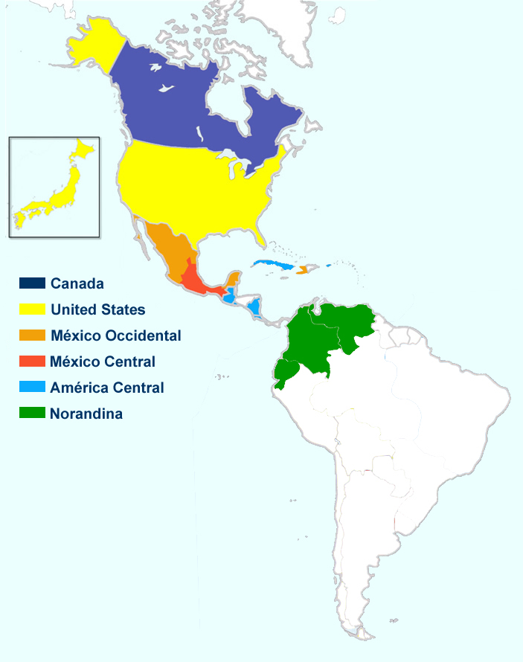

**ARTICULATION**

**Provincial Animation Commission**

**Brother council Coordinator.**

**Provincial commission and lay Coordinator.**

**Provincial commission and Brother Coordinator.**

**Provincial commission and lay Coordinator.**

**Brother council Coordinator.**

**FORMATION PROCESSES**

**Training modules**

**FORMAR**

**Formation Plan - Retreat Brothers-Laity**

**Itineraries conversion**

**Retreat Brothers-Laity**

**Joint Formation - Retreat Brothers-Laity**

**Sharing Our Call Program – Level 1 & 2**

**Embracing Our Call - Deepening Our Call**

**Retreat Brothers-Laity**

**MARIST LAY VOCATION PROCESSES**

**Lay Marist vocational accompaniment itinerary**

**Process in development**

**MOVEMENT CHAMPAGNAT**

**12 Fraternities**

**5 Fraternities**

**31 Fraternities**

**9 Fraternities**

**21 Fraternities**

ARCO NORTE

**MIXED COMMUNITIES**

**Chiapas – Marqués de Comillas**

**Oaxaca – Ixtaltepec**

**Tarahumara**

**Alajuela, Costa Rica**

**Valcartier, Canada**

**Willowdale, Quebec & Sherbrooke, Canada**

**Juan Diego, New York**

**Marist Volunteer Community, Esupus**

**LAY MARIST GROUPS**

**Marist missionaries**

**Group of former brothers**

**Group of former brothers**

**Sisters of Champagnat**

**Leadership itinary**

**Marist Laity Association.**

**Laity of Venezuela**

**AMERICAN SUBCOMMISSION:**

Coordinator: Moisés Beltrán :

**SECRETARIAT OF THE LAITY**

***Paty Ríos***

**REGION**

**Commission :**

Moisés Beltrán : Coordinator

Paty Ríos

H. Daniel Martín

Raúl Amaya

Mauricio Fuentes  
João Luis Fedel  
Layza Gomes de Oliveira  
Mr Matt Fallon

**CANADA**

**Prov. Gérard Bachard**

provincialfmscan@hotmail.com

**Animation Team of Marist life**

Fr. Félix Roldán :

Mme Linda Corbeil :

[linda.corbeil@videotron.ca](mailto:linda.corbeil@videotron.ca)

Christian Boutin:

[Christian.boutin1@gmail.com](mailto:Christian.boutin1@gmail.com)

**Canadá:**

<http://www.freresmaristes.qc.ca>

**UNITED STATES**

**Prov.** Patrick McNamara

[patmcnam@aol.com](mailto:patmcnam@aol.com)

Br. Al Rivera: [ariverafms@marist.org](mailto:ariverafms@marist.org)

Matt Fallon: [mfallon03@gmail.com](mailto:mfallon03@gmail.com)

**Marist Laity USA:**

[**http://www.maristlaity.com/**](http://www.maristlaity.com/)

**NORANDINA**

**Prov. César Rojas**

hcrojas@maristasnorandina.org

**Provincial Commssion of the Laity**

Moisés Beltrán (Ecuador) [laicosecuador@maristasnorandina.org](mailto:laicosecuador@maristasnorandina.org)

Claudia Rojas: (Colombia) [laicoscolombia@maristasnorandina.org](mailto:laicoscolombia@maristasnorandina.org)

María Torres:

[mariajt99@gmail.com](mailto:mariajt99@gmail.com)

h. Orlando Escobar:

[hoescobar@maristasnorandina.org](mailto:hoescobar@maristasnorandina.org)

**MEXICO CENTRAL**

Prov. **José Sánchez Bravo** [pepesan73@gmail.com](mailto:pepesan73@gmail.com)

1. Pedro Chinchilla, coordinador

2. H. Alfonso Fernández (asesor) [ferpalf@hotmail.com](mailto:ferpalf@hotmail.com)

3. H. Jorge Carbajal (asesor) [jacaga7@yahoo.com.mx](mailto:jacaga7@yahoo.com.mx)

4. Arturo Buenrostro

5. Maria Antonieta Pérez

6. Anastacio González

7.  Viviana Gómez

8. Beatriz Coronado

9. Susana Tapia

**AMERICA CENTRAL**

**Prov. Luis Carlos Gutiérrez**

luiscarlosgutierrez@yahoo.es

**Provincial Commission of the Marist Laity**

Nohemy Pinto: Coordinator: [nohepinto03@hotmail.com](mailto:nohepinto03@hotmail.com)

h. Daniel Martín, asesor.: [elorejas2@hotmail.com](mailto:elorejas2@hotmail.com)

Gustavo Granados     [granadosgustavo@hotmail.com](mailto:granadosgustavo@hotmail.com)

Ivette Jiménez             [ivejm@hotmail.com](mailto:ivejm@hotmail.com)

Melva Aldana              [eli.von@hotmail.com](mailto:eli.von@hotmail.com)

**MEXICO OCCIDENTAL**

**Prov**. Miguel AngelSantos

[miguelansa@gmail.com](mailto:miguelansa@gmail.com)

**Provincial Commission Brothers and Laity**

Cecilia Cortez: [cecilia.cortez@maristas.org.mx](mailto:cecilia.cortez@maristas.org.mx)

H. Guillermo Villarreal: [guilermo.villarreal@maristas.org.mx](mailto:guilermo.villarreal@maristas.org.mx)

H. Iván Buenfil: [bugivan2002@gmail.com](mailto:bugivan2002@gmail.com)

H. Oscar Becerra: racsobg@yahoo.com

Patricia Ríos Gómez: [patricia0rios@hotmail.com](mailto:patricia0rios@hotmail.com)

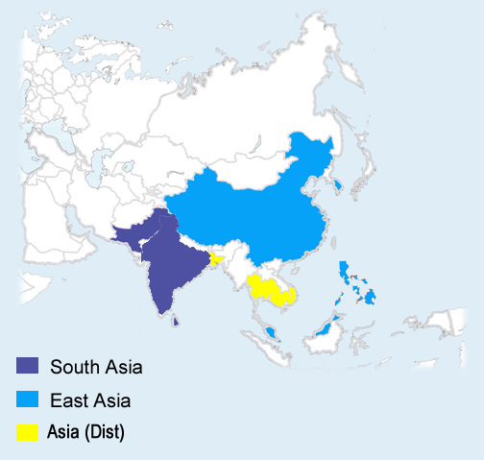

**FORMATION PROCESSES**

**Joint formation**

**LAY MARIST GROUPS**

**Campus Evangelization of Mary**

**MOVEMENT CHAMPAGNAT**

**5 Fraternities**

**(Marikina, General Santos, Marbel, Kidapawan, Cotabato)**

**ARTICULATION**

**Provincial Coordinator**

**Provincial coodinator**

**Provincial Coordinator**

**Commission:**

Agnes Reyes :

[agnes.reyes@rocketmail.com](mailto:agnes.reyes@rocketmail.com)

**MARIST LAY VOCATION PROCESSES**

**MIXED COMMUNITIES**

**Cambodya**

ASIA

**SECRETARIAT OF THE LAITY**

**Agnes Reyes**

**SOUTH ASIA**

Prov.

Br Paul Bhatti:[psbhatti@hotmail.com](mailto:psbhatti@hotmail.com) **Pakistan**

Br. China: [chinnafms@gmail.com](mailto:chinnafms@gmail.com) **India**

**Laity coordinator**:

Br. Roshan Silva:

[roshanfms@yahoo.com](mailto:roshanfms@yahoo.com)

**REGION**

**Asia commission:**

Agnes Reyes(Chairperson)

[agnes.reyes@rocketmail.com](mailto:agnes.reyes@rocketmail.com)

Br. Roshan Silva

Jude Preman

Elma Rafil

[elmabrafil@gmail.com](mailto:elmabrafil@gmail.com)

Br. Pat Corpus

Br. Ismael Valls

**East Asia:**

[**http://www.maristeastasia.org/**](http://www.maristeastasia.org/)

Bro. Joseph Peiris : [joepeiris@yahoo.com](mailto:joepeiris@yahoo.com)

Mr. Ajith Perera

Ema Rafil

Br. John Tan [**john@nddu.edu.ph**](mailto:john@nddu.edu.ph)

Br. Ismael Valls: [khunhoan@gmail.com](mailto:khunhoan@gmail.com)

(Juan Castro)

I just got confirmation that the new CMMF Animator for CMMF KIDAPAWAN is Ms. IvyYecyec her contact:  [ivy030282@yahoo.com](mailto:ivy030282@yahoo.com)

**MARIST DISTRICT OF ASIA**

**Sup**. Juan Castro: [juancale@hotmail.com](mailto:juancale@hotmail.com)

**Laity Coordinator**:

Br. Ismael Valls: [ishpanda@gmail.com](mailto:ishpanda@gmail.com)

**EAST ASIA**

**Prov.** Br. Robert Theo:[**robyttk@gmail.com**](mailto:robyttk@gmail.com)

**Coordinator:**

Br. Pat Corpus:

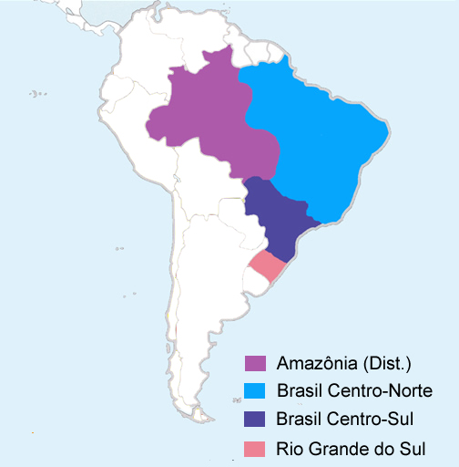

**LAY MARIST GROUPS**

**FORMATION PROCESSES**

**Processes**

**Joint Formation**

**MOVEMENT CHAMPAGNAT**

**31 Fraternities**

**26 Fraternities**

**29 Fraternities**

**ARTICULATION**

Area of Consecrated Life and laity (UMBRASIL).

**Commission. Lay Coordinator**

**Commission. Brother Coordinator**

**Commission. Brother Coordinator.**

**American subcommission:**

Layza Maria Gomes

lfonseca@marista.edu.br

BRASIL

**MARIST LAY VOCATION PROCESSES**

**“Itinerário vocacional para leigos e leigas”**

**MIXED COMMUNITIES**

**SECRETARIAT OF THE LAITY**

**João Luis Fedel**

**REGION**

**Area of Consecrated Life and laity (UMBRASIL).**

Br. Natalino: [natalino@marista.edu.br](mailto:natalino@marista.edu.br)

Paulo A. de Araújo

Sonia Vidal

<http://www.umbrasil.org.br/>

BCN: <http://www.marista.edu.br/>

BCS: <http://www.marista.org.br/>

RGS: <http://www.maristas.org.br/>

**BRASIL CENTRO-NORTE**

**Prov. Ataide José der Lima**

[atajoli@yahoo.com.br](mailto:atajoli@yahoo.com.br)

**Commission of the Laity**

Eder D'Artagnan, Coordinador

[eder@marista.edu.br](mailto:eder@marista.edu.br)

Heloisa Afonso [hafonso@marista.edu.br](mailto:hafonso@marista.edu.br)

Jaciara Pires: [jpires@marista.edu.br](mailto:jpires@marista.edu.br)

Layza Fonseca [lfonseca@marista.edu.br](mailto:lfonseca@marista.edu.br)

Maria Goretti Machado: [diretor.colatina@marista.edu.br](mailto:diretor.colatina@marista.edu.br)

Amparo Seibel: [mseibel@marista.edu.br](mailto:mseibel@marista.edu.br)

Ir. Wagner Cruz: [wcruz@marista.edu.br](mailto:wcruz@marista.edu.br)

Ir. Pedro Angelo Miranda: [pedroangelo@marista.edu.br](mailto:pedroangelo@marista.edu.br)

**BRASIL CENTRO –SUL**

**Prov.Ir. Joaquim Sperandio**: [irjoaquim@marista.org.br](mailto:irjoaquim@marista.org.br)

**Area of Consecrated Life and laity**

Ir. Bene Oliveira - [irbene@grupomarista.org.br](mailto:irbene@grupomarista.org.br)

Ir. Jorge Gaio - Setores Provinciais - [irjorge@marista.org.br](mailto:irjorge@marista.org.br)

Ir. Antonio Quintiliano da Silva [-irantonio@marista.org.br](mailto:-irantonio@marista.org.br)

Ernesto Sienna - [ernesto.sienna@grupomarista.org.br](mailto:ernesto.sienna@grupomarista.org.br)

João Luis Fedel Gonçalves - [jgoncalves@grupomarista.org.br](mailto:jgoncalves@grupomarista.org.br)

Lúcia Coelho - [lcoelho@grupomarista.org.br](mailto:lcoelho@grupomarista.org.br)

Dercio Angelo Berti - [dberti@grupomarista.org.br](mailto:dberti@grupomarista.org.br)

Fabiano Incerti - [incerti.fabiano@pucpr.br](mailto:incerti.fabiano@pucpr.br)

Irene Simões - [isimoes@grupomarista.org.br](mailto:isimoes@grupomarista.org.br)

Ascânio João Sedrez - [csedrez@colegiosmaristas.com.br](mailto:csedrez@colegiosmaristas.com.br)

Ana Tereza Naspolini - [anatenas@terra.com.br](mailto:anatenas@terra.com.br)

**BRASIL SUL- AMAZONIA**

**Prov. Inacio Etges** [**ietgesfms@gmail.com**](mailto:ietgesfms@gmail.com)

**Commission of Consecrated Life and laity**

Edison Carlos Jardim de Oliveira, Coordinador: [edison@maristas.org.br](mailto:edison@maristas.org.br)

h. Romidio Siveris:[**romidio@maristas.org.br**](mailto:romidio@maristas.org.br)

Ir Paulo Lorenzoni: paulol@maristas.org.br

Gustavo Balbinot: [gustavo.balbinot@maristas.org.br](mailto:gustavo.balbinot@maristas.org.br)

Aline da Cunha: [aline.cunha@maristas.org.br](mailto:aline.cunha@maristas.org.br)

Ir. Deivis A. Fischer: ir.fischer@maristas.edu.br

Ir. Claudiano Tiecher

Regina Biasibetti

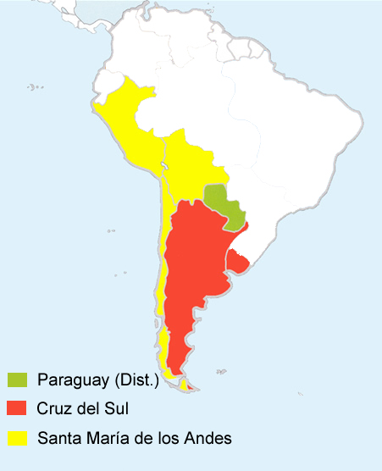

**American subcommission:**

Mauricio Fuentes:

[mauriciof1982@yahoo.com.ar](mailto:mauriciof1982@yahoo.com.ar)

**MIXED COMMUNITIES**

**Nueva Pompeya**

**Fraile Pintado Luján**

**Horqueta Surco Huacho**

**Puerto Maldonado Santa Cruz**

**Comarapa Los Andes**

**La Pintana Alto Hospicio**

**La Serena San José Chiquitos**

**Roboré Sullana**

**FORMATION PROCESSES**

**Retreat Brothers and Laity**

**Retreat Brothers and Laity**

**LAY MARIST GROUPS**

**Group of the vocation of Laity**

CONO SUR

**ARTICULATION**

**Commission Spirituality and Laity. Lay Coordinator**

**Provincial commission. Brother Coordinator**

**MOVEMENT CHAMPAGNAT**

**14 Fraternities**

**24 Fraternities**

**MARIST LAY VOCATION PROCESSES**

**Growth itinerary for the lay Marist vocation.**

**Itineraries to deepen the lay Marist vocation**

**SECRETARIAT OF THE LAITY**

**Raúl Amaya**

**CRUZ DEL SUR**

**Prov. Alberto Aparicio:** [hermanoalberto@gmail.com](mailto:hermanoalberto@gmail.com)

**Animation Team:**

Marcos Denevi:

[marcosdenevi@gmail.com](mailto:marcosdenevi@gmail.com)

h. José Khum:

[idegjos@adinet.com.uy](mailto:idegjos@adinet.com.uy)

h. Rubén Seipel:

[perro9@hotmail.com](mailto:perro9@hotmail.com)

h. Demetrio Espinosa:

[despinosa47@jahoo.com](mailto:despinosa47@jahoo.com)

Mauricio Fuentes:

[mauriciof1982@yahoo.com.ar](mailto:mauriciof1982@yahoo.com.ar)

Mónica Linares:

**Cruz del Sur:**

[**http://www.maristas.com.ar/**](http://www.maristas.com.ar/)

**REGION**

**American subcommission of Laity:**

Moisés Beltrán : Coordinador

Paty Ríos

H. Daniel Martín

Raúl Amaya

Mauricio Fuentes  
João Luis Fedel  
Layza Gomes de Oliveira  
Mr Matt Fallon

**SANTA MARIA DE LOS ANDES**

**Prov. Saturnino González**

[satur001@yahoo.es](mailto:satur001@yahoo.es)

**Commission of spirituality and laity**

Eliana Rojas (Perú), Coordinadora

Raúl Amaya: (Chile) [ramayamarista@gmail.com](mailto:ramayamarista@gmail.com)

Sylvia Pérez (Bolivia):

silviayricardo7@gmail.com

**Chile:**

**http://www.familiamarista.org/**

**PARAGUAY**

Sup. José María Custodi [chemacustodi@gmail.com](mailto:chemacustodi@gmail.com)

**Animation Team:**

José María Custodi [chemacustodi@gmail.com](mailto:chemacustodi@gmail.com)

Mirian A. García:

[miradel_27@hotmail.com](mailto:miradel_27@hotmail.com)

Damián Deleón: dadeloz27@hotmail.com

Gloria Dávalos: dggloria@yahoo.es

Marisa Armoa: sarimar04@yahoo.es

Techy Ramírez: [techiramirez@hotmail.com](mailto:techiramirez@hotmail.com)

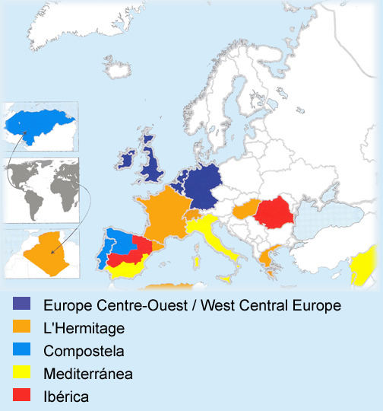

**LAY MARIST GROUPS**

**Groups Marist life (CAT)**

**Marist local groups (FR)**

**Marist groups**

Groups of Marist Spirituality

**FORMATION PROCESSES**

**Itinerary EMM**

**Itineraries spirituality**

**Joint formation.**

**Joint formation**

**Retreat Brothers and Laity**

**Retreat Brothers and Laity**

**Retreat Brothers and Laity**

**MOVEMENT CHAMPAGNAT**

**16 Fraternities**

**11 Fraternities**

**2 Fraternities**

**3 Fraternities**

**27 Fraternities**

**ARTICULATION**

**Commission and Coordinator Brother**

**Commission and Lay Coordinator**

**Commission and Lay Coordinator**

**Commission and Coordinator Brother**

**MIXED COMMUNITIES**

**Comunity of l´Hermitage**

**Comunity of Mulhouse**

**Community of Erandio**

**Community of Spirituality´s Center**

**Community of Salamanca**

**Community of Giugliano**

**Community of Llinás**

**European commission:**

h. Teodorino Aller, coordinator

[teoaller@maristascompostela.org](mailto:teoaller@maristascompostela.org)

EUROPA

**MARIST LAY VOCATION PROCESSES**

**Itinerary for the laity to adhere to the Marist charism**

**SECRETARIAT OF THE LAITY**

***Pep Buetas***

**L´ERMITAGE**

**Prov. Maurice Berquet**

[provincial@maristes.org](mailto:provincial@maristes.org)

**Secretariat Brothers-lay communion**

Marta Portas, Coordinadora:

[martaportas7@gmail.com](mailto:martaportas7@gmail.com)

Pep Buetas: [jbuetas@maristes.com](mailto:jbuetas@maristes.com)

h.Jaume Parés : j.pares@maristes.net

Annie Girka: [annie.girka@gmail.com](mailto:annie.girka@gmail.com)

Maria Kokalakki: [kokkalaki@leontios.gr](mailto:kokkalaki@leontios.gr)

h. Maurice Goutagny [mgoutagny@maristes.net](mailto:mgoutagny@maristes.net)

H. Jordi G. Llussà

[**http://www.maristes.com**](http://www.maristes.com)

[secretariat.fmslaics@maristes.com](mailto:secretariat.fmslaics@maristes.com)

**EUROPE CENTRE-OUEST**

**Prov**. h. Brendan Geary :

provincial@maristen.nl

Wolfgang Hacker: [wh.hacker@t-online.de](mailto:wh.hacker@t-online.de)

Province :

http://www.maristes.eu/

**REGION**

**European Commission:**

H. Teodorino Aller, *Coordinador*

Pep Buetas, *Secretariado L.*

Joseba Louzao

Wolfgang Hacker

H. Ventura Pérez

Marta Portas

**European Council of MCH:**

Andrés Gil, Coordinador

h. Albert André

Annie Girka

h. Fernando Hinojal

Alejandro Romero

**Consejo europeo del MCHFM**

**COMPOSTELA**

Prov. Tomás Briongos:

[supprov@maristascompostela.org](mailto:supprov@maristascompostela.org)

**Commission Brothers-lay communion**

H. Teodorino Aller: [teoaller@maristascompostela.org](mailto:teoaller@maristascompostela.org)

Carmo Maciel: [carmomaciel@gmail.com](mailto:carmomaciel@gmail.com)

Emma Manzano: [emanzano.59@gmail.com](mailto:emanzano.59@gmail.com)

Felicísimo Pérez: [fechi52@gmail.com](mailto:fechi52@gmail.com)

Francisco Guisasola: [fcoguisasola@gmail.com](mailto:fcoguisasola@gmail.com)

H. Javier Barreales: [jbtreceno@gmail.com](mailto:jbtreceno@gmail.com)

**Compostela :**

[**http://www.maristascompostela.org**](http://www.maristascompostela.org)

**MEDITERRANEA**

Prov. Juan Carlos Fuertes [juancarlosfm@maristasmediterranea.com](mailto:juancarlosfm@maristasmediterranea.com)

[provincial@maristasmediterranea.com](mailto:provincial@maristasmediterranea.com)

**Provincial commission**:

h. Ventura Pérez: [venturafms@yahoo.es](mailto:venturafms@yahoo.es)

Tere Rodríguez:   [**teresa1ciclo@gmail.com**](mailto:teresa1ciclo@gmail.com)

Bartolomé Gil:     **bartgilg@gmail.com**

Sabatino Abbate: [sabatinoa@maristasmediterranea.com](mailto:sabatinoa@maristasmediterranea.com)

Alfredo García: [evayalfredo@gmail.com](mailto:evayalfredo@gmail.com)

**Mediterránea:** [**http://www.tresvioletas.org**](http://www.tresvioletas.org)

Foro del laico marista.

**IBERICA**

Prov. Moisés Alonso Pérez

[provincial@maristasiberica.es](mailto:provincial@maristasiberica.es)

**Marist Laity Commission**

María Gismero: [mariagis@gmail.com](mailto:mariagis@gmail.com)

José María Peréz-Soba: [asche@arrakis.es](mailto:asche@arrakis.es)

h. José Luis Santamaría :

[jluisss@maristasiberica.es](mailto:jluisss@maristasiberica.es)

Ana Sarrate, Coordinadora: [anasarrate@gmail.com](mailto:anasarrate@gmail.com)

Joseba Louzao:

[joseba-louzao@cardenalcisneros.es](mailto:joseba-louzao@cardenalcisneros.es)

**http://www.maristasiberica.es/**

[**laicadomarista@maristasiberica.es**](mailto:laicadomarista@maristasiberica.es)

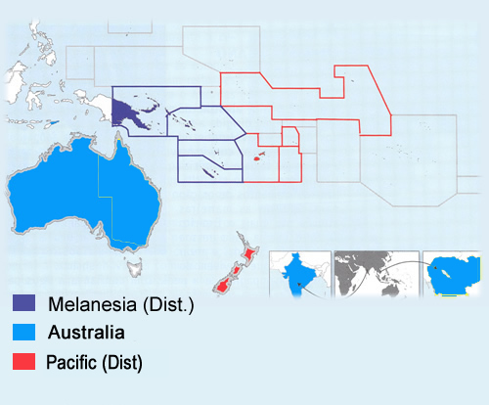

**FORMATION PROCESSES**

**School Staff Formation**

**Formation for those in ministries**

**Champagnat in the Pacific**

**LAY MARIST GROUPS**

**Local Marist Groups**

**Local Marist Groups (Gatherings led by members of the Association)**

**Local Marist Groups**

**MOVEMENT CHAMPAGNAT**

**ARTICULATION**

**Regional Commission**

**Lay Coordinator**

**Lay Coordinator**

**Lay Coordinator**

**Provincial Commission and Lay Coordinator (Sydney/Melbourne)**

**Oceania commission:**

Tony Clarke: (Sydney)

[tony.clarke@marists.org.au](mailto:tony.clarke@marists.org.au)

OCEANIA

**MIXED COMMUNITIES**

**Melbourne (REMAR GAP team – Young Marist Lay Community)**

**Lower Hutt (Young Adult Community)**

**Auckland (Vocation Discernment Community)**

**MARIST LAY VOCATION PROCESSES**

**Marist Families**

**Discernment offered to people joining the Marist Association**

**SECRETARIAT OF THE LAITY**

***Tony Clarke***

**MELANESIA**

**Sup Jean-Marie**

jmbatickfms@yahoo.com

**Marist Life Team**

Br. Mark Kenatsi (Team Leader): brm_kenatsi@yahoo.com

Ruth Hihiru: sigalhiru@gmail.com

Br. Clement Pekubei: clepex_fms@yahoo.com.au

**REGION**

**Oceania commission:**

Tony Clarke: (Australia), Chair [anthony.clarke@marists.org.au](mailto:anthony.clarke@marists.org.au)  
Mr Joe McCarthy (Australia) joe.mccarthy@marists.org.au

Brother Carl Tapp (Pacific) [carlrtapp@gmail.com](mailto:carlrtapp@gmail.com)

Elizabeth Falconer (Australia)

elizabeth.falconer@marists.org.au

Mrs Lucy Sinei (Melanesia) sineilucy9@gmail.com

Dan Dungey (Pacific) champagnatpartnershipnz@gmail.com

Mrs Ruth Hithuru (Melanesia) [sigalhiru@gmail.com](mailto:sigalhiru@gmail.com)

Br Mark Kenatsi (Melanesia) [brm_kenatsi@yahoo.com](mailto:brm_kenatsi@yahoo.com)

**NEW ZEALAND**

**Sup. Br David McDonald:** nzdl.fms@extra.co.na

**Charism Committee**

Mr Daniel Dungey: champagnatpartnershipnz@gmail.com

Br Carl Tapp: carlrtapp@gmail.com

Mr Kevin Kneebone: kevin.bones@hotmail.com.nz

Mrs Louise Oliphant: loliphant@sacredheart.school.nz

Mrs Esther Saldanha: esthersal@gmail.com

Br Douglas Dawick: brdougfms@gmail.com

Br Barry Burns: barryburns@xtra.co.nz

Amy Aukusitino: aukusitino@gmail.com

David McDonald [rawiri@clear.net.nz](mailto:rawiri@clear.net.nz)

[**http://www.maristbrothers.org.nz**](http://www.maristbrothers.org.nz)

**AUSTRALIA**

**Sup.** Peter Carroll

[peter.carroll@marists.org.au](mailto:peter.carroll@marists.org.au)

[provincial@marists.org.au](mailto:provincial@marists.org.au)

**Australia Marist Community Pastoral Team**Mr Joe McCarthy (Coordinator): [joe.mcarthy@marists.org.au](mailto:joe.mcarthy@marists.org.au)  
Mrs Sharon Williams: sharon.williams@marists.org.au  
Br Graham Neist: grahamn@herewelive.com  
Br Paul Kane: paul.kane@marists.org.au  
Mrs Gail Coates: gail.coates@marists.org.au

**http://www.maristmelb.org.au/**