BROTHER CRISANTO

AND

67 COMPANIONS MARTYRS

OF WHICH TWO LAY PERSONS
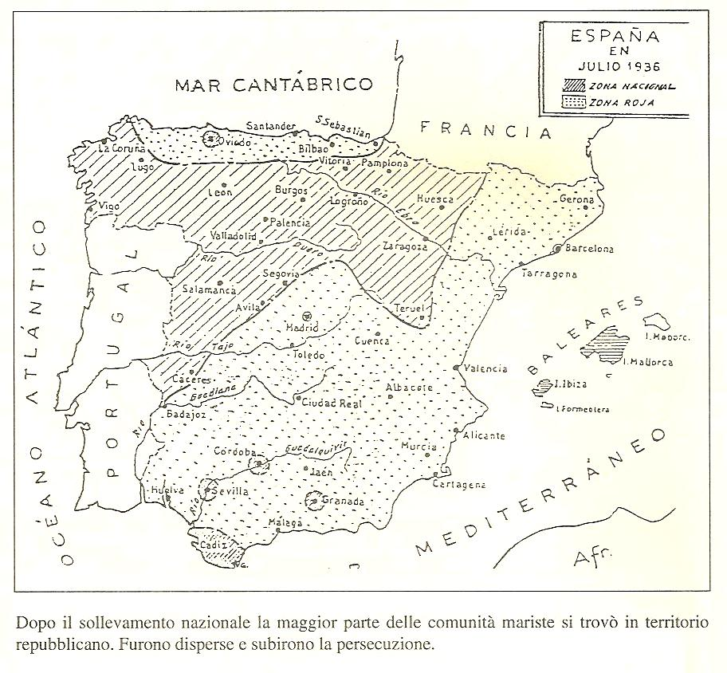
Marist Spain in July 1936
1- The persecution

“A Marist Brother must have no politics other than Christ!”
Brother Laurentino

Brother Laurentino shows clearly how much our brothers in Spain were aware that martyrdom was a real possibility for them and that the climb to Calvary had already begun.

We would like to forget that today. Our society has become more tolerant and we weigh up better the horrors that were perpetrated on both sides in what we call “the Spanish Civil War”. It could be that we are tempted to view our martyred brothers as simply political victims because of the forces and social violence at the time.

It is very rare for the political dimension to be absent from martyrdom. In the death of Christ, the political actors and motivations are strongly evident and the real reason that John the Baptist was beheaded was because a young woman had danced in front of a weak king. A martyr is the one who is killed because somebody wants to kill God, Christ, the Church and destroy all that builds humanity and organises society in the values of the Spirit.

The brothers were aware that they should avoid the trap and the pretext of politics. Brother Laurentino wrote to them in February 1933: “Now more than ever we must remove all that is political from our houses, as all of this can foster divisions and groups. What a sad spectacle would be offered by the religious who declared himself partisan of some political sector…The religious, or at least a Marist Brother, must have no politics other than Christ!”

Those who killed our brothers in Spain clearly expressed this project to expel God from the heart of mankind and of society; this was the collision of two different visions: Promethean man or man in the light of God. The testimony of Brother Elias Arizu Rodríguez confirms this explanation: “I had been called before the leaders of the Revolution to be expelled from Spain. I spoke to four men, Aurelio Fernández, Portela from the F.A.I., Eroles and Ordaz, and I asked them why they were persecuting and murdering us. They answered that they had nothing against us personally; but that the ideas we profess are completely opposed to theirs and that they wanted to exterminate these ideas. Thus, the only reason for the death of so many Servants of God was the hatred of the Church and of its ministers.” This intention was clearly confirmed by one of the leaders of the revolution: “We intend, in all of Spain, but especially in Catalonia, to finish with all that smells of candle wax!” The militiamen of the Revolutionary Committee sang a similar refrain to Brother Hipolito, Director of the house at las Avellanes: “You and yours should manage to leave this area as soon as possible. In the case that this does not happen you are going to have a nasty time, we want neither religions nor religious people. Our religion is humanity.”

The material facts also talk of persecution. Out of about sixty communities and establishments that we had in Spain in 1936, forty-four had members who were victims of persecution, eleven establishments were burnt down, just as many were ransacked with countless numbers of chapels and sacred objects profaned. One hundred and seventy-two of our brothers were murdered but many more knew imprisonment, torture and insults. “As soon as the revolutionary movement was declared on 18th July 1936, churches and convents were set on fire, wrecked and destroyed; priests and religious were persecuted to the point of death, many were murdered… and religion was totally forbidden until the end of the war in January 1939.”
Today we have strong feelings about the large number of martyrs in Russia during the Marxist period and we admire their silent witness to their faith. Our martyred brothers in Spain deserve as much and for the same reasons. They speak to us of how to love and to remain faithful in extreme situations. As examples of humanity and holiness, they are a precious treasure in our Marist Family, they are our intercessors and they are our brothers.

The struggle that we know today is simply more muffled, but in the media and social laws there are constantly two opposite visions of mankind: the one who has no other vision than absolute mortality, a child of the absurd and the one in the light, a child of God, strong in the hope and the freedom that is given by love; daily violence without the pouring forth of blood but also without the pouring forth of life.

Reflecting on our martyrs will help us to respond to God and to all humanity in a way that is audacious, full of integrity, faithful and that opens the doors to hope.

2-Two letters

First letter

Letter from Manuel de Irujo, Minister of Foreign Affairs of Spain in the Republican Government, 7th January 1937.

The Minister of the Republic to the Government of the Republic.

The Constitution of the Republic proclaims the freedom of conscience and of religions. The law on the congregations and the denominations rules on the practice of religion and guarantees it.

The present situation of the Church, as of last July, throughout all the loyal territory, except in the Basque Country, is the following:
a-All the altars, objects and images of worship, except in some rare exceptions, have been destroyed and often profaned.
b-All the churches have been closed to worship, which remains totally and absolutely suspended.
c-A large number of churches has been burned in Catalonia, and this seems to have been accepted as if that was normal practice.
d-The warehouses and official organisations have received bells, chalices, ciboria, candelabras and other objects of worship; they have melted them down for military or industrial purposes.
e-Warehouses of all types have been set up in the churches: markets, garages, military stables, shelters and other various modes of occupation…
f-All the convents have been emptied and religious life forbidden. The buildings objects of worship and goods of any sort have been burnt, vandalised, seized or destroyed.
g-Priests and religious have been arrested, sent to prison and shot by the thousands without any process. This state of affairs, instead of having diminished, continues all the more, not only in the countryside, where they are hunted down and killed savagely, but also in the cities. Madrid and Barcelona and the other large cities have hundreds of detainees whose only fault is to be a priest or a religious.
h-It is now absolutely forbidden to have images and objects of worship in private. The police keep registers of families, searching their houses, in the most intimate aspects of their personal or family life and destroy maliciously and violently any religious images, prints or books and anything to do with worship or things that are simply just a reminder of it…

The opinion of the civilised world is observing, with an astonishment that is tilting towards repulsion, the conduct of the government of the Republic, which has not prevented these acts of violence mentioned previously and which consents to their continuation in the form and terms thus exposed. The revolutionary wave may be considered blind, irresistible and uncontrollable in the first instances. The systematic destruction of churches, altars and objects of worship can no longer be considered as a business out of one’s control.

The participation of official organisations in the transformation of churches and objects of worship has industrial motivations, the imprisonment in State goals of priests, religious, their assassinations, the continuation of a truly fascist system given that everyday the individual conscience of believers is outraged in the intimacy of their very houses and by the official forces of public power, all of that cannot receive a possible explanation without placing before the Government its complicity or powerlessness in this dilemma. The conclusion is that the exterior policy of the Republic is not attracting the esteem of the civilised world to its cause.

The Minister concludes by suggesting a series of measures to put an end to this situation: give freedom back to priests and religious, reopen the churches, allow public worship, no longer attack the families in their private life…

Second letter

Now is the time!

These are the quite surprising New Year greetings that Brother Laurentino, Provincial, sent to his brothers at the start of 1933:

“You who tell God every day that you love him with all your heart, with all your soul and with all your being, well, now is the time to show this. Yes, now while those who persevere in loving him are mocked, abandoned, defamed, deprived of their legitimate rights as citizens, insulted and made the target of a satanic persecution.

Now is the time to show how great is the fidelity that you have sworn to the Lord. Now is the time to prove that your desires for sacrifice are not illusory and pure fantasy. Perhaps those who today show cowardice and desert the good cause once believed they were invincible…

The time is coming when we will see the valiant, those for whom there is nothing that they cannot master with the help of the One who gives them strength, those for whom nothing in the world can take away their peace, but who shelter behind the rampart of God, give the impression that their souls are becoming stronger as they face the present difficulties and worries. They do not recoil from great sacrifices – although they willingly recognise their fragility – as the pleiad of martyrs, of confessors and of men enamoured of Jesus Christ did not recoil from the tyrants and persecutors…

Now is the time to rejoice and to exult, as Jesus told us and as the apostles did when the time came to suffer trials and persecutions for the name of the divine Master.

Besides, it is not we who are persecuted, but Jesus who is persecuted in each of his faithful servants. Each of us suffers for one only, but he suffers in all his members.

So cease your complaints and lamentations, you who follow the Redeemer; you have not yet experienced the sufferings of Calvary or the destitution of the Saviour. He remains silent, prays, suffers and redeems. Pray, make amends, work, co-operate with Him for the salvation of souls. Would you want any better preparation to celebrate the 19th centenary of the blood-soaked drama of Calvary?

Now is the time to make amends more efficaciously for oneself and for others for our unfaithfulness to God. Now is the time to storm heaven with fervent and continual prayers for the intentions of God and of the Church; and for the intentions of the people and the works that are so dear to us and particularly recommended to us.

Yes, now is the time to pray and to pray indeed as our situation demands of us.

Now, now, without waiting any longer… Now is the hour to benefit from this time of trial, which is a time of grace and of blessing… This is to be our motto for the year 1933.
Brother Laurentino – Stella Maris, January 1933, number 138, page 5.
BROTHER CRISANTO

Brother Crisanto’s cause is complex since it regroups instances of the martyrdom of brothers who belonged to dispersed communities on the Spanish territory. Sometimes the same community knows two different moments where brothers are killed, leading to two groups of martyrs.

This page presents these communities for the sake of clarification:

1- The martyred Brothers of Les Avellanes:
a) Brother Crisanto
b) The martyrs at the pediment of Les Avellanes,
2- The Brothers of the community of Toledo,
3- The Brothers of the community of Valencia
4- The Brothers of the community of Vich,
5- Brother José de Arimatea at Ribadesella,
6- Brother Aureliano at Badajoz,
7- The Brothers of the community of Malaga,
8- The Brothers of the community of Madrid,
9- The four Brothers of Chinchon,
10- The three Brothers of Torrelaguna,
11- Our Brothers of Villalba de la Sierra (Cuenca),
12- The Brothers of Cabezon de la Sal and Carrejo,
13- The Brothers of Barruelo de Santullán,
14- Brother Benedicto Andrés de Huesca,
15- Brothers Valente José and Eloy José of Valencia,
17- Brother Luis Firmín of Arceniega
18- A launderer, a gardener, a mason of Les Avellanes,
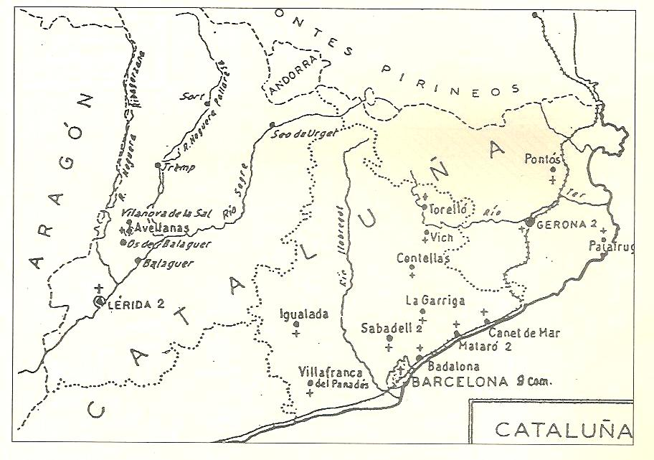
19- Brother Pablo Daniel of Barcelona.

From the martyrdom of Brother Crisanto, in 1936, to that of Brother Pablo Daniel, in 1939, we are dealing with the same cause. Each group is presented in a few compact pages, but they are often stirring and call for our admiration. Many of these brothers were killed before Brother Laurentino, Virgilio and the forty-four others who were declared blessed on October 28, 2007.

THE MARTYRS OF LES AVELLANES

Les Avellanes was an important Marist centre in 1936. It numbered 210 brothers and aspirants undergoing their training. The house included the juniorate, the postulancy and the novitiate, and the scholasticate, along with their teachers. It also included the provincial infirmary and a community for the different services: administration, farm, masonry and repairs.

Brother Crisanto was in charge of the aspirants, Brother Aquilino, the sub-director of the novices and three handicapped brothers: Fabian, Felix Lorenzo and Ligorio Pedro who suffered martyrdom on this very location or in the surroundings.

Brother Crisanto (Casimiro Gonzalez Garcia)

1-The martyrdom

Towards twelve o’clock, on August 27, in 1936, a group of foreign militia entered the village of Tartareu; the people guessed the militia’s intention was to kill Brother Crisanto. He replied that he could not abandon the young aspirants in his charge; thus he quickly walked to the police station where the strange intruders had been waiting for him. The local militia were told to withdraw.
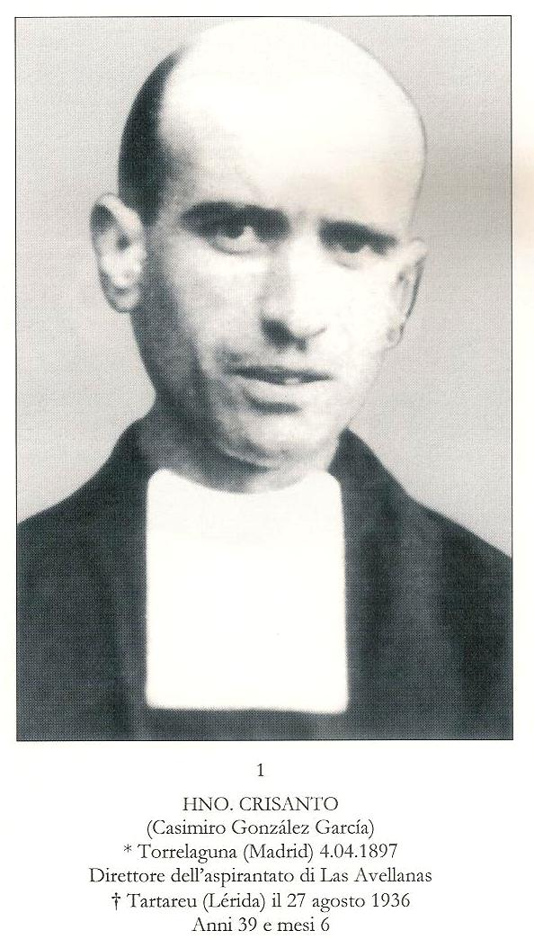

“Knowing that I had a vehicle, they ordered me to put it at their disposal. Soon, Brother Crisanto left accompanied by the militia and members of the local committee. Brother was smiling, tranquil while saying his adieu to those near him. The village people were very aggrieved by the fact that Brother had fallen into the hands of such savages. The chief of the militia noticed their reaction, and threatened the crowd with his gun and ordered them home.

Having moved three hundred metres further beyond the Mas del Pastor, the militia led Brother Crisanto to an escarpment where they invited the three members of the Tartareu Committee to shoot him. These refused explaining that they could not kill anybody from their own village.

Immediately, we heard seven or eight shots as we had turned our backs so as not to assist at the assassination. And, as the servant of God lay on the ground the torturers finished him with another shot. Turning towards us, they showed us the brother’s personal objects: a watch, a pen and a few coins.”

The militia forced the local farmers to bury the deceased threatening them with a similar fate if they were to refuse do so. These peasants noticed the cross in the brother’s fingers.

Killed around midday, Brother Crisanto was buried in the afternoon.

The corpse was exhumed for the first time four years later, on 4 May 1940 in the presence of a hundred witnesses. The body was decomposed but the right hand still held the little cross.

A second exhumation took place thirty-one years later on 15 August 1967. During this second ceremony, the mortal remains of Brother Crisanto and those of other martyred brothers during the same period, such as Brother Laurentino’s group of forty-six were transferred to the great chapel of Les Avellanes. This is now a place of pilgrimage.

2-A Transparent Man

“I spent the first years of my childhood at Torrelaguna quiet and far from the world, hearing only the prayers that my mother taught me. What a serene home! Thus growing like a little delicate flower sheltered from the wind I busied myself decorating a small altar of the Blessed Lady. I knelt in front of that altar with my mother many times to recite the rosary or do the month of Mary’s exercises.” This testimony introduces us into the family of Brother Crisanto.

He was born on 4 March 1897 and at his baptism, three days later, he received the name of Casimiro.

He joined the Marist Brothers in 1914. He already showed a great availability: “Here I am, do with me whatever will be your pleasure. My only wish is to obey.”
He took the habit on 2nd February 1915. That day, he exclaimed, “O my Mother, cover me with your mantle! May God not allow that this day ever vanishes from our memory and that at the end of our lives we crown our lives with the characteristic death of a Marist Brother who shouts loudly “Ave Maris Stella”. The day has come, Brother to unite yourself to God and to offer him your heart for ever.”

From 1916, he worked in many of our schools. The superiors, noticing his qualities, entrusted him with the formation of the aspirants in 1935 at Les Avellanes. That was a difficult period: while he assumed his task with a fatherly heart and responsibility, he had to live with the knowledge of a possible martyrdom. In August 1936, the Balaguer Revolutionary Committee relocated the aspirants who were in residences into families and farms of Tartareu. Brother Crisanto had to present himself to the town hall to append his signature twice a day. The people of this village had welcomed them with generosity. One of the aspirants, recalling the days when the aspirants lived with families of Tartareu, confided, “During the conversations, he told us: ‘They are going to kill me!’ and he would embrace us. Brother Crisanto said: ‘Pray a lot for me, the death sentence is already out against me.’ It seemed that their affection for us became stronger by the day.”

One village youngster offered a safe hiding place to Brother Crisanto who replied, “Thank
you, if necessary, I’ll give my life of the young aspirants”.

On 25 August, two days before his martyrdom, Brother Crisanto visited some confreres who invited him to flee. “I gave my word to the Committee that I would present myself every day and I will do it. I won’t even run away when they come to kill me. It’s my duty to accompany those youths whom the Superiors entrusted to me. On the other hand, I don’t want to compromise this population that welcomed us so well. If the militia kill me, their real motive will be that I am a Marist religious and that I do my duty. How can you even suggest that I abandon my dear aspirants? As long as I live, with God’s and Mary’s help, I will take care of them.”

At the very moment of the assassination, he expressed his worry for the young ones’ future, “In the name of God”, he begged, “do not kill me, let me take care of my aspirants.”

A volley of shots punctured the brother’s chest, then a second one, “So that he does not escape us!” said the murderers.
His young aspirants, the novices and the scholastics crossed the French border on October 5, 1936. These were guided by Brother Moisés Felix, the closest collaborator of Brother Crisanto at Las Avellanes. Thus, the final prayer of Brother Crisanto was answered.

3-A real martyr

Speaking of the victims of the Spanish revolution, John Paul II apprised us of the fact that there will always be people who will deny them the martyrs’ crown under the pretext of political motives. But John Paul II concluded, “If we cared to listen to such people we would have to cancel from the saints’ list all the classic martyrs of the Roman times. Yes, there was a political motive: they refused to worship the emperor. Yet all our altars are filled with relics of these saints, authentic martyrs and proclaimed such then and now.”

In the case of the martyrs of Les Avellanes, it was not an accidental gun shot, but the case of an obsession: priests and religious people were literally hounded. Brother Hippolytus, the then superior of the Les Avellanes house wrote, “There is not a single free priest left in Catalonia, nor any church that has not been set on fire or profaned, as well in the towns as in the countryside. The Lord is chased away from the whole of this region which has become a situation of death and desolation. And the militia will be quite explicit with him, ‘See that you and your friends leave your premises as soon as possible; otherwise misfortune will hit you for we want neither religion nor religious persons. Our religion is humanity.’

Wherever the members of the C.N.T.-F.A.I. were in command, everything was done to wipe out whatever could witness to faith: the churches were destroyed, the priests, the religious people and the practising Christians were constantly harassed or killed without any political activity charged to the victims.

Our community of Les Avellanes endured phases of growing persecution.

1-On July 18 1936, on the first day of the insurrection in Barcelona, the mayor of Balaguer, Mister Verdaguer, who was also the community’s doctor, came to visit the community. He wanted to know whether we are willing to cede our house to make it into a hospital or whether it will have to be confiscated. The brothers agreed to relinquish their house and moved to villages and farms nearby. However, the sick brothers were authorised to stay with the brother in charge and the Director.

2-On July 23, a new command was issued: everyone must leave the premises. In the evening, the president of the Revolutionary Committee of Balaguer and Os came along with the militia to give the order. “Nobody at all must remain. Before 8 P.M. we will send a lorry that will transport the sick to the hospital.” 25 July was a Sunday; and the brothers attended mass; for some of them it was to be their last one before martyrdom.

3-On July 30, the Revolutionary committee announced through all the small villages around Les Avellanes: All the assets of the convent: victuals, clothes, blankets and mattresses had to be returned. The brothers had allotted them to the families to allow these to welcome and to feed the young people in formation. The brothers themselves returned the different items. From that day, they had to sleep on mere boards, on the ground. They did it with joy to suffer for Christ.

4-On August 5, a group of foreign militia took possession of Les Avellanes. The Committee spread the rumour that arms were hidden in the convent. Guided by Brother Hippolytus, the militia inspected all the premises without finding anything. But they had a second mission: locate the brothers’ hiding places, make a list, and register the names of the sick brothers who lodged at the hospital, along with the names of the novices.
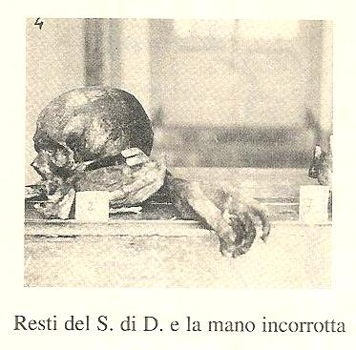
5-On August 23, the militia reappeared. They investigated whether all the assets had been returned. As some clothes had been found in his home, one man had to pay a heavy fine!

6-Brother Crisanto had found refuge in the small village of Tartareu where the Revolutionary Committee was very moderate and even made up of practising Christians. On August 6, the population had gathered to welcome Brother Crisanto and his twenty-five aspirants. These were accommodated by families and farms where they helped in the fields. Unfortunately, the Balaguer Committee did not lose sight of this.
Reliquias del H. Crisanto

Brother Crisanto had been given a make-believe freedom for he had to present himself to the town hall twice a day. Brother did this with simplicity and fidelity. “I gave my word to present myself to the Committee every day and I will do it. I won’t run away even if they come to kill me.”

7-During the first days of August, thanks to its moderate Committee, Tartareu knew neither destruction nor death. But soon a group of outside young communists entered on the scene. These forced the families to pile up their religious objects, books and symbols of their faith on the public square; they set all the objects on fire in front of the dismayed villagers. Four members of the Tartareu Committee were demoted and replaced by more “convinced” ones.

8-On August 27, some foreign militia turned up at Tartareu with rather wicked intentions. The villagers soon found out what was happening and sent somebody to warn Brother Crisanto that he should hide. Those militia had come to execute the death sentence issued against him. When called, he presented himself. He looked free from anxiety and greeted the villagers with affection.

4-The popularity of the martyred Brother

Brother Crisanto’s body was hastily buried and no symbol was set on his tomb. But the owner of the field did not cultivate anything at that particular spot. Many witnesses heard by the diocesan tribunal mention that “As soon as the body was interred the reputation of the holiness and of the martyrdom of the servant of God spread and up to now, the location of the burial has been respected and kept free from farming activities.

The Garrofé family who had welcomed him at Tartareu confirmed the reputation of holiness, “The story of the holiness and the martyrdom of the servant of God went around immediately after his death.”

That reputation grew through the years to the point that people started to pray to him to obtain special favours. Here is one case among others:

“While my husband happened to be in Barcelona, he suffered from such a strong cerebral attack that the doctor told my children that my husband would not last more than two hours. Considering the seriousness of the situation, my son who is a doctor carried him to Alicante. During the trip he injected his father with camphor oil and kept changing the packs of ice on the patient’s head. Nobody thought that my husband would outlive the journey.

At Alicante, the doctors gave up hope for my husband. Then, with great faith, I prayed to Brother Crisanto; I placed his image and relic in evidence and I started a novena with faith and hope. A few days later, my husband felt better and he continued this way up to his complete cure.
I am convinced my husband recovered his health thanks to Brother Crisanto.

Las Avellanas: In 1936 there were 210 people living in.
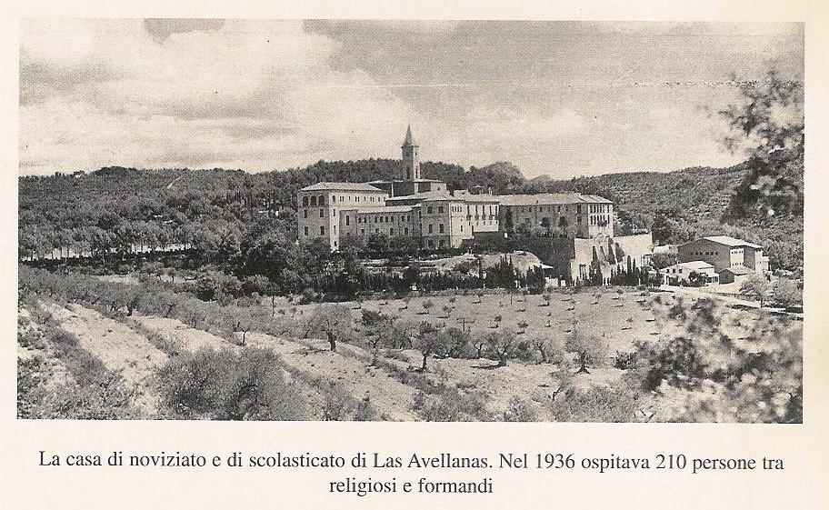
Les Avellanes: In 1936, 210 people were living in this house.
THE MARTYRS OF THE PEDIMENT (FRONT WALL)

BROTHERS: AQUILINO, FABIAN,

FELIX LORENZO, LIGORIO PEDRO

LES AVELLANES - 3 SEPTEMBER 1936

1 The Martyrdom
“At the end of August or during the first days of September of 1936, I happened to be in the city of Balaguer and I was getting ready to return home. At that very moment, I was ordered by a certain “Chala” to drive his four armed companions and himself to Les Avellanes’ convent.

Here is the scene that was waiting for me at the convent: “‘four metres in front of me stood an individual named “El Peleteiro” and two other armed men. At about thirty metres, I saw four Marist Brothers dressed in civilian clothes, lined up in front of the wall. I recognised them as Marist Brothers because I had often met them at the convent. I did not know them except for Bro. Aquilino. We exchanged greetings. The fellows I had driven in got off and joined El Peleteiro. At that moment, Brother Aquilino addressed them: ‘I want to talk to you.’ El Peleteiro replied, ‘Speak while we load the guns!’ But the militia did not listen to him. ‘As a man I forgive you and as a Catholic I thank you for you are putting into my hands the martyr’s palm that all Christians must desire..’ El Peletiro asked him, ‘Have you finished?’ To this, Brother Aquilino Baro shouted, ‘Long Live Christ the King!’ El Peleteiro said: ‘Now, you can turn around!’ Aquilino replied, “Front wise!’ The militia triggered their guns and the four servants of God fell to the ground.”

2 The Life

1-Brother Aquilino (Baldomero Baro Riera)
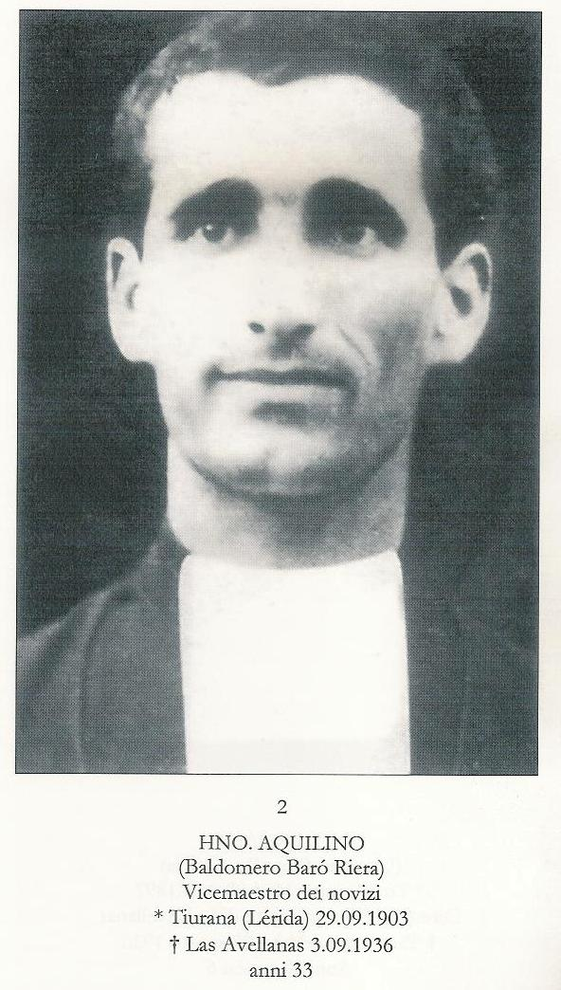

Brother Aquilino was born on 29 September of 1903 at Tiurana (Lérida), a charming village of 600, in the rich valley of the River Segre. The next day, at his baptism, he received the name Baldomero, Miguel, Geronimo. He was not yet 33 when he was killed on 3 September of 1936.

He entered the Vich juniorate in 1916 and went through the normal religious training. He professed his first vows on September 8, 1920, and at twenty he was already teaching at the Vich juniorate. His first attempt at teaching was not a success. The superiors sent him to Arceniega where his results were better than at Vich.

At the time of his perpetual profession on 19 July 1925, his confreres noted his growing interest in spiritual life and his proper interconnection between interior, community and apostolic life.

His unlimited devotedness to the training of the juniors made him a candidate as an associate to the novice master at Les Avellanes. In this task, one noticed his Marist characteristics: “His humility and his simplicity made him work at his apostolate without making any noise. Brother Aquilino’s whole pedagogical activity aimed at preparing true and committed Christians.

He did not forget to support the faith of his family. The second censor theologian made this reflection, “Each of his letters was animated with a spiritual inspiration. None of his letters forgot to speak the language of a religious person, to exhort to the practice of Christian virtues. The recipients of these letters were surely very edified.”

His prayer to Mary, composed shortly before his martyrdom reveals his interior life:
“O Mary! O Mother of God and Mother of my soul! Because of you, there is a fusion of two very different beings, and still made to be united: God and my soul! Please, may God give himself to my soul and may my soul give itself to God. Grant me, Good Lady that the thought of God occupy all my soul; that my heart may be invaded by his unique Love and that the great motto of Saint Theresa become truly the norm of my life: “God is sufficient to me! Only God is sufficient to me!”

Living in the presence of God had become habitual to him. Also he developed a great trust in God. This latter virtue was evident when events led him to martyrdom. He wrote to his sister: “As far as we are concerned, don’t worry; I agree that life has changed, the threats against the religious people, the churches and the convents are frequent, but aren’t we all in the hands of God? He called us, he gathered us, he watches over us.”

After the July 18, 1936. uprising and the confiscation of our house at Les Avellanes on the same day, Brother Aquilino and his novices were relocated to the nearby village of Vilanova de la Sal. Then, he moved with his family at Tiurana. For a month, his voluntary mortification increased. He considered his body as the grain that must be laid in the soil so that it can bear fruit (Mc 8, 34-35).

The death sentence against him was already out. He knew it and he was ready.

2-Brother Fabian (Juan Pastor Marco)
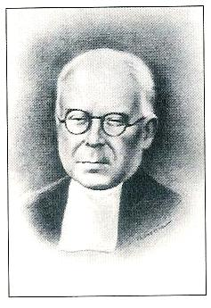
Brother Fabian was born at Barcelona on January 14, 1876. Two days later, he received the sacrament of baptism and the names Juan, Jaime, Ramón.

On September 3, 1936, the day of his martyrdom, he was his sixty years old, and the eldest in the group of the four gunned down at the wall of Les Avellanes.

Fabian underwent his religious training at Saint Paul Trois Châteaux since the Marist Brothers arrived in Spain only in 1886 and did not yet possess any training house.

In 1891 he was sent to work in our schools in France: Beausset, Lambesc.
He gave himself to the Institute definitively by professing his perpetual vows on September 21, 1897.

He was recalled to Spain where Spanish brothers were needed and his first obedience was Mataró. But new houses appeared like mushrooms and Brother Fabian was often transferred. He succeeded everywhere because he gave himself to his apostolate. His simplicity and kindness attracted pupils to him. Among them, he behaved like a father. He even went begging to help those most in need. This testimony was given by the Ministry of Labour itself.
In August 1935, he was at Barcelona. He could not teach until the end of the school year; a serious disease forced him to move to the infirmary of Las Avellanes. Though seriously ill he was forced by the militia to line up at the wall. They killed him simply because he was a religious person, a Christian educator of youth.
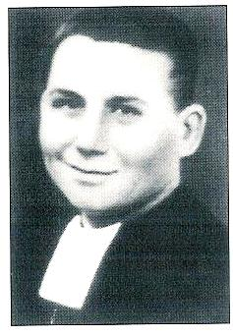

3-Brother Felix Lorenzo (Lorenzo Gutiérrez Rojo)

Lorenzo was born on August 10, 1906, in the village of Las Hormazas (Burgos). The next day he was baptized and received the names Lorenzo, Macario, Julian. At 13, he entered the juniorate of Arceniega. After having gone through the different stages of his formation, he made his first vows on September 8, 1923. His perpetual vows were made in 1928.

He first taught at Murcie. But as his health was poor, his superiors sent him to Zaragoza in 1930 in the hope that a change of climate might help him. He suffered from a weak heart; sometime, spasms seemed to bring him near death. At the infirmary of Les Avellanes in 1931, the doctors gave him five months to live. Three times, he received the sacrament of the sick.

He lived through his sufferings with gentleness and humility. In spite of the seriousness of his illness, he kept smiling and made himself useful with some work requiring precision.

On 23 July 1936, the Revolutionary Committee of Balaguer allowed the brothers twenty-four hours to empty the house.

On July 25, Brother Lorenzo suffered one of his worst heart attacks; he was very near death. Yet, the militia carried him on a lorry to the municipal clinic of Balaguer.

The anarchists did not spare this man who was just holding to life by a straw. They got him out of the hospital, drove him to the public place where he was shot down together with Aquilino, Fabian and Ligorio Pedro. These last two helped Brother Felix to stand during the execution.

4-Brother Ligorio Pedro (Hilario de Santiago Paredes)

He was the youngest Brother of the four who were killed at the wall on 3 September 1936. He was only 24. His four brothers and sisters came to give their testimonies at the diocesan trial. They also gave details of his childhood.
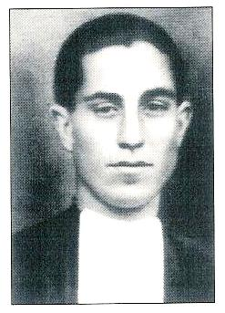

Brother Ligorio Pedro was born on 13 May of 1912 at Cisneros de Campo (Valencia). At his baptism, he received the name of Hilario.

His family was poor. They even ran short of food at times. One of his uncles who was a priest helped him in his studies. He would have liked Hilario to become a priest but the Marist attraction was stronger than the priesthood.
On 24 September of 1927, Hilario entered the juniorate of Carrion de los Condes. That juniorate was intended to prepare missions candidates but also welcomed youngsters from Latin America. Little by little, Hilario took up an international mentality.
At Espira de l’Agly, France, Hilario continued his studies and improved his knowledge of French. Then, he moved to Pontos (Gérone) to do his postulancy. On 2 August of 1932, he professed his first vows and changed his name to Ligorio Pedro.

This is when he was called to do his two-year military service. During that period he contacted a disease called “the Pott sickness”. Brother Ligorio himself described this disease, “The sickness of Pott is an affliction whereby the bones and the blood become pus.” After his military service the superiors granted him a year to complete his studies at Carrion de los Contes. He was preparing to go and work in Mexico. However, his sickness worsened and on the advice of the doctors, he moved to the infirmary on 12 May 1936. This was where martyrdom was awaiting him. The militia wrested him from his bed, and led him to the public place where they assassinated him offering no resistance but shouting, “Long Live Christ the King!”

3-The making of martyrs.

From reading the historical facts, one realizes that the servants of God: Aquilino, Fabian, Felix Lorenzo and Ligorio Pedro were killed for the sole reason that they were persons consecrated to God. The behaviour of the militia confirms this. We would like to add that in the whole of Catalonia, churches were burned; profaned and all religious people were hounded out and killed when caught. Without that hatred of religion how can one explain what was inflicted on the three handicapped Brothers, Fabian, Felix Lorenzo and Pedro Ligorio? The three of them were already confined to a public hospital, they were in the hands of the Balaguer Committee.

To kill three sick persons because they are religious is not only unequivocally detestable and vile but contrary to the basic statutes of any civilized country.

Let us see how the new “owners” behaved when they took possession of our house at Les Avellanes:

“They spent the first days banqueting. The orgy lasted many days, emptying the pantry, decimating the chicken coop and the stable. But most painful were the blasphemies and the profanations of the sacred icons that matched the bacchanals. The life-size crucifix in the chapel was dragged in front of the house where the militia rogues aped the Passion scenes before reducing it to smithereens. The statue of the Sacred Heart that towered over the cloister met the same fate, as did the statue of the Virgin Mary that had stood in the chapel. Likewise, the statue of the Virgin that embellished the fountain of “The Contes d’Urgel” was profaned and broken; a similar fate befell a statue high on the hill where the Brothers had sung the Salve Regina so many times. Even the XVIIth century cross of great artistic value that had attracted many pilgrims became the prey of those uncultured iconoclasts.”

During the night of the 4th August, the killings of the priests and the religious started at Lerida. The bishop was one of the first victims along with two Marist Brothers, Candido and Emerico. On 5th August, the anarchists killed eleven religious from the Franciscans and the Brothers of “des Écoles Pies”. On the night of 12th August, members of the Os Committee came to Vilanova with the intention of burning the church, but the local Committee opposed the evil deed. The ruffians reappeared on next day with more bravado; they did not burn the church but took out all the religious objects and set them afire on the public square.

Our Brothers who now lived in the midst of the people knew of the happenings. They were also aware that the enemies were looking for them and that they had already been condemned to death by the fact that they belonged to Christ. The Brothers realized that the situation was very grave indeed. Brother Laurentino, Provincial had challenged them to prepare for martyrdom.
The testimonies given at the Diocesan hearing reveal the same sentiments. Of Br Aquilo one witness said: “I am convinced that Brother Aquilino had the fibre of martyrs; he was incapable of yielding to cowardice, he was ready to die for Christ.”

Before his death Brother Aquilino confided to a Brother, “As far as I am concerned, I believe I must not abandon these young men placed in our care, I have a responsibility for them especially now that the Brother-in-charge has had to run away. Although I cannot do all that I would like to do to protect them, I hope my presence constitutes a buffer. If the enemies kill me, I will be happy to die for the Lord and for our dear novices.”

During the last days he spent with his family, he did not hide. He would recite his prayers in the open. On feast days, he would gather the young people to recite the rosary. He continued to wear his scapular. His letters still carried the heading J.M.J.29 His family warned him that he was flirting with danger. He answered, “If they kill me, I will be a martyr on earth and a saint in heaven.”

To a ruffian who had entered his brother’s home and who was taunting him with being afraid, he retorted, “It is not true; we are not afraid of death. Jesus Christ was persecuted and killed before us. Hence we do not fear death if we can offer our lives to God. It is yourself who is afraid of death!”

Brother Aquilino is, perhaps, the most outstanding representative of the group. We have more testimonies for him than for the three others because he was tracked down for a longer time and because his novices and relatives survived him to testify in his favour.

Impact of a bullet on the wall of the fronton,
Les Avellanes.
THE BROTHERS OF THE TOLEDO COMMUNITY

1-The community
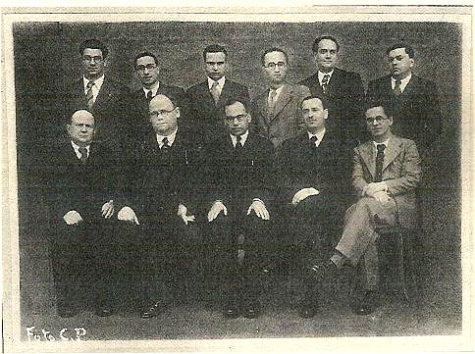
During the school year of 1935-1936, the Toledo Marist community numbered sixteen Brothers. Here are those who were present in mid-July:
Brothers Claudio Luis, Cipriano José, forty-three years old and the superior,
Jorge Luis (50), Jean Marie (63), Julio Fermín (37), Javier Benito (24), Anacleto Luis (23),
Bruno José (21), Evencio (37), Abdon (41), Eduardo Maria (21), and Felix Amancio (24).

Four young Brothers were attending summer courses at Murcie. Brother Claudio Luis did not join the group of martyrs. The others were killed on 23 August 1936, except Brother Jorge Luis who was assassinated on the following day, on 24 August.

Reference to this group of martyrs will be made as we recall events in the last days of Brother Cipriano Jose, the superior.

1-Brother Cipriano Jose (Julian Iglesias Bañuelos)

Brother Cipriano Jose was born on 26 February of 1893 at Valcarceres (Burgos). Baptized two days later, he was named Julián. His parents were modest peasants whose inheritance to their children was twofold: piety and the love of work.
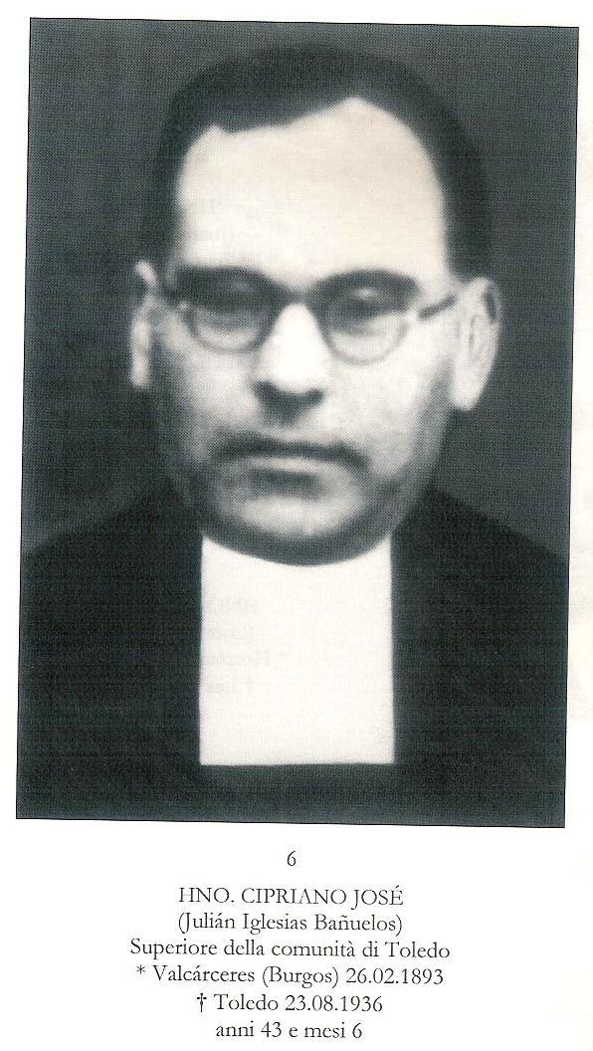

In 1905, Julián, at the early age of 12 started his Marist training at the Juniorate in Burgos. He took the habit at San Andres de Palomar (Barcelona) on 8 September 1908 and became Brother Cipriano Jose. He made his perpetual vows on 1st August of 1915 and pronounced his vow of stability on 15th August 1924.

Talented and tenacious, he obtained his master’s degree in literature and in philosophy. He displayed an astonishing professional competence. From external observation, he might have given the impression of being reserved and, perhaps, even severe. In fact, he had a sensitive, noble and very honest soul. He showed himself enterprising, accommodating and very attentive to the needs of others. He provided for all the Brothers before thinking of himself. Whenever anyone was sick he would spend the whole night at the Brother’s bedside in spite of the next day’s tasks. That dedication was inspired by his great devotion to the Eucharist. To the Brothers and the teachers he often recommended the pious practice of visits to the Blessed Sacrament; he found this practice very fruitful. He prayed in such a fervent way that his Brothers did not need any exhortation in this field.

His obedience was salutary. The least desires of his superiors were accepted without the “buts” that would have been justified on some occasions. He fought old habits or little abuses that had introduced themselves into community life at the risk of losing popularity. Poverty was his most characteristic virtue. He was satisfied with what was indispensable. On the other hand, he ensured that his Brothers would not want for anything. He even promoted the innocent pleasures such as the Christmas tree, the gifts at the Epiphany, and a well prepared dish on the important feast days.

“When the superiors gave us the order to wear a secular clothing so that we complied with the political requirements, he let the Brothers choose the best suits first and then chose his suit afterwards.” “He bought such an ordinary overcoat that we suggested that the superior should have chosen better quality. He replied with a smile.”

He amazed everyone by the quantity of work he could do. He hardly had any time for the newspaper. He would tell the Brothers, “Take it, there is some urgent work waiting for me!”

Headmaster of a school that numbered 185 pupils in the secondary section and 300 in the primary cycle, he was also the bursar and the administrator. He received the school fees himself and sold the stationery. He taught three or four subjects in the upper classes. Still, he found time to inspect the classes and to accompany the young teachers. His confreres would say, “What a life, he never gets tired!”

In fact, in this quantity of work one could easily discern the devotedness of a religious person. He placed the greatest emphasis on the teaching of religion. He, personally, gave those lessons to the upper classes. One of his favourite refrains was: “All classes are dispensable except the period of religion!”

This is the man whom the Toledo republican authorities made their victim and God’s martyr.

2-The martyrdom

1-The Situation at Toledo
H. Félix Amancio

The first two days after the national uprising of 18 July of 1936, Toledo lived in relative calm; the public power had sided with the nationalists. But when on 21 July, six thousand militia warriors arrived from Madrid, the Guardia Civil retreated to the Alcazar and the town was taken on 22 July.
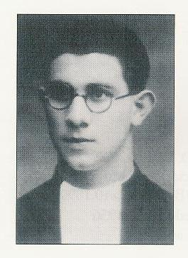

The Marxists did not delay in setting in motion their persecution projects. They confiscated all the Church assets. Immediately thereafter the hunt for the priests, religious and committed lay people started.

“At Toledo, the persecution assumed a catastrophic antireligious character. I could notice this fact because I was in charge of the cemetery. The victims were all committed Christian people. The revolution attacked the priests and the religious. Between four hundred and fifty and five hundred people were killed in the city of Toledo. Among those victims were all the canons of the cathedral, the parish priests and the two communities of the town: the Carmelites and the Marist Brothers.”

2-The Brothers Are Arrested

At the beginning of the revolution, the Brothers adopted an attitude of resignation while they waited for the events to unfold. The confusion and disorder that had erupted after the declaration of the state of war on 21 July of 1936 did not deter them from occupying themselves with their usual tasks and they did not seek out safety inside the Alcazar as they had been advised to do.

The Brothers did not imagine that they had been included on the list of those to be sent to jail.

This naïve simplicity made it very easy for the militia to catch them by surprise. When Brother Cipriano Jose realized the situation, he begged the Brothers to rush to the chapel to consume the consecrated hosts. Unfortunately, the people from the militia, who had already broken into the school interrupted the Brothers before they could reach the chapel.

“The militia group shouted, ‘All the religious of the college, present themselves in the yard’. They lined up the Brothers near the wall, separating them from the other persons. They also forced me to line up against the wall under the pretext that I was a religious teacher at the college. As I protested that I was a lay teacher, one of the militia pushed me outside, shouting, “Get out of here!” I remained around the college to find out what was going to happen. At night, I saw a group of men from the militia pushing the Brothers violently. The Brothers were then force-marched to jail.

All the arrested people were frisked. The discovery of a rosary, a medal or a scapular triggered excesses of rage and blasphemies. The militia unleashed the same tantrums when they inspected the school. Instead of the arms that they were seeking they found an abundance of religious objects that they broke to pieces and threw out the windows.”

The prison was not humanitarian at all. “We were thrown into a ‘brigata’ (cell) immediately. We stayed in those cells that had neither air nor water for twenty days. We could not go out to drink water. There was only one jug of water for the forty incarcerated persons. The guards soon became torturers; and they kept threatening to send us to the firing squad. Prisoners who would never return were made to pass in front of us.” A witness reported, “The Brothers prayed with resignation at the approach of sure death. People were killed at the very door of the prison. Yet, the Brothers kept calm and prayerful.”

3-The Execution

Franco’s planes had bombed Madrid on 22 August 1936 inflicting many deaths. The militia people took their revenge on the prisoners by slaughtering a group on the Transito esplanade on 23 August. On that same day, it was the turn of the Marist Brothers and the other religious and the priests to suffer the same vengeful and cruel punishment. But the Transito was encumbered with corpses. The Marist Brothers and the others were then led to the “Puerta Del Cambron” where they were mown down by machine gun fire. Those executions had not been preceded by any judgment or by any opportunity of defense. The fact of being a religious person was sufficient to deserve execution!

4-The Martyrdom of Brother Jorge Luis

Brother Jorge Luis was killed on the following day. When his confreres had been taken to jail, he was helping in the kitchen. Warned that his confreres had been arrested, he was advised not to move. But a militia member recognized him as a Marist Brother and reported him. Brother Jorge was arrested and locked in an especially secure cell. Don Carmelo Moscardo Guzman who shared the same cell, left the following testimony:
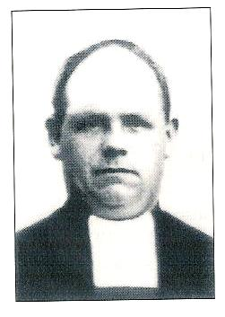

“…One day the guards took me from the jail and I was locked up in a special cell. Late that night ‘Granadino’ showed himself in. When I inquired about my brother’s death, he simply replied that it was ‘justice’ to shoot him. ‘Like the justice you will get.’ Then a Marist Brother was let in who had not been found the day before. The ruffians questioned him at length on God’s existence. While this was happening Granadino interjected, “Here is how it will all end.” And he stuck the Brother heavily on the head with his gun. Shortly afterwards I was removed from the cell. I could, therefore, not know whether the Brother’s death was due to the blow from the gun or whether he was assassinated later.”

It happened that Brother Jorge Luis survived the blow; the next day he was shot at the Transito.

3 The souls of the martyrs

Let us now enter into our Brothers’ souls when they were in jail by listening to those who shared the same fate.

“During all the time I spent in jail with them, all these Brothers showed a great meekness, without any coarseness, bearing the humiliations with dignity.”

They tried to create a strong atmosphere of prayer in the prison, as one witness testified:
“During their time in prison, the Brothers lived eminently Christian and religious lives, thus constantly edifying and encouraging the prisoners. They prayed a lot. The rosary was recited every day, often animated by a Brother. With great courage, they prepared themselves to suffer death out of love for the Lord. From their first day in jail, they expected death with certainty.”

A companion of the Brothers in jail, Mr. Felice Bretaño Encinas related, “During the days of the revolution the servants of God dedicated themselves to observe the discipline of penance and during the moments when they were not seen they prayed.”
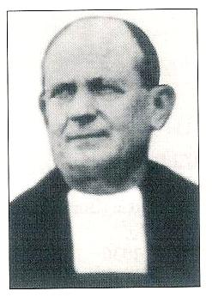

Brother Jorge Luis did not hide his desire to become a martyr,
“My greatest desire, after my conversion has been to shed my blood for Christ.”

Mr Carmelo Moscardo Guzman had witnessed the conversation between Granadino and Brother Jorge Luis on God’s existence. Brother had defended religion so well that the other, burning with rage had struck him with a violent blow on the head with the stock of his gun.
Br. Jean Marie
Brother Jean Marie was of French stock. When the French consul informed him that he had started the procedures to get him out of jail and repatriate him, the Brother refused categorically, “This never! I always lived with them; I want to die with them!”
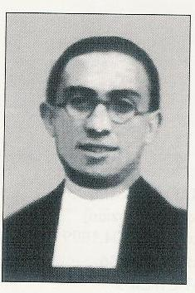
Brother Anacleto Luis wrote to his relatives, fifteen days before being shot.
“Do not worry for me. How happy you would be to die in the same way I will soon do!”

Brother Bruno’s mother and sister came to visit him. The latter described the scene,
“At the moment our anxious mother mentioned the dangers that threatened the religious, he, my brother, stood up and joyfully exclaimed, ‘O Mother! What a joy it would be to die a martyr!’ My mother burst in sobs while I admired my brother’s determination. And he, to assuage his mother’s pain whispered to her that there was a secret escape door at the college.”
Br. Bruno José

“The son of General Moscardo, defender of L’Alcazar of Toledo was in jail with the Brothers. Father and son engaged into a memorable dialogue. The son told his father that unless he surrendered he (the son) would be shot. Then addressing himself to Brother Javier Benito, his teacher, he implored, “What will happen to us?’ The Brother replied, “My son, may God’s will be done!” That night, in small groups, all were led to their execution. That night, the Brothers of the College, Moscardo’s son and other persons died.”

Witnesses affirm that Brother Jorge Luis walked to the execution ground with the same contemplative mien as when going to communion. “I heard that he walked with his arms crosswise with his eyes closed.” And at the execution ground, he made a great apologia in favour of Religion for which he died happy. Finally, after he had shouted, ‘Long Live God! Long Live Religion! Long Live Christ the King!’ he was shot.” A man who lived near the execution place told how he had heard perfectly Brother Jorge forgive those who were taking part in his assassination, declaring that he bore them no grudge. He testified that Brother’s last words had been, “Long Live Christ the King!”

Hearing or reading these testimonies one may be tempted to think, “This is idealized biography!” What is certain is that those witnesses to faith had long prepared themselves for this extraordinary grace of martyrdom.

4 Already the Dawn of Glory
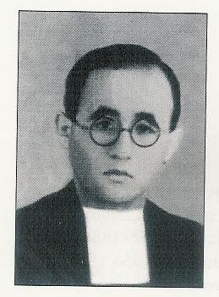

Eight Marist Brothers Interred in a Toledo Parish Church

The 24th and 25th of October of 2003 were important days in the annals of the Marist saints. They marked the legal recognition of the mortal remains of eight Brothers of the Toledo community, Spain. These Brothers had been killed on 23rd and 24th August of 1936. The ceremony took place in front of an ecclesiastic tribunal in the afternoon of 24th October 2003.
Br. Javier Benito
On Saturday 25th October, we attended the burial of the mortal remains of these Brothers in Santa Teresa, near our College. Everything developed around a solemn mass presided over by the Archbishop of Toledo. Relatives of the martyrs and one hundred Brothers attended the ceremony. The mortal remains had been laid down into eight small urns. These, carried by relatives of the deceased Brothers at the end of the mass, were laid into a marble sarcophagus that now stands at the left hand side of the nave in the chapel of the Blessed Sacrament.
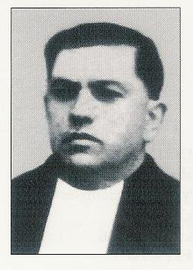
The transfer of the mortal remains of the martyrs is a very ancient Church tradition that can be traced as far back as the first martyr, Saint Stephen. Through the celebration of the transfer, the Church expresses its esteem, its respect and its gratitude to the great witnesses of faith. In martyrdom, it recognizes the ideal for all Christians: to make of one’s life a complete gift to the Lord.

Our Congregation numbers many martyrs: they are gifts from the love of God. And the power of this gift manifests itself right now. That was evident on Saturday 25 October, at the moment of the re-interment: the church was full of people happy to welcome those eight witnesses of Christ among them. From now on, the faithful will have the leisure to pause in front of the common tomb of the eight Brothers for a moment of reflection and prayer. These witnesses belong to them, they belong to the Church. And we, the Marist Brothers why should we not open our hearts and our lives to that grace and sing with the Virgin Mary a loud Magnificat for all the marvels that God has done among us?
Br. Abdón
The eight Brothers interred in Saint Teresa parish church are:

Javier Benito Cipriano Jose Julio Firmin Jean Marie
Bruno Jose Abdon Felix Amancio Jorge Luis
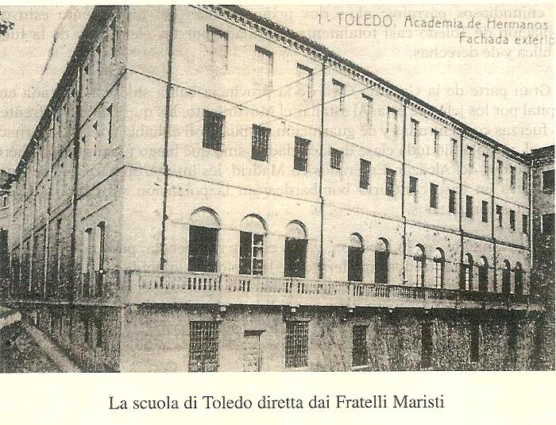
Toledo: College of the Brothers, 1936
OUR MARTYRED BROTHERS
FROM THE COMMUNITIES OF VALENCIA

The Marist Brothers directed two prosperous schools in Valencia:
The “Academia Nebrija Nutria” primary cycle and C.E.G and The “Liceo Mayans.”
The two communities maintained fraternal relationships and often visited each other.

The following pages will present the case of the martyrdoms of the Brothers of the “Academia Nebrija” Community.

1-A community of martyrs

Four Brothers made up the “Academia Nebrija” community during the 1935-36 school year. They were Brothers Luis Damián 45 years old, the school headmaster,
José Ceferino (31), the sub-director, Berardo José ( 24) and Benedicto José (23).
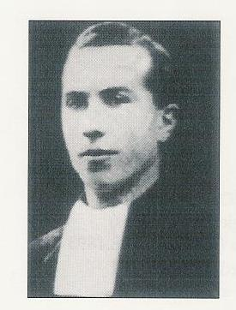
1-Brother Luis Damián was born in France in 1891 in the eastern Pyrenees. When the Combes laws confiscated the Brothers’ possessions and forced them into exile, the young Joseph Sobraqués (Luis Damian) asked to become a Marist Brother and to go to Spain for his training. He was at Vich for his juniorate and he went to make his novitiate at San Andrés de Palomar. He never considered himself in exile in Spain. He wrote to a Spanish confrere in-charge of vocations in France, “That you are at Espira (in France) should not give you the impression of being in exile! I have never considered myself an exile; to a Christian the fatherland is heaven, to a religious the field of apostolate is anywhere in the world whatever name it bears. May God make us, you and me, firm in these principles!”

He confirmed these sentiments when the Spanish state legislated that Spanish nationals only were authorized to teach in Spain. Brother Luis Damián immediately renounced his French nationality to take up Spanish citizenship. When dangers became imminent he was advised to re-apply for French citizenship. His sister suggested that he return to Perpignan and orientate himself towards the priesthood. He, however, remained faithful to his vocation as a Brother and retained his Spanish citizenship. He followed his conscience in all these matters. He was deeply distressed by the plight of the Spanish people, especially the poor. In a letter to his aunt who was a nun he wrote: “It is dreadful to think of all the Catholic convents and churches that have been burned or ransacked! Religious Houses in the smaller towns have been the most affected. So much so that many religious have had to give up their apostolates.”

In another letter he indicated what he thought were the social reasons for the persecution,
“The well-off people have forgotten the serious Gospel precepts regarding the use of material goods; they do not share with the poor; that is what swells the ranks of the communist and socialist parties; here is what brings a hatred of religion that is wrongly accused of being in cahoots with the bourgeois class”

He asked his aunt to pray for him and his community, “More than ever, I wish to recommend myself to your good prayers that I may be up to par in war time and that I may lose no-one that the good Lord has entrusted to me.”

His wish was granted. He, his three confreres and the school chaplain were all martyred together.

2-Brother José Ceferino was born at Centelles (Barcelona) in 1905. In 1918, after his mother’s death, he started his Marist training. Of cheerful character, he was used to humility and liked to care for others. He was appointed the sub director of the Academia Nebrija for the school year 1935-36. He and Brother Director made a perfect pair for proper school administration and for the progress to holiness. A Brother from another school of the same town said of him, “On familiar terms, we used to call him ‘Saint Louis’ (of Gonzaga). He was a wholesome and virtuous youth, a committed man possessed of an interior life that reflected beauty, simplicity, transparency and availability. He was great in his knowledge, great in his skill to discern people’s needs and in his readiness to help everybody.”
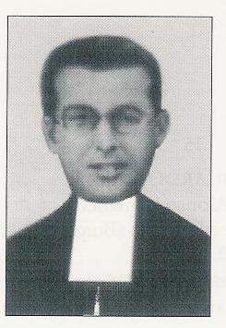

3-Brothers Berardo José and Benedicto José were the two young Brothers from that community of martyrs; the former was 24 and the latter 23. Both came from the Burgos province. Berardo showed himself as a simple, frank, lovable and jovial young man. He was constant in his studies. Although not endowed with great intellectual talents he became a successful teacher.
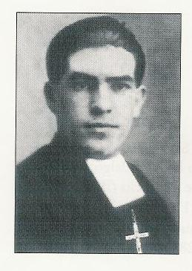

Benedicto José was a young man with noble but simple feelings. His first teaching appointment took him to Vallejo de Orbo; then he was stationed at Barruelo de Santullan, a coal mining area, in the Palencia Province. For three years he lived in the community of Brother Bernardo. In 1935-36, he was part of the community of the “Academia Nebrija” of Valencia. When the persecution forced the Brothers to disperse, Benedicto José remained with Bernardo. They were arrested together and sent to jail where they found their director and sub director.
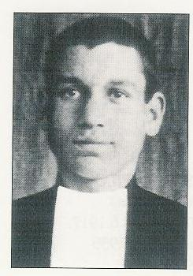

Isn’t it beautiful to see a community walk together to martyrdom and together show their fidelity to Christ?

2-The martyrdom

The news of the military uprising by Franco was publicised on 17 July 1936. Immediately, a storm of terror was unleashed against the Church and its property in Valencia where a mad crowd ransacked the priests’ training college. The fear that the next target might be the Marist schools made Brother Damián try to avoid any sacrilegious profanations. His first preoccupation was to carry the College’s ciborium to a safe hiding place. Once he had done that he hurriedly crossed the town, despite the intermittent gun-fire, to reach the other college. He told me, ‘We must save the Blessed Sacrament; I will put it in a safe place where I have already hidden the ciborium of our college!’ And this is what he did crossing the town again through streets infested with many armed men.”

On 21st July, a militia group barged into the school and gave the Brothers thirty minutes to vacate the premises and to move to an allocated residence. As the residence’s owner had been condemned to house arrest, the Brothers decided to disperse. Brother Damian hid himself in an old boy’s home; Brother José Ceferino at the chaplain’s house, Brothers Berardo and Benedicto in a pension cared by three elderly ladies. A Brother who had come from Barcelona to hide at his sister’s home advised Brother Luis Damián to go and see the French consul. Brother Damián interjected, “And who will take care of my Brothers”?

We don’t know exactly how Brother Luis Damián was arrested. On 4th August when Father Francisco Martinez Ciudad was thrown into prison he found Brother Damian already there. “When I was taken to the Sagunto jail, the servant of God was already there. He was lying down on a poor mattress. When he found out I was a priest he asked me to hear his confession. Later, I heard from him that his entire community and the chaplain had been arrested. He was lying down with his arms crossed over his chest, as in prayer.”
The stay in prison was short but the sufferings were cruel. “The reason why Brother was lying on his poor mattress was because of the extreme weakness he felt after three days without food. Besides, he had been submitted to moral tortures: threats, abominable noises, and taunts from immoral people, and provocation from prostitutes and constant threats with daggers. The authorities kept him in that weakening state that they called ‘the bleeding’ as an immediate preparation for his execution by the firing squad.” (What Father Martinez said about Brother Luis Damian must also have been the experience of the other Brothers before they died.)

Father Francisco Martinez Ciudad continued his testimony thus:
“I was present when they led him out into the presence of chief Ungria, who was brandishing a revolver. Ungria shouted, ‘Will the Director of the Marist Brothers present himself with his four companions.’ With my own eyes I saw Brother Director, three Brothers and the chaplain rise up. A few minutes elapsed while the Brothers walked down the steps to the yard. Then we heard five gun shots followed by other staccato sounds that suggested that coffins were being nailed shut. And then the noise of a lorry made us realise that the corpses were being taken elsewhere.

Next, Ungria requested the attention of the four Alicante priests who were there.
‘You saw, the five gentlemen are already killed and buried; you will suffer the same treatment if at the end of twenty-four hours you have not bring in twenty thousand pesetas!’

We never knew where the four Brothers had been buried. It was the same case for all the religious who died in that prison. Hiding the corpses was part of the persecution.”

3- A real persecution

At Valencia, the F.A.I. committees and the socialist party did not waste time with court trials. The arrested religious, the priests and lay people were quickly executed. There were short detentions but no trials.

Brother Rafael Iriberri San Martín of the Mayans Lycée who made a stay in jail described what happened, “The 1936 revolution was highly anti-Catholic. At Valencia where I happened to be, almost all the churches were burned. Many priests, religious and even nuns were killed.”

Father Francisco Martinez Ciudad added, “In the prison yard there was the icon of a saint. The thugs practiced their shooting on it and they measured the correct distance from it when executing their victims. In the prisons they used to offer their victims two choices: either a good ticket to Russia or freedom if we apostatized. We can surely assume that those proposals were made to our martyrs.”
An interesting testimony came from Father Francisco Sastre Vallés, the parish priest of Mislata, who shared the same jail,
“The communist officials felt that the Brothers were seen as influential people within the local community because of their religious life and holiness. For this reason they selected them as their first victims.” He added that during the few days they stayed in prison they catechized the other prisoners, “They distinguished themselves by their heroic faith and stability, and by their deep piety. All considered them as extraordinary souls.”

Here is the image that Father Francisco Martinez Ciudad still had in memory when he was called to witness at the diocesan tribunal: “I had the impression I was hearing the confession of a saint. His preparation for martyrdom and his demeanour revealed this very well. Since the day of his execution I have never forgotten the aura of sanctity that was evident at his martyrdom. Since then I have always recommended my needs to this servant of God; I have even invited the sick people in my care to recommend themselves to him.”

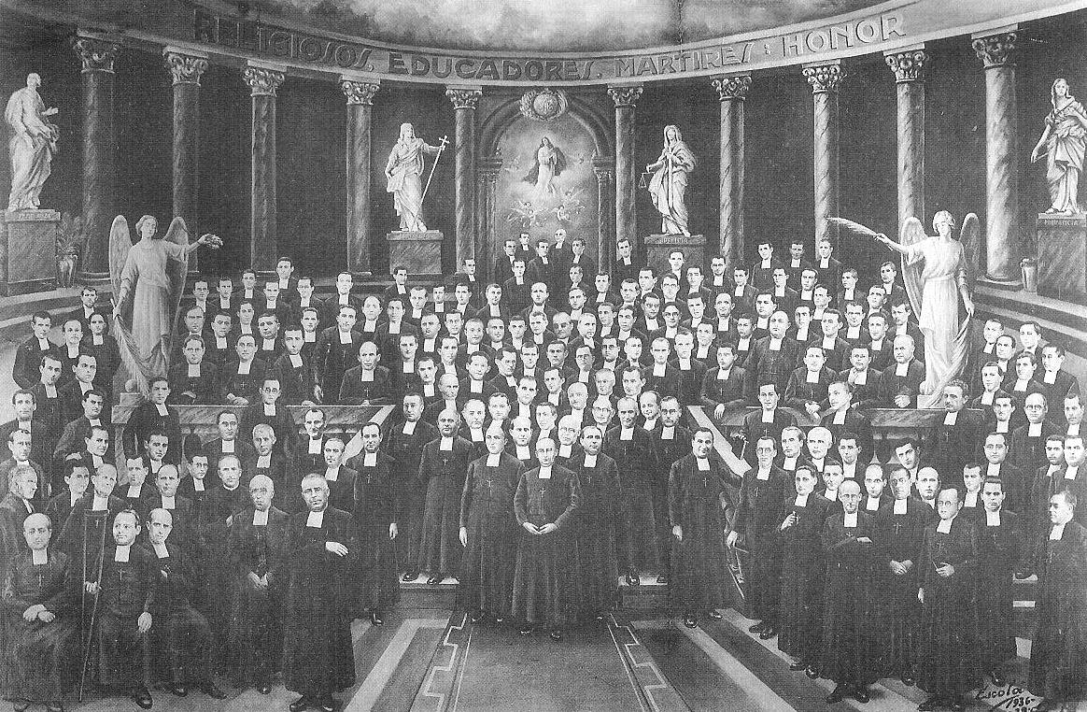
THE MARTYRED BROTHERS OF THE COMMUNITY OF VICH

Vich is a little town in the midland of Catalonia, forty kilometres north east of Barcelona. In 1936, there were three Marist communities :
a school: ‘Sagrado Corazon de Jesus’
a tailor shop that supplied all the Spanish Brothers
a juniorate with forty young ones.

Each of these communities had its martyrs but here we will particularly follow the fate of the community of the juniorate. There were four Brothers:
Severino, 28 years old
José Teofilo, 19
Justo Pastor, 29 and
Alipio José, 20.

The entire community was eliminated but in two different moments. First Brothers José Teofilo and Severino on 1st August 1936, then Brothers Justo Pastor and Alipio José on 8 September 1936.

This was a group of young martyrs since the eldest one, Brother Justo Pastor was hardly 29. He was the first one to pour his blood for the Lord. The youngest one was Brother José Teofilo still in his teens.

1-A climate of persecution

The main organisers of the persecution in Catalonia were the members of the F.A.I., a society specially thirsty for the blood of the priests and religious and whose dreadful purpose was the disappearance of the Church. Many historical testimonies are in line with this statement, “If there was an antireligious movement at Vich its cause had originated in Barcelona. In itself Vich, a little provincial town was favourable to the priests. The F.A.I. elements imposed the revolutionary movement in Vich. The first buildings to be burned were the cathedral and the bishop’s house.

The militia had piled up religious objects in the central place intending to burn them. “We came here to do some cleaning!” they said. Noting this iconoclastic fury, a Franciscan concluded, “We can very well observe that what ignites their rage the most is whatever has a relationship to God!”

What happened to Brother Severino was very eloquent. While accompanying his juniors he was arrested by the militia who asked him who he was. “Well, I am a teacher going for a stroll with my pupils.” They said, “We are looking for the priests only.” They let him go. A few days later, he was identified as a Marist Brother and arrested along with the others. They were on the militia’s vehicle that stopped at a control station. He heard, “Make them get off, we will pluck them like chickens!”. The one who seemed the chief bully told Brother Severino, “Now, we know that you are a defrocked Jesuit, if we save your life, you will fall back into our hands.” Lawyers could not defend religious; as the death sentence was already decreed against Church people “a priori”. The F.A.I. leaders had given this instruction to their patrols, “Do not offer any protection to priests, monks and nuns.”
That was the hostile climate under which the Brothers of Vich had to live during the 1936 summer.

2-Our four Brothers

1-Brother Severino (Severino Ruiz Hidalgo)

Severino was born on 5 November of 1907 in the Asturias. Although two of his siblings were Marist Brothers, it was not easy for him to join the latter. Two uncles, one of them a priest and the other a Marist Brother tried to coerce the parents so that they would prevent Severino from entering the juniorate. Only after his three-year military service did he manage to enter the Les Avellanes novitiate. That was in 1930 and he was 23. His training over, he remained to work as the postulants’ prefect, and then was assigned to the Vich juniorate in 1935. It was at that moment that he had told his director, “Brother, do not fear to point out the defects that you see in me, I am an old fox.”
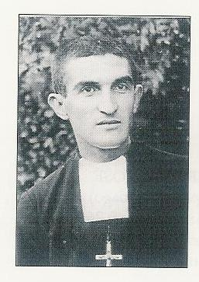

His spiritual life was guided by three words: sacrifice, prayer and self-denial. He would have liked his younger brother to join the Brothers so that all the boys of his family would have been Marists.

For the Vich community everything sped up from 27 July 1936 after an inspection by the Revolutionary Committee. The juniors and the Brothers who had found a refuge in different neighbourhood farms now had to come together again in the house. For a few days, they were on house arrest under the direct supervision of the militia. Brother Severino maintained his joyful equanimity. On 30 July, after having emptied the community’s bank account, the militia placed the aspirants into the “Casa de la Caridad” and the Brothers received a safe-conduct to travel to Barcelona. The four Brothers were arrested on 31 July and both Brothers, Teofilo and Severino, received their palms of martyrdom at dawn, on 1st August.

2-Brother José Teofilo (José Mullet Velilla)

Teofilo was born on 28 June 1917. He entered the juniorate in 1928 when he was only 11. Already he showed a personality that was marked by a wholesome cheerfulness, a lively intelligence, a love of work and piety.
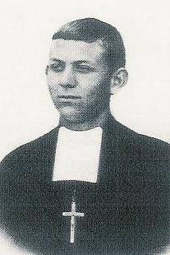

He happened to be in the Vich community during September 1935 for his teaching practice.

It was in this community that the 1936 events took him by surprise. He shared Brother Severino’s fate. He was only 19 when on 1st August he became another victim of religious hatred and the first one to shed his blood for the Lord.

3-Brother Justo Pastor (Maximo Aranda Modrego)

Maximo was born on 3rd September 1907, near Zaragoza. When he was 12 the parish priest of his village took him to the Vich juniorate where his Marist vocation grew and ripened. One of his teachers left this testimony, “May God give us many Brothers of that mould: pious, zealous, committed to their studies, industrious to amass spiritual and intellectual riches…”
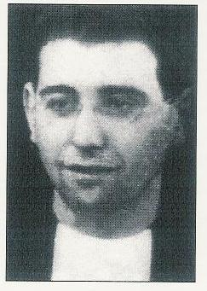
Brother Cleto who lived with him during the last two years of his life said that Maximo’s spiritual life had three solid fulcrums:

The love of Jesus in the Holy Sacrament,
A tender devotion to the Virgin Mary and
Fidelity to the rules of the Institute.

Every day, he thanked the good Mother for his vocation and he asked her to help him persevere in it till the end.
From September 1934, his field of work had been the Vich juniorate. When he secured a safe conduct on 30 July 1936, he went to lodge with his sister Angelita at Barcelona. Brother Egidio Paniagua accompanied him. He did not forget to visit the juniors at the “Casa de Caridad.” When he introduced himself as the music teacher the house director let him in. He encouraged the juniors, accompanied them on their strolls and grasped the opportunity to teach them a bit of catechism. Alas! As Brother Justo Pastor was not registered with any syndicate he could not stay any longer.
He landed in a Barcelona pension with Brothers Alipio, Maximo and Jacinto Miguel. On 7 September, the four of them are arrested during supper time and on the next day, 8 September, feast of the nativity of the Virgin Mary, they were killed.

4-Brother Alipio José (Maximiano Drionda Lehoz)

Maximiano was born at Uzstarroz, Navarra, on 8 June 1916. At the age of 14, he started his Marist training at Villafranca, Navarra. His novitiate classmates attested that he was obedient, devoted, hard working and self-denying. To avoid the dangers of the military service, he requested to go and work in a mission country. On 15 July, he left Les Avellanes to travel to Vich until he could find transport to Argentina. Alas, he shared the fate of the juniorate community. Aware of the possibility of martyrdom, he begged the good Mother, “If I must die, O dear Mother, may it be on your feast day!” He was thinking of 15th of August but his martyrdom was to come on 8 September, feast of the nativity of Mary, the anniversary of his taking the habit and of his first profession.
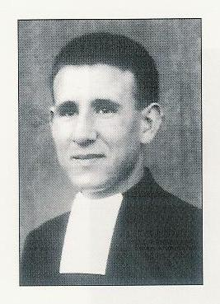

3-Martyrdom

1-Brothers José Teofilo and Severino: 1st August 1936

On 27 July 1936 towards 6 pm., a dozen well-armed militia, sent by the Barcelona Committee, entered for a so-called inspection of the Vich house or rather to take it over. They transferred the fifteen juniors to the “Casa de Caridad” while the Brothers were allowed to spend their nights in the community house until 29 July. On 30 July, the thugs accompanied Brother treasurer to the bank to withdraw and confiscate the whole of the community’s money. Next, they remitted one hundred pesetas to each Brother and a safe-conduct to Barcelona.

Brothers Cleto Luis, Dionisio David, Severino and José Teofilo lodged in the San Antonio Pension but had their meals at “Hôtel Espagnol”. On 31st July a group of militia came to the hotel and arrested the four Brothers. During the interrogation session, these were accused of being “fascists like all the monks and priests and of organising night raids to kill ordinary people.” Then came the killing threats.

On 1st August 1936, towards 4 am. the Brothers are led out under escort. The vehicles of the militia were already at the gate. The Brothers understood that they were to be taken for the final ride. They were driven out of Barcelona, Brothers José Teofilo and Dionisio David in one vehicle, Brothers Severino and Cleto Luis in the other. The vehicle of these last two stopped along a deserted road; on the right hand side there were fruit trees, on the left hand side there was the slope of a hill. They all got out of the vehicle. Brother Cleto Luis was told to walk towards the hill. Brother Severino was asked to shout, “Long live the “F.A.I.”, but he proclaimed, “Long live the Virgin of the Pilar!” Then, he was offered, “Say, ‘Long live the republic’ and we will release you.”; Severino replied, “Long live Christ the King!” Furious, the militia pushed him back into the car, “Get in, we will fix you!” At that very moment, the other vehicle arrived with Brothers José Teofilo and Dionisio David. Brother Severino asked to be allowed to embrace them one last time. At their refusal and thinking they were just about to shoot Brother Cleto Luis, he shouted, “Long live Christ the King!” One the militia dressed as a soldier, told the others, “He is emotional, he does not know what he is saying.” The thugs asked Severino to get into the car with the two others. Reaching the Rio Llobregat, the car stopped again. They asked Brother Dionisio David to run towards the brook. While he was running, he heard a gun shot. The militia had just killed the young Brother José Teofilo. Brother Severino was the only one remaining in their hands. They carried on their sadistic journey up to La Palma de Cervello. As Brother Severino kept refusing to repeat the revolutionary slogans, they made him get off and unloaded their guns at him. He died while shouting, “Long live Christ the King! Long Live Our Lady of Pilar!” Those who had not shot him yet came near and they also unloaded their guns. Finally, they poured petrol on him, set him on fire and abandoned him.

2-Brother Justo Pastor and Alipio José: 8 September 1936

These two Brothers undertook to help the Vich juniors who had been unable to return to their families and had found board at “Casa de Caridad.” That apostolate becoming impossible, Brother Provincial called them to Barcelona. They lodged in a cabaret with two elderly Brothers: Jacinto Miguel and Masimino. The four of them were arrested on the night of 7 September and shot on the next day. That was typical of the F.A.I. expeditious executions. Their bodies were identified at the Clinica by Brother Gérard who was being treated and by the Brothers Eraclio Maurin, Swiss, Ismier, French and by Brother Raimondo (Egidio Paniagua) who was killed later on.

All those Brothers had a heart ready for martyrdom. Before the dispersal at Vich, Brother Jeronimo Emiliano, Director encouraged the others, “Goodbye, God willing. Otherwise, adieu! May we meet in heaven in the eternal life, with all the saints. I am quite certain that we won’t see each other again. Let us remain united in prayer.”

Recalling the night of the interrogations, Brother Cleto Luis wrote, “Through all this, we were tranquil, since five days earlier, we had confessed and received communion as if it had been the last time.”

Brother Severino revealed his deep feelings when he wrote to his father and his brothers, “Do not worry for me. We know very well what we are looking for and at what cost! Dreadful days will come, maybe very dreadful but with Christ, we say, “We have overcome the world.”

During the interrogations, the militia told the young Brother José Teofilo, “Look, you are still young, tell us the truth and we will let you live; life is so beautiful!” You will see your family again and there will be a lot of joy.” But the young Brother did not listen to this alluring promise.

Brother Cleto Luis wrote, “During the three days our house was used as a jail, (27th, 28th, 29th July) and continually watched by the militia, Brother Justo Pastor used to walk to and fro in the cloister, reciting his rosary or making other pious exercises.”

Those Brothers ascended to martyrdom together and they received this grace that places Jesus above everything and can transform death into a peak of love and joy.

BROTHER JOSE DE ARIMATEA

The Marist Brothers had opened a school at Ribadesella, Asturias in 1930. That school had three primary classes and three at the secondary level. Brother José de Arimatea was the Director.

The intellectual and moral education were excellent; hence the Brothers’ work was well appreciated by the parish priest and the population. However, the Mayor and the public teacher had no sympathy for the establishment. This Mayor had registered Brother José de Arimatea among his “dangerous” persons!

1-Biography

Brother José de Arimatea (Restituto Santiago Allende) was born near Santander on 10 June 1902. His entire Marist formation took place at Anzuola in the Basque country: from his juniorate to his scholasticate. Of sanguine character, he sometimes gave the impression of being intractable and belligerent; enough to make relationships difficult.
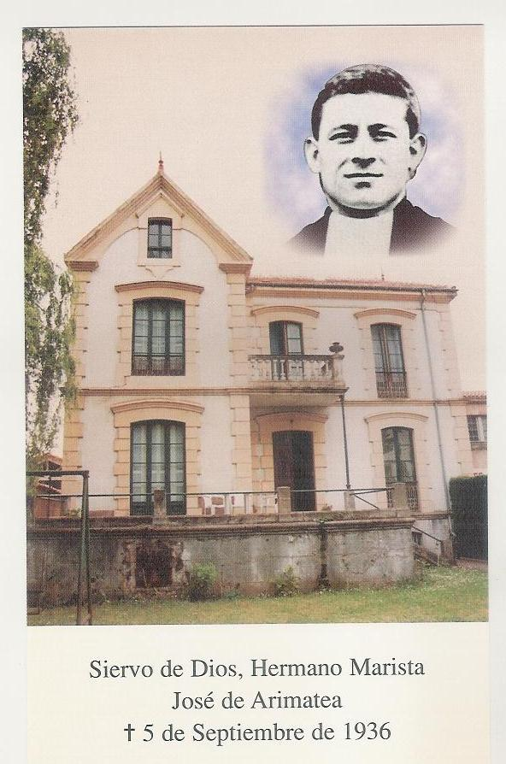

He profited by his second novitiate, at Grugliasco, in 1930 to try and control his impetuous nature. On his return, his confrères discovered a man at ease and more sociable. Evidently his nature showed up again once in a while and the Brothers found him abrupt, quick to retort. Thus, at the time of the Asturias revolution, in October 1934, (the time Brother Bernardo was killed.) a policeman had given a revolver to the Brothers for defense purposes. During an outing, the Brothers were carrying that revolver that was loaded. Walking in front of a cabaret, they met some individuals. One of them taunted the Brothers, “Tonight, you will see the blood flow!” The Director had a quick repartee, “And some bullets, now if you wish!” This reaction so far from the beatitudes nevertheless revealed strength and courage. Brother José de Arimatea was incapable of silence in front of the Mayor’s injustices or immoral actions.

Yet, this man with a little violent character prepared children for their first communion and was training them to love the Lord; he directed “la schola cantorum” that enriched the parish liturgies. He was sensitive enough to welcome poor children for free. He never sent back a beggar empty-handed. He was not only paternal with the workers but he treated them justly. The village young pharmacist was not too close to the church, yet, when he contracted tuberculosis Brother José watched him, day and night with such care that the patient reconciled with God before dying. Brother had and deserved the esteem of the people. But there was no love lost between him and the unjust Mayor and the public school master.

On 25 July, the Ribadesella village fell to the Marxists. Towards 1 am. the militia broke into the school with an arrest warrant for the Director. They asked for and arrested him only. They left the other Brothers alone, allowing them to stay in the house. They even asked Brother Demetrio Ortigosa Oraa, the sub-director to take over. The jail time was long and painful but finally came to an end with the assassination on 4 September 1936.

2- The way towards martyrdom

The first harassment of the Brothers started on 16 March 1936. Three Brothers who were coming back from the church one evening were attacked by a volley of pebbles. The same night, the community was awakened by some violent banging at the entrance door. The local police asked for the Director, handed a warrant for arrest and proceeded to a house inspection. The police accused the Brothers of plotting the Mayor's assassination, of hiding arms, of manufacturing noxious gases and explosives. Nothing was found but the Director was led to the Mayor's office. Brother José de Arimatea, with his hot temper did not miss to scorn the Mayor for this gullibility.

Sometime after 22 July, Asturias fell into the hands of the marxists. On 25 July, the parish priest was arrested and led to the town hall amidst the people's mockeries. The persecution had started.

Brother José de Arimatea was arrested at 1 am. on 26 July and kept in the town hall's basement. That place being too small, all the prisoners were herded into the church transformed into a jail. Until 15 August, life was a real calvary of humiliations and physical sufferings. The guards behaved as torturers and the leaders organized executions of unbelievable fierceness. Thus, the artillery commandant was tied to a tree where he was burned. When the merchant ship Mistral docked, the prisoners were forced to the hard labor of unloading under the mockeries and insults of the militia. Yet, the prisoners had hardly eaten anything. Again, the parish priest was the favourite victim of the humiliations.

On 14 August, the militia gathered thirteen detainees. Led to the cemetery they were peppered with bullets. On the next day, a pick-up truck carried Brother Jose de Arimatea and two other persons to the cemetery. The choice of persons was calculated: the Brother had to bury his friend the priest, then his brother and his brother-in-law. The vision of the bullet ridden bodies greatly disturbed Brother José. A deep friendship had been broken, the Brother and the parish priest having worked in closed collaboration in the administration of the parish.

On 4 September, Brother had to climb into a lorry already filled up with condemned people. Carried to a mine well, the militia tied the prisoners' hands with metal cords and pushed them to the bottom of the pit alive where they left them to die of hunger. The peasants nearby heard howls all night; that prevented them from sleeping.

When in October 1937, Franco's army took possession of the Asturias, the Red Cross took charge of the exhumations. The Brother's remains could be identified by the habit, shirt initials and his scapular.

On 3 June, 2000, the mortal remains of Brother José d'Arimatea were interred in the Ribadesella parish church.

Maria Cuevas Vitorero, the community's cook often visited Brother José in jail. She left this testimony, “I visited him every day bringing him meals and clothes. I never heard him complain against Providence and as I encouraged him by telling him, 'You will get out of this.', he would answer, 'No, it won't be so; I will die because I am a religious; but I accept my sufferings because God chose me.” I often saw him pray in jail. He had his rosary, his scapular and his profession crucifix with him. A few days before his death, he entrusted me with his crucifix for fear it would be profaned.”

BROTHER AURELIANO
(PEDRO ORTIGOSA ORAA)

The “Nuestra Senora Del Carmen” College of Badajoz City had been recently founded in 1930. The Marist community in 1936 was made up of twelve Brothers. Brother Aureliano belonged to that community but he taught at the diocesan seminary.

1-Life and Martyrdom
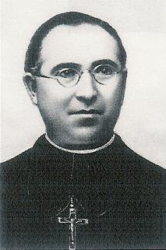

Brother Aureliano was born on 5 February 1894, in the village of Torralba del Rio, in Navarra.

When he was sixteen years old, he started his Marist training at Anzuola. He showed himself to be a strong, determined, cheerful young man with an innate optimism. In his apostolate, he had set this goal: “to guide the children, to guide them in such a way that they may make the experience of God's love.” As for himself, the secret of his spiritual life was to remain in the “presence of the Good Mother and to go to Jesus through her!”
As he had a talent for cooking, he often surprised the community with well-prepared dishes. Besides his ordinary courses at the seminary, he visited the poor suburbs. He had even opened a small school for the marginalized families.

When the militia took possession of Badajoz, on 18 July 1936, they also appropriated all the churches and convents and threw three hundred people into prison. Out of prudence, Brother Estanislao José, the superior of the community invited the Brothers to seek refuge in the pupils' families. On 2nd August, the communists authorized the celebration of a mass in a sisters' convent. At the end of the mass, the religious, among them three Marist Brothers were thrown into jail.

On 14 August, the nationalist troops freed the town, the prisoners found their liberty again. The community re-assembled but Brother Aureliano was missing.

With a group of friends, he had attempted to escape to Portugal. Arms were carried to assure progress. Considering this fact, Brother Aureliano changed his mind. He preferred returning to the Pesini family that had offered him refuge at Badajoz. They hid him in a small villa outside town. But the family's cook revealed the hiding place to the militia.

Meeting him on the road, one of them shouted, “This is a priest!” They all rushed on him, hitting him with their gun stocks, hitting him so hard that he fell down many times. He got out his crucifix and started to kiss it. This excited their violence so much that they beat him until one of his eyes came out of its orbit.

Continuing their roughing up, they led Brother to a bridge. They wanted to shoot him standing but he kept kneeling down. They would forced him to stand up, he would kneel again. During all that time the militia had not stopped blaspheming. Many times Brother was invited to repeat the blasphemes. But either he kept quiet or answered, “That I won't do!” the militia asked him, “Where do you want us to kill you?” His answer, “Wherever you want!” He was kneeling down, shouting, “Long live Christ the King!” when they shot him.

2-To Suffer for Jesus, Here is the Real Joy

One of these resolutions qualifies Brother Aureliano very well:
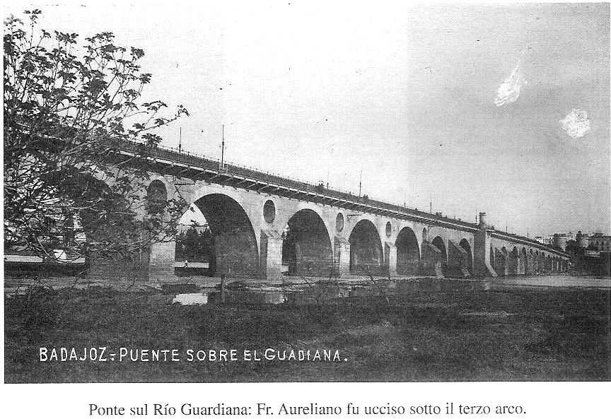

“From today, the goal of my whole life will consist in being the Cyrenian, carrying the cross that the Lord will give me. Lord, this is my resolution. But, you know my great weakness; do not abandon me for a single moment lest I fall and my enemy laugh at me.
Bridge on the Guadiana where Brother Aureliano was killed
Holy Virgin, engrave your seal of mercy on that resolution so that I may fulfill it until you see me in heaven. In return, I promise never to forget you and I will urge the others to do the same.

“To suffer for Jesus and with Jesus, here is the true joy; one day without Jesus, there is the greatest suffering!”

3-We Trust Him and we Pray to Him

Esteban Esquiroz Pascual suffered from a stomach ulcer that allowed him the nuirishment of only milk and water. Seeing him reduced to this extremity, the doctor foresaw his death.

“When Modesta Ortigosa, Brother Aureliano's sister, came to know the seriousness of my state, she sent me as a relic a little piece of cloth that had belonged to him. It was sewn on my clothes without my knowledge. The priest gave me the anointing of the sick at four o'clock on 3 August 1942. I then lost conscience. Twenty minutes later, I asked for a glass of milk. Surprised, my wife and my mother refused to do so at first; I drank and I felt better. Twenty minutes later, I asked for another glass of milk. Everybody was surprised even the priest and the doctor. The latter told me, 'You certainly drank the milk with a lot of water!' “No, it was only milk! At this, his surprise was greater. From that moment onwards, I have been feeling very well.”

“I insist in declaring that having suffered from a pulmonary embolism, Doctor Alexandro Encinas de la Rosa considered me as finished. Then, I asked my sons to introduce underneath my mattress a bit of the soil where the servant of God had fallen. My cure was so rapid and complete that it had the doctors amazed. I am still feeling in good health and I work as much as before.

BROTHER GUZMAN AND HIS CONFRERES

OF THE MALAGA COMMUNITY

“After Brother Bernardo's death, I heard Brother Guzman say, “It is with such a death that God rewards his elect, the just and his friends. I feel a holy jealousy. The straw, like myself, he doe not want, he leaves us in the world to find out whether we will do penance for our sins or not!”

At Malaga, during the full persecution, he was seen reciting his rosary in the bus.

At Malaga, the Brothers administered the “Nuestra Senora de la Victoria” College. During the school year 1935-1936, the Director was Brother Guzman (50). Eight Brothers worked in collaboration with him: Teógenes (50), Fernando Maria (41), Roque (51), Luciano (44), Pedro Jerónimo (31) all martyrdom companions and Brothers Dalmiro, Isaias and Paulino Leon who shared jail time with them but did not suffer martyrdom.
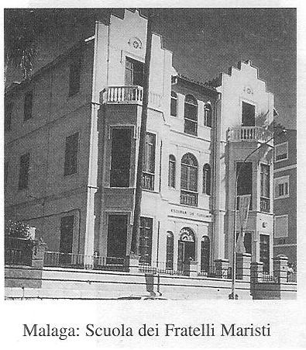

Brother Guzman was one of the founders of the school that was established in 1924. He was the sub-director when the first marxist uprising occurred on 11 May 1931. Both the bishop's palace and the Marist School that stood just next to it perished in the flames. From 1933, he was the school headmaster and the community superior.
Malaga: The college of the Brothers

The following will mainly attempt to describe Brother Guzman but all the others fit quite well in the same description. These were: Brothers Teógenes, Fernando Maria, Roque, Luciano and Pedro Jerónimo.

1-Brother Guzman (Perfecto Becerril Merino)

Brother Guzman was born at Grajalba (Burgos), on 19 April, 1885 and was baptized by the name of Perfecto. At thirteen, he started his Marist life at the Burgos juniorate. From there, he moved to San André de Palomar (Barcelona). He made his first vows in 1901 and his perpetual vows 5 years later.
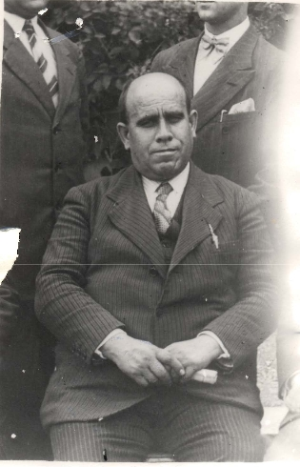

His confreres recalled that he lived deeply in the presence of God in the manner of Saint Theresa: “One more hour and one hour less; one more hour lived in the world, one hour less to wait until we meet the Lord.” He loved to call the Virgin Mary the heavenly Mother to express his loving and trusting relationship; and he wanted that nobody should be orphaned from this good Mother.

He was sensitive to the needy; families in financial difficulties could continue to send their children to school without paying. In such circumstances he would say, “We are poor, but we possess everything, whereas these poor will have nothing to eat today and the parents will go through lots of pains to find something for their children.”
Through his mediation, many workers found stable employment making them escape the day workers' often unjust conditions.

On the first anniversary of his martyrdom, the “Sur de Malaga” newspaper officially recognized his merits in the social sphere, “Brother Guzman, friend of the Malaga workers, knew how to attract their sympathy for he treated them with cordiality and kindness. He was assassinated on 24 September 1936.”

He willingly visited the sick in the civil and military hospitals and found them a confessor if they so wished.

When the school and the episcopal palace were burned on 11 May 1931 during the first marxist uprising, Brother Guzman went from room to room to make sure that no Brother was in any danger. The Bishop and some members of his family had remained in the burning palace. When he heard of this, he hurried up to go and save them, leading them through the school basement. He did not stop to weep over his destroyed school but he immediately offered lessons in private houses so that the children could end their school year.

2-Towards martrydom

Malaga had always been a subversive center, a leftists' and revolutionaries' fortress. After Franco's forces had come on the Spanish scene, the leftists took possession on the town on 19 July 1936. They occupied the cathedral, set four hundred buildings afire and arrested political adversaries and Church people.

Returning from church, seeing armed men camped in front of the school the Brothers decided to disperse. Brother Guzman did his best to encourage them and gave them money for their immediate needs.

On 20 July, the school was ransacked and destroyed. As the residence was not occupied the Brothers had a place to spend their nights. On 22 July, Brother Guzman assembled the whole community, gave advice to obtain places of refuge and shared the remaining money.

Many times arrested, he was as many times he was freed from the marxists by the secretary of the civil Governor who was his friend.

On 22 August 1936, the Brothers were now in great danger. On that very day, Franco's air force had bombed a popular suburb. The revolutionaries became so excited that they wanted to kill all the Church people. During the following days, all the Brothers were imprisoned, save Brother Isaias María.

1-At midnight, the first Brothers to be arrested were the three who still resided at the school, Brothers Fernando María, Dalmiro and Paulino León. The militia reminded the Brothers not to dress elegantly, because they were only going for the 'paseito' (the little stroll to execution). On the way, the Brothers heard the militia talk of the place and moment of the execution. But, at the police station, it was decided to throw them into the common jail. They were to stay there for more than a month, up to 24 September. On that day, the F.A.I. chief ordered the prisoners to line up and he told them:
-We will release you but the first one who disturbs us will go for the 'paseito'.
I was standing at the head of the line, Brother Fernando María stood in the middle and Paulino was at the end. When the F.A.I. Chief came in front of me, he asked me:
-Why are you here?
-I don't have my documents.
-Out with you! Pick up your documents and go away!
I then went through the first, the second and third door.
Brother Fernando María followed. But one of the F.A.I. recognized him and sounded the alert, “He is a Marist Brother!” They rushed at him, one of the militia twisted his arm and shot him twice leaving him half dead. His fellow assassins finished the Brother.

2-Brother Guzman was discovered in the Hotel Imperio on 24 August. A priest, Don Luis Vera Ordas saw him enter the jail. “We noticed that he was extremely pale. When we asked him why, he told us that the militia had taken him outside to kill him, but at the execution place, the torturers simply said, 'Turn around!' and they took him back into jail.”

Father Francisco Garcia Alonso, testified, “When I left the jail on 22 September, I left him at the infirmary suffering from a very strong fever. That morning, I confessed him, he kneeling, myself standing in the middle of the room.”
Brother Guzman was executed forty-eight hours later. The nationalist air force bombed the town of Malaga again. In retaliation, the militia shot many prisoners specially those who were at the infirmary. The victims were so numerous at the execution place that they had to wait for their turn. The Brother was killed with a group of priests and buried in a common grave of the nearby cemetery.

3-27 August marked the day Brothers Pedro Jerónimo, Teógenes and Luciano had to face the horrible militia. When the patrol arrived at Rosaria Jurado Rivas' home where the Brothers were lodging, the thugs announced,
-We are coming to arrest the three priests who are hiding at your home!
-Who are you looking for? A
sked Brother Pedro Jerónimo.
-Some priests!
-There are no priests here!
-We were told there are priests,... and you are one of them!
-We are not priests, we are Marist religious.
-It is all the same for us.
And the militia led them to the “paseito”.
The lady who had lodged them was also arrested. At the police station they made the victims sign their own death condemnation! The lady was released with threats but the Brothers were taken to the cemetery and shot.

4-Brother Roque had been welcome by the Mexican consul who had lodged him at his brother-in-law's home outside town. During an inspection, one of the militia, a former pupil recognized him and said, “Now you will pay for all the punishments you gave me for reading the newspaper in class!” He informed the others that they had someone important in their hands: a Marist Brother. The death sentence was immediately decreed and executed at the foot of a nearby tree. That was on 18 October 1936.

3-They Could Have Saved Themselves

Good people, indifferent to politics were hounded out, imprisoned and assassinated. It was not a question of justice or logic unless one meant full marxist justice and logic. Expressing his way of understanding the events, a witness affirmed,
“They were persecuted and martyred because they were known as religious. But why that hatred? Brother Guzman and so many others could not have enemies, their great kindness extended to everybody. Many Malaga workers regretted those cruel deaths and considered them as crass errors.

Father Luis Vera Ordas told us how he was judged,
“My judgment was summary; when they asked me why I had been arrested, I simply said, because I guessed that I might be martyred,
- Because I am a priest.
- And this seems to be little!” the judge retorted.

In fact, religious and priests were brought to court to hear their death or prison sentence only. No defense was possible. The militia had the right to kill the priests and religious they found like wild animals!
OUR MADRID MARTYRS

1 Marist Presence in the Capital

The Marist Brothers directed four schools in Madrid, two for the Spain province and two for the Leon one. There were martyrs from the four communities.

a) The « Colegio externado Chamberí», primary and secondary school of 693 pupils had a community of fifteen Brothers. The martyrs from that community were:
Brother Benigno José, 30 years old, killed on 1 August 1936,
Brother Adrian, 40, killed on 11 August 1936,
Brother Euquerio, 22, killed on 4 January 1937.

b) The « Colegio Los Madrazo » was founded in 1902. It numbered as many students as Chamberi but the community was made up of 23 brothers. Five of these obtained the palm of martyrdom. We will present three only:
Brother Gaspar, 38, killed on 22 July 1936,
Brother Camerino, 30, killed on 22 July 1936,
Brother Luis Alfonso, 25, killed on 26 August 1936.

c) The « Colegio San José » was the most prosperous one in Madrid. Its community had thirty-one brothers, Spaniards and Frenchmen.

d) The « Residencia de Estudiantes Cardenal Cisneros » welcomed brothers and old boys attending university. When the revolution erupted, the Colegio San José brothers took refuge into this residence considered a safer one. Six brothers were assassinated because of their faith:
Brother León Argimiro, 23, killed on 20 July 1936
Brother Luis Daniel, 26, killed on 16 October 1936,
Brother Ángel Hipólito, 33, killed on 12 December 1936.
Brother Julián Marcelino 22, killed on 3 December 1936
Brother Domingo Ciriaco, 25, killed on 20 April 1937,
Brother Jorge Camilo, 20, killed on 21 August 1937.

Once more that was a group of fairly young brothers: 40 years the eldest and 20 the youngest one.

2-The Persecution at Madrid

Being the centre of government and communications, Madrid was the first area to realize the seriousness of the national uprising. On 18 July, against the will of the government which wanted to maintain legality, the leftist people started a systematic attack against religion and social harmony. The central government lost control of the situation allowing the revolutionaries freedom to ransack, to burn and even to assassinate. More than fifty buildings were looted or burned. The Popular Front's 'checas' were set up everywhere. From these vipers' nests oozed the thugs who went out and arrested the « enemies of the revolution »: the priests and the religious with the liberty to assassinate without judgment or sentence.

Not a single Marist community escaped the militia’s rage. Many testimonies concur in their assertion that the brothers became suddenly objects of hatred, were chased away from their houses, hounded, put into prison and declared death candidates for the sole reason that they were religious: “By the way I was judged, I can certify that my brothers were martyred because they were religious. All the monks were considered as enemies. I appeared at the Popular Tribunal where I was asked what I had done on elections day. Surprised by this request, I enumerated all my movements but I absent-mindedly left out my going to mass. 'Enough', the judge said, 'I don't need any other proof. For having gone to mass, you are sentenced to one year in jail.' I could never have imagined that I could get such condemnation for having gone to mass! “

Josefa Aparicio Hierro recalled what the communist radio had said in a sarcastic way, « A cleaning had to be done in the Church of Our Lady of the Brooms! », alluding to the Virgin of the miraculous medal and the rays that come out of her hands.

Describing the brothers of the « Colegio Los Madrazo », the caretaker said, “Not only did the brothers suffer martyrdom, but they were also abused with all kinds of humiliations and insults. A mob rushed over the College ground, shouting, 'Down with the clergy!' The militia broke into the college. I witnessed the destruction of all the objects of worship. “

Against the religious and the priests, the communists displayed such a rage that they brought to mind the behaviour of frenzied wild animals. The most frequent testimony one can read from one positio to another regarding the Spanish martyrs is indeed that “ The death of these servants of God was due to the fact they were religious and to the revolutionaries’ hatred of religion and faith in Christ! There was no political motive, no protest for social justice.”

Exasperated by this climate of violence, a number of brothers gave up religious life. Some parents advised their sons to return to their families or to register themselves into syndicates or leftist parties.

The brothers who accepted martyrdom refused to take part into these ambiguous games. Their martyrdom meant their ultimate fidelity to the Lord. This is what thought a former pupil, Fernando Casals Camara, “To persevere up to martyrdom, they needed to possess extraordinary virtues. I agree that quite a few brothers left religious life at the first occasion. But, I am talking about those who stuck to their vocation up to the last moment and in that state have accepted martyrdom.”
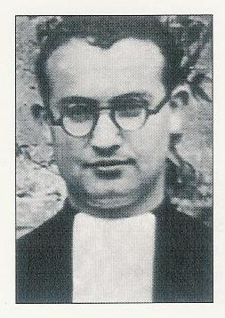

Driven from their residences, they tried to find friendly families to accommodate them. Those brothers suffered from being scattered around, from solitude, deprivations, insecurity and from being hunted. Some were eliminated without leaving any trace. This was part of the persecutors' strategy, not to leave any trace. What is true is that once the brothers fell into the militia's hands they always disappeared.
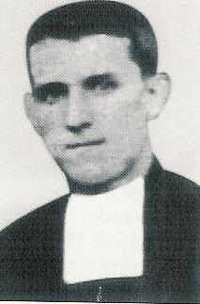
Br. Euquerio

3-When Martyrdom Knocks at my Door

1-Brothers Benigno José, Adrian and Euquerio

These three brothers from the 'Colegio Externado Chamberí' left the college after 22 July 1936 and went to seek out lodging in the residence 'Calle Modesto Lafuente ». On 11 August, a patrol of militia appeared and asked for information on 'the priests' who resided there. The caretaker assured them that there were neither priests nor monks in the pension but only teachers. The assassins were about to move away when a neighbour gestured that the priests lodged on the first floor. The militia climbed the stairs and surprised Brothers Benigno José and Adrian who were preparing a meal. They bound these brothers with towels, made the them tumble down the stairs while insulting them, “Bite the towels now!” They were taken to the “Checa de Bellas Artes”. It was between noon and two o'clock. At three o'clock they were taken somewhere else. Nobody ever knew how they had perished.
Br. Benigno José

Brother Euquerio found his boarding at Hotel Altorga. During the afternoon of 30 August, a few policemen asked the hotel manager to check out a list of names. The manager and the brothers were arrested. Brother Euquerio and his own brother related the facts, “We were taken to the Security's Head Office and from there to the General Porlier's Prison. There, we started a life of deprivation. Towards Christmas 1936, my brother became very sick because of all the deprivation. A doctor, also a prisoner, diagnosed a serious disease but could not do anything. For fear of contagion, he and I had to nurse him in a humid basement. Without food, medicine or warm clothes he soon became delirious, lost consciousness and died without having received any medical help.” That was on 4 January 1937.
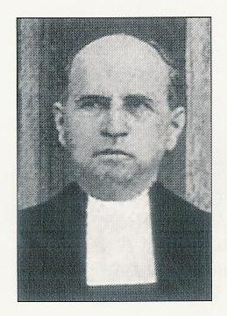
Br. Adrian
2-Brothers Gaspar Pablo, Camerino and Luis Alfonso
H. Gaspar Pablo

The calvary of Los Madrazo College community started on 20 July 1936. Forced to leave their premises, the brothers had to look for various boarding houses. Brothers Gaspar and Camerino set up in “Posada San Blas”. On 22 July 1936, at about 11 p.m., a patrol of militia barged into the pension. The caretaker informed us how the events progressed, ”I was interrogated about the few priests who had taken up lodging in our place. I consulted the register and advised the militia firmly that no priest's name was entered. One of them replied that he was certain that they were present but that they had declared they were teachers. Without saying anything more, they ran upstairs and started opening up all the doors. Opening Brother Gaspar's and Camerino’s room they asked them whether they were religious. Far from denying anything, these affirmed the fact candidly. The militia asked them to follow them. “We will follow you.” the brothers simply said without protesting. The brothers were serene; everything progressed without violence, fear or hysteria. They left quietly with the militia. Then, it was impossible to get news from them. Nobody doubted their having been martyred although no-one knew where they had been killed or where their bodies had been buried.
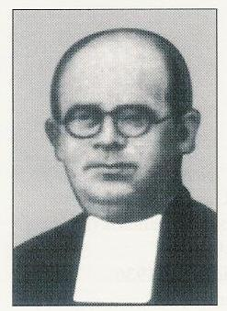
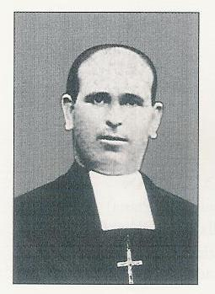
Brothers Luis Alfonso and Celso had found accommodation at Irene García's pension. Brother Celso recalls: “At supper time, a stranger came and told us verbatim, ‘ For once in my life, I can do a good turn to you. Hurry up and move away, they are coming for you!’ And he disappeared. Brother Luis Alfonso, a priest and I were preparing ourselves to move off. The lady let me out first and sent me to one of her daughters. From the latter, I learned that Brother Luis Alfonso had been arrested on that same night. That was 26th of August. After that, I got no other information.” But very soon the news spread that he had been martyred.”
Br. Camerino
3-Brothers León Argimiro, Luis Daniel and Domingo Ciriaco went through similar dreadful movements. They were taken by the militia, then all traces disappeared.
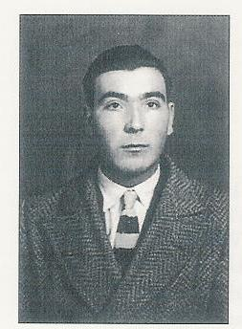

As for Brother Luis Daniel, he was forced into the same convoy as the CEDA deputy, Salvador Madero Ortiz. As soon as the convoy reached Villa Don Fadrique, Salvador’s own native village the deputy was shot right there. Brother Luis Daniel never reached that village.
Br. Luis Alfonso
H. Leon Arguimiro
Brother Domingo Ciriaco, betrayed by an old boy was taken to San José College that had become a « checa » whose director was the old boy's father. Bystanders saw him enter the college on 20 April but nobody ever saw him get out. Later, visitors found evident signs of torture that had been inflicted on the victims.
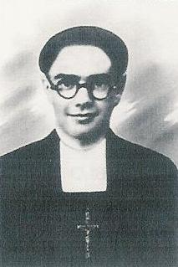

Brother Jorge Camilo was the youngest brother of the community. As he was now 21 he was called to do his military service. He avoided the battlegrounds so that he would not have to kill anybody. Discovered as a religious, he was shot in the barrack's yard on 21 August 1937.
The case of Brothers Ángel Hipólito and Julián Marcelino was much more tragic than whatever the persecuted brothers had experienced before. “Here is what I heard from the Aravaca's cemetery caretaker, who had been incarcerated in the San Anton's prison, in the college of the Écoles Pies. 'They brought a group of martyrs to the Aravaca cemetery. Brother Ángel Hipólito was among them. At the entrance, they undressed the victims completely. All the objects were thrown into sacks. They drove them two by two to the new cemetery. They forced them to dig a common grave. When the horrendous task was finished they mowed them down with bursts of machine gun so that they fell into the grave. The grave digger confessed he had taken no other loot other than the gold from the teeth.”
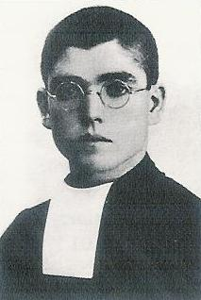
Br. Luis Daniel
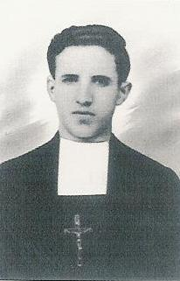
The following testimony is valid for all the martyred brothers of Madrid, “In the midst of this so hostile situation, Brothers Benigno José and Adrian showed themselves resigned, even serene and kind sufferers in their commitment to do God's will. Those who had the good fortune of meeting them saw their humility in their indigence. They never complained against their place of detention. They never discussed politics; they never made any judgment on the terrible events. In short, their behaviour was an absolute acceptance of the divine will.”
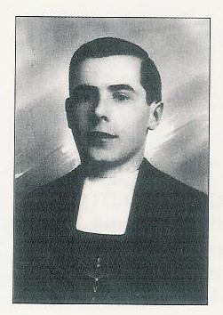
Br. Domingo Ciriaco

4-These Brothers who resemble us

However, it would be false to present those brothers as indifferent and always completely above the storm. They did have their moments of depression and fear. They suffered to see their innocence abused by an arbitrary justice. Their hearts skipped a beat whenever they heard of the demise of one of their friends. Brother León Argimiro fainted when he saw his friend knocked out by his side, and for that, he was kicked and called 'chicken hearted'. They ran away when they could. None sought martyrdom in a presumptuous way. In fact, these brothers were very similar to us in the ordinary life. Brother Benigno José had an optimistic and cheerful nature. The confreres said that with him “life was not a valley of tears!”
Br. Jorge Camilo
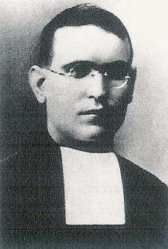
Brother Adrian loved to teach but he fell sick. When the persecution prevailed, he became the community’s cook. Conscious that food renews energy and enthusiasm, he made up his mind to prepare very appetizing meals.

Brother Euquerio was probably the only brother to pronounce his perpetual vows in the years of the Republic. He loved to study and was talented in learning languages. With the pupils, he was kind but exacting in the pursuit of the syllabi’s goals.
Br. Angel Hipolito
Brother Gaspar, on the contrary could not maintain discipline. He was warned the educator’s life would be difficult and that he should orientate himself towards another career. He replied that he loved Marist life so much that he would never leave it even if he would have to wash the dishes! He was so discreet that it was remarked, “He calls for our attention the more so because he does not look for it!”
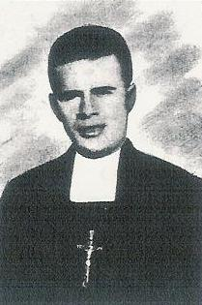
When Brother Camerino finished his military service at 24, he decided to become a brother. He was a strong man, enthusiastic, serenely courageous and very mindful of the others.

Brorther Luis Alfonso could have spent a quiet life if his conscience had been less sensitive. His cousin had found him a safe shelter with a friend who had married a communist. The latter blasphemed so much that Brother could not even stay a week.

Brother León Argimiro loved sports. He was a joyful young man in the best sense of the word.
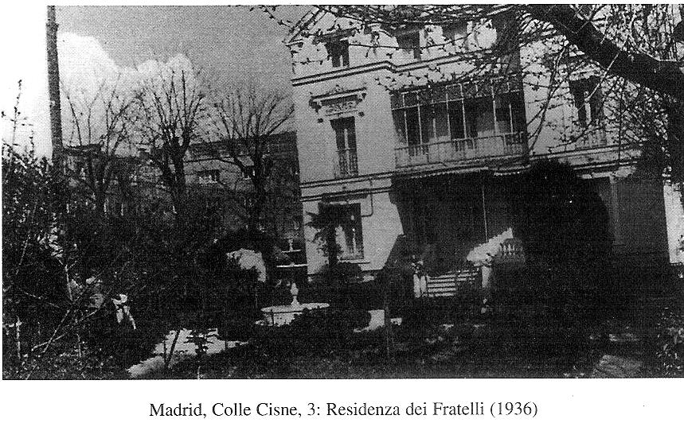

Brother Luis Daniel had to defend his vocation against his father who had come to the novitiate to take him back home. He had to defend it again when the family trade deteriorated. He exclaimed, “You have eleven children and you can’t give one to God?”
Br. Benigno José
Madrid, our College El Cisne
Brother Ángel Hipólito taught and attended university. We found the following prayer in his notes,

“I will walk with my cross

behind my Lord
And I swear to be faithful
to my vows and resolutions
until my death. Amen

Brother Domingo Ciriaco taught the lower primary classes only. He too, could have avoided death. His sister, a vegetable merchant, had welcomed him at Madrid and had registered him with a syndicate as her employee. Domingo attended the customers with great ease as if he had done this all his life. He provided his confreres with U.G.T. membership cards saving them from many dangers. On 20 April 1937, he went to a barrack to ask for a safe-conduct. He was identified as a Marist—he disappeared.

When the militias pushed their way into San José Colegio, on 20 July, Brother Jorge Camilo was in bed, sick with typhoid fever. Just the same, he was hauled to jail without mercy.

Those rapid flashes reveal that these brothers did not consider themselves as heroes. They lived an intense religious life because of their particular situation; persecution strengthens faith. Still, they remained simple men, with normal human relationships.

Never, did they resort to violence; they preferred to die rather than being killers. After the fears that followed the arrests, prayer and grace brought them back to peace, and made them joyfully proud of giving up their lives for the Lord.
THE FOUR MARTYRS OF CHINCHÓN

“If it were our concern only they would already be on the altars.”
“I don’t believe in heaven if these servants of God aren’t there!”
(Reflections from the simple people of Chinchon)

The Chinchon community set an example of simple and sympathetic martyrdom.

In 1936, Chinchon was a suburb in the north of Madrid with 7 000 inhabitants. The Marist brothers directed a small free primary school. The school was financed by Marquis Aparicio y de la Pena.

The brothers enjoyed the sympathy of the people who welcomed them in their homes at the moment of the ‘storm’. However, there was a sort of mission work to exercise. Brother Philippe de Neri explained, “The town numbers 7000 inhabitants. Most of them work on Sundays and feast days. They do not go to mass and blaspheme a lot. You can see that we do not have to travel to a far-away mission land! We do have our civilization work to do right here, near Madrid. I teach sixty-two pupils who behave very well, at least when they are in front of me!”

Brother Philippe de Neri continued, “Three of us teach, the other brother is the cook. We all wear civilian clothes. The cook helps me in the classroom for almost the whole day. We teach all the children of the town.

1 The Four Martyrdom Candidates

1-Brother Feliciano, director and superior was a mature man of 52. The pupils and the parents respected him because he preferred personalized advice and his example was sound. He preceded Brother Bernardo as the director at Barruelo de Santullán from 1928 to 1931. In fact, they worked together since Brother Bernardo at that moment was the director in the school near Vallejo de Orbó. Under Brother Feliciano’s direction, the Chinchon children changed radically; the people commented favorably. Parents who had not set foot in church since their marriage accompanied their sons to listen to the liturgical singing directed by Brother Feliciano.
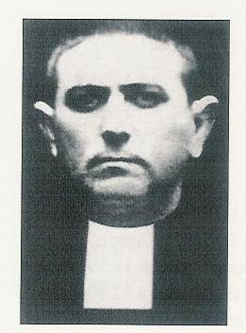

2-Brother Philippe de Neri makes up a special case. As a young soldier, when it was his turn to be on guard duty, he held the gun in one hand and his rosary in the other. His time was spent in prayer. He was preparing to get married. A strange thing was observed: while on a stroll with his fiancée, after exchanging a few words, they would continue on their way reciting the rosary.
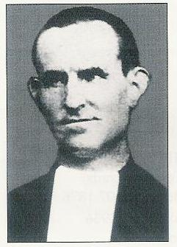

Brother Philippe remembered his mother as a saint. In his family, they were twelve children; five of them consecrated themselves to God. He was in the habit of making long visits to the Blessed Sacrament. One day, in front of the altar, he felt himself called to join the Marist Brothers. He was almost 30 when he entered the novitiate. After he had pronounced his vow of obedience in 1931, he worked as a cook for two years before starting to teach. Arrived at Chinchon in September 1933, he was soon noticed for his strong personality. Sometimes he said, “We shall defend our work… We are not going to remain passive and say, “We are here, kill us.” But after he had meditated on the Lord’s passion, he found the generosity to commit himself to God’s will. His firmness in his vocation had a healthy impact on the others.

3-Brother Herminio Pascal 24. This young brother was vacillating in his religious vocation. The superiors had to give him a new assignment every year. Thanks to his contact with Brother Philippe de Néri, his gift of himself to the Lord became firmer and he, the youngest in the community, gave the example of a generous martyrdom. The man who lodged him at Chinchon had found him a safe hiding place. But Herminio preferred to stay with his brothers and to share the same fate. With them, he was shot on 29 July 1936.
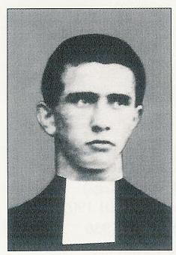

4-The fourth community member, the cook was a lay man with a Marist heart. Julián Aguilar Martín was a novice when he caught a disease that made him so miserable that he would have been unable to teach. The superiors judged that it would be reasonable to return him to his family. There, he tried out farm work but he was still attracted by the Marist life. He came back and begged Brother Feliciano to hire him as a cook. From that time, he shared the brothers’ life in full: prayers, work, persecution and martyrdom. Everybody at Chinchon thought he was a Marist Brother. Hence, he is rightly considered a Marist martyr.
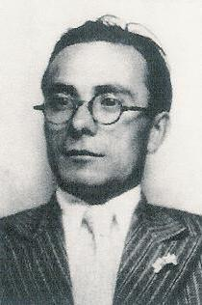

2 – 29 July 1936: the Day of Trial Has Come

During the first days of the revolution the militia did not dare disturb the little community. It was easy to gauge the brothers’ good work. But towards midnight of 21 July 1936 a group of outside militia men showed up. They besieged the school; some of them even tried to break in through the roofs. Francisco Medina Pintado left this testimony, “I was present when they attacked the college; the militia tried to seize it as if it had been a fortress. The brothers came out humbly and found refuge in private homes.”

Brother Feliciano was welcomed by the village’s notary but the president of the local Revolutionary Committee also offered him his hospitality. The other brothers found accommodation at Teodulo de la Pena Fenandez, the school founder’s nephew. That situation lasted a week.

On 29 July July, thirty militia members arrived and ordered the local Committee to banish the Marist Brothers from Chinchón. These were taken to the railway station where they boarded the train for Madrid. They could not rely on any Marist residence to offer them a refuge for all the communities had been dispersed and threatened.

They directed themselves towards a benefactor, Paula Aparicio. The house servant, Maria Ontalva Ruiz reported, “The janitor did not want to let them in because of their luggage. However, I think the janitor knew the brothers. Don Valentin told him to inform the Security Guard if he did not trust the brothers. But the janitor notified the militia. The brothers had had just enough time to install themselves on the first floor when the militia people showed themselves and took the brothers away. Nobody ate in the house on that day. The militia returned to collect the brothers’ clothes. After that, there was no sign of the brothers. The benefactor learned that they had been shot right away.”

Francisco Medina Pintado wonders,
« They were not rich and they had not harmed anybody in need. Then, what was the reason for killing them except that these men were religious?”

Jesús Sáez Lopéz, former student, testifies:
“They were men of faith, hope and charity. When the October 1934 revolution exploded the brothers said prayers for peace without ever uttering any word of hatred against anybody.”

This little community that disappeared abruptly without leaving any trace had had time to set a beautiful example reminding us of: “All the believers were one in heart and mind.” Acts 4, 32

That community was remarkable in its simplicity, its sincerity, transparency in the totality of its consecration. The holy or the strong one, the weak or the lay man, the early worker or the late one, together, they faced the trial of martyrdom generously.
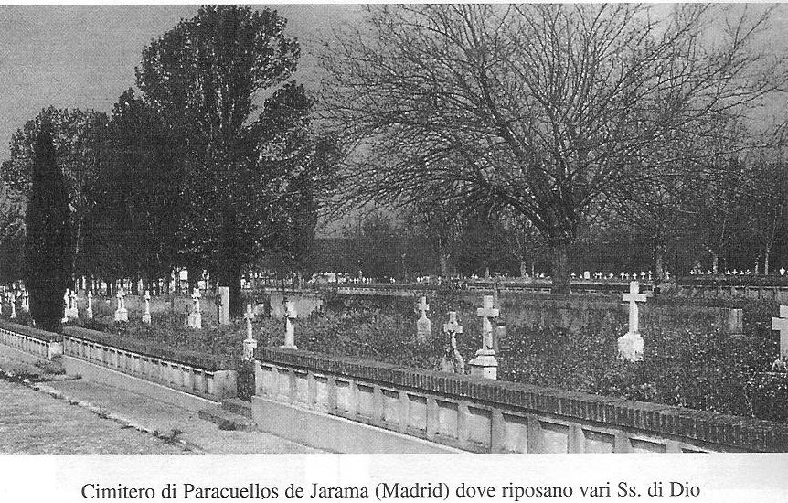
Cemetery of Paraquellos, close to Madrid: Several of our Brothers were buried here.
THREE VIOLETS

THE MARTYRS OF TORRELAGUNA

1-Let us sympathise with the simple people

In regard to the following three brothers united in their humble lives we are left with the memory of gentle lives totally committed to the very poor. Our information is not vast but the brothers’ examples still give light and comfort.

The three brothers, Victorico María, 42, Jerónimo, 60 and Marino, 35 were born in the small provincial villages of Burgos and Castellón. Now, Providence had gathered them at Torrelaguna, a village of 2000 inhabitants, in austere Castile not far from Madrid. Their 135 pupils received a basic learning.

They led a simple and a quiet life that faith made fertile. Three anonymous lives, but for those who could observe them closely, lives full of love and devotedness. After a visit to their school, Brother Moises wrote,
“On leaving the house, I could not but share the feeling that had filled me with joy and envy, I exclaimed for all to hear, ‘These are three saints!”

They were the director, a teacher and a cook. But, it was difficult to know who was doing what so united they were in sharing their daily tasks.

For the village people, the brothers were proof that humility and kindness could exist even at a time when violence and sectarianism were prevalent. The only one to snub the brothers’ success was the Master of the public school. At the decisive moment, he channeled the assassins’ dark work.

On 22 July 1936, many people, parents and old boys knew they had lost three unassuming teachers; the militia had just deprived them of a great source of kindness.

1-Brother Jerónimo (Trifón Tobar Calzada) was born on 3 July 1876. He was sixty years old when he was led to his martyrdom. He had first worked in Spain; next he devoted himself in Colombia for twenty-one years. He also taught in France. When he finally returned to Spain, he was never in good health. Indeed, the declinein his health had caused his return from Colombia. He arrived in Torrelaguna in March 1932. Brother Domicio remembered him as a humble, simple and serious person:
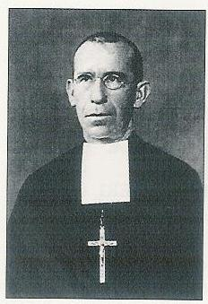
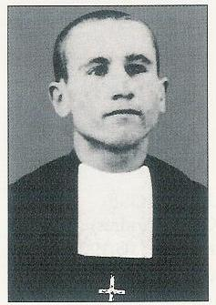
“He was an old-style brother, one of those who likes a hidden life without any pretension. But, in spite of his bad health, he was a cheerful man. His classes were always numerous. Due to his shyness, his discipline lacked firmness. However, he instilled a missionary spirit into many of his pupils.”

2-Brother Victorico María (Eugenio Artola Sorolla) was the school director. He was born on 12 April 1894. He was a trustworthy and helpful brother. He was working at Vallejo de Orbo when Brother Bernardo was the director and was his main collaborator. Torrelaguna saw him arrive on October 1928. Brother Maximiano Albéniz summarized Brother Victorico’s ideal in two words, “service and love.” The apostolic zeal of Brother Bernardo was reflected in Brother Victorico’s activities: Catholic action, study groups to deepen the youth’s faith, preparation for marriage course, hymns and novenas.

Everything was proposed with kindness, without coercion. His influence was so great that he obtained permission to continue to teach religion and to wear his cassock under the second republic.

3-Brother Marino (Pedro Alsonso Ortega) was the youngest one of the three brothers. He was born on 14 January 1901. Poor of health, he could not pursue his studies. He even had to make a stay at the Les Avellanes infirmary in 1932. Thus, his Marist life consisted mainly in his helping at the kitchen of the small communities and in his work in the lower classes and in the Catholic Action movement. The Superiors sent him to Torrelaguna in August 1929. He was a good and joyful young brother always helpful but happy to be away from the limelight. One witness did not hesitate to affirm that if Torrelaguna could pride itself of having young lay martyrs the fact was due to Brother Marino’s influence.
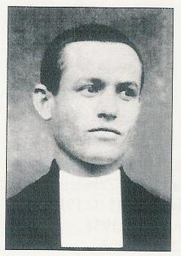

2-Work at Torrelaguna

Three Marist Brothers provided sound education to the peasants’ and the workers’ children. The night courses offered to the parents knew great success since one hundred and twenty attended them. That initiative was very appropriate since ninety percent of the adults were illiterate. One advantage of these courses was that the parents became more enthusiastic to send their children to school. Certainly, the parents were very thankful for the training their children were receiving. The brothers’ pupils were noted for their discipline, their courtesy and their assiduousness. Their primary school pupils were already promising a responsible society.

Visiting that school, Brother Moisés wrote,
“The punctuality and the attendance of the children are excellent. By the examinations I administered, I can certify that the pupils have covered the various syllabi and have assimilated its contents in great detail. As for the discipline, it can’t be better. Besides, the brothers agree very well among themselves.”

The people of Torrelaguna thought on the same lines because it was difficult to know who the director was, who the cook was or who was the last one!” An old boy stated,
“The three of them were perfectly devoted to our cause. Not only were the villagers grateful to the brothers but they loved them.”

Another old boy spoke in even stronger terms,
“I am running short of words to express my admiration for those Marist religious. They taught me to love, to forgive. I owe them this glory, to honour among the martyrs of Christ my own parents, my father and my mother; may these be in God’s glory! I have learned to pardon and to endure that terrible trial with a Christian love.

3-When the Hour of the Ultimate Gift Tolls

What happened during the Spanish revolution was very strange! Very ordinary people, proletarians, set themselves to killing priests and religious who had issued from modest and peasant families.

At Torrelaguna, the debacle was triggered by an un-repressed jealousy. The public school master could not bear the brothers’ success. During the Asturias’ revolt of 1934, this master was the local committee chief long enough to throw the brothers in jail. Fortunately, his term was cut short and he even had his turn in the infamous lockup.

Everything moved swiftly from 20 July 1936. The civil war had just started and the pupils were on holiday. The public school master, head of the revolutionary committee was also the mayor of Torrelaguna. He patrolled the streets in his search for victims. He thought of the brothers whom he desired to hang. Good! The moment for sweet vengeance had come!

The central revolutionary government dispatched “carabineros” to replace the Guardia Civil at Torrelaguna. That was tantamount to signing the brothers’ death sentence.

In fact, the three brothers were arrested by the carabineros on 20 July. They were locked up in the village dungeon (in the town hall’s basement) where they found themselves with a group of practising lay men, some of them, former pupils.

What was the accusation?

Wearing the religious habit?
Having consecrated their lives to God?
Having planted the seed of faith into the hearts of children?

During the night from 21 to 22 July the militia’s ruffians came from Asturias. Early, in the morning, they attacked the jail with the intention of eliminating the prisoners. They struck them, interrogated them while howling. A female militia hit the Catholic Action’s lady president so violently that the latter lost an eye. Then they selected their victims: all those whose hands were not calloused on one side, the peasants on the other. The latter were freed. The others: three brothers, two priests, the two Catholic Action’s presidents were handcuffed and forced to climb onto a lorry.

On 22 July in the morning, a dairy man from the little village of Redueña who was on another daily round discovered the nine corpses. He ran and asked for help.

One of the captives who had been with the brothers left us the following information:
“The brothers knew they were on their way to martyrdom. They had already accepted this greatest of trials with great firmness, without light optimism or useless pessimism. It was rather a holy realism that led them to accept martyrdom. Still, they were literally like lambs led to their sacrifice. Their courage did not flag. This is how I saw them leave for their deaths.”

A peasant who saw the execution reported,
“There were neither any scenes of despair nor anything similar. There was a call for mercy, yes, when two victims offered some money to save their lives, putting forward their need to care for their young children. Nothing else. They were making the sign of the cross when they received the mortal discharge.

On 23 July, Juan, a former pupil of 14 came to the school:
“I stood aghast! It had been completely ransacked. Our burned books were strewn on the floor, the pieces of furniture were broken and the large photo of all the pupils at the entrance had been torn down.”

On 15 July 2000, the mortal remains of the three brothers were placed into an urn that was transferred into the Torrelaguna parish church. This funeral urn, cut in stone is the master work of a former pupil.
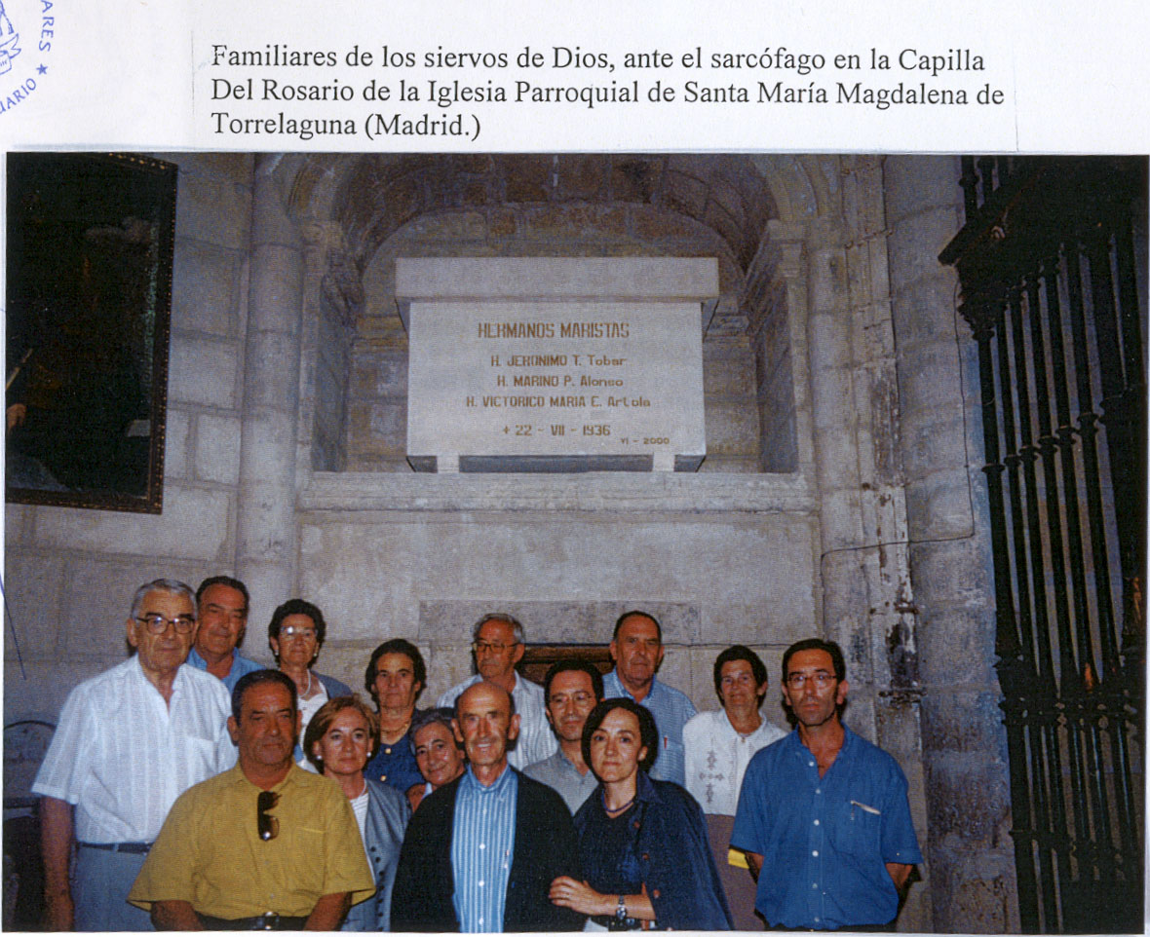
Urna de los Hermanos Mártires de Torrelaguna,
Madrid
OUR BROTHERS OF VILLALBA DE LA SIERRA
(CUENCA)

Our Cuenca55College can boast of having been founded during the Republic period in 1934 when signs of ill omen were already announcing the persecution. That new college “Fray Luis de Leon” with its purely civil statute then makes us infer how much the Spanish brothers were ready to face the new political situation and how they wanted to remain present in the world of youth. Their presence attracted the sympathy and the esteem of the population immediately. However, the anticlerical teachers were quick to begrudge the brothers’ success. That jealousy became fatal when the revolution broke out on 18 July 1936.

Of the seven brothers who worked at that college only one suffered martyrdom, Brother Julián José. His friend, Ramón Emiliano Hortelano Gómez walked along with him. He was a lay teacher and a committed Christian.

1-Portrait of two martyrs

These two servants of God became friends during their military service. That was a friendship based on a deep and shared faith. They agreed so well with each other that the public thought they were both religious. This was why they were executed together. Dragged to the foot of an electricity pylon, they were shot. Then their bodies were splashed with petrol and burned. That was 28 July 1938. Five days before, Ramón had been the happy father of a first child. Brother Julián and his friend were shy of a week to be thirty years old by just a week. Both had been born in 1908. Their mortal remains were kept in the same urn.

1-Brother Julián José (Nemesio Cabria Andrés)
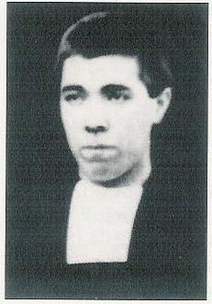
The future martyr was born on 5 August 1908 at Susilla near Santander. Two of his brothers had preceded him at the Arceniega (Álava) juniorate. One of them, Florentino went to work in Chile. Brother Julián pronounced his first vows on 8 September 1924, at the age of 16. He made his perpetual vows on 15 August 1929. He was one of the founders of the Cuenca College.

He was likable and sympathetic in character. In his studies, he had great facility in both Mathematics and Science. During his teaching, his great equanimity was remarkable. He never became angry, not even with the less endowed children. He preferred encouragement to motivate his pupils. He did not mind menial tasks. He swept the classrooms when there were no maintenance men. The pupils volunteered to help him. At Cuenca College, the janitor was an old man without any learning. Brother Julián taught him how to read and write. Little by little, he made him appreciate the beauties of religion so well that this man who had abandoned all religious practices started to frequent the church. This very caretaker offered him the safest hospitality of all when the persecution dispersed the community. But in March 1938, Brother Julián was called for military service in the Republican army. He could not hide his religious status for long and was shot.

2-Ramón Emiliano Hortelano Gómez

This servant of God was born at Cuenca on 8 August 1908. His father was a police inspector and his mother a lady with solid Christian principles. He was a kind child, with a passion for learning and a lover of pus. During his studies, he collaborated in the preparation of the school magazine. To no-one’s surprise, he oriented himself towards teaching. His wife left a precious testimony, “My husband and I knew each other from a very young age. He used to come to our home to play with my brother. Ramón always appeared as more refined than the other boys: more virtuous, more exemplary. Very soon, he developed a strong affection for me. But out of respect, he did not dare breathe a word about it to me! We sat for the same teaching examination together. And we were assigned teaching posts at the same village. He wanted to marry immediately so as not to get separated by the war.”
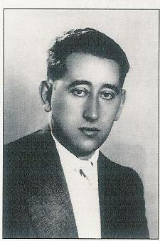

His wife judged him to be an innovative pedagogue: he sometimes allowed time for sexual education. And he advised his wife to do the same with the girls.

The joys of matrimonial and professional life were short-lived. On 1st March1938, called to do his military service, he was sent to Villalba de la Sierra (Cuenca). There, he met the brother who was to become his friend and martyrdom companion, Brother Julián José: they lived together for five months in such a friendship that they went to martyrdom together.

2-The martyrdom

In the city of Cuenca it was on the very first day of Franco’s uprising, on 18 July 1936 that the persecution set in. Elements of the Popular Front invaded the streets. On the next day, the cathedral and the bishop’s palace were surrounded. The bishop was arrested on 28 July, sent to jail and killed on 8 August. On 18 July, the brothers had been forewarned of the imminent occupation of the school by the Socialist Youth Group. The brothers scattered, begging for lodging from safe families. Brother Julián José was taken in by the school janitor, Zoilo Escamilla for a year and a half. But on 1st March 1938 he was called to work in the auxiliary services of the Villalba de la Sierra’s barrack. This is where, on the same day, he met Ramón Emiliano Hortelano Gómez.

They rapidly discovered that they had common characteristics and tastes. Their friendship grew as their life met greater and greater dangers that became very real when they were sent to a certain station called “El Sitio De Abajo.” They had to prepare the camp for the infamous “Columna del Rosal.” Among the soldiers of that column, many were common criminals, public atheists, coarse villains, violent ill bred people, all without any respect for life. Wherever they set foot, their favourite occupations were plunder, attacks on churches and convents or the assassination of religious. These “soldiers” soon became aware that two certain gentlemen were either religious or fervent Christians and they made up their mind to keep them in their sights.

On 23 July, 1938, Ramón Emiliano was granted a 48-hour leave of absence to go and see his new- born child. On his return to camp, he was arrested and executed.
“From a shepherd who supplied us with milk, we learned that my husband and Brother Nemesio (Julián José) had been seized by some militia thugs who killed them. They were then sprinkled with petrol and burned (condemnation reserved to the traitors). When my father-in-law went to collect the mortal remains, he found a few bones only.”
It was possible to identify them thanks to some pieces of clothes incompletely burned and some fragments of paper belonging to Brother Julián José.
The little that remained of the two bodies was kept in a single urn that still lies in the Cuenca cemetery.

3-The Forewarned Heart Had Said Yes

Brother Julian José and Ramón Emiliano had had a presentiment of their martyrdom and they prepared themselves for it as realistic people.

On 1st March 1937, Brother Julian José wrote to his brother, Florentino, missionary in Chile, in a coded message,
“You can’t imagine the rivers of blood that have flown over the fatherland! Fortunately, all the sacrifices made will allow us to forge the new Spain and delete its old and rotten image. You surely heard that the revolution has started under different aspects. We do not see any longer the black crows that people used to disdain so much! The saints and the church altars were burned. The prisons have been emptied: the true “revolutionaries” escaped from them!

Although Brother Julian José had been inclined to fear and to worry, he welcomed God’s will, “That it may be what God will want!”
We never saw him angry. “During the long hours when he had had to hide in the janitor’s house, he showed strength and courage.”
Ricardo Martinez who was his confrere then, gave this account,
“Although his confinement was total, he kept patient and serene and put his trust in God.”
Ramón Emiliano kept his habit of playing on words up to the last minute. His cousin wrote,
“He came to greet my parents. As his lodging when he currently resided was called “Sitio de Abajo”, my father wished him to stay there where he was far from danger.”
Ramon transformed that wish into a joke, “Yes, may they leave me there but not for ever!” He was referring to a typical Spanish saying, ‘Dejar en el sitio’, that means to die in one place. At that moment, his humour was normal. Two days later, he received the martyrdom’s palm.”

The case of these two servants of God endears us by its simplicity and humanity:
- a great friendship during the first military service
- The same death, at the same place for the same motive: to be profound Christians.
- The same execution, the one reserved to the traitors: they were shot and burned.
- The same funeral urn
- The same fame of holiness among God’s people who invoke them and pray to God that they may have a common beatification

CABEZON DE LA SAL AND CARREJO

“If we dare affirm that there are saints in this world, well that group of Marist Brothers surely radiated and inspired holiness from all angles.”

The confreres who survived the persecution maintained that God found their companions worthy of martyrdom because their lives had been unconditionally committed to Him.

In the two localities of Cabezon de la Sal and Carrejo, the brothers directed two modest schools in the style of the first years of the Institute. At Cabezon de la Sal, the brothers conducted a primary school and a class for Art and Trade courses. In all, they took care of 182 pupils.
The three Carrejo brothers were busy with forty-four pupils in three primary school classes. The two neighbouring villages were situated in the province of Santander. There were two victims in each community:

Cabezon: Brothers Pedro 53, and Narcisio 59
Carrejo: Brothers Colombanus-Paul 59 French, and Nestor Eugenio 24.

1-Our Martyred Brothers
1-Brother Pedro (Jaime Cortasa Monclus)
This brother had been very much appreciated at Cabezon de la Sal. He had worked there for eighteen years; twelve of them as the school director. Thanks to his influence, he was able to get his brothers out of jail but he ended up by staying there himself.
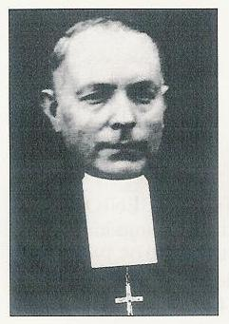

His whole life was dedicated to the education of the modest social classes, i.e. the peasants’ or workers’ children. As director, he would invite his teachers to personally follow each of their children. A former pupil, Victoriano Fernandez wrote,
“When anybody had committed an error he was taken aside to be given a warning that was all wrapped up in prudence and Christian affection. Up to today, the priests of Cabezon have praised the moral rectitude of the Marist pupils.”

Brother Pedro was born at Milla, (Lérida), on 15 July 1883. He consecrated himself to the Lord by pronouncing his perpetual vows on 27 August 1905.

2-Brother Narcisio (Baldomero Arribas Arnaiz)
Brother Narcisio was born on 27 February 1877 at Santibañez de Esgueva (Burgos). At 17, he professed the vow of obedience. He immediately began teaching. Our Marist work was still in its first stages in Spain but the foundations had been laid. Knowing Brother Narcisio’s talents, the superiors often asked him to open or direct schools or to administer boarding institutions.
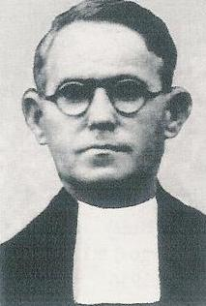
He came to Cabezon after thirty-eight years of experience in education. He was happy to be of help in that modest establishment. Indeed, he was very attentive to the needs of the poor. He was called “The Friend of the Poor”? An anonymous letter came to him with an acid remark, “You would have done better to take care of the pupils of your class rather than the class of the poor!”

3-Brother Colombanus-Paul (Henri Oza Motinot)
Brother Colombanus was French. He was one of those who had had to exile themselves from France in 1903 because of the Combes law. He would never have imagined that he would be martyred in Spain thirty-three years later!
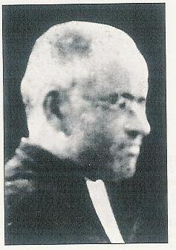
He was born in Lyon, on 1st August 1877. He did his Marist training at St Paul Trois Châteaux.

In France or Spain discipline was never his strong point. Hence, the superiors had to transfer him quite often. He was too timid and too kind. Starting in 1926, he was the Carrejo cook. But he had intellectual talents since he easily obtained his teaching degrees. Besides his maternal French, he spoke Spanish and he could manage English quite well. Talented in music, he assured interesting liturgies in the parishes.

His teaching difficulties did not weaken his spiritual life. One pupil exclaimed one day,
“He is a saint; you can see it on his face!”

As a Frenchman, he could have escaped martyrdom but the love of his community led him to share their fate up to the bitter end.
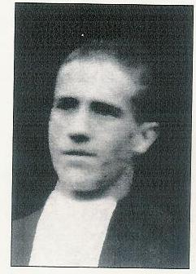

4-Broter Néstor Eugénio (Tesifonte Ortega Villamudrio)
He was the youngest one in his group of martyrs. He was born on 10 April 1912 at Arlanzón (Burgos). When he went to Arceniega, in 1924, he was in such a miserable state of health that the superiors advised him to return home. He later returned to follow the postulancy programme at Les Avellanes in 1929. He made his first vows on 8 September 1932. Because of the revolution, his presence in the Carrejo community enjoyede “the duration of a smile!” He came in 1935.

2 A Martyrdom in Several Stages

1-The Start of Pettiness
In the Santander province, the Popular Front had the upper hand at the time of Franco’s nationalist uprising. Thus, the brothers were not disturbed until the end of October. Then, at the end of October the Culture Commission confiscated the school at Cabezon. The brothers moved to Carrejo.
At the beginning of November, a group of militias inspected the Carrejo school. They fined the brothers one hundred pesetas which had to be paid before three o’ clock. The village people clubbed together and paid. That was not enough meanness! Brother Erasmo José, the superior of the community was led to jail where he found the parish priest, a seminarian and other people in a very pitiful state. Brother Pedro who knew the right persons obtained the freedom of his superior. But before departing, the latter had to sign the charge: “for hiding a flag that he worships.”

A second inspection deprived the brothers of all their food. To survive, they had to give private lessons.

2-First Arrest on 27 December 1936
As a reprisal against the nationalists’ bombings on Santander, the militia thugs decided to throw the brothers into jail.
“The jail was already full, there was no more room. Then the church was used. But we were locked up in the town hall where we stayed for two days before being set free. It was raining so heavily that when we reached home we had to change clothes. Thus, our punishment ended.”

3-Second Arrest, on 30 December 1936
On 30 December, towards four o’ clock, the brothers were thrown into prison once more. Brothers María Ruperto and Luis María were missing: they had gone to Santander. On their return, the house servant informed them of the situation. They quickly walked to jail to visit their confreres. They were also detained!

4-Martyrdom on 1st January 1937
On 31st December, the militia people drove the seven brothers to Santander. They were hurled into the provincial prison. Brother Ruperto wrote the following about the night of 1st January,
“They had already inspected the cells. However, towards nine fifteen our cell was reopened. We were lying down on the hard ground without any cushion or blankets; luckily we had our overcoats. We stood up. Two officers came in with our files. They called Brothers Pedro, Narcisio, Colombanus and Nestor Eugenio. They all left together.”

In the prison there was a rumour that they had been set free. However Victoriano Fernandez Zubiaurre reported : “They were martyred near the Santander light house and then thrown into the sea.”
Ambrosio Calzada Hernandez gave a similar report,
“They were sacrificed either at the light house or at Jesus del Monte, two sinister spots befitting executions. Then, they were thrown into the sea or over a cliff.”

In the city of Santander, nobody doubted that the brothers had been killed.

3- The Man behind the confrontation

Hatred was the first motive of those assassinations. The main actor in this criminal affair was Manuel Forcelledo from Asturias. On his return from America, he had become the owner of a cheap restaurant at Cabezón. He boasted of being an atheist. He resented the brothers so much that he ordered them to be shot.

When the thugs had the brothers at their mercy, not only did they satisfy their rage against them but they carried their aggression to the religious objects that the brothers wore on them. They wrenched the crucifix from Brother Pedro’s chest, trampled it while shouting, “What other proof do we need?” Brother Colombanus Paul carried his rosary. That ‘deserved’ harassment: they took also Brother Colombanus’ rosary.

The brothers who saved their lives had declared they were teachers. Those who were shot had declared they were professors. The professors were considered as religious.

Those who had been in prison with the brothers gave this account,
“Our life in jail was really full of deprivation. In spite of that, the brothers’ high spirits did not weaken. We became very happy to suffer for Christ. I knew the Brothers’ mind because we often talked honestly with each other. I told them that I would have liked to die for Christ with them. Life was tragic. Either we would go without food or we would have to eat out of the cleaning tub. Having no utensils, we made up goblets out of powdered milk containers so that we could draw some soup out of the pot! I repeat that even in that so un-human situation our spirits did not weaken.”

Another prisoner commented,
“We were resigned and had committed ourselves into the Lord’s hands. But, that situation of tragic disorder was heavy on our souls and I must admit that there were moments of sadness and despondency although we were resigned and certain we were in the Lord’s hands.”

Martyrdom remains a horrible thing for our human nature. But without eliminating suffering, grace tells us that God is near,

“The blood of his poor is precious to the Lord’s eyes.” Ps. 71, 14
ONE GRAVE: SIXTY MARTYRS
(BARRUELO DE SANTULLÁN)

1-From Prison to Death

“Who will remind me of October 1936? On the first of the month, towards 8 p.m., a key turned in the lock, making the familiar noise. The door opened and two of Lenin’s sons entered and quickly went out with four of our companions. An hour later, two were brought back. They were unrecognizable; their bodies did not show a single sound spot. Our friends explained: They had been thoroughly battered and bruised with sticks, fists and boots. So that they would not retaliate, the “freedom champions” held their victims in handcuffs all the time. What had happened to those who did not return? It was easy to imagine their fate for no-one ever heard of them again. Thus, the carnage carried on from 1st to 5th October. In that way, our prison became a hospital without any medical aid.”

On 12 October, it was announced that the prisoners would be transferred from Reinosa to Santander. Really, for many of them, it was going to be the “paseito” –the little death ride-. During a bull fight, the paseito is the moment when the toreador must directly face the bull; the martyrs had to face death unarmed.

On Friday, 23 October, at 10 o’clock in the morning, the underground gate opened. Martin Erro Ripa and Leonardo Arce Ruiz were called out. We said our adieus knowing we would never meet again. Through the keyhole, we saw the usual scene: the handcuffing, the climbing into a vehicle that soon moved away. The rumour went that they had been taken to Santander. But, when I was taken to that same town, two months later, I was greatly disappointed to find out that they had not arrived there.”

One year later, as the nationalists took the region over, the people started to look for their departed ones. On 14 October 1937, somebody discovered a common grave of forty-three victims on Mount Saja, forty kilometres from Reinosa on the road to Santander.
“The corpses showed signs of mutilation, with the hands still tied up with steel cables. Among the dead, Brothers Egberto (Leonardo Arce Ruiz) and Teófilo Martín (Martín Erro Ripa) were identified.

The mortal remains were transferred on 17 October 1937. The Reinosa local government had decided to build a large and beautiful common grave for sixty victims.

2-Barruelo Revisited
Barruelo is known as the locality where Brother Bernardo endured martyrdom on 6 October 1934. After Franco’s uprising on 18 July1936, the persecution started again. In that town, many miners were impregnated with Marxist ideas and those who directed the People’s House wanted the elimination of the catholic schools.
The brothers had been working in that mining region since 1914. They opened the Barruelo School in 1920. During the school year 1935-36, the community numbered six brothers including Egberto and Teófilo Martín, the two victims.

When the revolution started, in July 1936, the Vallejo de Orbo brothers succeeded in moving to Burgos. The superiors had authorized three Barruelo brothers: Heraclio José, Egberto and Teófilo Martín to board the train for Cillamayor. But on the way, they decided to travel as far as Quintanilla. They thought they would reach Burgos more easily that way.
At Quintanilla, the brothers were recognized by some railway workers and by a few women who immediately started howling that they should be shot. The militia people arrested them and drove them to Reinosa where they were locked up in jail. We already know what happened.

3-Very Young to Die
Brother Egberto was 29, Brother Teófilo Martín 22. They had been at Baruelo since 1935.

1-Brother Egberto (Leonardo Arce Ruiz)
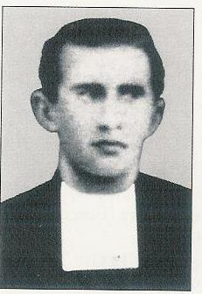
Brother Egberto was born on 6 Januay 1907 at Arcellares del Tozo (Burgos). At 12, he was already at the Arceniega (Álava) juniorate. He was kind, docile and pious but of modest intelligence. The poor man was kept in the kitchen for four years! After that, he taught in the primary classes only.

His former pupils remember his total dedication. His confreres spoke of his family spirit, his joy and his willingness to work in modest conditions. He went to Morocco for his military service for two years. On returning, in 1935, Brother Egberto was sent to Barruelo. Everything was calm during the school year 1935-36.

Travelling towards Barruelo, Brother Egberto had a presentiment that he would inherit Brother Bernardo’s fate.

2-Brother Teófilo Martín (Martín Erro Ripa)
Brother Teófilo was born at Viscarret (Navarra) on 2nd March 1914. At 11, he was already on his way to Marist life. He was generous in his perseverance. His apostolate was rather brief since 1935-36 was his last year of teaching at Barruelo de Santullán.
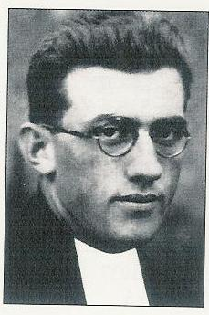
His director spoke highly of him: “His charity radiated in his relations with his brothers and pupils. Serving others, he spared no sacrifice. I never had anything to reproach him with.”

Brother Teófilo looked up to Brother Bernardo as his model. For the miners’ children, the latter spent his energies, worked tirelessly and with great enthusiasm.

AN EXTRAORDINARY MARTYR

BROTHER BENEDICTO ANDRÉS

“As a Spaniard I forgive you, as a Marist religious I thank you for offering me this martyrdom to glorify my God. Although I was not your brother on the earth because of our different ideas, I hope I will be so in heaven.”

“What a courageous monk we have just killed!”

1-Not a serious candidate?

Brother Benedicto Andrés was doing his military service. A rumour started that he had defrocked. His cousin, Brother Jerónimo Emiliano wrote him a stern letter. Benedicto answered, “Humanly speaking I would have motives to give up; but thanks to God, I am far from thinking of leaving the community. I do not forget that I have made commitments. You will tell whomever it may concern that Brother Benedicto continues to be Brother Benedicto.”
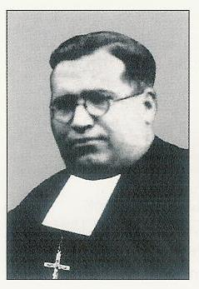

Already during his very first years of teaching, he had been brought to court for sexual abuse. When he presented himself, the boys’ parents said, “This is not the one, we thought of another one!” Between the accusation and the court case he had greatly suffered from anguish and shame.

When he returned from his military service he asked for permission to visit his parents. He had to live a difficult moment of obedience when the superior refused to grant him permission!

Brother Benedicto Andrés (Enrique Andrés Montfort) was born on 25 April 1899 at Villafranca del Cid, in the Castellón province. Later, a vocation promoter assured his father that the Marist Brothers cherished a great devotion to the Virgin Mary and that this devotion if well nourished was a sign of salvation. The little Enrique understood that “a Marist Brother could not go to eternal punishment.” He kept this idea and on 22 January 1911, after having walked through many kilometres of snow he entered the Vich juniorate.

Very soon two characteristics were showing up in the young man: seriousness and firmness. Indeed, these qualities marked him, and little by little, one could discern in him the rich interior life of a man in communion with his God. During his military service, he prayed in the midst of the others without shame. He taught reading to some of his companions who were illiterate.

He described war as an abominable calamity. Spain was at the time fighting certain Moroccan tribes.

In 1935-36, he taught at La Immaculada College, an entirely free school. He was pleased to teach children from low-income homes. Paradoxically, he was now deprived of that joy by the very ones whose political ideal was to improve the fate of the working class.

2-Judas’ Kiss

On 19 July 1936, the community superior and the brother in charge of the kitchen were arrested by the F.A.I. revolutionaries. The other brothers had to go into hiding. Brother Benedicto Andrés and his cousin Jerónimo Emiliano found refuge in their families’ homes.

When volunteers were invited to the military service with life guarantees for religious, Brother Benedicto registered himself thinking that his action would protect his family as well. Alas, he soon realised he had made a faux pas and he thus expressed his regrets to his family, “My death sentence was already signed!” and he added this message for his cousin, “Tell Emiliano not to enrol. He, at least should save himself!” To those who had offered him a safe hiding place, he said that he did not want to bring trouble on his family.

A committee member showed up on 7 December. He had been Benedicto’s childhood friend. Later, they had done their military service together. When his sister announced the macabre visit, he exclaimed, “My hour has come!” He embraced his family and told everyone, “Adieu, we’ll meet in heaven!” Then he followed his ‘comrade”.

As usual, there was no trial; he was thrown into jail right away. There, he found his old teacher and other friends.

His cousin, Maria Montfort Vicente told us, “I was one of the last to see him. We had brought him some food and a blanket. He refused the food but was pleased with the blanket for he suffered from some kidney dysfunction. With bitter tears, I told him, ‘Enrique, we won’t see each other again.’”

The lady was quite right. “The day after, on the feast of the Immaculate Conception, he was killed with his old teacher and three other friends, near San Pau in the Albocacer locality.
First, they killed the old teacher, then the sacristan, the doctor and finally the brother and the young man.”

His sister shared a few flashes of her brother’s life,
“He kept reciting the rosary. He was happy to suffer for Christ. I remember that on the eve of the Immaculate Conception feast, he had said, ‘Maria, even in these difficult times, we must fast; it is the eve of Mary’s feast.’ With this fast, he prepared himself to martyrdom.”

The militia people who killed him were the first ones to be amazed by his courage. They asserted this fact to Sister Balbina Fontanet, “I had to wait on a group of militia. One night, I was talking with one of them who told me, ‘What a courageous monk we have killed! At the first gun shot, he exclaimed, ‘Long live Christ the King!’ At the second discharge, he answered, ‘Long live the Immaculate Conception!’ At the third shot, at sotto voce, he said, ‘Holy Family, welcome me in your arms!’ What a brave man!”

The brother died but not before he could say his thank you and express his pardon as quoted at the beginning of this section.

That was a beautiful martyrdom
all that courage!
the generous pardon
the triple profession of faith
a violent death
and witnessed by Judas!

WHERE WERE THEY KILLED? WHEN?

BROTHERS VALENTE JOSÉ AND ELOY JOSÉ

On the night of 5 October 1936, in the train from Valencia to Barcelona…

“The brothers were forced to get off the train at Castellón. They were so badly treated that Brother Antonino fainted many times. Brother Crispin was ordered to lie on the railway line. The thugs wanted to wrench a confession from him. All they could pull from him was his hair repeatedly. There were even shots in the air to try and intimidate him. In court, the judges were surprised to see all the bruises on the brother’s face. The brothers were left in jail for an entire day without any food.”

Brothers Valente José and Eloy José worked in Mayans College in Valencia. The brothers directed another college in that town, the Academia Nebrija. We have already presented the latter.

1-The Two Martyrs
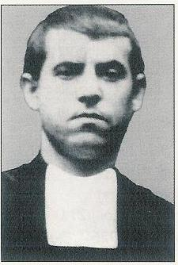
1-Brother Valente José (Jesus Delgado de la Fuente)
Brother Valente José was born on 17 April 1894 at Mazuelo de Muñó, in the Burgos province. At 13, he travelled to Vich to start his training as a future Marist Brother. He made his perpetual profession on 11 August 1915.

On his return from his second novitiate in 1935, he was sent to the Mayans College of Valencia as a mathematics teacher. Here is how his former pupils remembered him,
“He was our maths teacher and as such he was extraordinary. His talent consisted in the fact that he led us to glorify God and that he could sow hope in us. Being a mathematician, his spirituality wasn’t spectacular; but yet it was deep.”
One confrere added, “Brother Valente preferred a hidden life. His life was without any reproach as everything in it was for God’s glory and the people’s salvation.”
He walked on towards the Lord with his lamp fully lit.

2-Brother Eloy José (Eloy Rodriguez Gutiérrez)
Brother Eloy José too was born in the Burgos province, at Torrepadre on 9 September 1899. At 12, he entered the Arceniega juniorate. His final consecration to God took place on 28 September 1921.
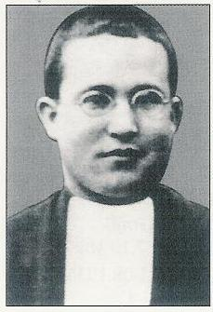
He worked many years in the Valencia schools, either at the Nebrija Academia or at the Mayans College. His likable character, for he was simple and cheerful, endeared him to all. His pupils affirmed that he trained them to witness to their faith. Mariano Andreu Llobat spoke in the name of all of them,
“He was of very great assistance to me. Sometimes his interventions were more efficient than those of a confessor: he sowed seeds of spiritual joy that changed my worried spirit. I want to add that he was the same for all the pupils of my class...”

After the leftists’ victory in February 1936 and at the moment that the threats were more imminent, he wrote to his brother,
“We carry on working at the sublime task that was entrusted to us but it is clear that the spirits of evil want to take it away from us. Pray seriously for me because we are at a very crucial moment for our religion and the country. If God does not come to remedy the situation, we will face an abominable catastrophe. The air we breathe is poisoned by the hatred of an impious regime.”

Brother Eloy José was one the first victims of that hatred.

2-The Death Train

After the nationalists’ countercoup, the city of Valencia went through days of plunder. Brother Valente José and other confreres were arrested. While they were led to jail, some people shouted, “Kill them immediately, they are fascists!” To their great surprise, the brothers were released and warned to get away quickly.

During the afternoon on 25 July 1936, two groups of militia took over the school. The thieves told the brothers, “From this moment, you must move away; this school is now the people’s property!” Therefore, the brothers had to go to their friends and beg for lodgings. Prudently, they often switched locations. The brothers were “visited” twice at their last residence and twice they were robbed until there was nothing left. Finally, they were led to the Public Salvation Committee where they thought seriously of the paseito. The thugs kept repeating, “Tu eres cura!” (You are a priest!); or they heard the militia bandits say among themselves, “Estos guardalos bien, pues mañana temprano les daremos su merecido.” (Keep those well, early tomorrow morning, we will give them what they deserve.”

At that moment, a brother arrived from Barcelona requesting the brothers, in the name of the Provincial to travel to Barcelona where a ship would take them to France. Five brothers boarded the night train from Valencia to Barcelona, thinking that the militia’s supervision might be less strict. Alas! They were found half way at Castellón. Brother Crispin Lope Sancho recalled,
“We were discovered at Castellón de la Plana. While the superior, a confrere and I were told to get off at Castellón, Brother Valente after having told the police that he belonged to the same group, had to continue the journey. The same decision stood for Brother Eloy José.”

From that moment, there was no further trace of them. The brothers never reached Barcelona. Some witnesses affirmed that Brother Valente José had been killed at the northern station of Barcelona in the morning of 6 October and that Brother Eloy José had been killed during the night of 5 October. But Brother Crispin Lope Sancho rather believed that Brother Valente José had been killed at Horta, near Barcelona and Eloy José in the city of Barcelona. It has been impossible to find the place of burial. We already mentioned the militia’s callous habit in similar circumstances.

3-My Heart Is Ready, O my God

When they were very conscious of the imminent danger, the most apparent mood of the brothers was their serenity. That was how a former pupil, Mariano Andreu Llobat admired them,
“I heard from Brother Valente that the persecution was evident and that the real Christians would have to suffer for Christ. He accepted that situation; he was hoping his death would be a seed for a new Church and a better Spain. He was really brave for he never thought of escaping. He neither hesitated nor became hysterical during the terrible events of those days. The last time I saw Brother Eloy, he told me,
“Andreu, if we don’t ever meet on this planet, we will enjoy each other’s company up there!”

Brother Crispin, who suffered with these two brothers maintained a beautiful memory of Brother Valente José, “At the beginning, everyone was dejected. But later, with the grace and the strength of God, we pulled ourselves together and got ready to face death. Brother Valente told the superior, ‘I am going for the sacrament of pardon in order to prepare myself for the other life. By the way events are turning out, I will be called upon very soon.’ His brave attitude prepared him to martyrdom.”
Mariano Andreu Llobat remained attached to these two brothers. He included them in his prayers to entrust them with all his needs. He has often been helped.
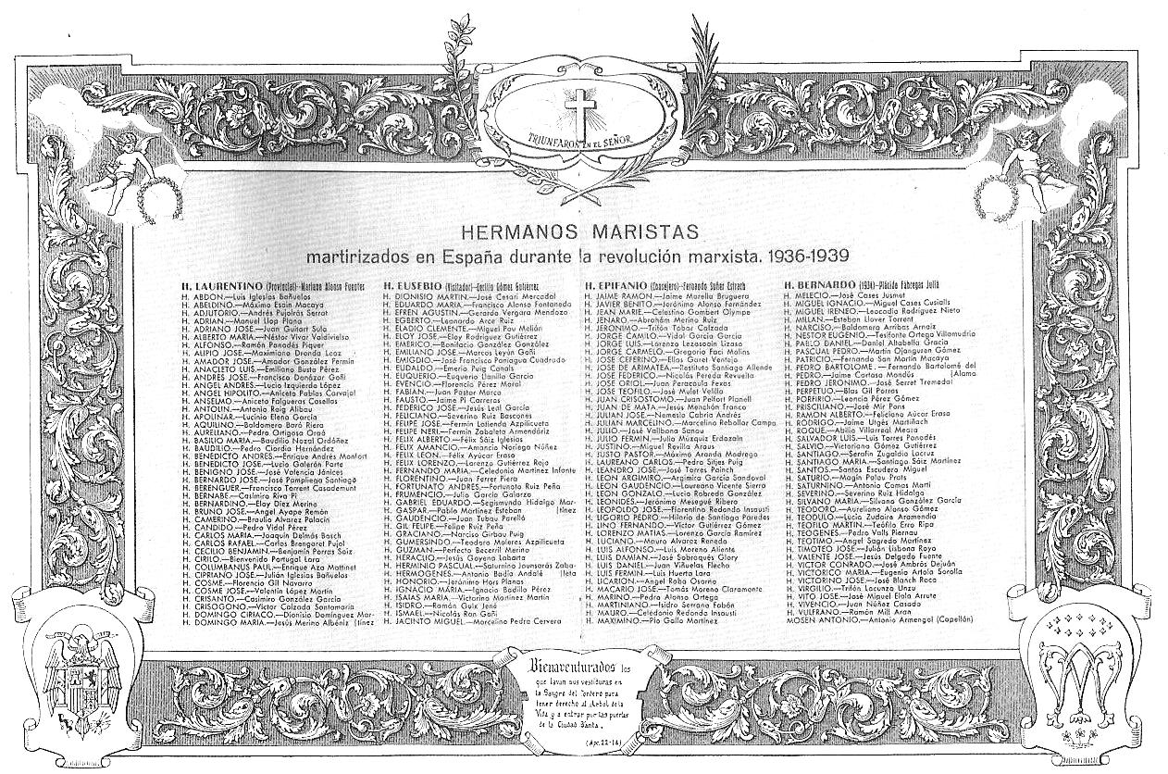
List of the Spanish Brothers who were killed during the persecution of 1936.
TO DIE TOGETHER, MASTER AND DISCIPLE

BROTHER MILLÁN

His martyrdom was not a random event.

One fact is certain, the witnesses at the Ordinary Trial saw in the servant of God, Brother Millán, a true saint whose life was crowned by martyrdom. Then the Marist Brothers, Millán’s relatives and his many friends will be happy to see him beatified.

1-Biography
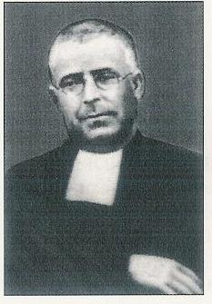
Brother Millán (Esteban Llover Torrent) was born on 27 July of 1885 at Las Planas, in the Girona Province. He lived a happy childhood with his peasant parents, who sent him early to work in the fields or to help around the farm buildings. All the eleven children had to give a hand.

At fourteen, he felt the Lord’s call towards religious life. He presented himself at San Andrés de Palomar (Barcelona) on 4 April 1899. He pronounced his perpetual vows in 1906, his vow of stability in 1922.

Soon, he showed great skill in training youth. Hence, the superiors assigned him at the formation houses. Later on, he was sent to the apostolic communities. To his professional competence he united his likable approach that attracted the pupils to the Christian message. His deep piety revealed his great intimacy with God.

In September 1928, the superiors entrusted him with the founding of a school at Denia. This school quickly boasted of pleasant success; Brother Millán gained the people’s esteem.

Difficulties erupted with the rising of the Republic in April 1931. And when the leftists won the February 1936 elections, a real persecution sprang up.

2-Calvary and Death

Petty harassments were not slow in poisoning the atmosphere: “On 10 April 1936, towards 1 p.m., the brothers received a communiqué from the town hall. This message notified the brothers as follows,
‘To avoid possible disorders, the Brothers must abandon the school and the
commune of Denia this very afternoon.’

To show their seriousness the town leaders stirred up a mob that met in front of the school to provoke its occupants with insults and mockeries.
On Good Friday, the brothers, protected by the pupils, vacated their school. Brother Millán stayed behind to guard the premises. He enjoyed such esteem from the population that the mob could not confront him directly. So the adversaries tried to ban any education at the brothers’ school by using promises, pressure, lies and threats. Finally, the brothers agreed to close the school. The parents begged the government to authorise the teaching of the school-leavers. But the lessons resumed at ‘La Senia’ farm offered by Francisca Moreno. As in many other cases, the brothers had to go around and beg for shelter. When the examination had ended, Brother Millán had to wander from village to village in the Denia area.

Finally, he decided to go and meet Brother Laurentino at Barcelona. At the end of July, he boarded the train. He was identified by a railway employee whose son had studied for free at Denia’s Brothers’ school. He was arrested, denounced and locked up in the Tavernes’ prison at Valldigna where he remained for a dozen days until his death.

“On 10 August 1936, towards 1 am., I was requisitioned by Salvador Grau Corella, ‘El Carabinero’ with three other militia men, to drive D. Rodrigo Gil and D. Esteban Millán to the place called Cuesta del Portichol (La Plana de Alcira). When we reached the destination, Salvador Grau C. stopped the lorry and ordered everybody to get off. The three militia men who moved a little away with the two prisoners shot D. Rodrigo Gil and D. Esteban Millán, leaving the corpses on the road.”

D. Rodrigo Gil was the most promising young man in the College. The Director and the disciple died together. Together, they were buried, then together solemnly transferred to Denia.

3-A True Martyr

According to the Church Canon Law:
When studying a case of martyrdom the experts must go beyond the victim’s physical death to try and verify whether the heart was ready to give itself completely to God, and whether the murderers, out of hatred, were attacking Christian faith and everything it represented.

1- The Persecutors’ Intentions
Two goals were obvious in the persecutors’ sectarian behaviour. First, they wanted to deprive the town of Denia of their centre of education and Christian training. That was a most important project for them. They would have done anything to close the school! The Governor did authorise teaching but for a short time and for the school leavers only.
Second: The revolutionaries wanted to be rid of an embarrassing champion. Brother Millán had too much influence at Denia for their taste! The former had the right opportunity. Arrested outside the commune, he was eliminated at night in a remote area so that the news of the incident did not reach Denia until their evil deed had been done.

Many witnesses shared Brother Miguel Coll Salis’ opinion:
“None of those religious died for any other motive than that they were religious. None of them had campaigned for any political party. The sole activities of these holy men were religious and pedagogical endeavours for the great good of our dear children.”

Others added, “To be religious was sufficient to be condemned to martyrdom.”

2-A State of readiness

Brother Millán had always shown a strong Christian personality that had led him to commit himself totally to the Lord, to his pupils, their families and the brothers. His influence was great in the parish. Hence his martyrdom was not a random affair.

“He was extraordinary in his charity. Nobody ever had such a beneficial impact on the population (Denia).”

Pedro Muñoz Cardona was the last one to host Brother Millán. He saw him in his last days. “He was calm, as if nothing untoward was going to happen to him. You have to remember that we had lived through very perilous moments.”

4-Memories of a Saint

Brother Millán will remain as a very precious memory in the hearts of his brothers, his pupils and the Denia population. Many people spoke of their sincere, loving and deep admiration for him.
“What I can say of the servant of God can be summed up by the memory that we, the former pupils, kept of him as a person of great human and religious quality. I was informed that he had been martyred; the tragedy was a shameful act that was regretted by the Denia people. That painful feeling was shared by all since everybody admired this religious.”

“A man of outstanding virtue, he was famous during his life and he will be renowned for a long time.”

His former pupils dedicated a marble plaque to him with the inscription,
“Your death was not a death but a glorious passage. This is why we, who are so impressed by what we heard about you, we pray together so that from where you enjoy your reward you may kindly continue to instil your spirit in all of us.”

It is reason for wonder and joy to observe that Brother Millán is still greatly admired by the brothers, the former pupils and the Christians of the Denia region. They all keep on calling him simply, “the martyr.”
THE DEATH OF A HUMBLE MARIST BROTHER

BROTHER LUIS FIRMÍN

In his kitchen, he occupied an important community position.
He was a humble man but he sowed joy.
He was killed because he had been carrying religious objects in his suitcase.

1-Brother Luis Firmín (Luis Huerta Lara)
Luis Huerta Lara was born on 21 June 1905 at Torrecilla del Monte (Burgos). He went to Vich for his Marist formation. He made his perpetual vows on 15 August 1927.
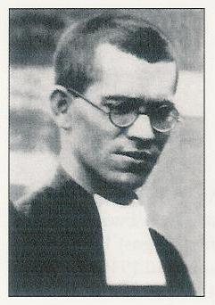

He suffered from such a severe near-sightedness that he could not teach. However, he was very useful in the kitchen in all the houses he went to. His last superior, Brother Luis Venancio wrote,
“He carried out his duty in the kitchen to a great perfection. Clean and punctual he cared not only to prepare some food but he was sensitive to the needs and tastes of his confreres. He suffered if he inadvertently offended anybody. One day, he let drop some disrespectful words against the superior. After night prayer, he went and knelt in front of him to ask for his forgiveness. Pardoned, he was thankful and he promised to amend himself.”

During the years 1932-35, he managed to teach some young students at Carrejo while continuing his work in the kitchen. During the next year, he did the same at Arceniega.

2-A Martyred Cook

The circumstances that led to Brother Luis Firmín’s arrest and martyrdom were most disturbing. On 18 July 1936, Brothers León Pablo and Firmín were at the community house. The superior was in Burgos. Holiday time. After they had been visited by the militia’ hounds, these two brothers did not feel safe. For this reason, they decided to join the juniorate community.

Brother Firmín asked the baker to kindly bring his suitcase to the juniorate. He was still with the baker when the militia people came in again. Opening the suitcase, they found pious objects inside. That was a sufficient reason to despatch him to prison where he remained for eight days; then he was transferred to Bilbao on the Cabo Quilates. On that ship, the prisoners were subjected to continual harassments. The guards harrassed religious fiercely. They were roughest on the weak ones to the point of practising their “art” of torture on these.

Carlos Langa Zuvillaga, prison companion of Brother Luis Firmín described the drama that was being played on the ship,
“I became acquainted with the servant of God on the prison-boat en route to Bilbao. I was with him for about twenty days. We were crowded up like animals. There were four cells; Brother was in the first while I was in the third one. On the Cabo Quilates, the executions were performed (the crucial part of the whole drama) on the poop deck. Not only did we hear gun shots, but sometimes, we clearly heard bursts of machine guns, some days we would hear one shot only. Quite often, we could make out that the victims had breathed their last after a last beating with gun stocks. Those executions were accompanied by insults, mockeries and slaps.”

The brother’s fate must not have been different from the one that befell a priest, Don Matias Lumbreras:
“Every night, towards 2 a.m., that priest was led to the bridge where the torturers with an abominable cruelty inserted lighted cigars into the priest’s body: neck, chest and belly. They sometimes ceased that strange burning to subject the victim to a pressure shower.”
On that ship one had to practise all virtues to a heroic degree. When we thought we had already suffered enough awful humiliations, we were forced to swallow food mixed with excrement.”

On 25 September 1936, the nationalist air force had bombed the town of Bilbao. In retaliation, some militia members ordered the attacks on the prison-boats Altuna Mendi and Cabo Quilates. Victims were chosen, handcuffed, led to the bridge where machine guns were waiting. It was in this way that the priests Matias Lumbreras and Mariano Larrea and Brother Luis Firmín died.

In fact, Father Matias had only been wounded. He was hoisted from the floor, tied with a rope, and then dropped into the sea. Hoisting him from the water, the cruel game continued until he was finished with the strike of a knife into the belly.

Father Don José Echeandria recalled the macabre scene that ended the execution of fifteen priests on the Cabo Quilates. A militia torturer tore a scalp from one of the victims. Next, exhibiting her “trophy” up high in the air, she howled, “Comrades, this is how we must raise all the detainees on poles. There must be no living prisoner left.”

Witnesses who reminisced on Brother Luis Firmín mentioned his love and his dedication. Folders, photos and a biography were printed and distributed. These are signs that reveal his reputation of holiness then and now.

The mortal remains of Brother Luis Firmín were exhumed on 24 October 2004. They were re-buried in the chapel of the provincial house of the Marist Brothers at Laredo (La Rioja).

Brother Luis Firmín :
the cook, the humble man, the dedicated Brother, the martyr

WITNESSES OF CHRIST

A LAUNDRY MAN, A GARDENER AND A MASON

« Bury the three animals ! »

All Christians can succeed in loving the Lord up to the shedding of their blood. This is the comforting message that comes to us from three martyred brothers. These had been assigned various manual occupations at our big house of Les Avellanes. Brother Emiliano José had been a helper at the laundry; Brother Timoteo José was the gardener; Brother Andrés José had been a mason and a ‘jack of all trades’.

1-Brother Emiliano José (Marcos Leyun Goni)
Brother Emiliano José was born on 7 October 1897 at Sansoain in the Navarra region. At 13, his mother accompanied him to the Arceniega juniorate where he started his training in the Marist family. From one stage to the other he kept going on to his final consecration by making his perpetual vows in 1919.
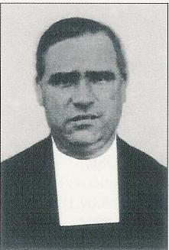

Brother Emiliano José distinguished himself by his passion for helping others. Skilful in electrical work, he would sacrifice his holidays to go and install electrical machines or to repair them in the various houses of the province. That is how, Brother Provincial had asked him to go and work at Les Avellanes during the summer of 1936. That was where the availability of this brother crossed martyrdom’s path.

2-Brother Timoteo José (Julián Lisbona Royo)
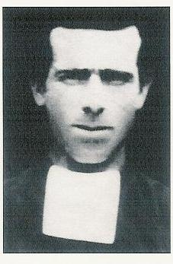
Torre de las Arcas, in the province of Teruel hailed the birth of Brother Timoteo José on 23 October 1891. His family was not well off. The mother was a saffron hawker. Young Julian would accompany her to advertise the sale in the villages’ streets. Later, he admitted that the task had been his burden because of his timidity. But, he wanted to help his mother so that she could buy some food. Alas! The father bent the elbow so much that he eventually neglected his familial duties.

It was only after his military service that Julián felt called to the religious life. His novitiate time at Les Avellanes was difficult. He carried with him the habits of a laborious and rough life. He had to work hard to try to reform a character that made him lose his patience. Anyway, at 28, he made his first vows on 2 February 1919.

He had such a high esteem for religious life that he could not understand why some candidates wanted to quit. Before joining the community, he had worked as a farm handy man for a lady who esteemed him so much that she was ready to bequeath all her possessions to him if he would only accept to dwell with her. But God’s attraction was stronger. That attraction became an unconditional love of God when he made his final consecration on 2 February 1924.

The superiors asked him to stay at Les Avellanes to take care of the heavy tasks. Later, he was in charge of the garden. Although he was assiduous at his humble occupations he managed to develop a great interior life and a true family spirit.

“Brother Timoteo José, as a gardener, had a lot of relationships with the young ones in training since he had to direct their work in the garden. Little by little, we found out that he continually lived in union with God. Thus, when some of the young ones showed a lack of interest in manual work he encouraged them to perform their task with a spiritual purpose. One day, he said, ‘My little brothers, if you work for God, what soils the hands can clean the soul!’
Everybody appreciated him for his virtues and even his kindness hidden beneath the rough exterior of the manual labourer.

Many witnesses marvelled at such a deep spiritual life in a man who spent all his time in manual tasks. That interior life had an impact on the brothers. The villagers were also influenced positively by him since so many of them wished to welcome him into their homes at the outbreak of the persecution.

3-Brother Andrés José (Francisco Donazar Goni)
Another Brother who came from Navarra. He was born at Iroz, on 10 October 1893.
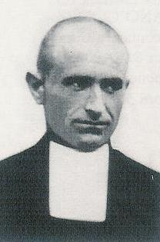
He inherited his father’s craft: both were masons. Unfortunately an accident made life very difficult for him: a bucket of caustic soda fell and spilled its contents on his eyes. It became very painful for him to bear the sunlight or even the whiteness of the walls. However, he stuck to his trade to help his widowed mother.

He suffered a great deception with his engagement when he found out that his fiancée was hiding that she was an unmarried mother. He then wrote to his brother Valente, already a Marist Brother to find out whether he could not join the community as a lay brother. The superiors allowed him this experience that led to his entry into the novitiate on 1st February 1921. He was 28. At the novitiate, he was noted for his kindness and simplicity. He followed the Marist training path with success for he made his final vows on 15 August 1927.

He also stayed at Les Avellanes to be in charge of all the building work and maintenance. He was happy to be of service to his brothers, to repair and improve their rooms. Besides, these occupations allowed him to develop a great union with God. He had a schedule of visits to the Blessed Sacrament.
“He was exemplary and more over, he was fervent. Either after breakfast or after supper we could see him in adoration in the chapel.”

He had taken the initiative of embellishing the chapel. That gave the idea to the superiors to authorise a complete restoration of it at the beginning of 1936. Brother made a nice home for the Lord and he did even better by offering his whole life along an unknown route.

2-Go And Bury the Three Beasts

What happened at Les Avellanes, after Franco’s coming on the Spanish scene on 18 July 1936, we already know. The house was confiscated; the brothers and the young ones in formation
had to disperse.
In a first movement, our three brothers found themselves with the novices in Vilanova de la Sal village. But when the militia killers started to murder some Brothers and wanted to arrest the others, our three brothers decided to move to Navarra by crossing the Aragon River. When they reached the Estopinan village, they were informed that the local revolutionary committee was moderate. Though they were tired after their long walk, the brothers wanted to ask for a safe-conduct to carry on travelling. After all those efforts, they were arrested just the same, locked up and their execution was decreed. The Estopinan committee did not dare undertake the execution themselves.
“On the following day, ruffians from the next village (Alguire) showed up. Pretending that they were going to free the brothers, they let them out. As the brothers were trying to find their way through a field, they were shot in the back.”

The reality was that the execution took place five kilometres from Estopinan, along the road. The details were narrated by Madam Joaquina Vidal Cama who saw the episode.
“I know they were killed on 11 August 1936. I happened to be standing at the window of my country house. I saw the lorry arrive. I was preparing the afternoon tea. My curiosity and the horror that we lived during those terrible times directed my interest to the lorry that had stopped close by. Quickly, a man got off. There was a gun shot. Then two other persons got off and I heard more gun shots. The murderers came to our home and told my husband, ‘Go and bury these three beasts.’ A little later, we heard that the victims were religious.”

When the peasants went to bury the “three beasts” the corpses were lying on the side of the road. The naive murderers had put berets on their heads to try and hide the deathblows.

From 1936 to 1939, that part of the field that had received the martyrs was never cultivated. Thus, the exhumation and identification of the bodies was very easy. These took place on 24 May 1939. The mortal remains were transferred to a funeral monument built for the victims of the persecution, in the commune of Tamarite de Litera (Huesca).

When somebody asked the lady who had observed the executions why these three brothers had been killed, her reply was simple,
“The communists killed them because they were religious. They killed so many of them!”

She had planted a simple cross over their grave on which she grew flowers.

Thus, we hear of these gentle marks of respect and esteem that subsequently became devotion, trust and prayer.

Brother Pablo Daniel

HE ANNOUNCED THE LORD IN THE PRISON
AND IN THE RED ARMY

“Above all, he knew how to sow Christian hope.”

This brother represents a unique case. Young, full of life, intelligent and daring, he publicly witnessed to his faith in prison, in court, in the forced-labour camp and in the republican army. He boosted the faith of the others who called him, “The Angel of comfort”. He even sought to convert his gaolers, tended the wounded soldiers. He was killed on 29 January 1939 because of his zeal to show himself as a religious. He was probably the last one to join the heavenly phalange of the Marist martyrs of that era. Jailed at 24, he was Christ’s martyr at the age of 28.

1-Biography

Pablo Daniel (Daniel Altabella García) was born on 19 October 1911, at Aguaviva (Teruel), in a very Christian family since all the boys consecrated themselves to God’s service, two Marist Brothers and one secular priest.
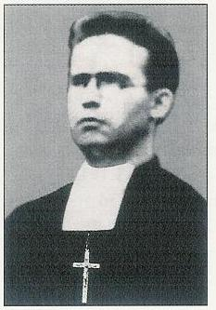

He was eleven when he entered the Vich juniorate. He moved to Les Avellanes for his postulancy and novitiate. He pronounced his first vows in that same house on 8 September 1928. His apostolic experience with the children and adolescents was rather brief. He worked at Alicante first then was sent to Mataró where he was captured by the persecution network in 1936.

This young religious, this enthusiastic and dynamic teacher easily attracted this pupils’ admiration. Because of his virtuous life, he was an all round man ready to train good citizens and authentic Christians.

Pablo’s brother who was a canon at Saint Peter’s in Rome did not hesitate to say that his brother would have deserved the canonisation without martyrdom.

2-The way to his martyrdom was like an obstacle race

For Brother Pablo Daniel the persecution lasted as long as the full civil war, from 1936 to 1939. The main stations of his way of the cross were three prison stays, one prison-boat, a forced labour camp and his enrolment with the republican army.

1-First Detention
Brother Pablo Daniel was among the 107 brothers who were supposed to travel to France aboard the ship, Cabo San Augustín. That escape offer had been a trap. All those brothers ended up in the Checa (prison) of San Elias on 8 October 1936. On the following night, forty-six brothers, Brother Laurentino among them, were shot down in the Moncada cemetery. The others, left in jail suffered all sorts of ill treatments, interrogations and continuous insults. Then, they were transferred to the Carcere Modelo of Barcelona. After a stay of thirteen months, Pablo Daniel was simply released without being accused of anything.

2-Second Detention
To survive, he sought a teaching post. It was found out that his teaching was too obviously Christian. He defended God with daring and bravery. Hence, the second detention on the jail-boat, Argentina. Life was tough but Brother Pablo was very well trained for such circumstance. He shared his cabin cum cell with five companions. That cell soon became a monastery. Daily mass and meditation, a full rosary and night prayers filled up the day. Retreats were organised, the Holy Week ceremonies were prepared. A priest celebrated mass with Brother Pablo taking care of the prayers and homilies. Because of his great spirit of faith, detainees from the other cells came to him to brush up their own spiritual lives.

After four months of imprisonment on the Argentina, he was sent to the castle-prison Montjuich, to wait for a judgment that never came. Without a court decision he was transferred to the Ogern concentration camp. That was a condemnation to forced labour. The prisoners had to build bridges and repair the highways. Brother Laureano, who was then his companion, gave this account,

“We met at night; we recited our prayers as well as we could and shared with each other. One night, when we were short of everything and we were dying of hunger, cold and itching with lice, Pablo told me, ‘It is true that we suffer much here but there are others who suffer more than we do. When Jesus wandered through Palestine, for his teaching wasn’t he in similar predicaments: tired, famished and at the mercy of the weather? Let us accept our fate with bravery!’”

3-Enrolment in the Army: October 1938
As his class was called to military service, he judged he would be useful to others by enrolling. Yes, he thought he could take care of the wounded and he registered accordingly. He was sent to the Calatan front.

4-His Martyrdom
During January of 1939, the republican army had to beat a retreat towards the French border. His company had come near Figueras. Brother exclaimed publicly his gratitude to God to be still alive and to have been freed from the enemies. Such a ‘bizarre’ speech was reported to his chief, Lister. The latter sent a squad of trigger-happy ruffians who shot him and all those who were with him. That was on 20 January 1939.

3-A Very Rare Personality

What is most striking when we listen to witnesses is their insistence on Brother Pablo’s energy and daring. To the other detainees he declared his identity immediately. That was not so extraordinary but he did the same with the judges and the militia people. One judge, admiring his intelligence offered to pay for his studies to obtain a law degree. But Pablo was too well grounded in his Marist vocation to fall for the lure! Brother Eduardo Escola Ganet, another prison companion, wrote,
“That brother’s life in jail was simply heroic. First, he encouraged everybody to martyrdom and he even preached in the prison yard.”
Another witness added,
“Above all, he knew how to sow Christian hope because he spoke of his martyrdom with a perfect serenity.”
Some people stressed his availability to do God’s will,
“His words revealed his total compliance with God’s will. There was no impatience in him and he did not begrudge his gaolers. He sensed God’s love for all of us even in the heat of persecution.”

It is not a surprise that the renown of his holiness became widespread. “If he had not been martyred, he would still have deserved the canonisation process because he practised virtue to such a heroic point. I base my affirmations on objective and tested data.”
His brother, the priest maintained, “There are persons outside our family who became acquainted with him in prison or outside of it. Those individuals entrusted themselves to him. Their letters to me emphasize his heroic virtues. I tried to cool down their enthusiasm without success. They already have some relics of Pablo: pieces of cloth from his clothes or objects that belonged to him.

There are lots of similar witnesses
-“I admire and venerate this servant of God’s memory. I am not the only one to do so. All those who knew him are proud to sing his great virtues.”

- “I am inclined to venerate that brother with a lot of respect and piety. Therefore, I strongly desire his beatification. In prison, we already called him, “The Angel of Comfort”. Possessing all the theological virtues he knew how to instil us with a great trust in God.”

- Every night before my last prayer, I entrust myself to him as a saint.”

Brother Pablo Daniel, that young martyr, bequeathed to all a lesson in holy daring when the winds are contrary and an ultimate example of generosity when it is time to remain faithful to Christ.
Praying with our martyrs

To pray with these Brothers, it is suggested to take them by groups of 5 or 6, to take the reading slowly, with pauses which allow us to take the testimonies in, all directed to glorifying God. Brief chants may alternate with the readings…

1-Brother Crisanto, you were in charge of the young postulants, you took on this responsibility even to putting your life at risk. On 25 August, two days before his martyrdom, Brother Crisanto visited some confreres who invited him to flee. “I gave my word to the Committee that I would present myself every day and I will do it. I won’t even run away when they come to kill me. It’s my duty to accompany those youths whom the Superiors entrusted to me. On the other hand, I don’t want to compromise this population that welcomed us so well. If the militia kill me, their real motive will be that I am a Marist religious and that I do my duty. How can you even suggest that I abandon my dear aspirants? As long as I live, with God’s and Mary’s help, I will take care of them.” (A short time of silence…)

Response in two choirs :
1-Lord, for Brother Crisanto, with his great sense of responsibility, and as a shepherd who gives his life for his young, we worship you.

2-Christ suffered for you, and left you an example to have you follow in his footsteps… By his wounds we were healed (1P 2, 21).

2-Brother. Aquilino, Some minutes before been gunned at the fronton of Las Avellans, Brother Aquilino addressed his killers: ‘I want to talk to you.’ El Peleteiro replied, ‘Speak while we load the guns!’ But the militia did not listen to him. ‘As a man I forgive you and as a Catholic I thank you for you are putting into my hands the martyr’s palm that all Christians must desire..’ El Peletiro asked him, ‘Have you finished?’ To this, Brother Aquilino Baro shouted, ‘Long Live Christ the King!’ El Peleteiro said: ‘Now, you can turn around!’ Aquilino replied, “Front wise!’ The militia triggered their guns and the servant of God fell to the ground.” (A short time of silence…)

Response in two choirs :
1-Lord, for Brother Aquilino, as he appeared in his last moments, courageous and ready to forgive, we worship you and we give you thanks.

2-Christ did no wrong, no deceit was found in his mouth. When he was insulted, he returned not insult. When he was made to suffer, he did not counter with threats. Instead he delivered himself up to the One who judges justly (1P 2, 22-23).

3-At Las Avellanas, Brothers Fabian, Félix Lorenzo and Ligorio Pedro were shot on 3 September 1936 with Br. Aquilino. The impact of the bullets can still be seen today on the wall of the handball courts. We are in the presence of three sick Brothers whom the Militia had gone to take to the town clinic of Balaguer. Félix Lorenzo had heart attacks which had brought him close to death. Ligorio Pedro, 24 years old, was a victim of « Pott’s syndrome » which turns blood and bone into pus ! » - The militia men took them out of the clinic, led them to Las Avellanas, put them up against the wall and shot them. (A short time of silence…)

Response in two choirs :
1-Seigneur, pour ces Frères malades et désarmés, Fabien, Félix Lorenzo et Ligorio Pedro, victimes innocentes comme ton Fils, we worship you, we give you thanks and we praise you for your glory.

2-In his own body he brought your sins to the cross, so that all of us, dead to sin, could live in accord with God’s will… For you had gone astray like sheep, but you have now returned to the shepherd and guardian of your souls (1P 2, 24-25).

4-The community of Toledo is the one which had the greatest number of martyrs, 11/12… All the arrested people were frisked. The discovery of a rosary, a medal or a scapular triggered excesses of rage and blasphemies. The militia unleashed the same tantrums when they inspected the school. Instead of the arms that they were seeking they found an abundance of religious objects that they broke to pieces and threw out the windows.” The prison was not humanitarian at all. A priest who stayed with them has left us the following testimony: “We were thrown into a ‘brigata’ (cell) immediately. We stayed in those cells that had neither air nor water for twenty days. We could not go out to drink water. There was only one jug of water for the forty incarcerated persons. The guards soon became torturers; and they kept threatening to send us to the firing squad. Prisoners who would never return were made to pass in front of us.”
Ten of these Brothers were killed on 23 August 1936. When they were taken from the prison, Br. Jorge Luis was out helping in the kitchen. He was shot the following day, 24 August. (A short time of silence…)

Response in two choirs :
1-Lord, for all the martyred Brothers of Toledo, who gave beautiful witness of a community entirely faithful in the face of martyrdom, we praise you, we bless you, we adore you, we give thanks for your glory.

2-Rejoice in the measure that you share Christ’s sufferings. When his glory is revealed, you will rejoice exultantly. Happy are you when you are insulted for the sake of Christ, for then God’s Spirit in its glory has come to rest on you (1 P 4, 13-14).

5-At Valencia, four Brothers made up the “Academia Nebrija” community during the 1935-36 school year. They were Brothers Luis Damián 45 years old, the school headmaster, José Ceferino (31), the sub-director, Berardo José ( 24) and Benedicto José (23). All will be victims of the persecution.
A priest has left this testimony: “When I was taken to the Sagunto jail, the servant of God, Luis Damián, was already there. He was lying down on a poor mattress. When he found out I was a priest he asked me to hear his confession. Later, I heard from him that his entire community and the chaplain had been arrested. He was lying down with his arms crossed over his chest, as in prayer.” The stay in prison was short but the sufferings were cruel. “The reason why Brother was lying on his poor mattress was because of the extreme weakness he felt after three days without food. Besides, he had been submitted to moral tortures: threats, abominable noises, and taunts from immoral people, and provocation from prostitutes and constant threats with daggers. The authorities kept him in that weakening state that they called ‘the bleeding’ as an immediate preparation for his execution by the firing squad.” “I was present when they led him out into the presence of chief Ungria, who was brandishing a revolver. Ungria shouted, ‘Will the Director of the Marist Brothers present himself with his four companions.’ With my own eyes I saw Brother Director, three Brothers and the chaplain rise up. A few minutes elapsed while the Brothers walked down the steps to the yard. Then we heard five gun shots followed by other staccato sounds that suggested that coffins were being nailed shut. And then the noise of a lorry made us realise that the corpses were being taken elsewhere. (A short time of silence…)

Response in two choirs :
1-Lord, for our Brothers of Valence, whom we admire for their witness as community, we worship you, we give you thanks and we praise you for your glory. For you alone are the Holy One, you alone are the Lord, you alone are the Most High, Jesus Christ, with the Holy Spirit, in the glory of God the Father.

2-These are the ones who have survived the time of the great distress ; they have washed their robes and made them white in the blood of the Lamb (Rev 7, 14b).

6-In the little town of Vich there was a juniorate community with 4 Brothers who were killed: Brothers José Teofilo and Severino 1st August 1936, and Brothers Justo Pastor and Alipio José, 8 September 1936. They were quite young and offered their lives out of youyhful generosity. Br. Severino was 28, Br. José Teofilo 19, Br. Justo Pastor 29 and Br. Alipio José 20.
Brother Severino revealed his deep feelings when he wrote to his father and his brothers, “Do not worry for me. We know very well what we are looking for and at what cost! Dreadful days will come, maybe very dreadful but with Christ, we say, “We have overcome the world.”
During the interrogations, the militia told the young Brother José Teofilo, “Look, you are still young, tell us the truth and we will let you live; life is so beautiful!” You will see your family again and there will be a lot of joy.” But the young Brother did not listen to this alluring promise. (A short time of silence…)

Response in two choirs :
1-Lord, for our Brothers of Vich, young and generous, we worship you.

2-O Lord, our God, you are worthy to receive glory and honour and power. For you have created all things; by your will they came to be and were made (Rev 4, 11).

7-Here is how Br. José d’Arimatea died :
On 4 September, Brother had to climb into a lorry already filled up with condemned people. Carried to a mine well, the militia tied the prisoners' hands with metal cords and pushed them to the bottom of the pit alive where they left them to die of hunger. The peasants nearby heard howls all night; that prevented them from sleeping.
But who was Brother José d’Arimatea? This man with a little violent character prepared children for their first communion and was training them to love the Lord; he directed “la schola cantorum” that enriched the parish liturgies. He was sensitive enough to welcome poor children for free. He never sent back a beggar empty-handed. He was not only paternal with the workers but he treated them justly. (A short time of silence…)

Response in two choirs :
1-Lord, for Br. José d’Arimatea, man of beautiful liturgies, just with his employées, generous towards the poor and taking in without payment needy children, we worship you, we give you thanks and we praise you for your glory.

2-Worthy are you, Christ and Lord, to receive the scroll and to break open the seals. For you were slain. With your blood you purchased for God men of every race and tongue, of every people and nation (Rev 5, 9).

8-Brother Aureliano
In his apostolate, he had set this goal: “to guide the children, to guide them in such a way that they may make the experience of God's love.” As for himself, the secret of his spiritual life was to remain in the “presence of the Good Mother and to go to Jesus through her!”
Meeting him on the road, one of the militia shouted, “This is a priest!” They all rushed on him, hitting him with their gun stocks, hitting him so hard that he fell down many times. He got out his crucifix and started to kiss it. This excited their violence so much that they beat him until one of his eyes came out of its orbit. Continuing their roughing up, they led Brother to a bridge. They wanted to shoot him standing but he kept kneeling down. They would forced him to stand up, he would kneel again. During all that time the militia had not stopped blaspheming. Many times Brother was invited to repeat the blasphemes. But either he kept quiet or answered, “That I won't do!” The militia asked him, “Where do you want us to kill you?” His answer, “Wherever you want!” He was kneeling down, shouting, “Long live Christ the King!” when they shot him. (A short time of silence…)

Response in two choirs :
1-Lord, for Br. Aureliano, dying on his knees, clutching his crucifix and crying « Long live Christ the King ! », we worship you, we give you thanks and we praise you for your glory.

2-Worthy is the lamb that was slain to receive power and riches, wisdom and strength, honour and glory and praise (Rev 5, 12)

9-Brother Guzman and his confrère of Malaga
At Malaga, the Brothers administered the “Nuestra Senora de la Victoria” College. During the school year 1935-1936, the Director was Brother Guzman (50). Eight Brothers worked in collaboration with him: Teógenes (50), Fernando Maria (41), Roque (51), Luciano (44), Pedro Jerónimo (31) all martyrdom companions and Brothers Dalmiro, Isaias and Paulino Leon who shared jail time with them but did not suffer martyrdom. This was a group of mature Brothers on their way to martyrdom. At the height of the persecution in Malaga, Br. Guzman recited the rosary on the tram.
In prison Br. Guzmán carried on a true apostolate of encouragement among the others. Father Luis Vera Ordás, an eye-witness of his death, writes: « I must add, regarding the spirit reigning in the red prisons, there was never the slightest hint of apostasy. Such was the grace of God, that we awaited death trusting in the Lord and not the slightest thought of apostasy occurred to us. We recited the rosary, made our meditation, lived a spiritual life so intense that martyrdom was expected as a true grace from God. »
Brother Guzmán could have saved himself. The Italian consul was his friend. He was invited to contact him, but he replied: « The captain of the ship saves himself last. While there is a single one in danger, I will remain at the helm. » (A short time of silence…)

Response in two choirs :
1-Lord, for the Brothers of the community of Malaga, for their courage in prison and in face of death, for the sense of responsibility of Br. Guzman who did not want to abandon his own, we praise you, we bless you, we adore you, and we give you glory.

2-We praise you, the Lord, God Almighty, who is and who was, you have assumed your great power, you have begun your reign (Rev 11, 17).

10-Our martyrs of Madrid. In the capital, 12 Brothers suffered martyrdom.
Describing the brothers of the « Colegio Los Madrazo », the caretaker said, “Not only did the brothers suffer martyrdom, but they were also abused with all kinds of humiliations and insults. A mob rushed over the College ground, shouting, 'Down with the clergy!' The militia broke into the college. I witnessed the destruction of all the objects of worship.” “The death of these servants of God was due to the fact they were religious! There was no political motive, no protest for social justice.”
This is what thought a former pupil, Fernando Casals Camara, “To persevere up to martyrdom, they needed to possess extraordinary virtues. I agree that quite a few brothers left religious life at the first occasion. But, I am talking about those who stuck to their vocation up to the last moment and in that state have accepted martyrdom.” (A short time of silence…)

Response in two choirs :
1-Lord, for our Brothers of Madrid, whose fidelity under humiliation, insults and threats lasted to the shedding of blood, we worship you, we give you thanks and we praise you for your glory. For you alone are the Holy One, you alone are the Lord, you alone are the Most High, Jesus Christ, with the Holy Spirit, in the glory of God the Father.

2-Now have salvation and power come, the reign of our God and the authority of his Anointed One (Rev 12, 10).

11-At Chinchon, a village near Madrid, three Brothers and the cook, who shared the Brothers’ life, conducted a little school of 162 pupils. Hatred of the faith made martyrs of all four. The simple people of Chinchon were saying : “If it were our concern only they would already be on the altars.” “I don’t believe in heaven if these servants of God aren’t there!”
Two other witnesses were adding : « They were not rich and they had not harmed anybody in need. Then, what was the reason for killing them except that these men were religious?”
“They were men of faith, hope and charity. When the October 1934 revolution exploded the brothers said prayers for peace without ever uttering any word of hatred against anybody.” (A short time of silence…)

Response in two choirs :
1-Lord, these four martyrs of Chinchon were persons united by a strong bond of unity, forming but one heart and one soul, like the first Christians. Thus, Lord, you renew your marvels in the Church, you reveal yourself to little ones, you reveal yourself in simple hearts, and for this we worship you.

2-For the accuser of our brothers is cast out, who night and day accused them before God. They defeated him by the blood of the Lamb and by the word of their testimony; love for life did not deter them from death (Rev 12, 10-11).

12-The three violets of Torrelaguna
The three brothers, Victorico María, 42, Jerónimo, 60 and Marino, 35 were born in the small provincial villages of Burgos and Castellón. Now, Providence had gathered them at Torrelaguna, a village of 2000 inhabitants, in austere Castile not far from Madrid.
An old boy stated, “The three of them were perfectly devoted to our cause. Not only were the villagers grateful to the brothers but they loved them.” Another old boy spoke in even stronger terms, “I am running short of words to express my admiration for those Marist religious. They taught me to love, to forgive. I owe them this glory, to honour among the martyrs of Christ my own parents, my father and my mother; may these be in God’s glory! I have learned to pardon and to endure that terrible trial with a Christian love.”
One of the captives who had been with the brothers left us the following information:
“The brothers knew they were on their way to martyrdom. They had already accepted this greatest of trials with great firmness, without light optimism or useless pessimism. It was rather a holy realism that led them to accept martyrdom. Still, they were literally like lambs led to their sacrifice. Their courage did not flag. This is how I saw them leave for their deaths.” (A short time of silence…)

Response in two choirs :
1-Lord, you are pleased with simple hearts and you make them witnesses to make our faith strong. For these Brothers whom you placed in our Family, we worship you, we give you thanks and we praise you for your glory.

2- So rejoice, you heavens, and you that dwell therein! (Rev 12, 12).

13-The martyrdom of two friends.
Br. Julian José formed part of the community of Villalba de la Sierre (Cuenca). During his military service, he became friendly with Ramon Emiliano Hortelano Gomez, a teacher and convinced Christian, just married, and also serving in the Republican army. The evidence of their faith led them to a martyrdom which consecrated their friendship:
“From a shepherd who supplied us with milk, we learned that my husband and Brother Nemesio (Julián José) had been seized by some militia thugs who killed them. They were then sprinkled with petrol and burned (condemnation reserved to the traitors). When my father-in-law went to collect the mortal remains, he found a few bones only.” It was possible to identify them thanks to some pieces of clothes incompletely burned and some fragments of paper belonging to Brother Julián José. The little that remained of the two bodies was kept in a single urn that still lies in the Cuenca cemetery.
The case of these two servants of God endears us by its simplicity and humanity:
- a great friendship during the first military service
- The same death, at the same place for the same motive: to be profound Christians.
- The same execution, the one reserved to the traitors: they were shot and burned.
- The same funeral urn
- The same fame of holiness among God’s people who invoke them and pray to God that they may have a common beatification (A short time of silence…)

Response in two choirs :
1-Lord, for the great friendship which bound Br. Julian José and Ramon Emiliano, a friendship built on faith and the love they had for you ; for this great friendship between a consecrated man and a married man, we praise you, we bless you, we adore you and we glorify your name.

2-Mighty and wonderful are your works, Lord, God Almighty ! Righteous and true are your ways, O King of the nations (Rev 15, 3).

14-« Precious in the eyes of the Lord is the blood of his poor! » We can apply this to our martyred Brothers of Cabezon de la Sal and of Carrejo, two little country schools. These Brothers are Pedro, Narcisio, Colombanus Paul (French) and Nestor Eugenio.
The following was the opinion of the people on these Brothers : “If we dare affirm that there are saints in this world, well that group of Marist Brothers surely radiated and inspired holiness from all angles.” The confreres who survived the persecution maintained that God found their companions worthy of martyrdom because their lives had been unconditionally committed to Him. Those who had been in prison with the brothers gave this account, “Our life in jail was really full of deprivation. In spite of that, the brothers’ high spirits did not weaken. We became very happy to suffer for Christ. I knew the Brothers’ mind because we often talked honestly with each other. I told them that I would have liked to die for Christ with them. Life was tragic. Either we would go without food or we would have to eat out of the cleaning tub… I repeat that even in that so un-human situation our spirits did not weaken.”

Another prisoner commented, “We were resigned and had committed ourselves into the Lord’s hands. But, that situation of tragic disorder was heavy on our souls and I must admit that there were moments of sadness and despondency although we were resigned and certain we were in the Lord’s hands.” (A short time of silence…)

Response in two choirs :
1-Lord, for having shared your cross with Brothers Pedro, Narcisio, Colombanus Paul and Nestor Eugenio, for having led them to the final gift of self through prison, privations, sadness, abasement, we worship you, we give you thanks and we praise you for your glory. For you alone are the Holy One, you alone are the Lord, you alone are the Most High, Jesus Christ, with the Holy Spirit, in the glory of God the Father.

2-Who would dare refuse you honour, or the glory due your name, O Lord ? Since you alone are holy (Rev 15, 4).

15-In the village of Barruelo Br. Bernardo had been martyred on 6 October 1934. In 1936 two other young Brothers of the community met their deaths: Br. Egberto 29, and Br. Teofilo Martín 22. A witness who shared prison with our Brothers wrote : “Who will remind me of October 1936? On the first of the month, towards 8 p.m., a key turned in the lock, making the familiar noise. The door opened and two of Lenin’s sons entered and quickly went out with four of our companions. An hour later, two were brought back. They were unrecognizable; their bodies did not show a single sound spot. Our friends explained: They had been thoroughly battered and bruised with sticks, fists and boots. So that they would not retaliate, the “freedom champions” held their victims in handcuffs all the time. What had happened to those who did not return? It was easy to imagine their fate for no-one ever heard of them again.
On Friday, 23 October, at 10 o’clock in the morning, the underground gate opened. Martin Erro Ripa and Leonardo Arce Ruiz were called out. We said our adieus knowing we would never meet again. Through the keyhole, we saw the usual scene: the handcuffing, the climbing into a vehicle that soon moved away. ” (A short time of silence…)

Response in two choirs :
1- Lord, for these Brothers who died without leaving any trace, without any friendly eyes to see how faithful they were to you in the time of trial, we worship you.

2-All nations shall come and worship in your presence. Your mighty deeds are clearly seen (Rev 15, 4).

16-Brother Benedicto Andrés, some minutes before his death said to the militians whe were going to kill him : “As a Spaniard I forgive you, as a Marist religious I thank you for offering me this martyrdom to glorify my God. Although I was not your brother on the earth because of our different ideas, I hope I will be so in heaven.”
The militia people who killed him were the first ones to be amazed by his courage. They asserted this fact to Sister Balbina Fontanet, “I had to wait on a group of militia. One night, I was talking with one of them who told me, ‘What a courageous monk we have killed! At the first gun shot, he exclaimed, ‘Long live Christ the King!’ At the second discharge, he answered, ‘Long live the Immaculate Conception!’ At the third shot, at sotto voce, he said, ‘Holy Family, welcome me in your arms!’ What a brave man!”

That was a beautiful martyrdom
all that courage!
the generous pardon
the triple profession of faith
a violent death
and witnessed by Judas! (A short time of silence…)

Response in two choirs :
1-Lord, to Br. Benedicto Andrés you gave a big heart, ready to forgive following the example of your Son, and like him betrayed by a childhood friend. For the gift of this Brother, we worship you and we give you thanks.

2-Alleluia. Salvation, glory, and power to our God : Alleluia. His judgments are honest and true. Alleluia (Rev 19, 1-2)

17-On the train from Valencia to Barcelona, will desappear Brothers Valente José and Eloy José :
“The brothers were forced to get off the train at Castellón. They were so badly treated that Brother Antonino fainted many times. Brother Crispin was ordered to lie on the railway line. The thugs wanted to wrench a confession from him. All they could pull from him was his hair repeatedly. There were even shots in the air to try and intimidate him. In court, the judges were surprised to see all the bruises on the brother’s face. The brothers were left in jail for an entire day without any food.” (A short time of silence…)

Response in two choirs :
1-Lord, in your martyrs your passion still continues. In them it is You who is killed and You whom they glorify. For willing to share with them your passion, for making yourself present in their passion, we worship you, we give you thanks, and we praise you for your glory.

2-Alleluia. Sing praise to our God, all you his servants, Alleluia. All who worship him reverently, great and small. Alleluia (Rev 19, 5).

18-Brother Millán and his disciple
“On 10 August 1936, towards 1 am., I was requisitioned by Salvador Grau Corella, ‘El Carabinero’ with three other militia men, to drive D. Rodrigo Gil and D. Esteban Millán to the place called Cuesta del Portichol (La Plana de Alcira). When we reached the destination, Salvador Grau C. stopped the lorry and ordered everybody to get off. The three militia men who moved a little away with the two prisoners shot D. Rodrigo Gil and D. Esteban Millán, leaving the corpses on the road.”
Thus died together the teacher, Br. Millan, and his pupil, Rodrigo Gil.
Brother Millán will remain as a very precious memory in the hearts of his brothers, his pupils and the Denia population. Many people spoke of their sincere, loving and deep admiration for him. “What I can say of the servant of God can be summed up by the memory that we, the former pupils, kept of him as a person of great human and religious quality. I was informed that he had been martyred; the tragedy was a shameful act that was regretted by the Denia people. That painful feeling was shared by all since everybody admired this religious.” (A short time of silence…)

Response in two choirs :
1-Lord, we do not understand why your servants were killed, men with rich human personalities, from whom all benefitted and all admired ; but so it was also with your Son. Lord, for this martyrdom which joined teacher and pupil, we praise you, we bless you, and we adore you and we glorify your name.

2-Alleluia. The Lord, our all-powerful God is King ; Alleluia, let us rejoice, sing praise, and give him glory. Alleluia (Rev 19, 6-7).
19-Brother Luis Firmín or the martyr cook
He suffered from such a severe near-sightedness that he could not teach. However, he was very useful in the kitchen in all the houses he went to.
He was imprisoned on the ship Cabo Quilates, in Bilbao, simply because some prayer books were found in his travelling bag. A companion of jail describes the dramatic situation as follows : “I became acquainted with the servant of God on the prison-boat en route to Bilbao. I was with him for about twenty days. We were crowded up like animals. There were four cells; Brother was in the first while I was in the third one. On the Cabo Quilates, the executions were performed (the crucial part of the whole drama) on the poop deck. Not only did we hear gun shots, but sometimes, we clearly heard bursts of machine guns, some days we would hear one shot only. Quite often, we could make out that the victims had breathed their last after a last beating with gun stocks. Those executions were accompanied by insults, mockeries and slaps.”

Brother Luis Firmín : the cook, the humble man, the dedicated Brother, the martyr. (A short time of silence…)

Response in two choirs :
1-Lord, you love the little ones and the humble, you chose them for washing their robes in the blood of the Lamb, mingling their blood with that of your Son, we worship you, we give you thanks and we praise you for your glory. For you alone are the Holy One, you alone are the Lord, you alone are the Most High, Jesus Christ, with the Holy Spirit, in the glory of God the Father.

2-Alleluia. The wedding of the lamb has begun, Alleluia, and his bride is prepared to welcome him. Alleluia (Rev 19, 7).

20- A Laundry man. A gardener and a Mason
All Christians can succeed in loving the Lord up to the shedding of their blood. This is the comforting message that comes to us from three martyred brothers. These had been assigned various manual occupations at our big house of Les Avellanes. Brother Emiliano José had been a helper at the laundry; Brother Timoteo José was the gardener; Brother Andrés José had been a mason and a ‘jack of all trades’.
The reality was that the execution took place five kilometres from Estopinan, along the road. The details were narrated by Madam Joaquina Vidal Cama who saw the episode.
“I know they were killed on 11 August 1936. I happened to be standing at the window of my country house. I saw the lorry arrive. I was preparing the afternoon tea. My curiosity and the horror that we lived during those terrible times directed my interest to the lorry that had stopped close by. Quickly, a man got off. There was a gun shot. Then two other persons got off and I heard more gun shots. The murderers came to our home and told my husband, ‘Go and bury these three beasts.’ A little later, we heard that the victims were religious.” (A short time of silence…)

Response in two choirs :
1-Lord, you are worthy of praise because you choose your witnesses as you will. Here you have chosen a Brother who worked in the laundry, another who was the gardener at Las Avellanas, and a third who was a builder and jack-of-all-trades, because it is you who is the great master of hearts. Lord, for acting thus, Lord God, heavenly King, God and Father, we worship you, we thank you, we praise you for your glory.

2-Praise be God, the Father of our Lord Jesus-Christ, the Father of mercies, and the God of all consolation ! He comforts us in all our afflictions (2Cor 1,3).

21- Brother PABLO DANIEL
He announced the Lord in the prison and in the Red Army. “Above all, he knew how to sow Christian hope.”
This brother represents a unique case. Young, full of life, intelligent and daring, he publicly witnessed to his faith in prison, in court, in the forced-labour camp and in the republican army. He boosted the faith of the others who called him, “The Angel of comfort”. He even sought to convert his gaolers, tended the wounded soldiers. He was killed on 29 January 1939 because of his zeal to show himself as a religious. He was probably the last one to join the heavenly phalange of the Marist martyrs of that era. Jailed at 24, he was Christ’s martyr at the age of 28.
Brother Laureano, who was then his companion, gave this account,
“We met at night; we recited our prayers as well as we could and shared with each other. One night, when we were short of everything and we were dying of hunger, cold and itching with lice, Pablo told me, ‘It is true that we suffer much here but there are others who suffer more than we do. When Jesus wandered through Palestine, for his teaching wasn’t he in similar predicaments: tired, famished and at the mercy of the weather? Let us accept our fate with bravery!’” (A short time of silence…)

Response in two choirs :
1-Lord, the example of Br. Pablo Daniel inspires us to pray: Fill our lives with the same courage, the same strength, with a lively hope, that others may see that we believe in your Son, the Risen and Living One, He who leads us to fulness of life, and that they may join us as we worship you, we give you thanks and we praise you for your glory. For you alone are the Holy One, you alone are the Lord, you alone are the Most High, Jesus Christ, with the Holy Spirit, in the glory of God the Father.

2-Who will separate us from the love of Christ ? Trial or distress, or persecution or hunger, or nakedness or danger, or the sword? Yet in all these we are more than conquerors because of him who has loved us… Nothing will be able to separate us form the love of God that comes to un in Christ Jesus, our Lord (Rom 8, 35, 39).
To Glorify God in our martyrs

Motivation
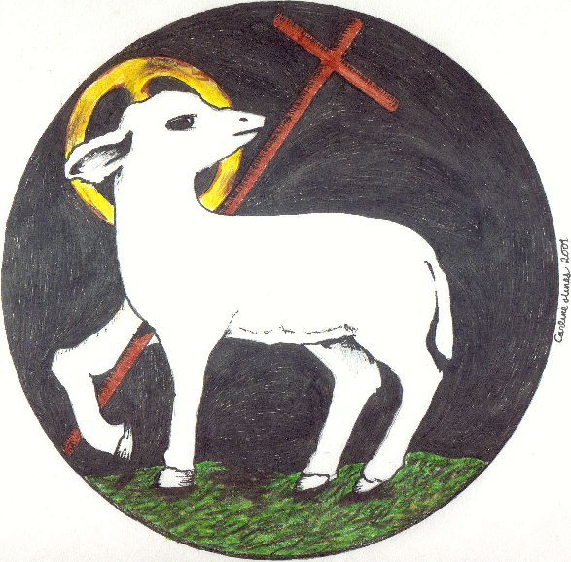
Brother Laurentino said: « Each martyr suffers in his body, but Christ suffers in each of us and in all his members ». The passion and death of the Lord is renewed in each martyr. To celebrate the martyrs is to glorify Christ, as they glorify him by their deaths: they have washed their robes in the blood of the Lamb.
This evening, we also wish to glorify Christ in his martyrs who are our brothers.

1-Longing for light, we wait in darkness, longing for truth, we turn to you,
Make us your own, your holy people, light for the world to see.

Christ, be our light! Shine in our hearts. Shine through the darkness.
Christ, be our light! Shine in your Church gathered today.

2-Many the gifts, many the people, many the hearts that yearn to belong.
Let us be servants to one another, making your kingdom come.

Christ, be our light! Shine in our hearts. Shine through the darkness.
Christ, be our light! Shine in your Church gathered today.

1-Brother Crisanto, you were in charge of the young postulants, you took on this responsibility even to putting your life at risk. On 25 August, two days before his martyrdom, Brother Crisanto visited some confreres who invited him to flee. “I gave my word to the Committee that I would present myself every day and I will do it. I won’t even run away when they come to kill me. It’s my duty to accompany those youths whom the Superiors entrusted to me. On the other hand, I don’t want to compromise this population that welcomed us so well. If the militia kill me, their real motive will be that I am a Marist religious and that I do my duty. How can you even suggest that I abandon my dear aspirants? As long as I live, with God’s and Mary’s help, I will take care of them.” (A short time of silence…)

Response in two choirs :
1-Lord, for Brother Crisanto, with his great sense of responsibility, and as a shepherd who gives his life for his young, we worship you.

2-Christ suffered for you, and left you an example to have you follow in his footsteps… By his wounds we were healed (1P 2, 21).

2-Brother. Aquilino, Some minutes before been gunned at the fronton of Las Avellans, Brother Aquilino addressed his killers: ‘I want to talk to you.’ El Peleteiro replied, ‘Speak while we load the guns!’ But the militia did not listen to him. ‘As a man I forgive you and as a Catholic I thank you for you are putting into my hands the martyr’s palm that all Christians must desire..’ El Peletiro asked him, ‘Have you finished?’ To this, Brother Aquilino Baro shouted, ‘Long Live Christ the King!’ El Peleteiro said: ‘Now, you can turn around!’ Aquilino replied, “Front wise!’ The militia triggered their guns and the servant of God fell to the ground.” (A short time of silence…)

Response in two choirs :
1-Lord, for Brother Aquilino, as he appeared in his last moments, courageous and ready to forgive, we worship you and we give you thanks.

2-Christ did no wrong, no deceit was found in his mouth. When he was insulted, he returned not insult. When he was made to suffer, he did not counter with threats. Instead he delivered himself up to the One who judges justly (1P 2, 22-23).

Refrain: Glory and praise to you, Lord Jesus Christ.

3-At Las Avellanas, Brothers Fabian, Félix Lorenzo and Ligorio Pedro were shot on 3 September 1936 with Br. Aquilino. The impact of the bullets can still be seen today on the wall of the handball courts. We are in the presence of three sick Brothers whom the Militia had gone to take to the town clinic of Balaguer. Félix Lorenzo had heart attacks which had brought him close to death. Ligorio Pedro, 24 years old, was a victim of « Pott’s syndrome » which turns blood and bone into pus ! » - The militia men took them out of the clinic, led them to Las Avellanas, put them up against the wall and shot them. (A short time of silence…)

Response in two choirs :
1-Lord, for your sick and unarmed Brothers, Fabien, Félix Lorenzo and Ligorio Pedro, innocent victims like your Son, we worship you, we give you thanks and we praise you for your glory.

2-In his own body he brought your sins to the cross, so that all of us, dead to sin, could live in accord with God’s will… For you had gone astray like sheep, but you have now returned to the shepherd and guardian of your souls (1P 2, 24-25).

4-The community of Toledo is the one which had the greatest number of martyrs, 11/12… All the arrested people were frisked. The discovery of a rosary, a medal or a scapular triggered excesses of rage and blasphemies. The militia unleashed the same tantrums when they inspected the school. Instead of the arms that they were seeking they found an abundance of religious objects that they broke to pieces and threw out the windows.” The prison was not humanitarian at all. A priest who stayed with them has left us the following testimony: “We were thrown into a ‘brigata’ (cell) immediately. We stayed in those cells that had neither air nor water for twenty days. We could not go out to drink water. There was only one jug of water for the forty incarcerated persons. The guards soon became torturers; and they kept threatening to send us to the firing squad. Prisoners who would never return were made to pass in front of us.”
Ten of these Brothers were killed on 23 August 1936. When they were taken from the prison, Br. Jorge Luis was out helping in the kitchen. He was shot the following day, 24 August. (A short time of silence…)

Response in two choirs :
1-Lord, for all the martyred Brothers of Toledo, who gave beautiful witness of a community entirely faithful in the face of martyrdom, we praise you, we bless you, we adore you, we give thanks for your glory.

2-Rejoice in the measure that you share Christ’s sufferings. When his glory is revealed, you will rejoice exultantly. Happy are you when you are insulted for the sake of Christ, for then God’s Spirit in its glory has come to rest on you (1 P 4, 13-14).

Refrain: Glory and praise to you, Lord Jesus Christ.

5-At Valencia, four Brothers made up the “Academia Nebrija” community during the 1935-36 school year. They were Brothers Luis Damián 45 years old, the school headmaster, José Ceferino (31), the sub-director, Berardo José ( 24) and Benedicto José (23). All will be victims of the persecution.
A priest has left this testimony: “When I was taken to the Sagunto jail, the servant of God, Luis Damián, was already there. He was lying down on a poor mattress. When he found out I was a priest he asked me to hear his confession. Later, I heard from him that his entire community and the chaplain had been arrested. He was lying down with his arms crossed over his chest, as in prayer.” The stay in prison was short but the sufferings were cruel. “The reason why Brother was lying on his poor mattress was because of the extreme weakness he felt after three days without food. Besides, he had been submitted to moral tortures: threats, abominable noises, and taunts from immoral people, and provocation from prostitutes and constant threats with daggers. The authorities kept him in that weakening state that they called ‘the bleeding’ as an immediate preparation for his execution by the firing squad.” “I was present when they led him out into the presence of chief Ungria, who was brandishing a revolver. Ungria shouted, ‘Will the Director of the Marist Brothers present himself with his four companions.’ With my own eyes I saw Brother Director, three Brothers and the chaplain rise up. A few minutes elapsed while the Brothers walked down the steps to the yard. Then we heard five gun shots followed by other staccato sounds that suggested that coffins were being nailed shut. And then the noise of a lorry made us realise that the corpses were being taken elsewhere. (A short time of silence…)
Fr. Luis Damián
H. José Ceferino

Response in two choirs :
1-Lord, for our Brothers of Valence, whom we admire for their witness as community, we worship you, we give you thanks and we praise you for your glory. For you alone are the Holy One, you alone are the Lord, you alone are the Most High, Jesus Christ, with the Holy Spirit, in the glory of God the Father.

2-These are the ones who have survived the time of the great distress ; they have washed their robes and made them white in the blood of the Lamb (Rev 7, 14b).

6-In the little town of Vich there was a juniorate community with 4 Brothers who were killed: Brothers José Teofilo and Severino 1st August 1936, and Brothers Justo Pastor and Alipio José, 8 September 1936. They were quite young and offered their lives out of youyhful generosity. Br. Severino was 28, Br. José Teofilo 19, Br. Justo Pastor 29 and Br. Alipio José 20.
Brother Severino revealed his deep feelings when he wrote to his father and his brothers, “Do not worry for me. We know very well what we are looking for and at what cost! Dreadful days will come, maybe very dreadful but with Christ, we say, “We have overcome the world.”
During the interrogations, the militia told the young Brother José Teofilo, “Look, you are still young, tell us the truth and we will let you live; life is so beautiful!” You will see your family again and there will be a lot of joy.” But the young Brother did not listen to this alluring promise. (A short time of silence…)

Response in two choirs :
1-Lord, for our Brothers of Vich, young and generous, we worship you.

2-O Lord, our God, you are worthy to receive glory and honour and power. For you have created all things; by your will they came to be and were made (Rev 4, 11).

Refrain: Keep in mind that Jesus Christ has died for us and is risen from de dead.
He is our saving Lord, he is joy for all ages.

1-If we die with the Lord, we shall live with the Lord.
If we endure with the Lord, we shall reign with the Lord.

2-In him all our sorrows, in him all our joy.
In him hope and glory, in him all our love.
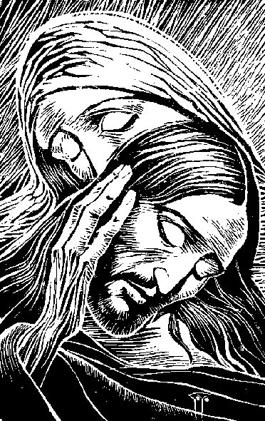

Prayers of intercession :
In our intercessions we can use an echo of what one or the other has said as the basis for our intercession :

Refr : Sure of your love, and strong in our faith , we pray to you , Lord.

Conclusion : At the foot of the cross, Mary is the Mother of the Martyr, the Lord Jesus, her Son.
At the foot of the cross, she becomes mother of all the martyrs, disciples of her Son. As she was present at the martyrdom of her Son, so she is present with each martyr and supports him by her prayer. In singing together the Salve Regina, we want to testify our gratitude to her for having enriched our Family with so many martyr Brothers.

Informatio, p. 367.
F.A.I. is for Federación Anárquica Ibérica.
Informatio, p 369.
Informatio, p. 370.
Informatio, p. 139.
Madame Mercedes Setoain Puig, witness to the diocesan process. Informatio p. 369.
Manuel de Irujo is of Basque origin, a committed Catholic, called to be a part of the Republican government on the 25th December 1936.
Source: Hilari Raguer, La pólvora y el incienso, La Iglesia y la Guerra Civil española, - PeninsulaHCS. pp. 418-420. The Republicans were in power in Spain in 1936. On the 18th July, Franco rose up against this government and created the Nationalist Movement. Spain was split into two: some regions stayed faithful to the Republic, others joined the movement of Franco. Persecution reigned in the regions that remained Republican. In these Republican regions priests and religious were killed by the thousands. – The letter of this minister is full of merit as it describes the persecution in all of its bluntness.
The 18th July witnessed the rising up of Franco against the government of Madrid.
5 5 These pages are inspired by the Informatio of Brother Crisanto’s group, pp.355-368

