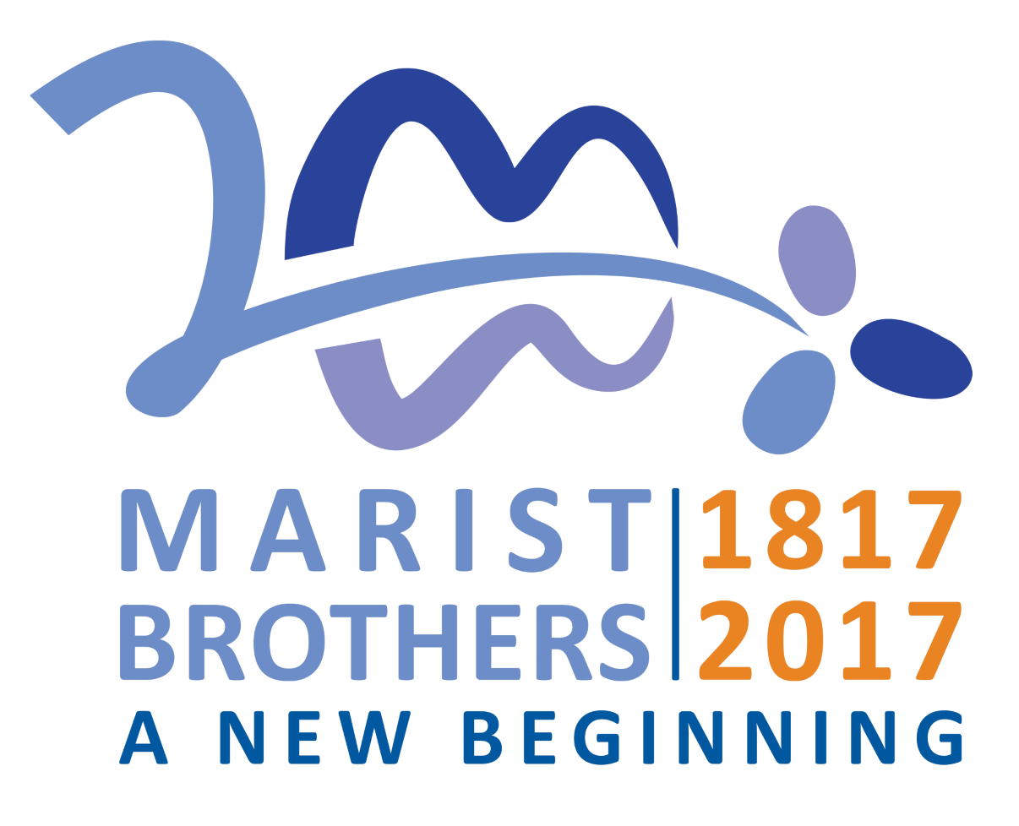

200th Anniversary of the Foundation Day
2 January 1817 - 2017

Prayer
God of new beginnings,
you inspired Marcellin Champagnat
to labour for your kingdom
and to make Jesus Christ known and loved
in the circumstances of the people of his time,
especially young people on the margins.

Through Mary’s guidance
Marcellin gathered a community around the table at La Valla.
From our simple foundation in La Valla
we come to the threshold of our third century,
to create a new beginning.

At this time you call us forth in faith, hope and love
to be attentive to the signs of your Spirit in our world.
Give us the same audacity and faith as we journey in faith
to the future which beckons us today and always. Amen.

Reading - Galatians 4:4-7
But when the fullness of time had come, God sent his Son, born of a woman, born under the law, in order to redeem those who were under the law, so that we might receive adoption as children. And because you are children, God has sent the Spirit of his Son into our hearts, crying, “Abba! Father!” So you are no longer a slave but a child, and if a child then also an heir, through God.

Psalm 127 - Nisi Dominus
Unless the Lord builds the house,
those who build it labour in vain.
Unless the Lord guards the city,
the guard keeps watch in vain.
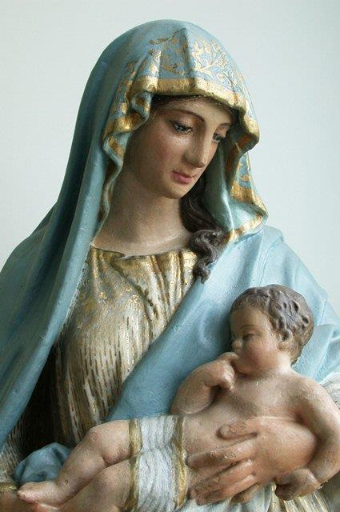
It is in vain that you rise up early
and go late to rest,
eating the bread of anxious toil;
for he gives sleep to his beloved.

Sons are indeed a heritage from the Lord,
the fruit of the womb a reward.
Like arrows in the hand of a warrior
are the sons of one’s youth.

Happy is the man who has
his quiver full of them.
He shall not be put to shame
when he speaks with his enemies in the gate.

Reading - Life of J B Marcellin Champagnat, p. 61
Since Fr Champagnat had two subjects who were so well disposed, he thought that it was time to launch his project. The problem was where to find suitable accommodation for them. Not far from the presbytery, there was a small house for sale. Though he had no money he didn’t hesitate about buying the place, which had two features particularly in its favour: closeness to the presbytery, a fact which would facilitate his guidance and formation of the young men; and a very modest price. Hence he brought it, and the small garden and lot of land that went with it, for the sum of sixteen hundred francs, which he was forced to borrow. When the deal was finalised, he set himself to repair and clean it, adding the bare necessities of furniture. The two small plank beds and the little dining table, were the work of his own hands.

These things done, he installed his two Brothers in that tiny dwelling which was thus the cradle of the Institute of the Little Brothers of Mary. The stamp of poverty was everywhere evident; but the stable of Bethlehem and the house of Nazareth were poor, and the children of Mary were to resemble their Mother and bear the seal of her poverty and humility from their very birth as a religious body. It was on the 2nd of January, 1817, that the two novices took possession of the house and began their community life, laying the foundation of the Institute of the Little Brothers of Mary.

A Prayer from the Constitutions
On January 2nd 1817, Marcellin Champagnat founded the religious Institute of Brothers, under the name of Little Brothers of Mary. (C.1). In thanks we pray: Praise be to Jesus Christ and Mary His mother.

Led by the Spirit, Marcellin was seized by the love that Jesus and Mary had for him and for others.
His experience of this, as well as his openness to events and to people, is the wellspring of his spirituality and of his apostolic zeal. (C.2). In thanks we pray: Praise be to Jesus Christ and Mary His mother.

Marcellin’s faith and eagerness to do God’s will led him to realise that his mission was to “make Jesus Christ known and loved.” (C.2). In thanks we pray: Praise be to Jesus Christ and Mary His mother.

The love which the Holy Spirit pours into our hearts gives us a share in the charism of Marcellin Champagnat and directs all our energies to this one aim: TO FOLLOW CHRIST AS MARY DID, IN His life of love for the Father and for people. (C.3). In thanks we pray: Praise be to Jesus Christ and Mary His mother.

Father Champagnat formed the community of the first Brothers into a real family. (C.49). In thanks we pray: Praise be to Jesus Christ and Mary His mother.

Marcellin shared their life at La Valla and at the Hermitage, and he spent himself on their behalf. (C.49). In thanks we pray: Praise be to Jesus Christ and Mary His mother.

“You know that I live only for you, that every day I ask God to give you everything that is genuinely good for you, and that I would give anything, even at the cost of the greatest sacrifices, to procure that four you.” (C.49). In thanks we pray: Praise be to Jesus Christ and Mary His mother.

In their turn, the Brothers loved Marcellin as their father. Living with him, living close to our Good Mother, they grew steadily in the sense of brotherhood, of devotedness, and of self-renunciation in the service of one another. (C.49). In thanks we pray: Praise be to Jesus Christ and Mary His mother.
As was the case with the community of the apostles gathered together on Pentecost day, we are conscious of the presence among us of Mary, Mother of the Church. (C.48). In thanks we pray: Praise be to Jesus Christ and Mary His mother. Amen.

Intercessions
Let us proclaim the greatness of our saviour who chose to be born of the Virgin Mary. Confident that God will hear us we ask: Lord, may your mother pray for us.

As Little Brothers of Mary we pray in thanksgiving for the many blessing bestowed on us, our District and our Institute. We pray, Lord, may your mother pray for us.

That like Mary, we may bring the word of life to birth in our every action. We pray, Lord, may your mother pray for us.

As we being the third century of Champagnat Marist life and mission may Mary hold us in her arms and in her heart. We pray, Lord, may your mother pray for us.

We pray that all those who have died may know the peace of God. We pray, Lord, may your mother pray for us.

Salve Regina

