MaristDistrict of West Africa
DistrictMariste de l’Afrique de l’Ouest
Distrito Marista de África del Oeste

NB: 9-19012015_____________________________________

CHRISTMAS

Dear Brothers,
This edition of our News Bulletin not only brings you the latest information in our District but also wishes you a joyful Christmas and a Happy New Year 2015. As you celebrate Christmas in your respective communities and countries,
remember and offer special prayers for our Brothers in Liberia and the people of that country who are affected by the Ebola virus. So far it has caused more than 3000 deaths.
Accept my greetings and best wishes for a Happy Christmas and New Year 2015. Christmas is a time of great joy. Be part of the excitement and celebrate the birth of Jesus.
Do not be afraid.
I bring you good news of great joy that will be for all the people.’
(Luke 2: 10).
This Christmas message of the angels was not meant only for the frightened shepherds but also for all of us since our world is full of terrifying events and situations. (Br. Francis Lukong: DS)

------------------------------------------------------------
LIBERIA:
THE EBOLA EPIDEMIC HAS GONE DONW CONSIDERABLY

Our Brothers in Liberia are doing fine and the Ebola Epidemic has gone down considerably. They report that schools will resume on Monday, February 2, 2015. In view of this, registration for the Academic Year 2014/2015 begins on Monday, January 12, 2015. The country is not yet Ebola-free. It should be noted that the 8,153 deaths: 2,915 reported from Sierra Leone, 3,471 in Liberia and 1,767 in Guinea are from the 20,656 confirmed or suspected cases.
Efforts to find a vaccine has yielded fruits. According to the World Health Organization (WHO) the two leading Ebola vaccines made by GlaxoSmithKline and Merck and NewLink will soon be tested in healthy volunteers in West Africa. In the meantime the drug called brincidofovir is being tested in patients at the ELWA 3 centre in Monrovia operated by Medicine Sans Frontiers.
------------------------------------------------------------
FINAL PROFESSION of Brother Dinayen Brendan Ghakanyuy

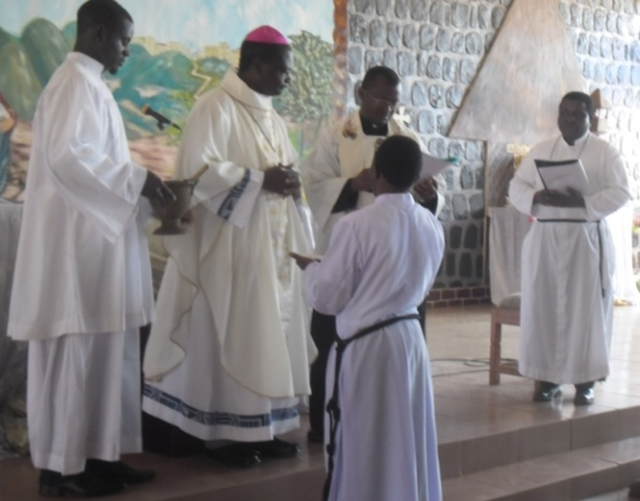

Monday December 22, 2014 marked another milestone in the annals of the history of the Marist Brothers of the schools as they all gathered together with family members, the Christian community of Tatum, priests, many religious men and women, and well wishers to witness the final profession of Brother Dinayen Brendan Ghakanyuy. They all enlivened the Saint Pius X Catholic Church Tatum where the occasion took place, presided at by the Bishop of Kumbo, His Lordship George Nkuo. In his sermon, he called on all to support Brother Brendan as he stood before the Lord to pledge his life commitment as a disciple of Christ by living the evangelical counsels. He reminded Brother Brendan of the fact that religious profession involves taking the evangelical counsels of poverty, obedience and chastity but living it is a matter of a life time. He called on him to be steadfast and courageous and to always look up to Christ in daunting and difficult moments. He ended by calling on all present to pray for Brother Brendan as he starts his missionary journey and called on Brother Brendan to always look to Mary as his model and intercessor.
In his address the superior of the Marist Brothers for the District of West Africa, Brother Francis Lukong, reiterated the fact that Brother Brendan had consecrated himself to God as a religious in the congregation of the Marist brothers and is now available to render service wherever and whenever he is needed, to embrace and love everyone as brothers and sisters in Christ and to accept the will of God through his superiors. He equally thanked the parents of Brother Brendan for giving their son to the church. He furthermore reminded the congregation that the field of evangelization of the Marist Brothers is the school and that they are called to make the young people know and love Jesus in the way of Mary. After this, pictures were taken and dancing and singing graced the occasion.

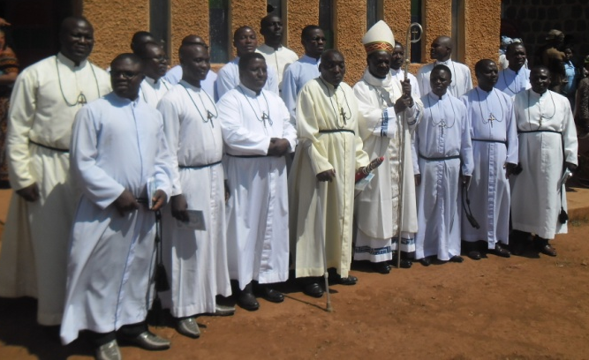
Brother Brendan and all the Brothers in Cameroon

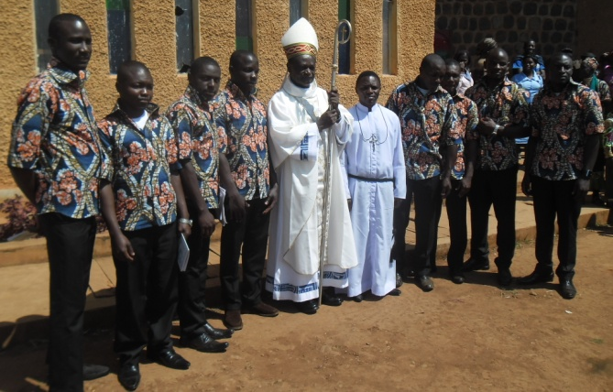
Brother Brendan and some of the postulants

--------------------------------------------------------------
Brother Sylvain Yao: the Novice Master of the Novitiate at Kumasi, Ghana

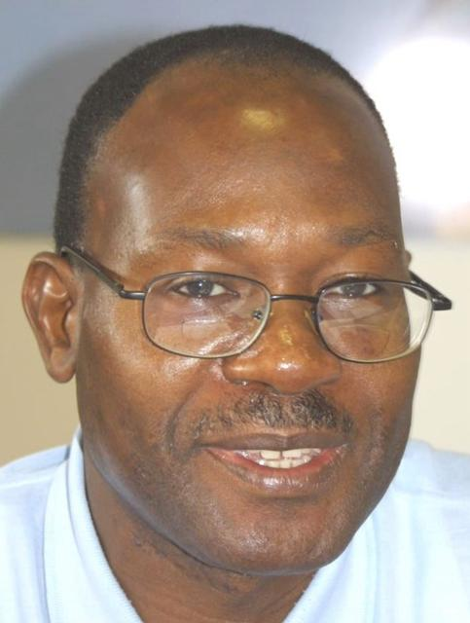

Brother Sylvain has been appointed the new Novice Master of the Novitiate at Kumasi, Ghana. He took over from Brother Mark Anokwuru during the handover ceremony which took place in the Novitiate in Kumasi on December 18, 2014 at 9.00 am after Mass in the Novitiate chapel. This happened in the presence of the Formation team, the Novices. Br. John Kusi, the representative of the District Superior in Ghana, and Br. Pascal Birkem, in his capacity as the District Secretary and District Bursar. The sent-off and welcoming ceremony in honour of Brothers Mark and Sylvain took place on December 26, 2014 in the Novitiate.

----------------------------------------------------------
THE VISIT OF THE LINK GENERAL COUNCILORS TO CAMEROON
Brothers Antonio Ramalho and Ernesto Sanchez accompanied by Brother Francis Lukong visited the Brothers in Cameroon from December 8-18, 2014. This last lap of their visit to the Marist District of West Africa took them to Mbengwi, Tatum and Bafut where the Brothers have communities and secondary schools. During their visit, they had interviews and meetings with the Brothers as well as talked to the teachers and students. They were also taken round to visit Bamenda town and the Ndu Tea Estate. Their visit was hitch-free.

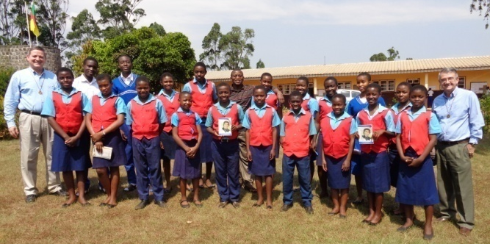
The friends of Champagnat of St. Joseph’s College, Mbengwi.

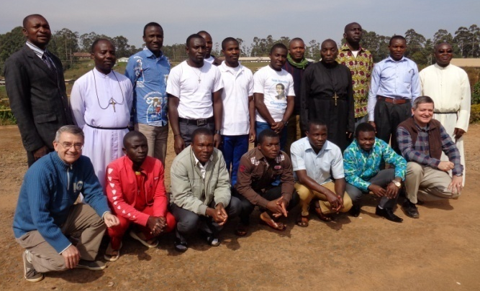
Tatum community and the postulants.

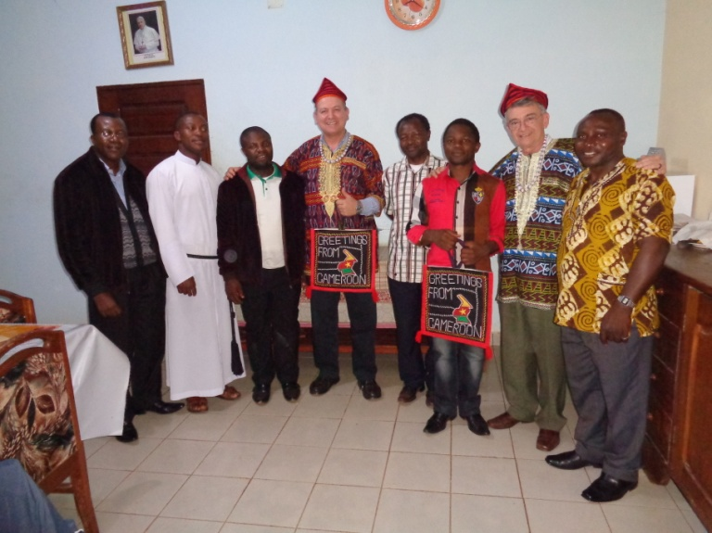
Bafut community

--------------------------------------------------------
SED AND SEMBRAR SPONSORED HOLIDAY CAMP

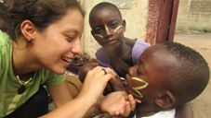
Laura painting children’s faces

About fifty children of ages ranging from two to fifteen years participated in a five-day SED and SEMBRAR sponsored Holiday Camp which took place on January 5-9, 2015 at Kuame Anum village in the outskirts of Accra in Ghana. With a variety of activities including games, singing and dancing, sports, story-telling, painting, swimming, various competitions, lessons on hygiene and environmental care, etc, the camp had as objective, according to the organizer: Laura Alejandra Miño Pérez– a Bolivian Lay Marist member of the District House community – to create “un espacio de alegría” (a space for joy) and continuous learning for the children.

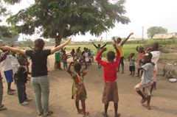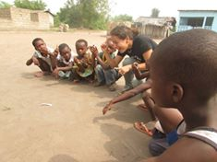
The day’s activities started with pray and singing

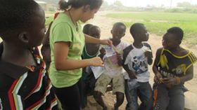
The children are resting after Clean-up Campaign

--------------------------------------------------------
BIRTHDAYS:

December, 2014
26th Tano Pokou Komenan
30th Evaristus Mbiydzenyuy

January, 2015
2nd Emmanuel T. Bongben
6th Elvis Tardzenyuy Tomla
13th Jose Luis Elias (he worked in Korhogo)
18th Cyprian Gandeebo
24th EmiliTurú, Superior General
26th Francis Amoako Attah

February, 2015
2nd Martin Nguma Mbeng
3rd Blaise Beguerem
19th BrendaneTombir Sunjo
20th Francis Verye
22nd Anthony Doe Siryeh
24th Manuel Acal (worked in Monrovia)
26th Joseph Kwame Mammah

-----------------------------------------------------------------
CALENDAR OF ACTIVITIES:
JANUARY to AUGUST, 2015

January, 2015 District House,Accra

February, 2015
9 – 12: CSAC AGM, MIC,
Nairobi, Kenya

13 – 14: Workshops, MIC, Nairobi, Kenya

15 – 18: Student Brothers, MIC, Nairobi

23 – 2 Feb: Canonical visit:
Tatum City, Cmr.

March, 2015
3 – 9: Canonical visit: Bafut City, Cmr

17 – 21: Canonical Visit: Kwadaso Cty, Gh

22 – 27: Canonical Visit: Buokrom Gh

April, 2015
13 – 15: Novitiate Board
Meeting (Kumasi)

April, 2015: District Council
(Date/Venue???)

June, 2015
7 - 12: Novitiate, Kumasi

10, First Rel. Profession
(Trede)

July, 2015
Date ???? District Council meeting

August, 2015
10 - 14: 6th District Chapter

