Marist Brothers - Irmãos Maristas
Province of Southern Africa - Província da África Austral
Province Office, Area 9/290B, Box 1077, Lilongwe, Malawi
November/Novembro 2012 Newsletter / Bolletim Informativo

From the Provincial’s Desk …

1 November 2012
Dear Brothers,
Let us continue the theme of began a few months ago: the evangelical use of goods. The story I’ve provided at the end of this letter illustrates this theme well. In the last paragraph, the point is made that when our brother is in trouble we are all in trouble. And so, too, when the poor suffer we all suffer.
Our spiritual wellness requires that we see all human life as precious. We must have respect for the dignity of all people. If we don’t, then not only will our spirituality suffer but also our morals. A deeper respect for human life leads us assign greater value to people than to material goods.
We need to learn to see reality from the perspective of those who have less. Pope Leo XIII (1878-1903) taught that once the demands of necessity have been met, the rest belongs to the poor: a statement that is both thought-provoking and a demanding challenge. This principle shows why it is good practice, when we are about to purchase something, to ask whether we need what the item or just want it. The message of Leo XIII is still relevant for the growth of our spirituality. We need to make the needs of the poor and vulnerable a priority in our lives.
Jesus said. “The Spirit of the Lord is upon me, because he has anointed me to bring the good news to the poor…..” [Luke 4:18-19]. Jesus was announcing this as a new reality in which we are to live - the kingdom of God- in which the poor are no longer to be ignored. Fr. Pedro Arrupe, former Jesuit Superior General coined the phrase “a preferential option for the poor”. This phrase for me sums up the way we brothers are called to relate to the poor.
Allow me to quote a paragraph from 7 keys to Spiritual Wellness by Joe Paprocki that resonated with me. In a section entitled Why we need the poor the author writes:
In speaking to a group of donors some years ago, Francis Cardinal George, the current Archbishop of Chicago, spoke to a group of major donors, “The poor need you to draw them out of poverty.” He then said something that took everyone by surprise: “And you need the poor to keep you out of hell!” Some people thought that he was being facetious, but anyone familiar with Francis Cardinal George knew tat he meant precisely what he said. Those wealth people who were donating large sums of money to the Church were sharing their abundance as God intended. To do otherwise would be to ignore the will of God. Hell is simply that state of being that rejects God’s will, which amounts to a rejection of God’s loving presence.
Sharing does not come easy for most of us. We are born completely self-centred. As infants we cry in order to have our needs met. As we learn to speak, one of the first words we grasp after “Mama” and “Dada” is “Mine!” As we grow our parents make their best effort to increase our vocabulary by one very important word: “Share!” As adults we have to learn that there’s plenty to go around. God’s creation is filled with everything we need, all provided by a generous and loving God who calls us to share likewise with others. Jesus’ first miracle, the changing of water into wine at the wedding feast at Cana, reinforces this notion of abundance. Six huge water jars, each capable of holding twenty to thirty gallons, are filled to the brim with finest wine. The message? For those living under God’s reign there is plenty of goodness to share.
May God enrich us in our poverty.
God bless you all,

Birthday greetings for November

13/11/32 | João Torcato 80
13/11/83 | Oswald Mkanda
13/11/82 | Asensio Njobvu
15/11/49 | Raimundo Puente Calleja
15/11/58 | Steven Finye
16/11/84 | Francis Bwalya Ndapisha
17/11/68 | Boniface Chirambo
18/11/90 | Felix Chabu
21/11/77 | Fortune Chakasara
24/11/68 | António Viana
27/11/48 | Vincent George
28/11/86 | Mark Chikandwe

Br Joe’s Calendar

NOVEMBER
1-10 | Centenary Madagascar.
12-15 | Visit Harare & Kutama
16-18 | Prov Council Zimbabwe
20-23 | Visit Dete, Zimbabwe
26-29 | Visit Nyanga, Zimbabwe
30 – 2 Dec | Via Jo’burg to Maputo
DECEMBER
3-7 | Visit Manhiça, Mozambique
8 | First profession of Novices
9 | Visit Nivava, Mozambique

Novices Picnic at Costa do Sul, Maputo
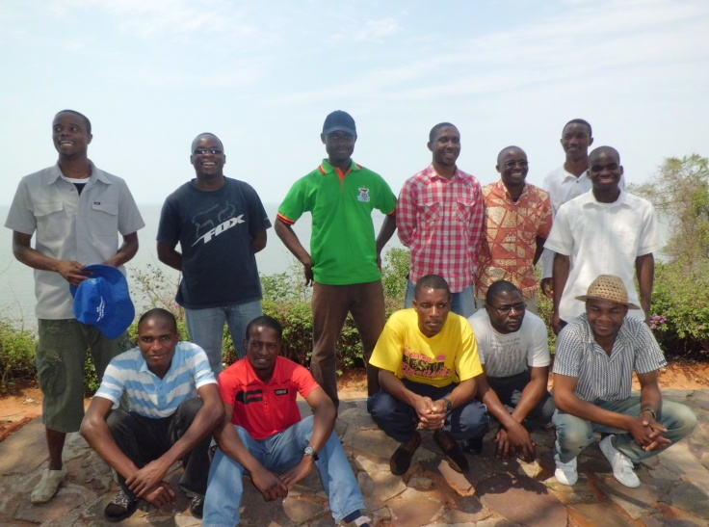A great day beside the Indian Ocean, with a visit to the museum, the “Garden of Lovers” and a long walk on the beach where we observed the Zionists in action. We learned that members are relieved of diabolic problems through being prayed over including several immersions in the sea. When the devil is very strong, vigorous beatings or massagings become the order of the day with loud prayers until the devil leaves his/her victim. This process can last all night. They say it is one way of preventing their members from visiting the traditional witch-doctor. On this occasion they were all women, the only man happening to be the Bishop.(Br Simeon Banda)
Novices in the "Garden of Lovers"

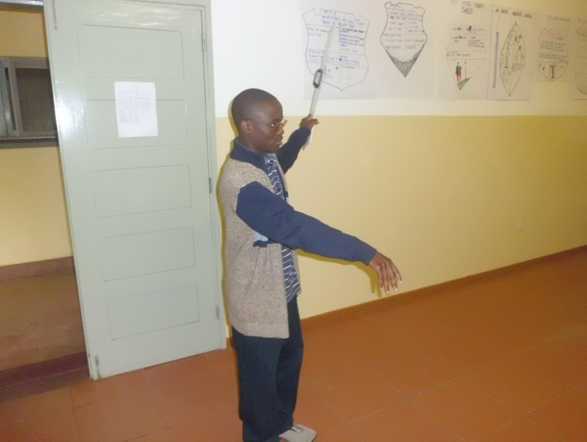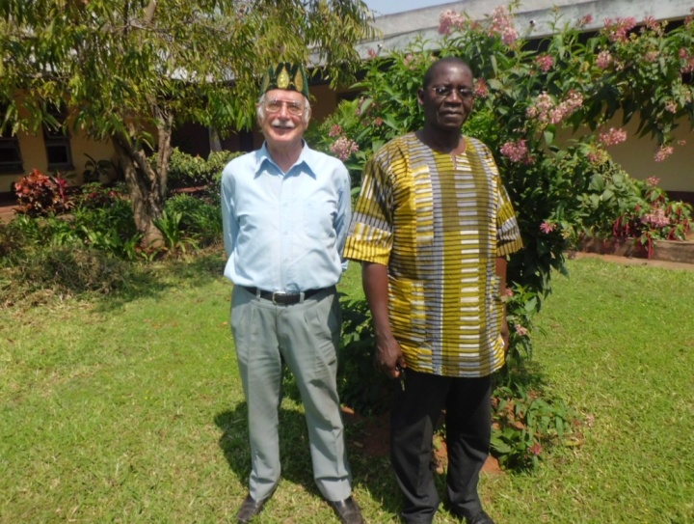
To complete the course on Teaching Skills Victor explains his logo to fellow novices
Jubilarians visit the Novitiate

MARIST YOUTH MINISTRY

Regional Meeting for Africa and Madagascar
Marist Brothers and a lay person from our continent of Africa gathered at Subiaco Centre in Nairobi from 27th August to 1st September for the Marist Youth Ministry (MYM) meeting to study how we can implement the document which was published by our Institute ‘Evangelizers in the midst of Youth’.
This was an important formative workshop which saw delegates from the Province of Nigeria, Province of Central and East Africa (PACE), Province of Southern Africa, Province of Nigeria, Province of Madagascar and the District of West Africa meeting in Nairobi. The workshop was a very enriching learning experience.
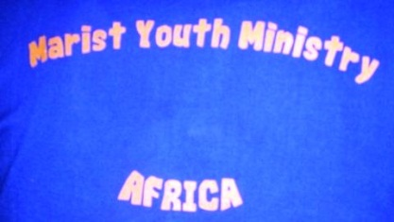
Our Province was represented by Brothers Chiza Phiri, Leonard Brito and Francisco Richardo. Brother Fortune Chakasara was one of the facilitators representing the Africa Mission Commission. We are grateful to our Province for giving us this timeless opportunity participate at this MYM Regional Meeting for Africa.
Over the years we have watched in various places a vast ridge grow rapidly between the way we work with young people throughout the Institute and the changes that are taking place in the world.
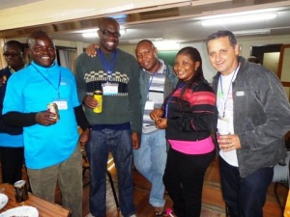While all these vast changes have taken place, very little change has happened in the way in which we work with young people in preparation for these 21st century realities. Therefore the MYM workshop was instrumental in helping us to bridge the gap that was looming in our various works with young people in our different Administrative Units.
Leonard Brito (Zim), Fortune Chakasara (Zim), Gregory Ekene (MIC), Ms Cecilia Obianuju (lay Marist Youth Minister -Nigeria), João Carlos do Prado
We would like to register our sincere appreciation to Brothers João Carlos Do Prado, Ifeanyi Mbaegbu and Fortune Chakasara who took us through the whole document explaining to us in detail how we can be effective and efficient Ministers of Youth in our Administrative Units. Our workshop would have been incomplete without the pivotal role that was played by Marist International Centre in facilitating the internal logistics of our meeting. Our gratitude goes to the Superior of MIC Bro. Lawrence Ndawala and Community for their hospitality.
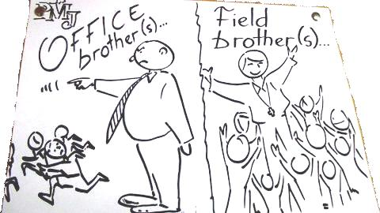
By now the document ‘Evangelizers in the midst of youth’ has been distributed to the whole Institute and for those who have already gone through it you will notice that it does not give clear cut answers and directives on how we should work with the youth. It is not an error; it was specifically designed to serve as a comprehensive guideline and a reference point for our work with young people in youth ministry in the whole Institute.
Through the different presentations from different Administrative Units in Africa we noted that we are at different levels in Youth Ministry approach. For instance in some Provinces like Nigeria they already have effective Marist Youth Ministry whilst in other Provinces they have different youth movements which are similar to MYM. Thanks to the document throughout the Marist world we will now have a unified approach in working with young people adapting the document to our different situations.
According to the document ‘Evangelizers in the midst of youth’ MYM is a privileged place for evangelization of the youth. Our founder Marcellin Champagnat used his methods of his time as he visited youth groups as a Catechist to reach them in their particular situations. It is evident he was greatly concerned about the religious, social and economic situation of the young of his time. Without doubt Champagnat was already an expert in youth ministry in his generation. Times may have change but no doubt as Marist apostles of youth this is still our concern today. We need to move in haste to meet the young people in their realities. How much are we aware of the realities of the young people in our schools?
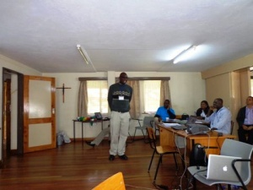
The other key elements of Marist Youth Ministry are that: it is organized with a clear structure, it is systematic, it stipulates well the importance of the Marist pedagogical dimension of presence, it encourages love of work, family spirit and it links to the vocational ministry. It takes into account of life experiences day to day life of young people and puts the human person at the centre of its interests. It has a life centered approach and structures with shared responsibilities.
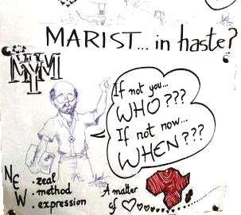
Lastly we would like to end by quoting our Superior General. In his speech to officially open the Regional MYM meeting in Nairobi, our Superior General Brother Emili Turu (via video footage) stated that this is an opportunity for us as an Institute to go in haste and meet the youth where they are. He further stated that ''If not you, WHO? And if not now, WHEN?'' Without doubt we should all feel strongly impelled to go in haste and take various initiatives in implementing Marist Youth Ministry in our Administrative Unit.
The workshop has come and gone and now we will wait to see the fruits of the workshop in our Province.
(Bro. Leonard Brito FMS)
I like a teacher who gives you something to take home to think about besides homework. Lily Tomlin

Children’s Rights Workshop at Marist Nyanga by Bro Fortune Chakasara
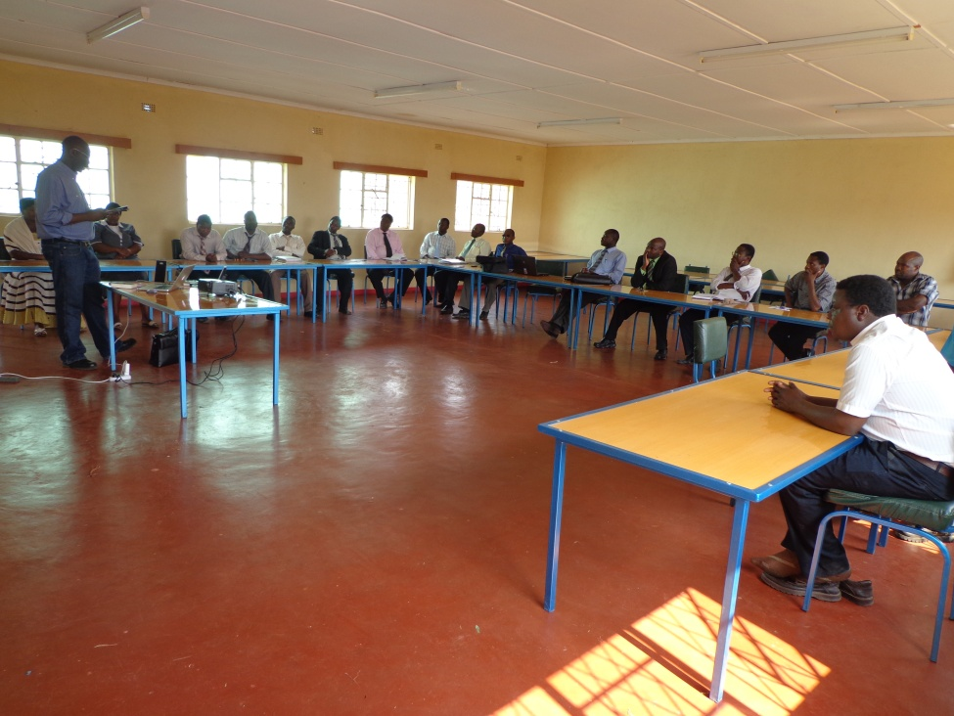
Here at Marist Nyanga we were honored by the visit of Bro Fortune Chakasara this time as the representative of FMSI (Fundazione Marista per la Solidarietà Internazionale) in the province. Apart from the joy of having to host him, he offered a workshop on CRC (Convention of the Rights of the Child) which took place on the 24th of September 2012. The whole teaching staff was more than eager to learn more on the topic as it is a hot matter in the teaching profession of late. In well animated and colorful slide shows and group discussions we had sessions that were breathtaking and thought provoking as far as child protection is concerned.
Bro Chakasara took the edge off our anxiety by explaining how the Marist Brothers have established an organization with basically deals with the rights and protection of children: FMSI. “Their office is in Geneva and they are working as a legal branch of the United Nations organization. Child rights are inevitable in the process of educating the child. It is an important responsibility we cannot turn our concerns from. It is all for the good of the child,” he explained.
To educate a child you have to love them first, it is the inspiration by Fr Champagnat in his vision for Marist education, however in the realities of the world today we have seen that it is important to protect the children even as we try to educate them. We have to do something to protect the children we look after and also protect ourselves in this noble profession.
We had ample time to discuss the document CRC and try to apply it to our situation in the school. In our efforts to apply discipline and order in the school, now we are challenged to always consider if really the course of action we are to take is for the benefit of the child for they too have rights and we are now well acquainted on the matter. Marist Schools should lead in respecting the rights of the Child and fostering a conducive environment for all round development of the children.
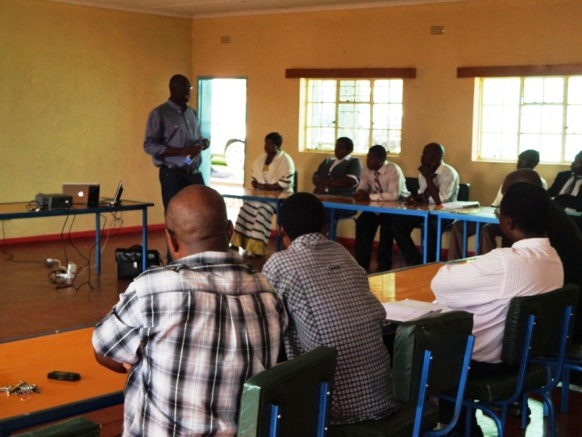
The Brothers and the teachers gave extensive feedback from their experiences in the profession and admitted that the workshop was a great step forward as here and there students were already ahead on the matter (some NGO’s have done some good work on awareness programs for the students) making disciplinary measures a tough affair in the campus. Many of our questions and doubts were cleared and by the end of the day, we were all smiles as we continued chewing over the implications of CRC as we walked home.
Many thanks to Bro Fortune for his expertise and availability; we are now a step ahead at Nyanga! (Br Tererai Gijima)

Something to think about

The Little Mouse
A little mouse living on a farm was looking through a crack in the wall one day and saw the farmer and his wife open a package. The mouse was intrigued by what food the package contained. He was aghast to discover that it was a mouse trap.
The mouse ran to the farmyard warning everyone “There is a mouse trap in the house.”
The chicken raised its head and said “Mr Mouse, I can tell you this trap is a grave concern to you, but it has no consequence to me and I cannot be bothered with it.”
The mouse turned to the pig, “I am so very sorry, Mr Mouse, but the trap is no concern of mine either.”
The mouse then turned to the bull. “Sounds like you have a problem, Mr Mouse,” the bull said, ”but not one that concerns me.”
The mouse returned to the house, head down and dejected that no one would help him or was concerned about his dilemma. He knew he had to face the trap on his own.
That night the sound of the trap catching its prey was heard throughout the house. The farmer’s wife rushed to see what was the caught. In the darkness she could not see that it was a venomous snake who’s tail the trap had caught. The snake bit the farmer’s wife.
The wife developed a bad fever and the farmer knew the best way to treat a fever was with chicken soup. He took his hatchet to the farmyard to get the soup’s main ingredient. The wife got sicker and friends and neighbours came to take turns sitting with her round the clock. The farmer knew he had to feed them, so he butchered the pig.
The farmer’s wife did not get better, however. In fact she died, and so many friends and family came to the funeral that the farmer had to slaughter the bull to feed all of them.
So – the next time you hear that one of your brothers is facing a problem and think it does not concern or affect you, remember that when anyone of your brothers is in trouble, we are all at risk.

