THE RELIGIOUS BROTHER
One way to live out the brotherhood of Jesus

Br José M. Ferre, Marist Brother
hermanoferre@gmail.com

Published in SAL TERRAE, 103 (2015) 805-818.- Reproduction permitted
Translated from the original Spanish

Abstract
This article presents the reality of the religious Brotherhood as a complete vocation within a Church as a communion of believers and in which the Spirit gives rise to specific charisms. In the heart of this vocation is the call of Jesus to fraternity, to live together. This call finds expression in both mystical and prophetic dimensions of the community of religious Brothers. Given that this vocation has not always been understood, the article offers explanations, challenges to overcome and evangelic icons which clarify it. The article concludes by presenting the wealth and possibility which surrounds the vocation of the religious Brotherhood.

Keywords
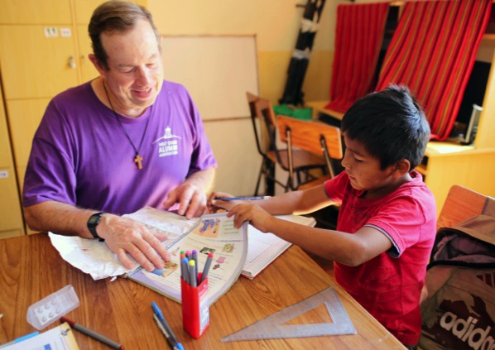
Vocation, Community, Charism, Mystic, Prophecy

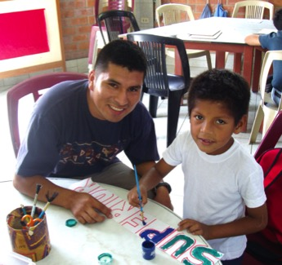
A few months ago, I took part in a meeting organised by the Conference of Religious of Italy as part of the events for the Year of Consecrated Life. During the event, one of the speakers announced the imminent release of "The Identity and Mission of a religious Brother in the Church", a document prepared by the Congregation for Institutes of Consecrated Life and Societies of Apostolic Life. In his description, he referred to Brothers as a "non-priest religious".
What I found odd is that he defined the Brothers by what they are not: "non-priest religious" Such a description shows a lack of understanding of our identity. It is the responsibility of all the Brothers in the Church to express our vocation and identity in positive terms.
In the following lines, I wish to express a few ideas on the vocation of 'Brother': put it in context; clarify certain aspects; and show the richness contained in this particular gift of the Spirit to the Church

What is a religious-Brother? What do people say?
Asking the question in this way, we get different responses from Catholics. Most think of the 'Brother' as a hybrid species difficult to classify; “they are men of the Church without being priests”; “they are unmarried lay people”. Many, simplistically, consider that in the Church there are only two types of people who live a “consecrated life”: Priests and Nuns. As the Brother does not fall within these two categories, they try to define him vaguely: "A 'Brother' is like a priest who does not celebrate Mass"; or, "A ‘Brother’ is like a nun, but he’s not a female!"
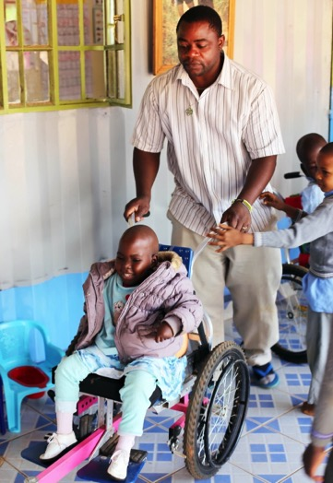
The answers given by those who know and have contact with us usually contain the idea of doing. They see them as people who teach in class, who are present among youth, who are attentive to the sick, who co-ordinate catechesis, do social work or other apostolic work, collaborate in the thousand and one material details of mission, or who are a discreet presence in the silence of a monastery.
True, that is actually part of what a Brother does; but it is an external and superficial vision. The Brother does things, for sure, and many see this as very positive; they are considered good professionals and very hard workers. But this is nothing extraordinary: it is so for many people in diverse fields. For deepening the identity of Brother further, we should rather ask how and why they do so. In other words, deepening the very being of a Brother. A Brother is much more than a cheap labourer in the Church.
Finally, I think of the small group of people who know the Brothers more closely: people who have had the opportunity to be among the Brothers often, to live with them; people who were thus able to grasp the essential elements of their lives and their identity
When the Brothers live together, share, collaborate with the laity and priests, it creates an osmosis in which each group finds and consolidates its own identity, and they come to realise that what they are is more important than what they do. Firstly, what is in the heart of the Brother is valued and gives meaning to his life: his consecration, his spirituality, his community, his sense of mission, his specific charism. On the other hand, a Brother rediscovers and recognises the vocation of the laity and of the priest in the Church. These relationships are based on communion.

To understand the Brother, we must first understand the Church
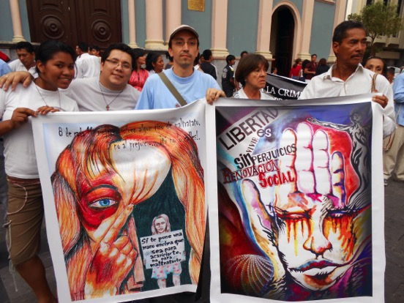
Fifty years after the completion of Vatican II, we are still in the process of assimilating the full meaning of looking at the Church as the People of God, and coming to terms with what this vision entails. In the idea of Church as People of God, we speak of a great community of believers, people consecrated by the same baptism, anointed by the same Spirit, called by the Father to follow Jesus. All live their faith, celebrate it, and give evidence of it in community. This is basic and fundamental. The logical consequence is that all of us have the same dignity, a dignity that was conferred at baptism. Together we form a people of prophets, of priests and of servants. All are brothers and sisters. This is the essential vocation of every Christian. Problems or conflicts arise when one focuses on other aspects [of the Church] that are secondary and that are the consequence of this primary vocation.
In this great community of believers, the Spirit arouses a variety of “charisms”. Charisms are gifts, gifts made for the growth of the Church. Suffice it to remember the rich Pauline theology on this score: Paul speaks of the Church as a single body that has many members and various functions, but everything is for the general good. The different vocations in the Church are all beautiful and complementary in their diversity.

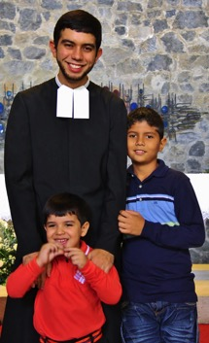
There are lay people, that is to say people aware of their vocation as baptised, who feel moved by the Spirit to transform this world, to make it more just and humane, following in the footsteps of Jesus Christ.
There are priests, that is to say ministers ordained for the service of the Church. They summon, call and lead the people of God. They are called to be a sign of the love and mercy of the Good Shepherd.

And there are also the consecrated…
In this vision of the Church as communion, there is another group of men and women who, from the early centuries of Christianity, are called by the Spirit to live their baptismal consecration in a specific way: by being a “memorial” of Jesus obedient, chaste and poor, and by identifying with him. These are called religious or consecrated persons.
This lifestyle, mainly secular from the beginning, has taken shape and changed throughout history in the Orders, the Congregations, the Religious Institutes where men and women have answered the call to live their consecration in community.
These men and women, consecrated for the mission of Jesus, wish to be signs that remind all the people of God of the essentials in Christian living: the primacy of God and the life style of Jesus, uniquely our Teacher. They want to be living reminders of Jesus' brotherhood.
In this sense, there is no need to ask which is better or worse or what vocation is most holy. How many times have we not heard those simple expressions like "You, who are close to God ..." "Ask God therefore, because you, he listens to you more than us ..." There are no higher or lower vocations. To understand the religious Brother’s vocation or any other vocation in the Church, it must be placed in a global context. The call to holiness is for all; baptismal consecration belongs to everyone; sharing Jesus' mission is for us all. What changes is the way of responding and of living the vocation to which each person is called.

Living the brotherhood of Jesus
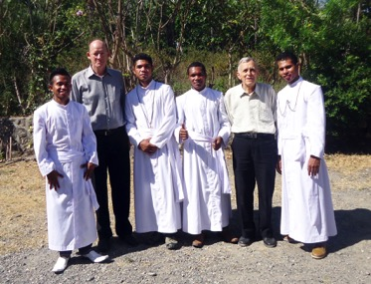
“The one who makes people holy and the people who are being made holy all come from one source. That is why Jesus isn’t ashamed to call them brothers" (Heb 2:11).
Fraternity is not something that is imposed; it is born of a relationship. Since the cry of Liberty, Equality, Fraternity, the great modern revolutions intended to create a brotherhood in which, unfortunately, the figure of the "father" is absent.
Jesus did not seek servants or students. He called some to be with him and to be sent, (Mark 3:13, 14) and so, under the gaze of the "Abba," the "Father," they became like brothers. For Jesus, the Kingdom is not a matter of power, as claimed by kings, nor a matter of doctrine, as the scribes would want, but the fruit of fraternal love.
Jesus' brotherhood is not based on blood ties or on common interests; it is not born of membership of the same race, with the same language and a common culture; it is not based on affinities of character or similarity of work. The sole basis is the common Father who loves us all, who does not make differences and who, if he shows some preference, it is for the poorest and the least.
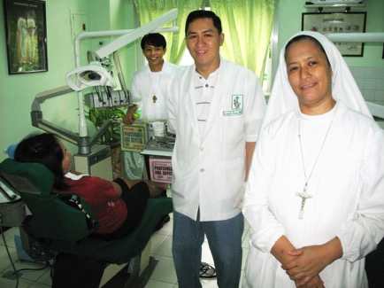
It is interesting to see how in the Gospels we gradually become aware of Jesus as Brother. The apostles, who felt themselves to be disciples of Jesus as Master, listen to the Master at the last supper telling them that he does not call them servants but friends. And the risen Jesus speaks of them by using the word brother when he told Mary Magdalene: Go and tell my brothers that I am going to my Father and your Father (John 20:17).
The Acts of the Apostles reveal the beginnings of the community, with its ups and downs, living out the brotherhood of Jesus.
The call to live the brotherhood of Jesus is the very essence of the vocation of the religious Brother. It is a call to all people of God, but the Brother assumes it as a specific objective, he lives it and wants to be a living memory of this fraternity. It's a gift received. We can deepen this by analysing some aspects of the life of a Brother, aspects that are both complementary and interrelated.

The mystical dimension of the community of Brothers
"Seek my face." And my heart has said:
"Your face, Lord, I seek" (Psalm 27:8).
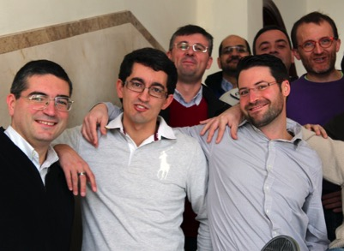
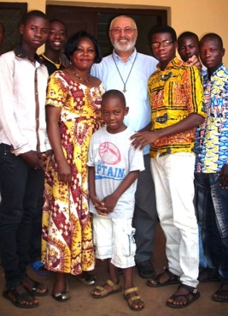
Sensing oneself as a Brother and being brother of Jesus is not the result of a simple logical reasoning. It is a gift that is welcomed in faith and which is lived and passed on. The religious Brother expresses the reception of this gift by religious consecration, a consecration expressed in three vows: Chastity, as fruit of the personal love of God, which grows into universal love and life in fraternity; Poverty, which makes one available for service, especially of the poor; and Obedience, which is the discernment and communitarian search for the will of the Father.
This lifestyle requires from the Brother a spirituality that is rooted in the Triune God and which has aspects common to all the People of God, a spirituality that is cultivated day by day in moments of personal encounter with Jesus, his elder brother, listening to the Father and attuning his ear to the whisperings of the Spirit; a spirituality that is shared with the community, which is nourished by the Word, by the liturgy and the sacraments.
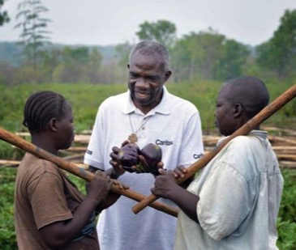
But if anything stands out in the religious Brother’s spirituality, it is perhaps its inclusiveness, and unifying character. While being a consecrated layperson, the Brother tries to overcome in his own life the dichotomy between the sacred and the profane and to discover traces of a God whose presence is not limited to specific times and spaces.
For the religious-Brother, the world is a place of encounter with God, a place of mission and of sanctification; he discovers and experiences God in temporal realities proper to his own ministry. This is the mysticism of the religious-brother, also called incarnational or apostolic spirituality. It makes Brothers contemplatives in action, monks-in-town, people who are not content with superficial readings of reality but with eyes, as it were, transplanted from God, see the way to go, and with sensitised ears, listen to the voice of the Spirit .
By listening and meditating on the Word of God, personally and in community, the Brothers are ready to interpret the signs of the times and discern the sacramental sense of reality.
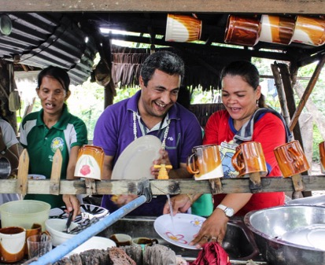
The community is the key to the spirituality of the religious -brother. The community is a theological reality, a space where the experience of God can reach its fullness and be transmitted to others. This impels the Brother to a prayer open to the reality of history and to be the echo of a life of solidarity; a prayer that brings together the sorrows and joys of the people that God puts in his way. For the religious-Brother, his brothers in community, the people he meets, especially the poorest, become day by day living sacraments of God and summons of the Spirit.

The prophetic dimension of the Brothers' community
"If only all the Lord's people were prophets,
and the Lord had given them his spirit" (Numbers 11:29).

Throughout the history of salvation, God continues to raise prophets in the midst of his people. These are people that he chooses freely and that he sends with a specific mission; some of those chosen resist the call to transmit the message. Aware of their own fragility and limitations, they realise that their lives may be in conflict with what they announce and denounce. But in reality, these are people who are seduced by the Lord, aware that the strength does not come from them but from God. It is in this group, that of prophets, that we can place the mission of the religious-Brother as an individual and as a member of a community. By living out his consecration as a religious, the Brother prophetically proclaims fraternity in the society and in the Church.
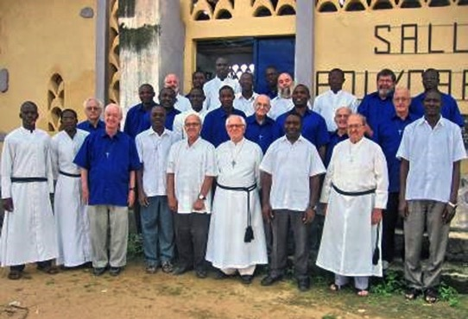
Independently of the actual duties that the religious brother must develop in the professional field, each community is called to be a prophetic sign proclaiming by its own way of living, and, if necessary, in words, that before God, we are all brothers and sisters, loved personally by Him.
Open to welcoming and serving people, beyond gender, nationality, religion or culture, the Brothers proclaim the value of every person and denounce all forms of discrimination: ethnic, religious, gender or social background.

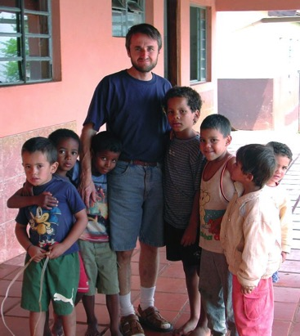
By living close to the poor and marginalised, close to those who have no voice, who do not count in society, religious announce Gospel values ​​and denounce the manipulation, intolerance, exclusion, lack of respect and anything opposed to human rights and the plan of God.
The Brothers renounce all forms of dominating power, the source of much injustice and abuse, the generator of corruption and excessive desire for wealth, and destroyer of all creation. By so doing, the community of brothers proclaims the simplicity of the Gospel and denounces all forms of violence and oppression against persons, because we are all children of the same God. At the same time the Brother also denounces everything that pollutes and damages the world, our common home.
By forming international communities, that are intercultural and interracial, the brothers proclaim that fraternity is possible among all people, even of different generations … and that it is possible to be not only brothers, but also joint builders of the Kingdom.
By not participating in the hierarchical structure of the Church, while feeling profoundly members of the Church, the religious-Brother turns into what JB Metz called the dangerous and subversive memory for a Church still in search of renewed fidelity. He thus announces a new way of being Church, more fraternal, more participatory; a Church as communion, that exhibits not only the face of Peter but also the traits of Mary; and with her, mother and prototype of the Church, he completes the unfinished prophecy of the Magnificat.

Chiaroscuro – Lights and shadows in the vocation of the Brother
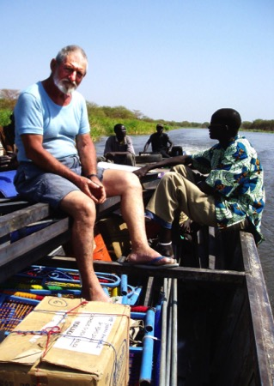
Specific elements.
There are a series of elements that stand out in the identity of the religious-Brother:
- As a person, he shares the joys and sorrows of the human condition and feels immersed in a concrete social context, in which he can develop and share his potential and put it at the service of the common good.
- As a Christian, he feels himself to be in communion with the all the people of God, rooted in the grace of baptism, committed to following Christ and sent on mission.
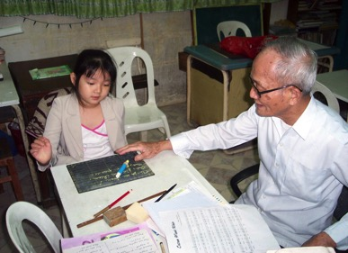
- As a consecrated person, he publicly professes his commitment to belong totally to the Lord by the evangelical counsels of chastity, poverty and obedience, living in community and feeding himself on a spirituality that harmonises and unifies his life.
- As people who are sent on mission, their services have much in common with those of the lay faithful. The Brother, however, accomplishes these services from his identity as consecrated in a religious family. Some of these services can be considered ecclesial ministries.
As members of the Christian people, religious Brothers benefit from the testimony and the assistance of people in other vocations, and at the same time bring their specific gift to the Christian community: the call to live out the brotherhood of Jesus in the Church.
“Religious Brothers are an effective reminder to Religious Priests themselves of the fundamental dimension of brotherhood in Christ, to be lived among themselves and with every man and woman, and they proclaim to all the Lord's words: "And you are all brothers” (Vita Consecrata, No. 60).
The same document (Vita Consecrata) includes a beautiful description of what the brother has received as a gift and offers to the whole Church
“These Religious are called to be brothers of Christ, deeply united with him, the firstborn among many brothers' (Rom 8:29); brothers to one another, in mutual love and working together in the Church in the same service of what is good; brothers to everyone, in their witness to Christ's love for all, especially the lowliest, the neediest; brothers for a greater brotherhood in the Church”. (VC 60)
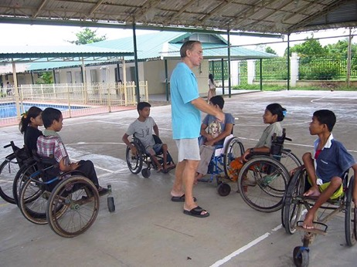
Possible confusions
The consecration of laypersons, both men and women, is a complete vocation in itself (cf. Perfectae Caritatis, 10). The consecration of the lay-brother has, therefore, a value in itself, independent of the sacred ministry, both for the individual person as well as for the Church. This point is quite clear in the case of consecrated women, since in the Catholic Church, the sacrament of ordination is restricted to men only.
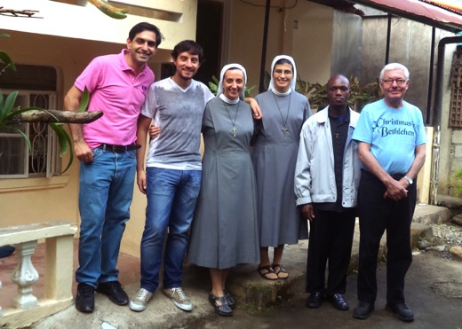
Confusions arise when, throughout history and for various reasons, some of these consecrated laity are ordained priests. There is no conflict between the vocation of the brother-religious and priestly vocation. The problem begins when we consider the priesthood as a vocation superior to others. This way of thinking has created a respectful distance between the priest and the Christian people. Another consequence is that the vocation of the religious-brother became undervalued and was considered incomplete. When I was young, people from my family and friends used to say: When will you be ordained? Even now, from time to time long-standing friends and acquaintances who I am close to lament, What a pity you haven’t been ordained! The underlying idea is that the religious-Brother has only gone half-way.
Many religious orders were born as groups of religious-Brothers. The very name "Fray" (Brother) that in some places is still in use is a derivative of frater (brother). Francis of Assisi did not want to be ordained a priest; the brother to all felt himself called to live and to witness to the brotherhood of Jesus. But when such congregations (or orders) opt to ordain some of their members, then internal differences begin to surface.
Later, congregations called “clerical” arose in the church: essentially, they were meant to be congregations of priests. However, the majority of these congregations/institutes continued to include some religious-Brothers whose vocation and identity remained in the background. The life of brotherhood in Christ, however, invites such institutes to establish relations of equality between religious-priests and religious-Brothers, with no differences other than those which come strictly from the exercise of their different ministries. In the same spirit of brotherhood, religious-Brothers should also participate fully in the services of animation and of government.
In the Church there are also Congregations of mixed composition, in which priests and brothers live and work together for the common mission. In more recent centuries, the Spirit has given rise to a number of Institutes comprising Brothers only. Such congregations help the Church as a whole to recover all the strength and meaning of this vocation in the Church.

The challenges of brotherhood
"We hold this treasure in pots of earthenware." (2 Cor. 4 - 7)
The brothers carry the richness of their vocation in fragile earthen vessels. To live out and to give witness to Jesus’ brotherhood is a challenge that requires ongoing conversion. They are exposed to internal and external forces that can stifle the call. I mention a few of them:
- The temptation of secularisation. Our nature as lay persons and the preparation for ministry of a professional type can lead brothers to relegate their religious consecration to second place. When we regard ourselves as just one professional among others and look upon our consecration as secondary, our identity as Brothers is at risk.
- The temptation of clericalism. Our vocation is not always understood and valued. The priest, however, always has social status. The religious-Brother who does not come to understand his vocation as complete in itself, may be tempted to self-fulfilment by becoming a priest or by performing similar functions,
- The temptation of professionalism. Religious brothers do not only have a religious and theological formation, they are also prepared for the professions in which they exercise their ministry. Some may find prestige and security in this area, but putting too much emphasis on this aspect, they may begin questioning the value of their consecration.
- The temptation of individualism, so common in society, can also affect us. Religious-Brothers form a community of consecrated persons practising their ministry in common. When individualism stifles this fundamental aspect, the mystical and prophetic aspects enter into crisis.

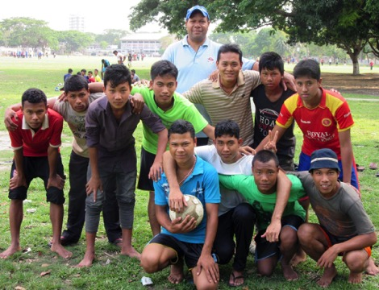
The icons of brotherhood
Faced with these temptations, the great evangelical icons remain alive; they give life and meaning to the life of the religious-Brother:
- Jesus, having put on his apron is ready for service (Jn 13:4).
- Jesus, who has pity on the crowd, challenges his disciples: Give them something to eat yourselves (Mark 6:37).
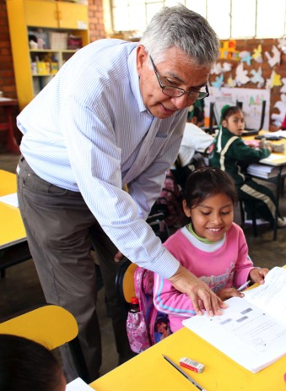
- Jesus identifies with the least and the most needy: Whatever you do to one of my brothers … (Mt 25:40).
- Jesus in the house of Martha and Mary, invites us to incorporate into our lives our many daily chores and to do the one thing necessary (Luke 10:41).
- Jesus who meets the Samaritan woman, helps her discover the best in herself and turns her into a messenger (John 4: 15-17).
- Jesus who reveals himself in the parable of the Good Samaritan (Luke 10: 41-42).
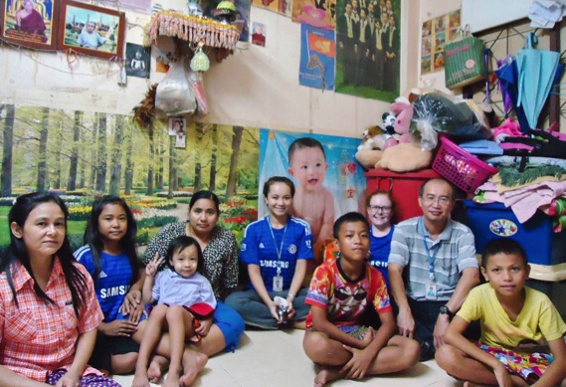
And above all, for religious-Brothers, there is the inspiring icon of Mary. She is the lay woman who receives the Word, meditates on it, makes it a reality in her life and passes it on to us. The woman who gives us Jesus and knows how to stay discreetly in the background, and leaving her Son in the limelight, A woman of attentive and effective presence, when need arises. The mystic, open and available to God and at the same time, the prophet by her proximity to the joys and sorrows of the people. Mary who, without belonging to the hierarchical structure of the Church, is present in the apostolic community on the day of Pentecost when the Church was born.

Conclusion: Religious-Brothers: a vocation full of wealth and opportunity
"The kingdom of heaven is like a hidden treasure…
like a precious pearl ... that someone finds." (Matthew 13, 44-46)
Being Brother is not just a simple title; it is a complete programme of life in itself, capable of giving the fullness and meaning to those who receive this call and offer to the whole Church the richness that this vocation encloses:
- Being a Brother, is an evangelical way of life reflecting the good news of brotherhood in Jesus as a basic and constitutive element of the Church
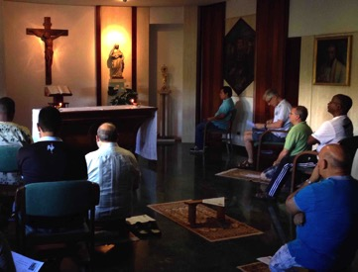
- Being a Brother is to combine mysticism and prophecy; to live out our belonging to God through consecration, and from this experience, to be available to reach out to new frontiers. It is to be open to welcome the diversity and to feel challenged to go beyond our little worlds, by letting ourselves be evangelised by others, without being limited by nationality, religion or culture
- Being a Brother, it is to grow in community, to live with other Brothers in simple relationships, sharing life and faith, with mutual forgiveness, and daily discernment in seeking the will of God in the world. From the richness of their secular condition, they offer themselves as a guide in the search for God, ready to accompany their contemporaries in their journey of faith.
- Being a Brother, is to live every day as a parable of simplicity, of equality, of fraternity; it is to offer an oasis, a haven in a world of division and competition.
- Being a Brother, is to be a welcoming and close presence to those who need someone to listen to them and to help them make sense of their lives, especially among the socially excluded. And to transmit a message of mercy, joy and hope.
- Being a Brother, is building bridges towards the laity, by a simple style of language, by a life of simplicity and hospitality, in our meetings and joint projects. Our communities can be platforms for dialogue and shared faith where Brothers and lay people enrich each other.
- Being a Brother, with theological and professional training in various fields, allows us to enter into the dialogue between culture and faith. Our communities and apostolic works are privileged places of evangelisation, where we can share our search for God, and our experience of God, and the longings of the human heart.
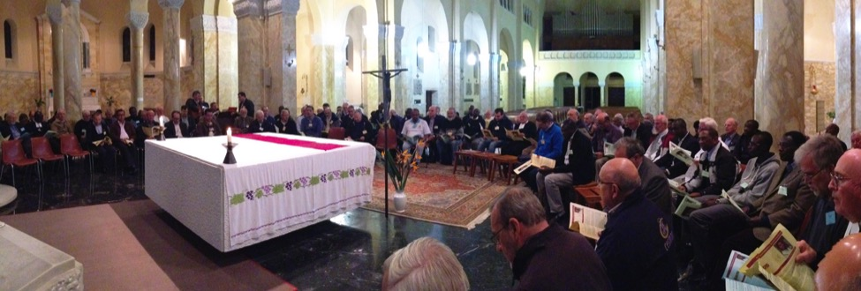
- Finally, in communion with all the vocations which the Spirit awakens, the Brother seeks to be a living reminder, a permanent memorial to the basic dimension of our faith: be a community of believers who want to live and bear witness to the brotherhood of Jesus. You are all brothers (Matthew 23:8).

