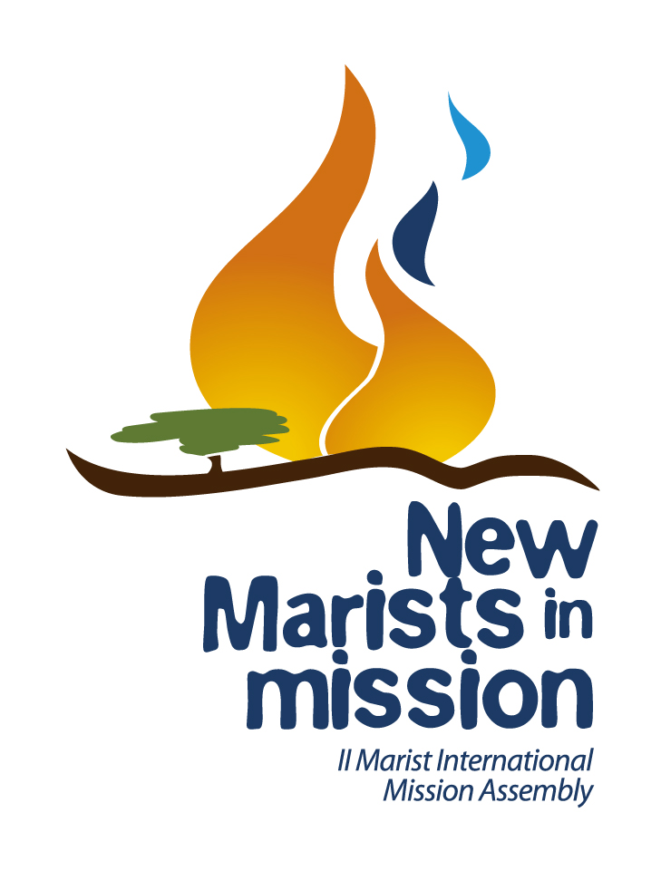
VOICES OF THE FIRE
Message from the II Marist International Mission Assembly
Nairobi, September 16-27, 2014

PREAMBLE
Around 150 thousand years ago in this African land, through the action of God, the first humans came into being; in the course of history, they grew and multiplied, moved out and reached new lands. They journeyed through valleys, deserts, mountains and oceans. A diversified humankind slowly emerged and came to inhabit all regions of the planet.
The Creator Spirit decided, 150 thousand years later, that some of them would return to this African land for a new beginning, and summoned us, the Marists of Marcellin Champagnat, to celebrate the II Marist International Mission Assembly in Nairobi, Kenya. The Spirit brought us together in the diversity of our vocations (lay men and women, sisters and brothers), languages, nationalities and cultures, ages and background. With joy and hope, we have witnessed the youth and vitality of those who embody the Marist charism in Africa. We were inspired and encouraged by their desire to respond meaningfully to the challenges expressed in the faces of the children of this beautiful and welcoming continent. To be able to celebrate the Assembly on African soil has been particularly significant, especially now that the continent is undergoing such a hard crisis, and invites us to shape our life and mission starting from a new point of departure.
We have experienced the centrality of Jesus Christ in our lives, and have felt how he is sending us out as missionaries and evangelisers. We have welcomed Mary’s invitation: “Do whatever he tells you” (Jn 2:5). Walking with her, we have heeded God calling us in the depth of our hearts with an invitation to respond as she did, to proclaim wholeheartedly the prophetic words of her Magnificat. As Mary, we want to develop a disposition of openness to the new situations emerging in our ever-evolving world.
Like a new Pentecost, the Spirit set our hearts on fire, and prompted us to dream of new horizons of greater vitality for the Marist charism, prompting us to dance to the rhythm of drums, and directing our steps towards the Montagne of our day. In a context of paradigm-shift and global change, we have strongly felt the need to have a new perspective, to see through the eyes of poor children, and with the tenderness and mercy of God. The Spirit has also sparked an attitude of deep communion among us, reflected in two African proverbs: “If you want to go fast, walk alone; if you want to go far, walk together”. “I am because we are” (UBUNTU). The closeness that came to us in the messages and prayers of so many people from our places of origin, who walked with us during these days, affirmed that this spirit of communion was across the Marist world.
In communion with our local Churches and the universal Church, the words of Pope Francis resonated in our hearts in a special way during the Assembly: “Each Christian and every community must discern the path that the Lord points out, but all of us are asked to obey his call to move out from our own comfort zones in order to reach all the peripheries in need of the light of the Gospel” (EG 20). “I hope that all communities will devote the necessary effort to advance along the path of a pastoral and missionary conversion which cannot leave things as they presently are. Throughout the world, let us be permanently in a state of mission” (EG 25).
On the threshold of the bicentenary Marist Institute, we have started to write a new story together, one in which our being prophets and mystics in a spirit of communion will become the characteristics by which we recognise ourselves as Marists of St Marcellin Champagnat, and so also we are recognised by others. Following on from the I Marist International Mission Assembly in Mendes (Brazil), we were called to be New Marists in Mission, and so we have explored new expressions of the Marist charism that beckon from the horizon of our third century.

DREAMS
Our dream is that people will recognise that we Marists of Champagnat are MYSTICS because:
- we are Spirit-filled evangelisers who have been transfigured by God;
- we are prayerful people gathering in prayerful communities, revealing God’s face as we grow in humanness;
- we set aside quality time and space to deepen our sense of who we are, so as to give meaning to what we do;
- we accompany people in their inner lives, in their spirituality and in their prayer, and involve ourselves in processes that foster this;
- we make visible the Marian face of the Church.
Our dream is that people will recognise that we Marists of Champagnat are PROPHETS because:
- we have moved out of our comfort zones, and are ready to go to the peripheries of our world, impelled to proclaim and build the reign of God;
- we are purposefully reaching out to the Montagne of our day, to be a significant presence among and with them;
- we give public voice to the promotion and defence of the rights of children and young people, in the social and political forums where decisions are considered and taken;
- we have a global missionary mindset, seeking new ways of being present on the periphery, both nationally and internationally;
- with courage and determination, we are opting for our educational works (schools, universities, social centres, etc.) to be platforms of evangelisation, and to promote an education that is inclusive, committed, compassionate, and transformative;
- we are accompanying people in Marist Youth Ministry programmes to ensure that they and their programmes are forming prophets and evangelisers for our time.
Our dream is that people will recognise that we Marists of Champagnat are men and women who live in COMMUNION because:
- we have responded to the call from Jesus to live the Gospel in the manner of Mary;
- we are a charismatic family with new and diverse expressions of community;
- we are implementing processes and structures to accompany our different ways of responding to this call to be Marist, leading to new ways of associating and belonging within the Marist charism;
- we are creating new structures that promote genuine participation and co-responsibility in decision-making;
- there are international, intercultural, and intercongregational community networks in place, marked by a missionary and responsive spirit.

CHALLENGES
To ensure our continued relevance in the decades ahead, we name the some challenges and pose some key questions to which we invite you to respond at local, provincial, regional, and international levels:
- To generate strategies that promote and accompany the vocational journeys of all Marists, personally and communally:
How do we envision the Marist vocation? What forms and styles of community express vitality in these calls to be Marist? What new elements should we include in our Marist communities in order to achieve greater vitality? What kind of accompaniment processes would be necessary? How can we enhance a spirit of communion among us?
- To cultivate the contemplative and inner dimensions of our lives for sustaining and nourishing both life and mission:
What kind of relationship are we living with the God revealed by Jesus of Nazareth? How are we revealing God to others at personal, community and institutional levels? Which traits of Mary are we called to embody today? How can we become Spirit-filled evangelisers? What paths must we follow in order to deepen our contemplative and inner lives? How can we develop an environmentally-aware spirituality that is connected to the Earth?
- To imagine new structures that will be required for enhancing vitality in the Marist charism:
What should we change in order to give birth to a new beginning? What strategies, processes or structures could promote relationships based on communion? What kind of structures do we need in order to accompany Marist life and mission and ensure greater closeness to children and young people? What would be the structural implications of functioning as an International Institute? How can we develop structures that foster continuing missionary availability?
- To overcome any fears and resistances for moving to the peripheries and promoting the rights of children and young people:
How could we go in haste to the peripheries of poverty and exclusion to be with the young Montagne of today? How could we help people to understand that getting to know Jesus Christ and his Gospel is a right for children and young people? How could our educational works be spaces that guarantee the rights of children and young people? What plans and projects should be our priority in order to engage in social transformation? How could we defend the rights of children in social and political forums?
- To promote “inter” processes (international - intercultural - intercongregational - interecclesial), which can strengthen the Marist mission in new lands.
How could we foster ongoing missionary availability? What could we do to envision diversity as an opportunity to grow? How could we enrich each other at all these levels? What networks could we organize to be at the service of these “inter” processes?
OPPORTUNITIES
With hope and joy, we have also identified the following as opportunities that will allow us to generate greater vitality for the Marist charism and mission:
- the thousands of children and young people for whom we are caring of as part of our mission;
- all the people already involved in Marist life and mission;
- the relevance and attractiveness of our Marist charism, which is an expression of ecclesial life for our time;
- the processes that accompany and develop new Marist vocations;
- the new forms of expression of the charism of St Marcellin Champagnat, especially among the lay Marists;
- the thirst for spirituality, and the search for meaning that is present in our world;
- the perspective that women bring to the Marist charism, integrating into our lives the Marian attitudes of tenacity, maternal tenderness, sensitivity towards those who are “the smallest”, attention to detail, and intuition;
- the strength and sensitivity of young people in our Marist Youth Ministry programmes, showing us potential for change and the face of the evangelisers of the future;
- the capacity of our works and Marist schools in the five continents with all their history and accumulated experience – the significance and relevance of the Marist educational and evangelising tradition;
- the commitment of many Marists who are already working with children and young people in situations of vulnerability and exclusion;
- the support and resources already in place at local, provincial, and international levels;
- the agencies and networks of solidarity and volunteering within the Institute that are responding to the Montagne of today, who are the reason for our mission;
- new technologies and social networks.

CONCLUSION
With a deep sense of gratitude, we thank God for granting us this experience of encounter and communion during the II Marist International Mission Assembly. Mary has been a companion along the way and has guided our steps. As we move forward, we hope our lives and witness will be “like flames that ignite life so fiercely that you cannot stare at them without blinking, nor approach them without catching fire” (Eduardo Galeano).
How wonderful is the path that lies ahead of us!
Your brothers and sisters, New Marists in Mission,

Nairobi - Kenya - Africa, on September 27, 2014.

