Let’s Evangelise
Marist International Centre (MIC) Band

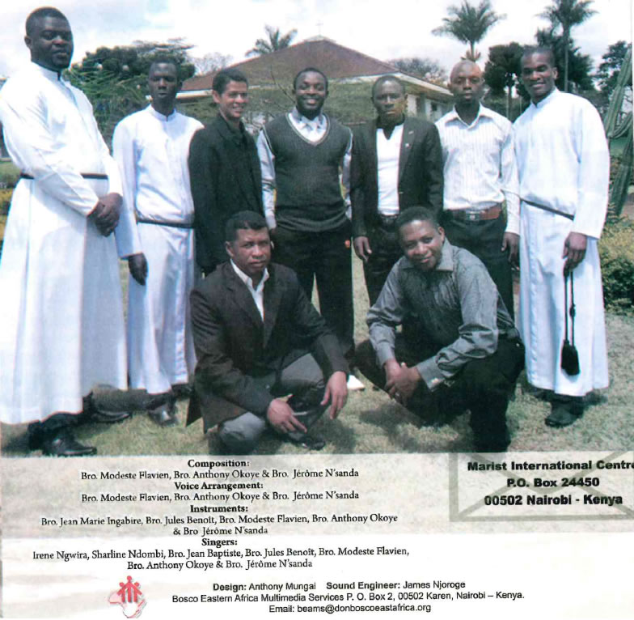
1. WE GATHER BY YOUR NAME (Bro.Modeste)

1. Father, hear our prayer
For this day, we gather by your name
You unite and gather us for your glory
To praise and worship you (x2)

Chorus: When we are here
We gather by your Name
When we are weak
You make us stronger
0, Father, hear your Children
0, Father, hear our prayer (x1)

2. Father, hear our Prayer
To be with you and worship in your presence
Give us, o Lord, your strength
To praise and worship you (x2)

2. MIMA AFRICA (Bro. Modeste)

Solo: MIMA. .......... AFRICA (x2)
. . . . . . . (Instruments) ........

Chorus: MIMA, mima Africa
Solo: we've gathered as one
MIMA, mima Africa
Solo: Nous venons d'un seul monde
MIMA, mima Africa
Solo: Somos novos Maristas
MIMA, mima Africa
Solo: MIMA, mima Africa (x2)

1. Heeey! Hello, Mama ll.frica!
Hello, people of Africa!
This day a special day for Africa
MIMA .. ... AFRICA. Heeey!

2. We've come from different continents
America, Asia, Oceania
Europe and Africa
For MIMA in Africa, Eeeeey!

3. SET OUR HEARTS ON FIRE (Bro. Anthony)

Set our hearts on fire; burning with divine love
Let us go on mission to a new land
(Holy Spirit) Set our hearts on fire; burning with divine love
Brothers and lay Marists the mission is one. (D.C)
We are here because of Jesus and the 'Yes' of our Founder

1. Our hearts are burning to join in his 'Yes'
Time has come for us Marists to walk the talk
Let us welcome the Spirit to lead us.

We are called to be voice for the poor
We are called to be just to them
We are called to be Brothers and Sisters to them
(Holy Spiri t-Chorus)

2. We are here because we felt his Spirit urging us on
Though very demanding with faith we can
Do not be discouraged and don't fear to say 'Yes'
Just be faithful, he will do the rest (Bridge and then, Chorus)

3. We are here because he called us, and he who calls is faithful
Though called differently we are all Marists
The call is so strong that we can't but respond
Holy Spirit, give us the courage (Bridge and then, Chorus)

4. THE CALL IS URGENT (Bro. Anthony)
1. It is said that our world of today need mystics
Who are the people who are better disposed to do this
work

If only you could see ..... If only you could see
If only you could hear ... If only you could hear
If only you could feel .If only you cloud feel
How urgent (how urgent) this call

Marists (Marists) Marists (Marists)
Who a re you (Who are you) in the world (in the world)
Marists (Marists) Marists (Marists)
You need to answer (answer) this call in the world

2. Looking around in our world of today you will see
So many children around everywhere with no one to care

If only you could see . . . . . ff only you could see
If only you could hear .... if only you could hear
If only you could feel . . .. if only you cloud feel
How urgent (how urgent) this call

Maristes (Maristes) Maristes (Maristes)
Qui etes-vous dans le monde
Maristes (Maristes) Maristes (Maristes)
A vous de repondre a cet appel dans le monde.

3. If you want to see . . . You will see
If you want to hear ..... You will hear
If you want to feel .... You will feel
II is about us Marists
Brothers and Lay Marists ... . we are all one
New Marists in mission ... going in haste
Poor children, young people . . . • . they need us all
The call is so urgent (Chorus in English and then i n French)

5. CALLED TO BE (Bro. Jerome N'SANDA)

1. Whenever you see children, what do u feel in your heart
Do you feel like telling them that Jesus loves them?
This is the call we all receive, as disciples of Marcellin.
To make Jesus known and loved by all
Above all the most neglected.

Called to be a light in the world
let us go to all the places
and teach the good news
if not you, if not me, then my brother tell me who?
if not now, if not today, then my sister, tell me when?

2. Called to be disciples, in a world that is changing
We all go to mission, with the zeal he alone can give
And when we face any challenge, we know we can overcome
we have a strong companion: Jesus our good friend.

3. Brothers and lay Marists, there is no time for tomorrow
Because the call is urgent, we need to respond now.
Bound by same zeal and fire which the come from the Spirit.
If not today then tell me when, if not you then tell me who.

6. I SING FOR YOU (Bro. Modeste)

1. I sing for you every day
I sing for you to day
I sing for you for ever
0 Lord, my King, my God

Wherever I go, o Lord
I sing for you
Wherever I go, o Lord
I praise your name (x2).

2. I sing for you, when I'm praying
I sing for you, when I'm walking
I sing for you, for ever
0 Lord, my King, my God

3. I sing for you, when I'm working
I sing for you, when I'm flying
I sing for you forever
0 Lord, my King, my God

7 . SEND ME (Bro. Jerome N'SANDA)

Ohhhh, here I am Lord, I come to do your will.
You called me to you, here I am, and here I am
Ohh, Send me Lord.

The voice of the Lord said: Whom shall I send?
Who shall go to my people, who shall speak my words to them?
And I said: Here I am, I come to do your will
Ohhh, send me Lord.

Here I am send me, lord i come tci do your will (x2)

Let it be done to me according to your words
I'm the servant of the Lord; I will do whatever you say
Send me Lord to teach your words and to heal broken hearts.
Ohhh send me Lord.

Here I am send me, lord i come to do your will (x2)

Here I come to you Lord, ooh take me, accept my gift
I give you all my life, send me Lord.

(Alleluia, praise the Lord)
A/leuia, praise be to the lord (Several times).

8. LET'S EVANGELIZE (Bro. Modeste)

1. Brothers and Lay have come as one
To share life and Marists mission
For good of life of the whole world
Together, we do just you and me

Let's evangelized the whole world with passion
In haste with Love like Marcel/in
And with Mary, we embrace (the) mission
New Marists in new mission (2x)

2. Challenges will help us to be strong
Jesus has been of help to us until now
With our Hope, Faith and Love
We can do in His name

3. Mission, to go and preach love
Make Jesus known and Loved
We are the salt of the new world
And the light of the world today

9. LET IT BE DONE (Bro. Modeste)

1. I have called you from your home
And you've said that you are still young
But, here, I am Lord, as young from a family
Here I am to give you my all

Jesus, Love of my soul
And here, I am, I've come to do your will
Let it be done, o yes, for your sake, Lord
As you are my friend, and Love of my heart (x2)

2. I send you, to the new world
And I will be with you for protection
Who am I Lord that can be sent
I have nothing; I've nothing in my life

3. Do not be afraid my friend for this call
And I assure you, my spirit is up on you
If it's like that, here, the whole of my life
Just for you, Lord, and Just for you

10. SING CHAMPAGNAT (Bro. Modeste)

1. Let's praise the lord our God
For the gift of Champagnat
Education for young people
The poor, abandoned children

Sing, sing Champagnat
Sing with shout of joy
Sing the friend of youth
For the glory of the Lord (2x)

2. Let's celebrate Champagnat
The humble servant of the Lord
To make Jesus known and Loved
That's his dream for the world

3. Let's celebrate new Marists
In mission to the new world
Go in haste with Mary
To make Jesus known and Loved

