MARY AS OUR MODEL
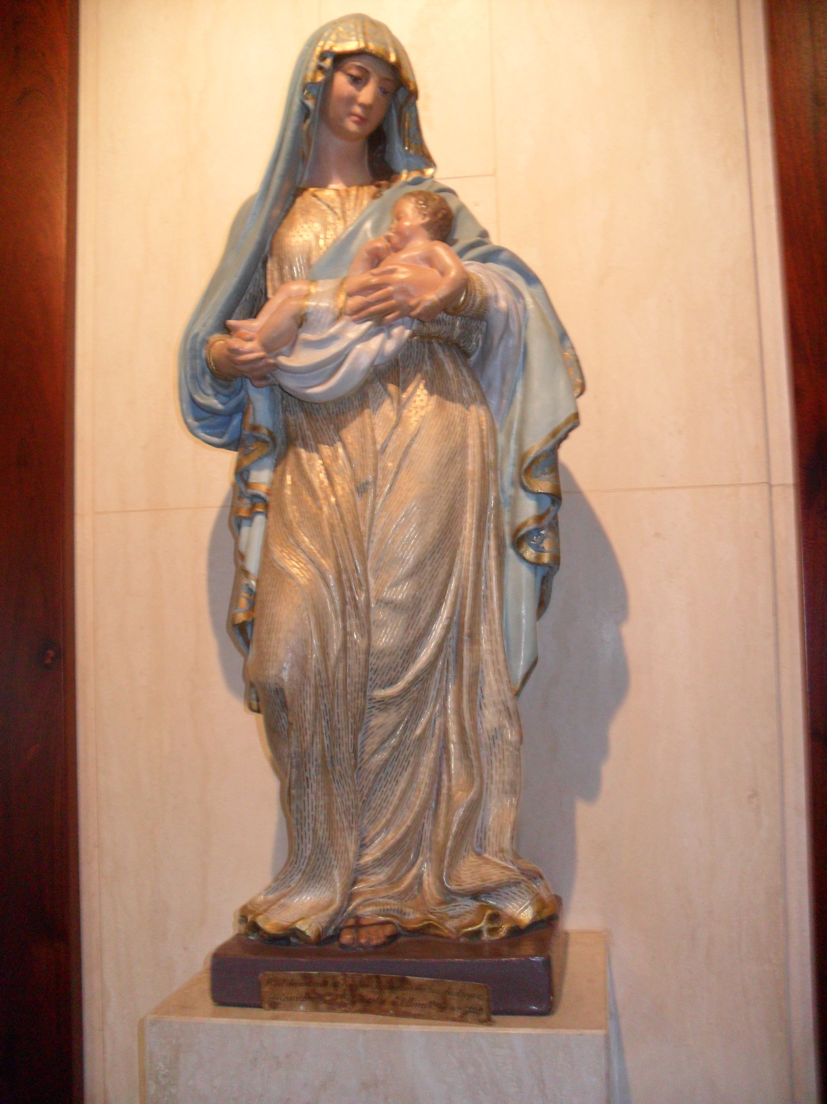]

OPENING PRAYER:

We thank you, Good Mother that you have a chosen us, you have given us your name and have made us your own in order that we might be, like you, wholly given to the Lord in faith and love and trust.
Share your spirit with us; inspire us with your ways of begin and acting, that we might come to see, feel as you feel, judge as you judge, love as you love with your sensitivity and respect for each other.
This we ask through Jesus Christ you Son who lives and reigns with you and the holy Spirit one God forever and ever. Amen.

REFLECTIONS ON THE LIFE OF MARY:

Like Mary in the ANUNCIATION, we are open to the moment of God in our lives, of God for whom nothing is possible. Despite our doubts, fears and feeling of inadequacy, we accept in faith God’s invitation to participate in the work of spreading the Good News. In the age of independence, we make room for God.
2 Hail Mary….

Like Mary in the VISITATION, we go out from our communion with the Lord full of faith and hope. We go to meet young people in their places of need, offering them our love. In an age of individualism, we put others first.
2 Hail Mary….

Like Mary of the MAGNIFICAT, we praise the Lord for the gift of life. In an age of concern over public morality, we side with the Lowly.
2 Hail Mary …

Like Mary in BETHLEHEM, we bring Jesus to birth in the hearts of others. We are ready to do so in the most unlikely and inhospitable of places. In and age of consumerism, we make do with simple comforts.
2Hail Mary …

Like Mary of NAZARETH, we nurture, guide and care for the young, developing in them a knowledge and love of the God who is active in their lives, and a respect for all God has created. Like her, we accept them as they are, even when we don’t fully understand theis decisions. In the ages of self-gratification, we give our love generously.
2 Hail Mary …

Like Mary of CANA, we are sensitive to the needs of others. We invite the young to do whatever Jesus bids. In the age self-centeredness, we feel for others.
2 Hail Mary …

Like Mary of CALVARY, we recognize Jesus in the face of the broken and the suffering, aching for them with a mother’s heart and believing in them with a mother’s passion. In age in which hope struggles with despair, we stand by those who are doing or grieving.
2 Hail Mary …

Like Mary of the CENACLE, we build community around us. In age that is adrift spiritually, we bring the belief and vision of a new and Spirit-filled church.
2 Hail Mary …

CONCLUDIND PRAYER:
Mary our Good Mother, you taught us to say YES to God with generosity; to be pilgrims of faith and disciples of Jesus; to develop a listening attitude; to discern God’s call by reflecting on events and keeping them in our hearts; and to rejoice and give thanks for the marvels God works in us.
Mary you invite us to be simple and open in our relationships, to form communities as prayerful as the group gathered in the Upper Room, and as warm as the family of Nazareth.
Mary you teach us to be close to children and young people and focused on their well-being, as you was to Jesus; to proclaim daring and prophetically that God prefers the “little ones”; and to be affectionate and kind towards them as a mother would be. Mary our Good Mother, be with us always. Amen.
