**Stations of the Cross - Way of the cross**

**The Work of God Apostolate**

|  |  |
| --- | --- |
| Stations of the cross, Way of the cross, Viacrucis, Via dolorosa   [*](http://www.theworkofgod.org/Devotns/Stations/st15.htm) | **Introduction**  Lord Jesus Christ my God, I humble myself before your Presence. As I come to accompany you and your Blessed Mother on the way to Calvary, grant me to feel for you with the tender feelings that She felt. May these stations of the cross remind me of your love and of the price you had to pay for my sins.  Let us pray the Way of the Cross with a humble and contrite heart; after all it is because of our sins that Jesus had to die for us.  It is customary to say before each station: "We adore you, O Christ and we bless you. Because by your holy cross you have redeemed the world."   After each station you say an Our Father, Hail Mary and Glory be.  To enter into the Spirit of the Passion, let us ask Mother Mary to help us live the Passion as She did: Mother Mary, help me to see with your eyes, to hear with your ears, to feel with your heart and to understand with your wisdom. Help me to know the depths of the love of Christ your Son and the bitterness of your Immaculate Heart. |

# FIRST STATION Jesus is condemned to death

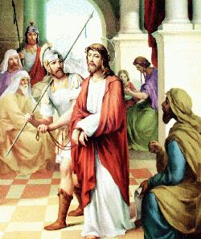**"We adore you, O Christ and we bless you.  
Because by your holy cross you have redeemed the world."**  
   
When Jesus came out wearing the crown of thorns and a purple robe, Pilate said to them: "Look at the Man!"  
John 19:5

Lord Jesus, you are the King of Kings and the Lord of Lords, you have been humiliated because of my pride, I am sorry to have enthroned the kingdom of the world in my heart, please grant me to attach myself only to you.

# SECOND STATION  Jesus carries his cross

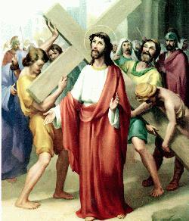**"We adore you, O Christ and we bless you. Because by your holy cross you have redeemed the world."**

He emptied Himself and took the form of a servant, being born in the likeness of men. Philippians 2:7

Jesus, you carried that heavy cross upon your wounded shoulder, and yet the weight of the cross was my sinfulness, so I repent of my sins and I beg you to grant me your Salvation. Forgive me Lord that I have failed to do your Holy Will

# THIRD STATION Jesus falls the first time

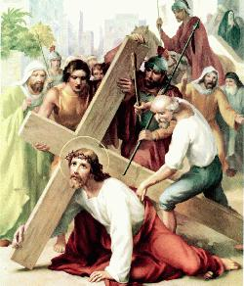**"We adore you, O Christ and we bless you. Because by your holy cross you have redeemed the world."**

Here is My servant, whom I uphold, My chosen one in whom I delight; I will put my Spirit on Him and He will bring justice to the nations. He will not shout or cry out, or raise His voice in the streets. Isaiah 42:1-2

Lord in this first fall you atoned for the original sin of all humanity, I thank you and praise for your unlimited love for me, please Lord, help me not to sin any more.

# FOURTH STATION  Jesus meets his mother Mary

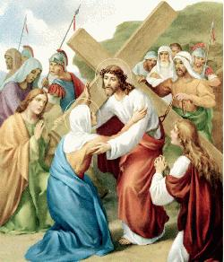**"We adore you, O Christ and we bless you.  
Because by your holy cross you have redeemed the world."**

Come, all you who pass by the way, look around and see. Is any suffering like My suffering that was inflicted on Me?  
Lamentations 1:12  
   
Sorrowful Mother Mary, allow me to share your sorrow so that the Holy Passion of my Lord remains always vivid within me as a reminder of God's Love for me.  
Come to meet me also in my sorrowful journey to the Lord.

# FIFTH STATION  Simon helps Jesus

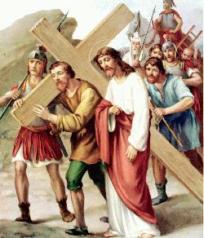**"We adore you, O Christ and we bless you.  
Because by your holy cross you have redeemed the world."**  
   
A certain man from Cyrene, Simon, the father of Alexander and Rufus, was passing by on his way in from the country, and they forced him to carry the cross.  
Mark 15:21

Lord you want us to share the cross with you by sharing and alleviating the sufferings of those in need, grant me to have a heart full of Charity and Love for my neighbor.

# SIXTH STATION Stations of the cross - Way of the cross - Veronica wipes the face of JesusVeronica wipes the face of Jesus

**"We adore you, O Christ and we bless you.  
Because by your holy cross you have redeemed the world."**  
   
He was despised and rejected by men, a man of sorrows, and familiar with suffering. Like one from whom men hide their faces, He was depised, and we esteemed him not. Surely He took up our infirmities and carried our sorrows.  
Isaiah 53:3-4  
   
Lord, you have created us for your Glory, please help us by wiping the stains of our souls with your Precious Blood to restore your image in us.

# SEVENTH STATION Jesus falls the second time

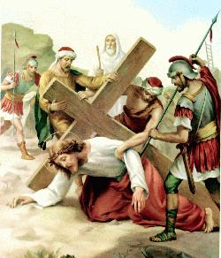**"We adore you, O Christ and we bless you.  
Because by your holy cross you have redeemed the world."**

Surely He took up our infirmities and carried our sorrows, yet we considered Him stricken by God, smitten by Him, and afflicted. But he was pierced for our transgressions, He was crushed for our iniquities; the punishment that brought us peace was upon Him, and by His wounds we are healed.  
Isaiah 53:4-5

By this second fall you confirm how weak we are, help us Lord to overcome our weaknesses with the strength of your sufferings. Teach us how to love good and to hate evil.

# EIGHTH STATION  Jesus comforts the women of Jerusalem

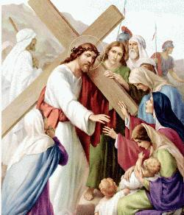**"We adore you, O Christ and we bless you.  
Because by your holy cross you have redeemed the world."**

A large number of people followed Him, including women who mourned and wailed for Him. Jesus turned and said to them, "Daughters of Jerusalem, do not weep for Me; weep for yourselves and for your children."  
Luke 23:27-28  
   
Lord, in our human weakness we are so concerned to live our lives without discomfort and pain, and yet you tell us that it is more important to seek the Kingdom of Heaven and to weep for our sins in order to gain eternal life.

# NINTH STATION Jesus falls the third time

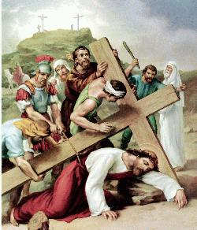**"We adore you, O Christ and we bless you.  
Because by your holy cross you have redeemed the world."**

We all, like sheep, have gone astray, each of us has turned to his own way; and the Lord has laid on him the iniquity of us all. He was oppressed and afflicted, yet he did not open his mouth.  
Isaiah 53:6-7

Lord you have stretched your generosity to the limits, please forgive us for the many times that we sin and don't remember what pain you had to go through to redeem us.

# TENTH STATION Jesus is stripped of his garments

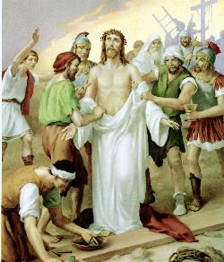**"We adore you, O Christ and we bless you.  
Because by your holy cross you have redeemed the world."**

When the soldiers crucified Jesus, they took His clothes, dividing them into four shares, one for each them, with the undergarment remain. John 19:23  
They divided My garments among them and casts lots for my clothing. Psalm 22:18  
  
Lord what they did to you is what we do to our souls, we strip your image which is given to us in baptism and we corrupt the temples of your glory.  
Clothe our souls once more with the robes of your Divine Mercy.

# ELEVENTH STATION Jesus is nailed to the cross

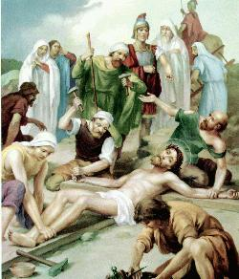**"We adore you, O Christ and we bless you.  
Because by your holy cross you have redeemed the world."**  
   
Just as Moses lifted up the snake in the desert, so the Son of Man must be lifted, that everyone who believes in him may have eternal life.  
John 3:14-15

Lord, you have called me to be your disciple, to deny myself   and to follow you. As I come before you, I crucify my will to yours, I crucify all the temptations of the world, the devil and the flesh and I pray for total submission to your Holy Will.

# TWELFTH STATION Jesus dies on the cross

Stations of the cross - Way of the cross - Jesus dies on the cross**"We adore you, O Christ and we bless you.  
Because by your holy cross you have redeemed the world."**  
   
And when Jesus had cried out again in a loud voice, he gave up His spirit.  
Matthew 26:50

Lord, it is here on the cross that you ask the Father to forgive me, here you give me your Mother to be my Heavenly Mother, here you promise me to be with you in your Kingdom.

I come to meet you and to partake of your holy sacrifice as I receive you in Holy Communion, grant me to relive your passion daily, unite me to your Precious Blood, Have Mercy on me Lord and on the whole world. (Prayer)

# THIRTEENTH STATION Jesus is taken down from the cross

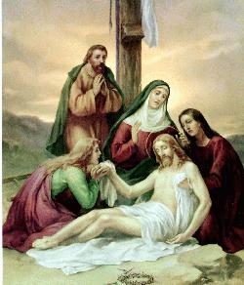**"We adore you, O Christ and we bless you.  
Because by your holy cross you have redeemed the world."**  
   
They will look on Me, the one they have pierced, and they will mourn for Him as one mourns for an only child, and grieve bitterly for Him as one grieves for a firstborn son. Zechariah 12:10

Lord, as you rested in the arms of your Mother, so I want to rest in your Sacred Heart, receive my brokenness and heal me for everlasting life.

# FOURTEENTH STATION Jesus is buried

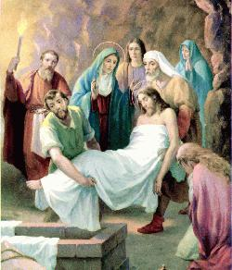**"We adore you, O Christ and we bless you.  
Because by your holy cross you have redeemed the world."**  
   
Joseph (of Arimathea) bought some linen cloth, took down the Body, wrapped It in the linen, and placed It in a tomb cut out of rock. Then he rolled a stone against the entrance of the tomb.  
MARK 15:46

Lord let me die in you and remain buried within me, I look forward to the moment of the resurrection from the dead when you will reveal your Glory to me. For now let me adore you in the Blessed Sacrament and grant the grace to live a holy life.

**The Resurrection**

**ON THE THIRD DAY HE ROSE AGAIN**

**He ascended into Heaven and is seated at the right hand of the Father to intercede for us, to prepare a place for our souls and to send His Holy Spirit to sanctify us**

|  |  |
| --- | --- |
| Stations of the cross - Way of the cross - The Resurrection - I am the Resurrection and the Life | Suddenly, without warning, Jesus stood before them and said, "Peace! Do not be afraid!  Go and carry the news to the others that they are to go to Galilee where they will see me."  Lord I believe in the Resurrection, I trust in you and I love you. |