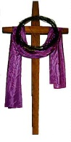The Season of Lent and the Blessed Virgin Mary
The commentary in the Sacramentary of the Collection of Masses of the Blessed Virgin Mary for the votive Mass, "Holy Mary, Disciple of the Lord," says about Lent:
Lent is a "journey" for the faithful, during which they "more diligently listen to the word of God and devote themselves to prayer with greater earnestness" [SC 109], and during which they are ready to bear the cross with greater zeal, so that with minds and hearts renewed they may reach a more worthy celebration of the Easter festival. In this way they show themselves true disciples of Christ, hearing his words and seeking to make them their own (see Luke 8:15), following in his footsteps in self-denial, (see Matthew 16:24) and striving to stand by his cross in faithful witness. (see John 19:26)
The Blessed Virgin Mary was such a disciple. One of the prefaces in the Marian Mass, "The Commending of the Blessed Virgin Mary," sums up the Marian outlook for Lent:
Father, all-powerful and ever-living God,
we do well always and everywhere to give you thanks.
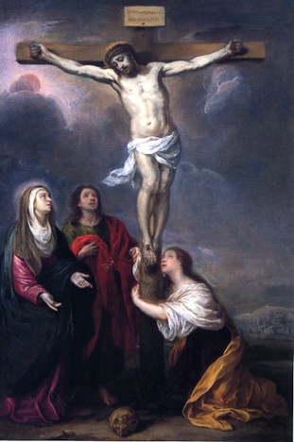
Pray 3 Hail Mary …
At the foot of the cross of Jesus,
by his solemn and dying wish,
a deep bond of love is fashioned
between the Blessed Virgin Mary
and his faithful disciples:
the Mother of God is entrusted to the disciples
as their own mother,
and they receive her as a precious inheritance from their Master.
Pray 3 Hail Mary …
She is to be forever
the mother of those who believe,
and they will look to her
with great confidence in her unfailing protection.
She loves her Son in loving her children,
and in heeding what she says
they keep the words of their Master.
Pray 3 Hail Mary …
Through him the angels of heaven
offer their prayer of adoration
as they rejoice in your presence for ever.
May our voice be one with theirs
in their triumphant hymn of praise.
Pray 3 Hail Mary …

