HOLY FRIDAY

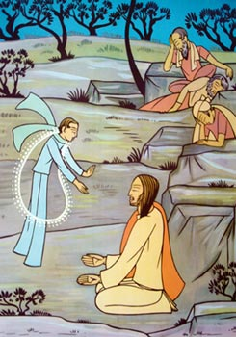

FIRST STATION
Jesus in agony in the Garden of Olives
V/. Adoramus te, Christe, et benedicimus tibi.
R/. Quia per sanctam crucem tuam redemisti mundum.
From the Gospel according to Saint Luke. 22:41-44
Jesus withdrew from them about a stone’s throw, and knelt down and prayed, “Father, if you are willing, remove this cup from me; nevertheless not my will but yours be done.” And there appeared to him an angel from heaven strengthening him. And being in agony he prayed more earnestly; and his sweat became like great drops of blood falling down upon the ground.

MEDITATION
Jesus was in agony. Grief and anguish came upon him. The sin of all mankind weighed on him heavily. But the greater his pain, the more fervently did he pray.
Pain always remains a challenge to us. We feel left alone. We forget to pray, and break down. Some even take their lives. But if we turn to God, we grow spiritually strong and go out to help our fellow-beings in trouble.
Jesus continues to suffer in his persecuted disciples. Pope Benedict XVI says that even in our times “the Church does not lack martyrs”. Christ is in agony among us, and in our times.
We pray for those who suffer. The mystery of Christian suffering is that it has a redemptive value. May the harassments that believers undergo complete in them the sufferings of Christ that bring salvation.
PRAYER
Lord Jesus, enable us to delve deeper into the great “mystery of evil” and our own contribution to it. As sufferings came into human life through sin, it was your plan that humanity be saved from sin through suffering. May none of the little annoyances, humiliations, and frustrations that we undergo in our daily lives and the great shocks that take us by surprise, go to waste. Linked with your own agony, may the agonies we endure be acceptable to you and bring us hope.
Lord, teach us to be compassionate, not only to the hungry, thirsty, sick, or those in some special need, but also to those inclined to be rude, argumentative and hurtful. In this way, as you have helped us in all our troubles, we may in turn “comfort those who are in any affliction, with the comfort that we ourselves have received”.
All: Our Father .....

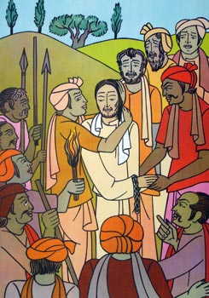

SECOND STATION
Jesus is betrayed by Judas, and restrains Peter from violence
V/. Adoramus te, Christe, et benedicimus tibi.
R/. Quia per sanctam crucem tuam redemisti mundum.
From the Gospel according to Saint Luke 22:47-50
and according to Saint Matthew 26:52.56
While Jesus was still speaking, there came a crowd, and the man called Judas, one of the twelve, was leading them. He drew near to Jesus to kiss him; but Jesus said to him, “Judas, would you betray the Son of man with a kiss?” And when those who were about him saw what would follow, they said, “Lord, shall we strike with the sword?” And one of them struck the slave of the high priest and cut off his right ear.
Then Jesus said to him, “Put your sword back into its place; for all who take the sword will perish by the sword.” Then all the disciples forsook him and fled.

MEDITATION
It is one of his trusted friends that betrays Jesus, and with a kiss. The way Jesus confronted violence has a message for our times. Violence is suicidal, he tells Peter: it is not defeated by more violence, but by a superior spiritual energy that reaches out in the form of healing love. Jesus touches the High Priest’s slave and heals him. The violent man today too may need a healing touch that comes from a love that transcends the immediate issues.
In times of conflict between persons, ethnic and religious groups, nations, economic and political interests, Jesus says, confrontation and violence are not the answer, but love, persuasion and reconciliation. Even when we seem to fail in such efforts, we plant the seeds of peace which will bear fruit in due time. The rightness of our cause is our strength.
PRAYER
Lord Jesus, you consider us your friends, yet we notice traces of infidelity in ourselves. We acknowledge our transgressions. We are presumptuous at times and over-confident. And we fall. Let not avarice, lust or pride take us by surprise. How thoughtlessly do we fly after ephemeral satisfactions and untested ideas! Grant that we may not be tossed to and fro and carried about by every wind of doctrine… but speaking the truth in love, grow up in every way into Christ the head.
May truth and sincerity of purpose be our strength. Restrain, Lord, our impetuosity in situations of violence, as you restrained Peter’s impulsive character. Keep us unruffled in spirit before opposition and unfair treatment. Convince us that “A gentle answer quiets anger” in our families, and that “gentleness” combined with “wisdom” restores tranquility in society. “Lord, make me an instrument of Your peace.”
All: Our Father…

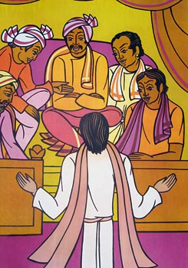

THIRD STATION
Jesus is held guilty by the Sanhedrin
V/. Adoramus te, Christe, et benedicimus tibi.
R/. Quia per sanctam crucem tuam redemisti mundum.
From the Gospel according to Saint Matthew 26:62-66
And the High Priest stood up and said, “Have you no answer to make? What is it that these men testify against you? But Jesus was silent. And the High Priest said to him, “I adjure you by the living God, tell us if you are the Christ, the Son of God.” Jesus said to him, “You have said so. But I tell you, hereafter you will see the Son of man seated at the right hand of Power, and coming on the clouds of heaven.” Then the High Priest tore his robes, and said, “He has uttered blasphemy. What do we still need witnesses? You have now heard his blasphemy. What is your judgement? They answered, “He deserves death.
MEDITATION
In every land, there have been innocent persons who suffered, people who died fighting for freedom, equality or justice. Those who struggle on behalf of God’s little ones are promoting God’s own work. For he presses for the rights of the weak and the oppressed. Whoever collaborates in this work, in the spirit of Jesus, brings hope to the oppressed and offers a corrective message to the evildoer himself.
Jesus’ manner of struggling for justice is not to rouse the collective anger of people against the opponent, so that they are led into forms of greater injustice. On the contrary, it is to challenge the foe with the rightness of one’s cause and evoke the good will of the opponent in such a way that injustice is renounced through persuasion and a change of heart. Mahatma Gandhi brought this teaching of Jesus on non-violence into public life with amazing success.
PRAYER
Lord, often we judge others in haste, indifferent to actual realities and insensitive to people’s feelings! We develop stratagems of self-justification and explain away the irresponsible manner in which we have dealt with “the other”. Forgive us!
When we are misjudged and ill-treated, Lord, give us the inner serenity and self-confidence that your Son manifested in the face of unjust treatment. Keep us from an aggressive response which goes against your Spirit. On the contrary, help us to bring your powerful word of forgiveness into situations of tension and anxiety, so that it may reveal its dynamic power in history.
All: Our Father

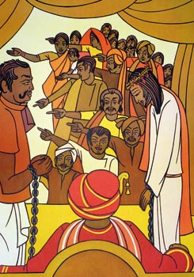

FOURTH STATION
Jesus is denied by Peter
V/. Adoramus te, Christe, et benedicimus tibi.
R/. Quia per sanctam crucem tuam redemisti mundum.
From the Gospel according to Saint Luke. 22:54-62
Then they seized Jesus and led him away, bringing him into the high priest’s house. Peter followed at a distance; and when they had kindled a fire in the middle of the courtyard and sat down together, Peter sat among them. Then a maid, seeing him as he sat in the light and gazing at him, said, “This man was with him.” But he denied it, saying, “Woman, I do not know him.” And a little later someone else saw him and said, “You also are one of them.” But Peter said, “Man, I am not.” And after an interval of about an hour still another insisted, saying, “Certainly this man was also with him; for he is a Galilean.” But Peter said, “Man, I do not know what you are saying.” And immediately, while he was still speaking, the cock crowed. And the Lord turned and looked at Peter. And Peter remembered the word of the Lord, how he had said to him, “Before the cock crows today, you will deny me three times.” And he went out and wept bitterly.

MEDITATION
Peter claimed to be strong, but he broke down before a servant girl. Human weakness takes us by surprise, and we collapse. That is why Jesus asks us to watch and pray. He urges self-renunciation and closeness to God.
There is a rebellious “self” within us. We are often of “two minds”, but we fail to recognize this inner inconsistency. Peter recognized it when his eyes met the eyes of Jesus, and he wept. Later, Thomas, encountering the Risen Lord, acknowledged his own faithlessness and believed. In the light of Christ, Paul became aware of the inconsistency within himself, and he overcame it with the Lord’s help. Going deeper still, he discovered: “It is no longer I who live, but it is Christ who lives in me.”
PRAYER
Lord, how easily do we allow a distance to grow between what we profess to be and what we really are! How often do we fail to carry out our own decisions, or even fulfill our most solemn promises! And as a result we often hesitate to make any permanent commitment, even to you!
We confess that we have failed to bring into our life that inner discipline that is expected of any adult person and required for the success of any human Endeavour. Give sturdiness to our inner determination; help us to bring every good work we have begun to a successful conclusion. Enable us to stand firm, as mature and fully convinced Christians, “in complete obedience to God’s will”.
All: Our Father …

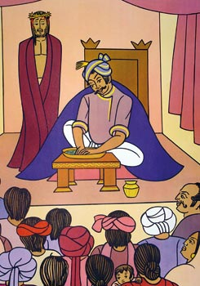
FIFTH STATION
Jesus is judged by Pilate
V/. Adoramus te, Christe, et benedicimus tibi.
R/. Quia per sanctam crucem tuam redemisti mundum.
From the Gospel according to Saint Luke. 23:22-25 A third time Pilate said to them, “Why, what evil has he done? I have found in him no crime deserving death; I will therefore chastise him and release him”. But they were urgent, demanding with loud cries that he should be crucified. And their voices prevailed. So Pilate gave sentence that their demand should be granted. He released the man who had been thrown into prison for insurrection and murder, whom they asked for; but Jesus he delivered up to their will.

MEDITATION
It was not the rightness of an issue that mattered to Pilate, but his professional interests. Such an attitude did not help him, either in this case or in his later career. He was so unlike Jesus, whose inner rectitude made him fearless.
Nor was Pilate interested in the truth. He walks away from Jesus exclaiming, “What is truth?” Such indifference to truth is not uncommon these days. People are often concerned about what gives immediate satisfaction. They are content with superficial answers. Decisions are made based not on principles of integrity, but on opportunistic considerations. Failing to make morally responsible options damages the vital interests of the human person, and of the human family. We pray that the “spiritual and ethical concepts” contained in the word of God will inspire the living norms of society in our times.
PRAYER
Lord, give us the courage to make responsible decisions when rendering a public service. Bring probity into public life and assist us to be true to our conscience.
Lord, you are the source of all Truth. Guide us in our search for ultimate answers. Going beyond mere partial and incomplete explanations, may we search for what is permanently true, beautiful and good.
Lord, keep us fearless before the “slings and arrows of outrageous fortune”. When shadows grow deep on life’s wearisome paths, and the dark night comes, enable us to hearken to the teaching of your Apostle Paul: “Be watchful, stand firm in your faith, be courageous, be strong.”
All: Our Father ….

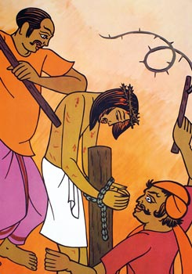
SIXTH STATION
Jesus is scourged and crowned with thorns
V/. Adoramus te, Christe, et benedicimus tibi.
R/. Quia per sanctam crucem tuam redemisti mundum.
From the Gospel according to Saint Matthew. 27:26-30
Then Pilate, having scourged Jesus, delivered him to be crucified. Then the soldiers of the governor took Jesus into the praetorium, and they gathered the whole battalion before him. And they stripped him and put a scarlet robe upon him, and plaiting a crown of thorns they put it on his head, and put a reed in his right hand. And kneeling before him they mocked him, saying, “Hail, King of the Jews!” And they spat upon him, and took the reed and struck him on the head.

MEDITATION
Inhumanity reaches new heights. Jesus is scourged and crowned with thorns. History is full of hatred and wars. Even today we witness acts of violence beyond belief: murder, violence to women and children, kidnapping, extortion, ethnic conflict, urban violence, physical and mental torture, violations of human rights.
Jesus continues to suffer when believers are persecuted, when justice is distorted in court, corruption gets rooted, unjust structures grind the poor, minorities are suppressed, refugees and migrants are ill-treated. Jesus’ garments are pulled away when the human person is put to shame on the screen, when women are compelled to humiliate themselves, when slum children go round the streets picking up crumbs.
Who are the guilty? Let us not point a finger at others, for we ourselves may have contributed a share to these forms of inhumanity.
PRAYER
Lord Jesus, we know that it is you who suffer when we cause pain to each other and we remain indifferent. Your heart went out in compassion when you saw the crowds “harassed and helpless, like sheep without a shepherd”. Give me eyes that notice the needs of the poor and a heart that reaches out in love. “Give me the strength to make my love fruitful in service.”
Most of all, may we share with the indigent your “word” of hope, your assurance of care. May “zeal for your house” burn in us like a fire. Help us to bring the sunshine of your joy into the lives of those who are trudging the path of despair.
All: Our Father ….

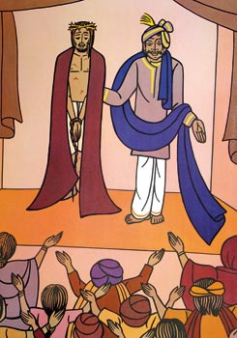
SEVENTH STATION
After Jesus is made an object of fun, he is led out to be crucified
V/. Adoramus te, Christe, et benedicimus tibi.
R/. Quia per sanctam crucem tuam redemisti mundum.
From the Gospel according to Saint Matthew. 27:31
And when they had mocked him, they stripped him of the robe, and put his own clothes on him, and led him away to crucify him.

MEDITATION
Jesus, at whose name every knee in heaven and earth bends, is made an object of fun. We are shocked to see to what levels of brutality human beings can sink. Jesus is humiliated in new ways even today: when things that are most Holy and Profound in the Faith are being trivialized; the sense of the sacred is allowed to erode; the religious sentiment is classified among unwelcome leftovers of antiquity.
Everything in public life risks being desacralized: persons, places, pledges, prayers, practices, words, sacred writings, religious formulae, symbols, ceremonies. Our life together is being increasingly secularized. Religious life grows diffident. Thus we see the most momentous matters placed among trifles, and trivialities glorified. Values and norms that held societies together and drew people to higher ideals are laughed at and thrown overboard. Jesus continues to be ridiculed!
PRAYER
We have faith, Lord, but not enough. Help us to have more. May we never question or mock serious things in life like a cynic. Allow us not to drift into the desert of godlessness. Enable us to perceive you in the gentle breeze, see you in street corners, and love you in the unborn child.
God, enable us to understand that on Tabor or Calvary, your Son is the Lord. Robed or stripped of his garments, he is the Savior of the world. Make us attentive to his quiet presences: in his “word”, in tabernacles, shrines, humble places, simple persons, the life of the poor, laughter of children, whispering pines, rolling hills, the tiniest living cell, the smallest atom, and the distant galaxies.
May we watch with wonder as he walks on the waters of the Rhine and the Nile and the Tanganyika.
All: Our Father …

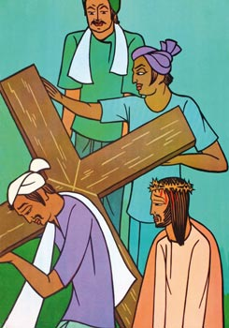
EIGHTH STATION
Jesus is helped by Simon of Cyrene to carry the Cross
V/. Adoramus te, Christe, et benedicimus tibi.
R/. Quia per sanctam crucem tuam redemisti mundum.
From the Gospel according to Saint Luke. 23:26
The soldiers led Jesus away, and as they were going, they met a man from Cyrene named Simon who was coming into the city from the country. They seized him, put the cross on him, and made him carry it behind Jesus.

MEDITATION
In Simon of Cyrene, we have the proto-type of a faithful disciple who takes up the Cross and follows Christ. He is not unlike millions of Christians from a humble background, with deep attachment to Christ. No glamour, no sophistication, but profound faith. Such believers keep rising on the soil of Africa, Asia and the distant islands. Vocations arise from their midst.
Simon reminds us of small communities and tribes with their characteristic commitment to the common good, deep rootedness in ethical values and openness to the Gospel. They deserve attention and care. The Lord does not desire that “one of these little ones should perish”. In Simon we discover the sacredness of the ordinary and the greatness of what looks small. For the smallest have some mystic relationship with the greatest, and the ordinary with the most extraordinary!
PRAYER
Lord, it is your wonderful plan to lift up the lowly and sustain the poor. Strengthen your Church in her service to deprived communities: the least privileged, the marginalized, slum dwellers, the rural poor, the undernourished, untouchables, the handicapped, and people given to addictions.
May the example of your servant, Mother Teresa of Kolkata, inspire us to dedicate more of our energies and resources to the cause of the “poorest of the poor”. May we one day hear these words from Jesus: “I was hungry and you gave me food, I was thirsty and you gave me drink; I was a stranger and you welcomed me; I was naked and you clothed me; I was sick and you visited me, I was in prison and you came to me.”
All: Our Father …

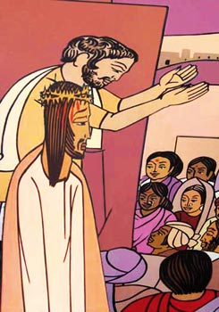
NINTH STATION
Jesus meets the women of Jerusalem
V/. Adoramus te, Christe, et benedicimus tibi.
R/. Quia per sanctam crucem tuam redemisti mundum.
From the Gospel according to Saint Luke. 23:27-28
And there followed him a great multitude of the people, and of women who bewailed and lamented him. But Jesus, turning to them, said: “Daughters of Jerusalem, do not weep for me, but weep for yourselves and for your children.

MEDITATION
Before the weeping women, Jesus is self-forgetful. His anxiety is not about his pains, but about the tragic future that awaits them and their children.
The destinies of societies are intimately linked to the wellbeing of their women. Wherever women are held in low esteem or their role remains diminished, societies fail to rise to their true potentiality. In the same way, wherever their responsibility to the rising generation is neglected, ignored, or marginalized, the future of that society becomes uncertain.
There are many societies in the world where women fail to receive a fair deal. Christ must be weeping for them. There are societies too that are thoughtless about their future. Christ must be weeping for their children. Wherever there is unconcern for the future, through the overuse of resources, the degradation of the environment, the oppression of women, the neglect of family values, the ignoring of ethical norms, the abandonment of religious traditions, Jesus must be telling people: “Do not weep for me, but weep for yourselves and for your children.”
PRAYER
Lord, you are the Master of history. And yet you wanted our collaboration in realizing your plans. Help us to play a responsible role in society: leaders in their communities, parents in their families, educators and health-workers among those who need to be served, communicators in the world of information. Arouse in us a sense of mission in what we do, a deep sense of responsibility to each other, to society, to our common future and to you. For you have placed the destinies of our communities and of humanity itself into our hands.
Lord, do not turn away from us when you see women humiliated or your image disfigured in the human person; when we interfere with life-systems, weaken the nurturing power of nature, pollute running streams or the deep blue seas or the Northern snows. Save us from cruel indifference to our common future, and do not let us drag our civilization down the path of decline.
All: Our Father ...

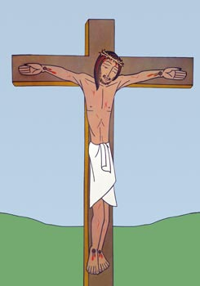

TENTH STATION
Jesus is crucified
V/. Adoramus te, Christe, et benedicimus tibi.
R/. Quia per sanctam crucem tuam redemisti mundum.
From the Gospel according to Saint Luke 23:33-37
and according to Saint Matthew. 27:46
There they crucified him, and the criminals, one on the right and one on the left. And Jesus said, “Father, forgive them; for they know not what they do.” And they cast lots to divide his garments. And the people stood by, watching; but the rulers scoffed at him, saying, “He saved others; let him save himself, if he is the Christ of God, his Chosen One!” The soldiers also mocked him, coming up and offering him vinegar, and saying, “If you are the King of the Jews, save yourself!” And about the ninth hour Jesus cried with a loud voice, “Eli, Eli, lama sabachthani?”, that is, “My God, my God, why have you forsaken me?”

MEDITATION
The sufferings of Jesus reach a climax. He had stood fearlessly before Pilate. He had endured the mistreatment of the Roman soldiers. He had preserved his calm under the scourge and the crowning with thorns. On the Cross itself, he seemed untouched by a shower of insults. He had no word of complaint, no desire to retort. But then, finally, a moment comes when he breaks down. His strength can stand no more. He feels abandoned even by his Father!
Experience tells us that even the sturdiest man can descend to the depths of despair. Frustrations accumulate, anger and resentment pile up. Bad health, bad news, bad luck, bad treatment – all can come together. It may have happened to us. It is at such moments we need to remember that Jesus never fails us. He cried to the Father. May we too cry out to the Father, who unfailingly comes to our rescue in all our distress, whenever we call upon him!
PRAYER
Lord, when clouds gather on the horizon and everything seems lost, when we find no friend to stand by us and hope slips from our hands, teach us to trust in you, who will surely come to our rescue. May the experience of inner pain and darkness teach us the great truth that in you nothing is lost, that even our sins – once we have repented of them – come to serve a purpose, like dry wood in the cold of winter.
Lord, you have a master design beneath the working of the universe and the progress of history. Open our eyes to the rhythms and patterns in the movements of the stars; balance and proportion in the inner structure of elements; interrelatedness and complementarity in nature; progress and purpose in the march of history; correction and compensation in our personal stories. It is this harmony that you constantly keep restoring, despite the painful imbalances that we bring about. In you even the greatest loss is a gain. Christ’s death, in fact, points to resurrection.
All: Our Father …

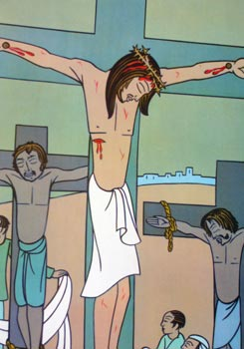
ELEVENTH STATION
Jesus promises his Kingdom to the Good Thief
V/. Adoramus te, Christe, et benedicimus tibi.
R/. Quia per sanctam crucem tuam redemisti mundum.
From the Gospel according to Saint Luke. 23:39-43
One of the criminals who were hanged railed at him, saying, “Are you not the Christ? Save yourself and us!” But the other rebuked him, saying, “Do you not fear God, since you are under the same sentence of condemnation? And we indeed justly; for we are receiving the due reward of our deeds; but this man has done nothing wrong.” And he said, “Jesus, remember me when you come into your kingdom.” And he said to him, “Truly, I say to you, today you will be with me in Paradise.”

MEDITATION
It is not eloquence that convinces and converts. In the case of Peter, it is a look of love; in the case of the Good Thief, it is unresentful serenity in suffering. Conversion takes place like a miracle. God opens your eyes. You recognize his presence and action. You surrender!
Opting for Christ is always a mystery. Why does one make a definitive choice for Christ, even in the face of trouble, or death? Why do Christians flourish in persecuted places? We shall never know. But it happens over and over again. If a person who has abandoned his faith comes across the real face of Christ, he will be stunned by what he actually sees, and may surrender like Thomas: “My Lord and my God!” It is a privilege to unveil the face of Christ to people. It is even a greater joy to discover – or rediscover –him.
“Your face, O Lord, do I seek. Do not hide your face from me.”
PRAYER
My cry to you today, O Lord, in tears is this: “Jesus, remember me when you come into your Kingdom.” It is for this Kingdom that I fondly long. It is the eternal home you have prepared for all those who seek you with sincere hearts. “No eye has seen, no ear has heard, no mind has conceived what God has prepared for those who love him”. Help me, Lord, as I struggle ahead on my way to my eternal destiny. Lift the darkness from my path, and keep my eyes raised to the heights!
“Lead, kindly Light, amid the encircling gloom. Lead thou me on.
The night is dark, and I am far from home. Lead thou me on.
Keep thou my feet; I do not ask to see
The distant scene; one step enough for me.”
All: Our Father ..

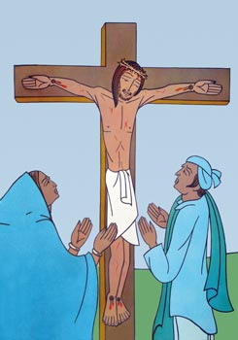
TWELFTH STATION
The Mother of Jesus and the Beloved Disciple at the foot of the Cross
V/. Adoramus te, Christe, et benedicimus tibi.
R/. Quia per sanctam crucem tuam redemisti mundum.
From the Gospel according to Saint John. 19:25-27
Standing by the cross of Jesus were his mother, and his mother’s sister, Mary the wife of Clopas, and Mary Magdalene. When Jesus saw his mother, and the disciple whom he loved standing near, he said to his mother: “Woman, behold your son!” Then he said to the disciple: “Behold your mother!” And from that hour the disciple took her to his own home.

MEDITATION
In suffering we long for solidarity. Mother Mary reminds us of supportive love and solidarity within a family, John of loyalty within a community. Family cohesion, community bonds, ties of friendship – these are essential for the flourishing of human beings. In an anonymous society they grow weak. When they are missing, we become diminished persons.
Again, in Mary we do not notice even the least sign of resentment; not a word of bitterness. The Virgin becomes an archetype of forgiveness in faith and hope. She shows us the way to the future. Even those who would like to respond to violent injustice with “violent justice” know that that is not the ultimate answer. Forgiveness prompts hope.
There are also historic injuries that often rankle in the memories of societies for centuries. Unless we transmute our collective anger into new energies of love through forgiveness, we perish together. When healing comes through forgiveness, we light a lamp, announcing future possibilities for the “life and well-being” of humanity.
PRAYER
Lord Jesus, your Mother stood silently at your side in your final agony. She who was unseen on occasions when you were acclaimed a great prophet, stands beside you in your humiliation. May I have the courage to remain loyal even where you are least recognized. Let me never be embarrassed to belong to the “little flock”.
Lord, let me remember that even those whom I consider my “enemies” belong to the human family. If they treat me unfairly, let my prayer be only: “Father, forgive them; for they know not what they do.” It may be in such a context that someone will suddenly recognize the true face of Christ and cry out like the centurion: “Truly this man was the Son of God!”
All: Our Father …

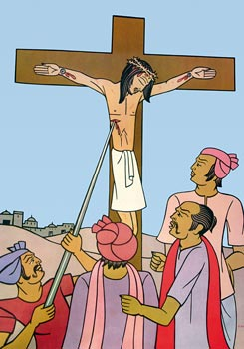
THIRTEENTH STATION
Jesus dies on the Cross
V/. Adoramus te, Christe, et benedicimus tibi.
R/. Quia per sanctam crucem tuam redemisti mundum.
From the Gospel according to Saint Luke. 23:46
Then Jesus, crying with a loud voice, said, “Father, into your hands I commend my spirit!” And having said this, he breathed his last.

MEDITATION
Jesus hands over his spirit to the Father in serene abandonment. What his persecutors thought to be a moment of defeat proves, in fact, to be a moment of triumph. When a prophet dies for the cause he stood for, he gives the final proof of all that he has said. Christ’s death is something more than that. It brings redemption. “In him we have redemption through his blood, the forgiveness of our trespasses.”
With that begins for me a mystic journey: Christ draws me closer to him, until I shall fully belong to him.
“As a deer longs for flowing streams, so my soul longs for you, O God…
When shall I come and behold the face of God?”
PRAYER
Lord Jesus, it is for my own sins that you were nailed to the Cross. Help me to gain a deeper understanding of the grievousness of my sins and the immensity of your love. For “while we were still weak, Christ died for the ungodly.” I admit my faults as the prophets did long ago:
“We have sinned and done wrong and acted wickedly and rebelled, turning aside
from your commandments and ordinances; we have not listened to your servants the prophets….”
There was nothing in me to deserve your kindness. Thank you for your immeasurable goodness to me. Help me to live for you, to shape my life after you, to be joined to you and become a new creation.
“Christ be with me, Christ within me, Christ behind me, Christ before me,
Christ beside me, Christ to win me, Christ to comfort and restore me.”
All: Our Father …

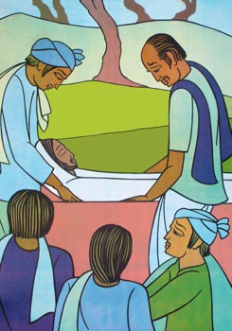
FOURTEENTH STATION
Jesus is taken down from the Cross and placed in the tomb
V/. Adoramus te, Christe, et benedicimus tibi.
R/. Quia per sanctam crucem tuam redemisti mundum.
From the Gospel according to Saint Mark. 15:46
Joseph bought a linen shroud, and taking him down, wrapped him in the linen shroud, and laid him in a tomb which had been hewn out of the rock; and he rolled a stone against the door of the tomb.

MEDITATION
Tragedies make us ponder. A tsunami tells us that life is serious. Hiroshima and Nagasaki remain pilgrim places. When death strikes near, another world draws close. We then shed our illusions and have a grasp of the deeper reality. People in ancient India prayed: “Lead me from the unreal to the real, from darkness to light, from death to immortality.”
After Jesus left this world, Christians began to look back and interpret his life and mission. They carried his message to the ends of the earth. And this message itself is Jesus Christ, who is “the power of God and the wisdom of God”. It says that the reality is Christ and that our ultimate destiny is to be with him.
PRAYER
Lord Jesus, enable us, as we press forward on life’s weary way, to have a glimpse of our ultimate destiny. And when at last we cross over, we will know that “death will be no more; mourning and crying and pain will be no more.” God will wipe away all tears from our eyes.
It is this Good News that we are eager to announce “in every way”, even in places where Christ has not been heard of. For this we work hard. We work “night and day” and wear ourselves out. Lord makes us effective carriers of your Good News.
“I know that my Redeemer lives, and at last he will stand upon the earth; and in my flesh I shall see God.”
All: Our Father …

