M

ARIST CHARISM

When we speak about charism, we are referring to the special gifts that the Spirit grants to believers and that defines a specific vocation in the community for the service of the good of men and women.

Within the life of the Church, a way of living and developing a charism is through the charism of a founder and/or of the Institute. Understanding the founder’s charism as that personal gift that, being at the origin of the institution’s experience, traces the essential spiritual lines that characterize the identity of the Institute, its mission in the Church, and its peculiar spirituality.

From this perspective, what is the personal gift (charisma) left behind by Marcellin? What are the essential features that characterize our identity as Marists? There are three key elements that the Marists receive as a personal gift of Marcellin Champagnat and that today define the essential features of our identity as Marists:
Spirituality: centred on Jesus, marian and apostolic.
- A life seduced by Jesus, lived in intimacy with Him.
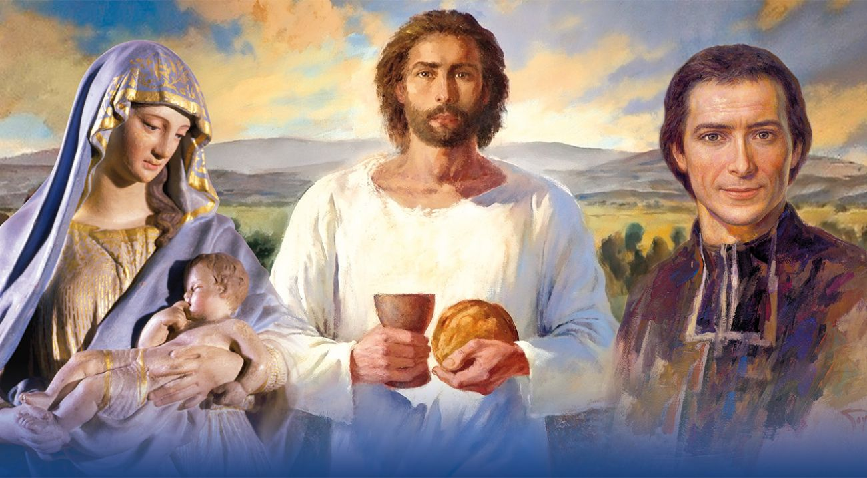
- Cultivating the inner dimension of life, characterized by the exercise of living in “God’s presence, which accompanies and gives sense to our daily work”.
- “Marian and apostolic, invites us to look to Mary as the first disciple of Jesus for our response. She is our model of listening, of love for the poor and host to the message of God.”

Fraternity: family spirit.
- “The family spirit provides space and time to share faith and life: it generates community. Following the example of Jesus, Mary and Marcellin, we meet with others to walk together, sharing and helping each other grow in faith and mission”.
- “That they can say of you as they did of the first Christians: See how they love each other!” (Testament of St Marcellin Champagnat).

Mission: In the midst of the children and young people.
- “Help new generations discover the face of God and have life in abundance. Following the footsteps of Champagnat, we also must respond to the cry of the Montagnes of today. We cannot see a child without loving him and telling him how much God loves him.”

Cf. EMM 115
EMM 115
Water from the Rock, 151
EMM 84
EMM 42

