V
OCATION AS BROTHER
A first approach to the identity as brother taken from the Constitutions – by applying the Gospel to the life of the brother and a roadmap to carry out their life project –, offers the following nuances on the vocation of a brother.

Vocation is a personal loving response to a call from God. Through it, one opts for a lifestyle recognized in the Church as religious life or consecrated life. To follow Christ as Mary did, in His life of love for the Father and for people, in community, turns into the goal of his life and turns him into a witness and servant of the Kingdom of God. His vocation as Brother is a special call to live the brotherhood of Christ with everyone, especially with young people, loving them with a selfless love.

As a follower of Jesus, the brother commits himself by public vote to live the evangelical counsels or vows of chastity, poverty, and obedience. Celibacy, lived in community, expresses the totality of God in his life and in being a sacrament of humanity and compassion with all.
Poverty demonstrates the evangelical freedom that supersedes the desire of possession and makes him available to give his life in solidarity and commitment to the poorest. Obedience to God makes his daily openness meaningful in wanting God by means of listening, contemplation, discernment of the signs of the times and his availability for the Kingdom. Apostolic action is part of the very nature of his religious family, it begins with the testimony of his consecration, and it has a strong community, missionary and international dimension.
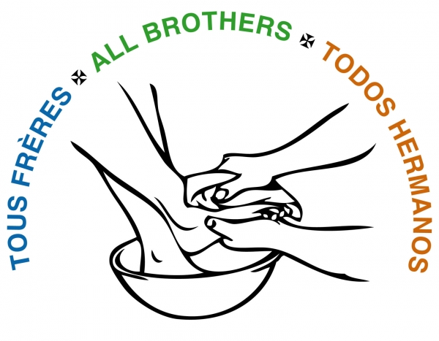

The XXI General Chapter underscores the originality of the vocation as brother through the same name, “Little Brothers of Mary”, but likewise urges the search of “a new way of being Brother”. In this way of being a brother, he speaks of a consecration that should lead one to belong to God alone, to bear witness to the conversion to Jesus Christ in a life of unconditional love and radical availability, to set out in haste for the new frontiers of children and young people, journeying with Mary.

Brother Emili Turú’s circular, “He gave us the name of Mary”, provides some new clues to the identity as brother. The presence in the world and in the Church – aspiring to live the Gospel as Mary did –, is a prophetic contribution, i.e. a religious that is not part of the hierarchical structure. That is the originality of his vocation, which specifies its contribution to the Church and society, not only for what he does, but by how it does and for what it is.

He is called to build the Marian face of the Church with three fundamental attitudes: sharing Mary’s spiritual maternity when she takes up the task of bringing Christ-life to the world of those whose lives we share in the ecclesial community. In welcoming Mary in his home, he learns to love all, and in this way becomes a sign of the Father’s tenderness. He takes up with joy the responsibility of carrying on the inheritance of the first brothers, who living close to the Good Mother, grew steadily in the sense of brotherhood, of devotedness, and of self-renunciation in the service of one another.
Mary, who treasured all these things in her heart, indicates him the path to follow: silence, openness, attentive listening, and abandonment. An active abandonment, that tries to discern the footprints of the God of surprises in everything. In that way, the brother becomes contemplative in action.

The last general Conference, convoked under the theme Awakening the Dawn: Prophets and Mystics for Our Time, points to the profile of the brother for this new era, a person with a lot of creativity, imagination and innovation. He is a prophet and a mystic, keeping in mind the call to the peripheries and the attentive care for the mystical dimension of his life.

cf Marist Constitutions and Statutes, No. 169.
Cf Constitutions No. 3; (No. 4 states that the founder wanted the brothers to live in her spirit when he gave us the name of Mary.)
cf idem, No. 3.
cf “ , No. 15.
cf “ , No. 17; No. 82.
cf Doc. XXI General Chapter. pp. 18, 32. (With Mary, go in haste to a new land)
cf “He gave us the name of Mary”. Br Emili Turú, S.G.f.m.s., pp. 37 – 38.
cf “He gave us the name of Mary”. Br Emili Turú, S.G.f.m.s., pp. 50 – 51 / Water from the Rock, No. 26.
cf “He gave us the name of Mary”. Br Emili Turú, S.G.f.m.s. pp. 61 – 62 / C. nº 21.
cf “He gave us the name of Mary”. Br Emili Turú, S.G.f.m.s. pp. 68 – 70.
cf “Just a Tent as the Heart of our Future”. Br Emili Turú, S.G. f.m.s. pp. 5-6

