T
HE CHURCH AS COMMUNION
The Second Vatican Council assigned a complicated and not easy task to the entire Church: replacing an ecclesial system represented by a pyramid with another system based on a horizontal circle; moving from a Church defined as “perfect society”, that is, perfectly hierarchical, to a Church understood as “communion”. This Church as Communion has found the common ground on which all members of the Church stand and establish their relationships, in order to define strategies to carry out their common mission.

The apostolic exhortation Christifideles laici states it very clearly: “In Church Communion the states of life by being ordered one to the other are thus bound together among themselves. They all share in a deeply basic meaning: that of being the manner of living out the commonly shared Christian dignity and the universal call to holiness in the perfection of love. They are different yet complementary, in the sense that each of them has a basic and unmistakable character which sets each apart, while at the same time each of them is seen in relation to the other and placed at each other’s service”.

The Congregation of the Faith indorsed this in 1992 with a document entitled precisely “On some aspects of the Church understood as communion”. It clearly stated that all Christians have an active role both within the Church and in her mission towards the world. John Paul II himself expressed this idea in a subsequent letter: the Church as communion states that “all the members of the People of God, in the way suited to each of them, participate in the threefold office of Christ: priestly, prophetic and kingly”. The common ground on which all the members of the Church as Communion stand includes the Sacraments of Initiation as source and foundation of all Christian life; the common call to holiness, and to the same dignity; and the shared right, which is also a duty, to participate in the evangelizing mission of the Church.
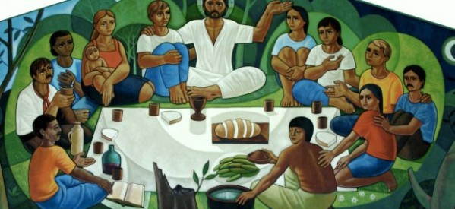

The new relationships within the Church as Communion result from the things we share, not from the things that separate us from each other. This was not the case in previous ecclesial ecosystems, which rather highlighted the differences between Church members and, consequently, brought about separation, distance, privilege, and a grandiose attitude of some members towards others. Today we are recovering the awareness of our common ground, a great treasure that makes us essentially equal to each other, as we share the same dignity, duties and rights.

Communion is a topic that repeatedly appears in the Scriptures. Indeed, as the apostolic experience of Pentecost indicates, the early Church during the first centuries stressed the deep internal bond that united her as a missionary community in the Holy Spirit. It was not a self-contained community idea, however, since communion also referred to the believers’ filial relationship with God. It is no surprise, therefore, that it has become a core dimension of Christian life including a vertical communion with the Trinitarian God and a horizontal communion within humanity.

From this perspective, we can highlight some principles and dimensions stemming from an Ecclesiology of communion: God is communion in diversity. Unity does not mean uniformity. The People of God is “a communion of life, charity and truth”. In this sense, each particular Church must be an expression of communion. There are no different missions within the Church. In fact, the mission is the same with the participation of all.

Under the light of the Church understood as communion, we no longer define her internal configuration through the threefold distinction of “clerics - religious - laity”, but through the interaction of “community - ministries and charisms”, highlighting that unity (community) precedes and grounds any difference (the ministries and charisms forming the community). Nowadays we stress the Christian condition we share and, at the same time, the free and varied initiative of the Spirit, which brings about a variety of ministries and charisms for the common good of the Church. We appreciate and endorse differences but in a complementary way and at the service of unity.

For the Church, charisms become an expression of communion regarding her mission. Because “society and the Church have an urgent need for communion: sharing and participating bring us closer to each other, lay and consecrated members in a special way, as they relate with ordained members”. Understanding the Church as communion brings about an internal dynamic we must incarnate in concrete reality. That is to say, the term communion cannot become just another word of our daily vocabulary, a simple slogan, but it must express an actual Church project. Communion aims at the union with God and others, and we need effective means to make this happen: “Our life becomes unified around Christ in the three dimensions of the charism: spirituality sends us to the mission and it engenders shared life; communion strengthens us in the mission and deepens spirituality; the mission discovers for us new facets of spirituality and makes us experience brotherhood”.

The II Extraordinary General Assembly of Bishops in 1985 offered the first programmatic statement of the Church as communion: “The ecclesiology of communion is a central and fundamental idea in the documents of the Council”. That is, the bishops endorsed the idea of communion as a key to understand the Church.
CL 55.3
Sacræ disciplinae leges.
Cf. Antonio Botana, Las familias carismáticas en la Iglesia-comunión.
Lumen Gentium, 9.
Cf. Antonio Botana, Las familias carismáticas en la Iglesia-comunión.
José María Arnaiz, Vida y misión compartidas. Laicos y religiosos hoy, PPC, Madrid, 2014, p. 24.
To better understand how the Institute is welcoming this idea, please consult the term “communion” in this same Lexicon Project: http://www.champagnat.org/330.php?a=11a&id=4
Gathered Around the Same Table, 123.

