E
VANGELIZATION
Evangelization basically means “proclaiming the Good News” of Jesus Christ. At the center of this message we find the salvation offered to everyone as a gift of grace and mercy from God (cf. EN, 27). After Vatican II, the concept of evangelization was extended to be understood not only as a mission with the purpose of “establishing the Church and its culture”, but also as the promotion of human dignity, the common good, and life at full. In this sense, it refers to the overall mission of the Church, in which everyone – laity, religious, and priests – are to bear fruit within a missionary communion, wherein the same and only Spirit calls and unites the Church to preach the Gospel to the ends of the earth (cf. CL 32). True to Christ’s wishes, the Church strives to promote the Kingdom of God, being present among people and cultures in a meaningful way in order to promote their dignity by different means:
- Giving an authentic witness to faith, hope and charity.
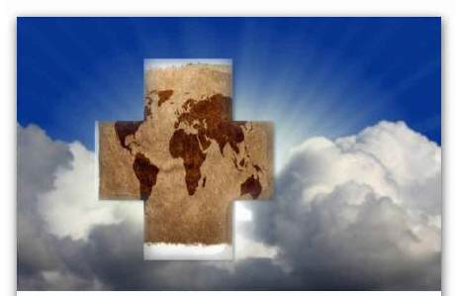
- Serving all persons and peoples.
- Promoting solidarity, justice, peace, and the common good.
- Promoting unity and dialogue between cultures, religions, and fields of knowledge.
- Praying, and performing liturgical and sacramental functions.
- Proclaiming the Gospel, the life and mission of Christ.
- Imparting catechesis and using other means to deepen the faith.
Evangelization through education is the characteristic way of evangelizing according to the Marist charism. Both in educational institutions, as through pastoral projects and informal contacts, we offer a full education, founded on a Christian vision of the human person and his/her development. For Marcellin Champagnat, the core of the Marist Mission is “making Jesus Christ known and loved.” He viewed education as a means to bring children and young people to the experience of personal faith, and make them “good Christians and good citizens”. This is now expressed through the educators’ effort to help children and young people – regardless of the faith they profess or the spiritual stage they are at – to welcome an integral formation, and become people of hope, assuming their leadership in terms of transforming the world. By promoting the Gospel values ​​through educational initiatives, Brothers and Lay Marists partake in the mission of building the Kingdom of God here and now. In fact, the Marist apostle – as every apostle in the Church, strengthened by the faith in Christ – helps to build not only an eternal hereafter, but also our concrete societies, in order to help them move into a future of hope, which is based on relationships founded on God’s love (cf. LF, 51).

Expression taken an adapted from: PROVÍNCIA MARISTA BRASIL CENTRO-SUL. Termos, Expressões e valores institucionais. São Paulo: FTD, 2010, p. 57-59.
The term Church refers to the conclusions of Vatican II: “The Church as People of God”, which amounts to any community established in Christ through the sacrament of baptism for a communion of life, charity and truth (Cf. Lumen Gentium, 9).
According to Aparecida 543, serving all peoples in the context of evangelization “entails fully assuming the radicality of Christian love, which is embodied in following Christ on the Cross (…); self-surrendering love as solution to conflict must be the ‘radical’ cultural thrust of a new society”.
In Redemptor hominis 15, John Paul II presents justice as “an essential element of the mission of the Church, inseparably united to her”. The same vision of justice is stated by article 86 of the Marist Constitutions.
In the Footsteps of Champagnat, p. 64.
Ibid.
Ibid
Ibid

