J
OINT FORMATION
Joint Formation is a particular style of formation that has been developed in response to the calls of the first International Marist Mission Assembly at Mendes in 2007 and the 2009 General Chapter. Emerging from these gatherings of Marists was an affirmation of the vocation of the Lay Marist and an identified need to provide some formation in common for all Marists which respects the differences and lifestyles of each person while at the same time promoting what is specific in each vocation and what is complementary in a Church of communion.

Joint Formation requires participants to spend time together to deepen the common Christian vocation as Marists while at the same time deepening the understanding of their specific identities and states of life. It is an experience of shared mission, shared life and shared faith experienced at both the personal and communal level. Joint Formation is a lived expression of co-responsibility and charismic vitality.

Joint Formation goes beyond the formation offered in regular staff programmes, incidental or informal experiences, or the experience of sharing in a Marist ministry. It is an invitation to live as a spiritual family who wishes to share life together and to discern the call of the Spirit through the Marist spirituality. It presupposes an itinerary or pathway but is open to the creative intuitions and gifts of participants to allow for a flexible process that is constantly being evaluated and adapted throughout. Underpinning the pathway and the formation experience itself is the commitment of making Jesus Christ the centre of our life, by living our faith in a mature way as companions travelling together, and by taking Mary as our model.
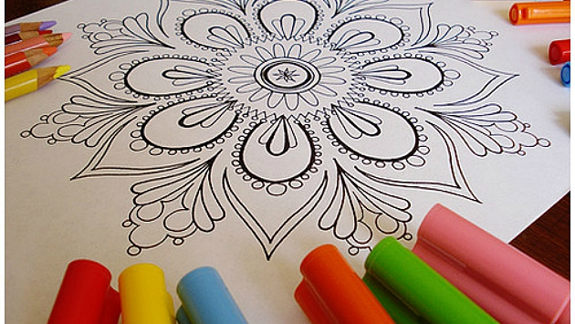

The elements of the process which give shape to the pathway of the experience are:
- Process of faith where participants strive to deepen their relationship with God with a particular reference to Marist spirituality.
- Process linked to vocation where participants discover the common ground of their Marist identity and what is specific to each one’s vocation.
- Process of mutual relationships where participants explore and experience the community dimension which is essential to ‘being Marist’.
- Process of mission where participants are invited to discover and participate as much as one can in the mission of the Institute be it in a traditional apostolate or on the ‘new horizons’ of mission.
- Process of recreating Marist life where participants reflect on the individual and group formation needed to support the vitality and viability of Marist life in themselves and others into the future.

Joint Formation offers an innovative and daring opportunity to discern new possibilities for making community, exploring new edges of mission and common solidarity projects, for ongoing vitality across the Institute, and for deepening and enriching the Marist way of being Christian as married or single lay people, brother, sister or priest.

Choose Life, 44.6
Choose Life, 29
Mendes, 1.2
Around the Same Table, 17
Around the Same Table, 156
A Guide to Animate Processes of Joint Formation, p.10
A Guide to Animate Processes of Joint Formation, p.6

