Theme: CHOSEN AND CALLED

- Presence Prayer:
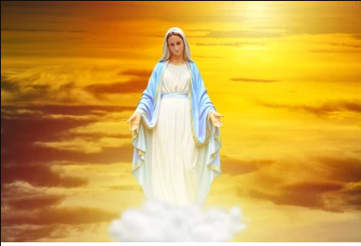
Lord, you call us each by name, choosing us to be your companions and co-workers, with great love in the hope that we will respond. This day we thank you for the grace given us and we accept again as our own, this vocation to be Marists, Brothers and Lays, to all under the care and in the spirit of Mary. Bless each of us and draw us deeper into the intimacy with you that is the goal of our calling. We celebrate and thank you for rich diversity that our Marist vocations bring to the world. We call on you, who call on us, that today we may be faithful to the grace given us. Amen.

- Greeting Mary:
Our sister, Mary, we greet you today, happy to be called Marists, to be heirs to the charism that you gave to Marcellin, our Founder. May his love for Jesus, his love for you, his enthusiasm to reach out to young people in need and those at risk, permeate our lives today. Walk alongside us as we carry out our mission. Make us conscious of the Lord’s presence, surrounding us, within us and within those we meet. May the Marist goal of making Jesus and you known and loved, become more real, more vital in our lives.

- Song: Here I am Lord

- Scripture Reading: Jeremiah 1:4-10

- Reading and Reflection:
- God chooses us individual men and women and calls each of them by name. He leads them into the desert and there speaks to their hearts. Those who heed him, he sets apart. By his Spirit he transforms them constantly, leading them more and more deeply into his love in order to send them forth on mission (pause).
- Thus, is born a covenant of love in which God gives himself to the person and the person to God – a covenant which the Scriptures speak of as a betrothal. From the heart of this covenant flows the whole dynamic of the consecrated life (pause). (Constitutions 11)
- Spirit of God, I feel a quiet stirring with me. It is the call to enter more fully into the life that you offer to me in my calling to be a Marist Brother (Lay Marist), to be energized and vivified in the wonder of the vocation given to me. It is my heart yearning for living at a deeper level of relationship with you, with my Brothers, Sisters and with those that you send us to.
- Lord I need a heart that is not held back by routine and the drag of the ordinary but is fresh with enthusiasm and energy in the wonder of what is given to me. Create in me a vibrant spirit that appreciates more and more the richness of the covenant that you have established between us.

- Intercessions:
Response: LORD, HEAR OUR PRAYER AND BLESS OUR VOCATIONS!
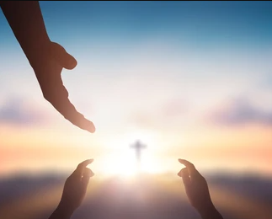
- Both Jesus and Marcellin, chose to invite their followers to communion and community. Jesus expressed this invitation at the last supper with his disciples. The table of the Lord has since become a central symbol of communion and self-giving for Christianity. For the community today that Marcellin created, the table at La Valla is also a powerful symbol of family and service. R
- Such spirituality enables us to ‘feel-with’ our brothers and sisters… This spirituality helps us to recognize that a group of individuals can grow into a community with one heart and one mind. R
- Marcellin shows us how we are to form and live in communities of mission. In the very name he chose, Little Brothers of Mary, Marcellin summarizes the fundamental identity of his community: the gospel virtue of simplicity, the call to fraternity, and the contemplation of the person of Mary. This identity is particularly expressed in the practice of the little virtues. R
- We are blessed with the gift of life and with companions for our mission and our life’s journey. Life together supports and challenges us to be a community of mission. In ministry we find ourselves, like Jesus, broken open for our brothers and sisters. Truly, we are bread of life for others as Jesus has been for us. R
- As for Marcellin and the first Brothers so also for us, Mary inspires the style of our fraternal relationships. Mary inspired in the first Marists a new vision of being Church which was modelled on that of the first Christians. Shared faith enables us to see beyond problems and differences. R
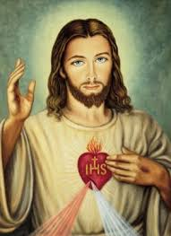
- Living as sisters and brothers offers a hopeful and caring means by which our differences enrich our communion. Marist fraternity becomes a sign of hope for the world with a growing need for tolerance and peace. Communities that are multicultural invite us to share in the richness of other traditions and faiths. R

- The Lord’s Prayer

- Final Prayer:
Lord, we pray You, send laborers into your field for the enemy ravages the harvest. Raise up men and women who will tend and garner it. Among the youth confided to our care, show us those of your choice, that knowing them, we may form them to labor for You. O Mary our Mother, you are the superior and guardian of this Institute. You have gathered us under your banner to promote the glory of your divine Son, notwithstanding the opposition of the world. If you do not come to our aid, we shall fail and, like a lamb without oil, become extinguished. But if this work perishes, it is not our work that fails, but yours, for you have done everything for us. We therefore trust in your powerful protection, and we shall trust in it always. Amen. (Marcellin Champagnat).

- Invocations:
St Marcellin, our beloved Founder: help us to have a greater appreciation of the beauty of our calling.
Mary, you chose us, gave us your name and spirit: strengthen us in our vocations.

- Ending hymn: Be not afraid
&&&&&&&&&&&
Scripture Reading: Jeremiah 1:4-10
Now the word of the Lord came to me saying, 'Before I formed you in the womb I knew you, and before you were born, I consecrated you; I appointed you a prophet to the nations.' Then I said, 'Ah, Lord God! Truly I do not know how to speak, for I am only a boy.' But the Lord said to me, 'Do not say, "I am only a boy"; for you shall go to all to whom I send you, and you shall speak whatever I command you. Do not be afraid of them, for I am with you to deliver you, says the Lord.' Then the Lord put out his hand and touched my mouth; and the Lord said to me, 'Now I have put my words in your mouth. See, today I appoint you over nations and over kingdoms, to pluck up and to pull down, to destroy and to overthrow, to build and to plant.'
I. Song: Here I am Lord

I the Lord of sea and sky
I have heard my people cry
All who dwell in dark and sin
My hand will save.

I who made the stars of night
I will make their darkness bright
Who will bear my light to them?
Whom shall I send?

Here I am Lord, Is it I Lord?
I have heard you calling in the night
I will go Lord, If you lead me,
I will hold your people in my heart.

I, the Lord of snow and rain
I have borne my people's pain
I have wept for love of them
They turn away.

I will break their hearts of stone
Give them hearts for love alone
I will speak my words to them
Whom shall I send?

Here I am Lord, Is it I Lord?
I have heard you calling in the night
I will go Lord, If you lead me
I will hold your people in my heart.

I, the Lord of wind and flame
I will tend the poor and lame
I will set a feast for them
My hand will save.

Finest bread I will provide
'Til their hearts be satisfied
I will give my life to them
Whom shall I send?

Here I am, Lord. Is it I, Lord?
I have heard you calling in the night
I will go, Lord, if you lead me
I will hold your people in my heart.

II. Song: Be not afraid

You shall cross the barren desert
But you shall not die of thirst
You shall wander far in safety
Though you do not know the way
You shall speak your words to foreign men
And they will understand
You shall see the face of God and live.

Be not afraid
I go before you always
Come, follow me and I will give you rest.

If you pass through raging waters in the sea
You shall not drown
If you walk amid the burning flames
You shall not be harmed
If you stand before the power of hell
And death is at your side
Know that I am with you through it all.

Be not afraid
I go before you always
Come, follow me and I will give you rest.

And blessed are your poor
For the kingdom shall be theirs
Blest are you that weep and mourn
For one day you shall laugh
And if wicked men insult and hate you
All because of me
Blessed, blessed are you.

Be not afraid
I go before you always
Come, follow me and I will give you rest.

