PRAYER GUIDE 1
Called to be God’s seekers
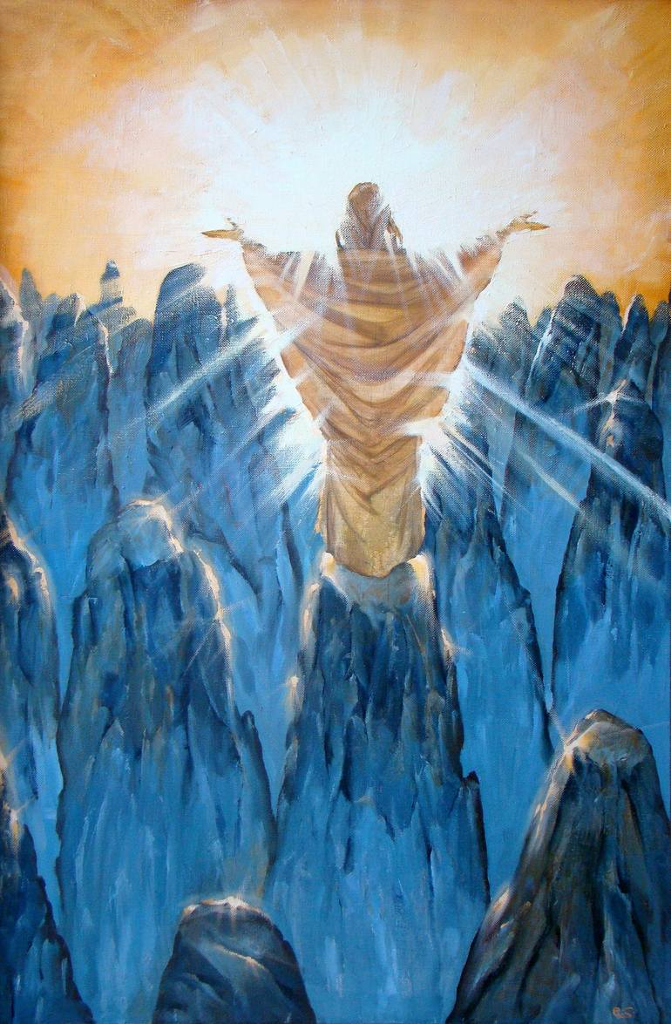
A call to prayer: Everyone moved by the spirit (Carey Landry).
Everyone moved by the spirit is the son and daughter of God.
Led by the power of his love,
We will live in the light of the Lord,
We will live in the light of the Lord.

Come spirit of Jesus;
Come with the power of his name,
Renew the depths of our heart.

Come spirit of Jesus
Send forth the power of your love,
Renew the face of the earth.

Introductory message
From Rule of life art.1
(To be read slowly but with an urging tone)
BROTHER, take heed as you set out on your journey and listen to Jesus who invites us to “Come and see” (Jn 1:39). Your call to brotherhood contains an element of mystery; accept it as a gift. Take on the attitude of a pilgrim each day and discover that the path that you trod transforms your way of looking at life as well as your understanding of it. Come now, live with the Lord. Allow yourself to be guided by the Master. Like his earliest followers, never forget the moment when Jesus first touched your heart and called forth your deepest and most authentic self.

God’s word: Isaiah 43. 1-7.
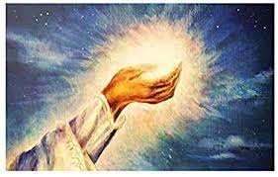
(The leader may not take the full text)
But now, this is what the Lord says—
he who created you, Jacob,
he who formed you, Israel:
“Do not fear, for I have redeemed you;
I have summoned you by name; you are mine.
When you pass through the waters,
I will be with you;
and when you pass through the rivers,
they will not sweep over you.
When you walk through the fire,
you will not be burned;
the flames will not set you ablaze.
3 For I am the Lord your God,
the Holy One of Israel, your Savior;
I give Egypt for your ransom,
Since you are precious and honored in my sight,
and because I love you,
I will give people in exchange for you,
nations in exchange for your life.
Do not be afraid, for I am with you;
I will bring your children from the east
and gather you from the west.
I will say to the north, ‘Give them up!’
and to the south, ‘Do not hold them back.’
Bring my sons from afar
and my daughters from the ends of the earth—everyone who is called by my name,
whom I created for my glory,
whom I formed and made.”

Echoing God’s word in THE heart
(Take time to savor God’s word in your heart)
(The leader may play a soft background music)
SHARING EXPERIENCES
(Each community member will share his moments of joy of being consecrated to God in the Institute of the Marist Brothers.)
Concluding prayer
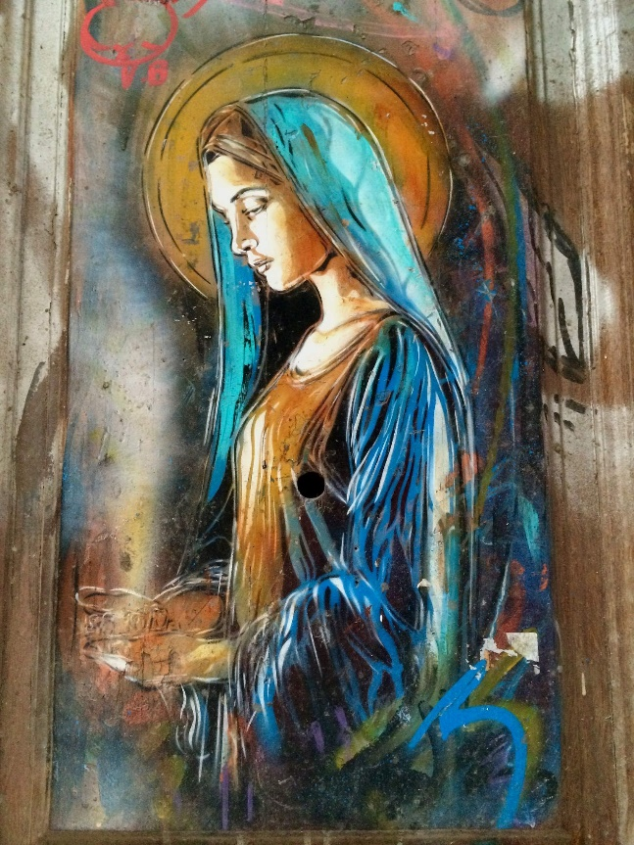
MARIST LITANY TO MARY
Mary, wellspring of peace: be our source of consolation.
Model of courage: be our example.
Model of risk-taking: be our inspiration.
Model of perseverance: be our strength.
Mar y, our Good Mother: lead us to Christ.
Woman of mercy: teach us to be merciful.
Woman of faith: help us in our unbelief.
Woman of vision: open our eyes.
Comforter of the afflicted: give us a heart of compassion.
Cause of our joy: lead us to life.
Sign of contradiction: help us in uncertainty.
Woman of wisdom and understanding: gift us with knowledge.
Ordinary Resource: protect and guide us.
Woman pregnant with hope: be our source of new life.
First disciple: show us the way.
Fellow pilgrim: accompany us on life’s journey.
Seeker of God’s will: help us to do the same.
Mary, our companion and guide: be with us. Amen.

