PRAYER GUIDE 2
Brotherhood, the gift we receive, and we give away
Preparation: Before you begin, gather a pitcher full of warm water, basin, towel and lotion. You may want to add bath soap to the water. The leader invites all to sit comfortably in a circle.

INTRODUCTION
Leader reads:
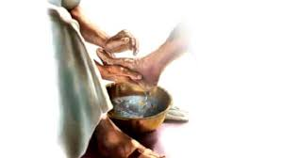
On the night of the Last Supper, Jesus demonstrated how we - His disciples - are to act towards one another and the world. He performed a pure act of love and service – and He calls us Brothers to do the same. We can shy away from this ritual – ashamed of our feet, uncomfortable. Allowing our feet to be washed, accepting that service, can be more difficult than being the washer.
Let us overcome our hesitation and let us give those with whom we live the gift of love and service by washing each other’s feet and allowing ours to be washed.

God’s word: Jesus Washes His Disciples’ Feet
It was just before the Passover Festival. Jesus knew that the hour had come for him to leave this world and go to the Father. Having loved his own who were in the world, he loved them to the end. The evening meal was in progress, and the devil had already prompted Judas, the son of Simon Iscariot, to betray Jesus. Jesus knew that the Father had put all things under his power, and that he had come from God and was returning to God; so he got up from the meal, took off his outer clothing, and wrapped a towel around his waist. After that, he poured water into a basin and began to wash his disciples’ feet, drying them with the towel that was wrapped around him. He came to Simon Peter, who said to him, “Lord, are you going to wash my feet?”
Jesus replied, “You do not realize now what I am doing, but later you will understand.” “No,” said Peter, “you shall never wash my feet. ”Jesus answered, “Unless I wash you, you have no part with me.” “Then, Lord,” Simon Peter replied, “not just my feet but my hands and my head as well! ” Jesus answered, “Those who have had a bath need only to wash their feet; their whole body is clean. And you are clean, though not every one of you.” For he knew who was going to betray him, and that was why he said not everyone was clean.
When he had finished washing their feet, he put on his clothes and returned to his place. “Do you understand what I have done for you?” he asked them. “You call me ‘Teacher’ and ‘Lord,’ and rightly so, for that is what I am. Now that I, your Lord and Teacher, have washed your feet, you also should wash one another’s feet. I have set you an example that you should do as I have done for you.

Washing of feet:
(Wash feet carefully and lovingly.)
(The leader may start. You may wish to anoint each other’s feet with lotion. Make sure every member gets a chance to wash and be washed.)(Soft music may be played during the washing of feet.)
Sharing:
(Members share their reflections about the many ways they wash each other’s feet in the community.)
SPIRITUAL TESTAMENT:
(Leader reads the excerpt from Spiritual testament of Father Champagnat: one paragraph about charity only, pp. 124-125 of Wherever you go-RULE OF LIFE)

CLOSING PRAYER:
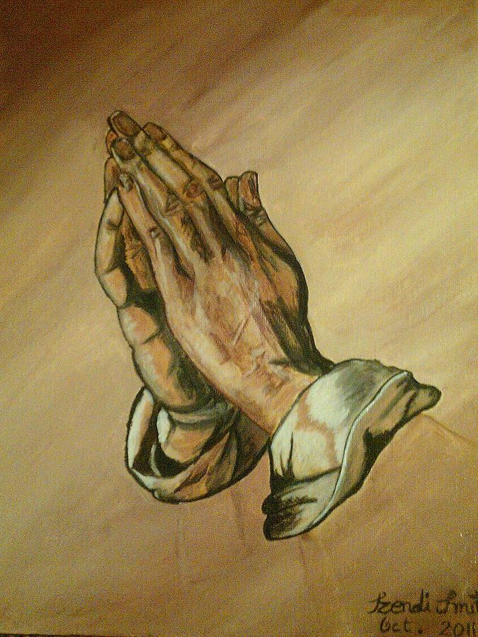
A Covenant Psalm
Wherever you go, I will go.
I will love and serve beside you.
And, together we will go with God.
Blessed be God who helps us transcend
into what must be said
and what must be heard
in the Spirit-charged intensity
of a changing world rooted in tradition and hope.
Wherever you stay, I will stay,
content and sure around you.
Your hopes will be the source of my hope
And together we will hope in God.
Blessed be God who unites two streams
to form one active current together,
enriching the lives of all on whom
our fullness overflows.
Wherever you are, I will be
loving and serving beside you.
Respecting and living within our differences,
uniting and serving within our sameness.
Your dreams will be my energy
and our future will be with God.
Holy One.... Wherever you go, we will go.
Wherever You Are, there we will be.
Your Love is all-encompassing
and that is enough for us. Amen.

