REDISCOVERING THEIR ORIGINAL PASSION AND REAPPRECIATION OF THEIR VOCATION AS MARISTS

OPENING PRAYER.
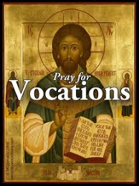
Our Loving Father. We give thanks to you for our vocation as a Marists. You are also calling us to renew our vocation and rekindle our passion for you and your people. Send us and blow us your Holy Spirit to make our heart be burning again. We make this prayer through our brother Jesus Christ your Son. Amen

Reading from the Acts of Apostles Chapter 10

THE VISION OF CORNELIUS.

Now in Caesarea there was a man named Cornelius, a centurion of the Cohort called the Italica, devout and God-fearing along with his whole household, who used to give alms generously to the Jewish people and pray to God constantly. One afternoon about three o’clock, he saw plainly in a vision an angel of God come into him and say to him, “Cornelius.” He looked intently at him and seized with fear, said, “What is it, sir?” He said to him, “Your prayers and almsgiving have ascended as a memorial offering before God. Now send some men to Joppa and summon one Simon who is called Peter. He is staying with another Simon, a tanner, who has a house by the sea.” When the angel who spoke to him had left, he called two of his servants and a devout soldier from his staff, explained everything to them, and sent them to Joppa.

THE VISION OF PETER.

The next day, while they were on their way and nearing the city, Peter went up to the roof terrace to pray at about noontime. He was hungry and wished to eat, and while they were making preparations he fell into a trance. He saw heaven opened and something resembling a large sheet coming down, lowered to the ground by its four corners. In it were all the earth’s four-legged animals and reptiles and the birds of the sky. A voice said to him, “Get up, Peter. Slaughter and eat.” But Peter said, “Certainly not, sir. For never have I eaten anything profane and unclean. “The voice spoke to him again, a second time, “What God has made clean, you are not to call profane.” This happened three times, and then the object was taken up into the sky. While Peter was in doubt about the meaning of the vision he had seen, the men sent by Cornelius asked for Simon’s house and arrived at the entrance. They called out inquiring whether Simon, who is called Peter, was staying there. As Peter was pondering the vision, the Spirit said [to him], “There are three men here looking for you. So, get up, go downstairs, and accompany them without hesitation, because I have sent them.” Then Peter went down to the men and said, “I am the one you are looking for. What is the reason for your being here?” They answered, “Cornelius, a centurion, an upright and God-fearing man, respected by the whole Jewish nation, was directed by a holy angel to summon you to his house and to hear what you have to say.” So he invited them in and showed them hospitality. The next day he got up and went with them, and some of the brothers from Joppa went with him.

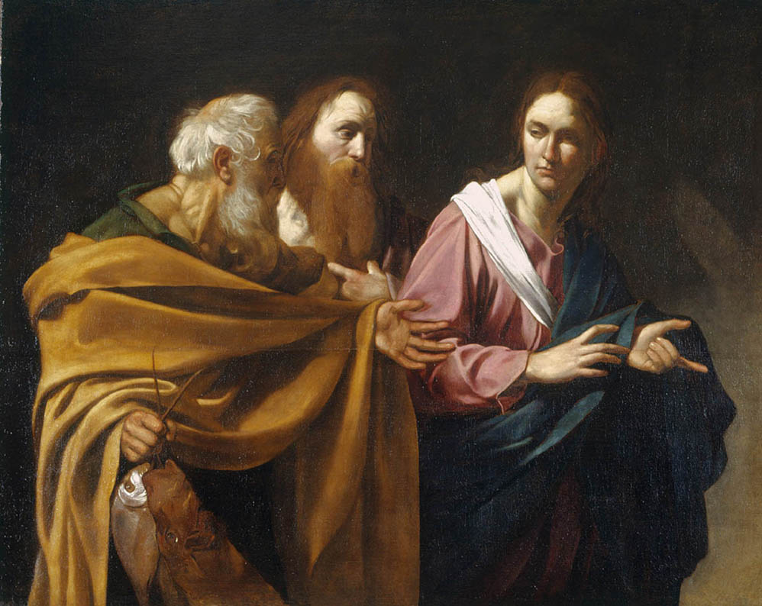
On the following day he entered Caesarea. Cornelius was expecting them and had called together his relatives and close friends. When Peter entered, Cornelius met him and, falling at his feet, paid him homage. Peter, however, raised him up, saying, “Get up. I myself am also a human being.” While he conversed with him, he went in and found many people gathered together and said to them, “You know that it is unlawful for a Jewish man to associate with, or visit, a Gentile, but God has shown me that I should not call any person profane or unclean. And that is why I came without objection when sent for. May I ask, then, why you summoned me?”
Cornelius replied, “Four days ago at this hour, three o’clock in the afternoon, I was at prayer in my house when suddenly a man in dazzling robes stood before me and said, ‘Cornelius, your prayer has been heard and your almsgiving remembered before God. Send therefore to Joppa and summon Simon, who is called Peter. He is a guest in the house of Simon, a tanner, by the sea. ‘So I sent for you immediately, and you were kind enough to come. Now therefore we are all here in the presence of God to listen to all that you have been commanded by the Lord.”

PETER’S SPEECH.

Then Peter proceeded to speak and said, * “In truth, I see that God shows no partiality. Rather, in every nation whoever fears him and acts uprightly is acceptable to him. You know the word [that] he sent to the Israelites as he proclaimed peace through Jesus Christ, who is Lord of all, what has happened all over Judea, beginning in Galilee after the baptism that John preached, how God anointed Jesus of Nazareth with the holy Spirit and power. He went about doing good and healing all those oppressed by the devil, for God was with him. We are witnesses of all that he did both in the country of the Jews and (in) Jerusalem. They put him to death by hanging him on a tree. This man God raised (on) the third day and granted that he be visible, not to all the people, but to us, the witnesses chosen by God in advance, who ate and drank with him after he rose from the dead. He commissioned us to preach to the people and testify that he is the one appointed by God as judge of the living and the dead. To him all the prophets bear witness, that everyone who believes in him will receive forgiveness of sins through his name.”

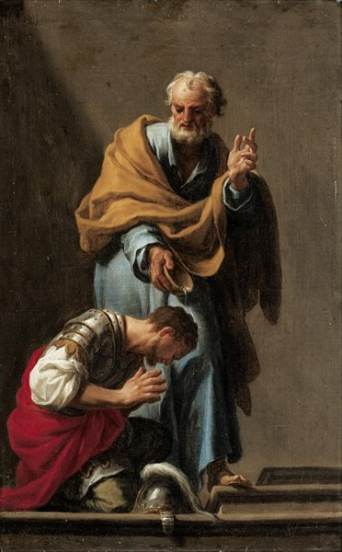
THE BAPTISM OF CORNELIUS.

While Peter was still speaking these things, the holy Spirit fell upon all who were listening to the word. The circumcised believers who had accompanied Peter were astounded that the gift of the holy Spirit should have been poured out on the Gentiles also, for they could hear them speaking in tongues and glorifying God. Then Peter responded, “Can anyone withhold the water for baptizing these people, who have received the holy Spirit even as we have?” He ordered them to be baptized in the name of Jesus Christ. Then they invited him to stay for a few days.

TAKE A MOMENT TO REFLECT THE STORY.

Guiding question

1. When the story happened, Peter already experienced Jesus’ resurrection and the receiving of the Holy Spirit. However, as the story mentioned, he also needed to be renewed and reoriented his mission and ideas. In your life, have you ever experienced such renewal?

2. In the story, God called Cornelius and Peter became the instrument for the baptism of him. Have you ever been an instrument for such mission or guide the people to believe Jesus, like Peter, which event also make to grow in your religious life?

TAKE TIME TO SHARING YOUR THOUGHTS.

Closing: You may wish to pray your own prayer or listen to the Song “Make me a channel of your peace. (Prayer of St. Francis)”

Make me a channel of your peace.
Where there is hatred, let me bring your love.
Where there is injury, your pardon, Lord,
And where there's doubt, true faith in you.

Make me a channel of your peace.
Where there's despair in life, let me bring hope.
Where there is darkness, only light,
And where there's sadness, ever joy.

Oh, Master, grant that I may never seek
So much to be consoled as to console.
To be understood as to understand.
To be loved as to love with all my soul.

Make me a channel of your peace.
It is in pardoning that we are pardoned,
in giving of ourselves that we receive,
and in dying that we're born to eternal life.

