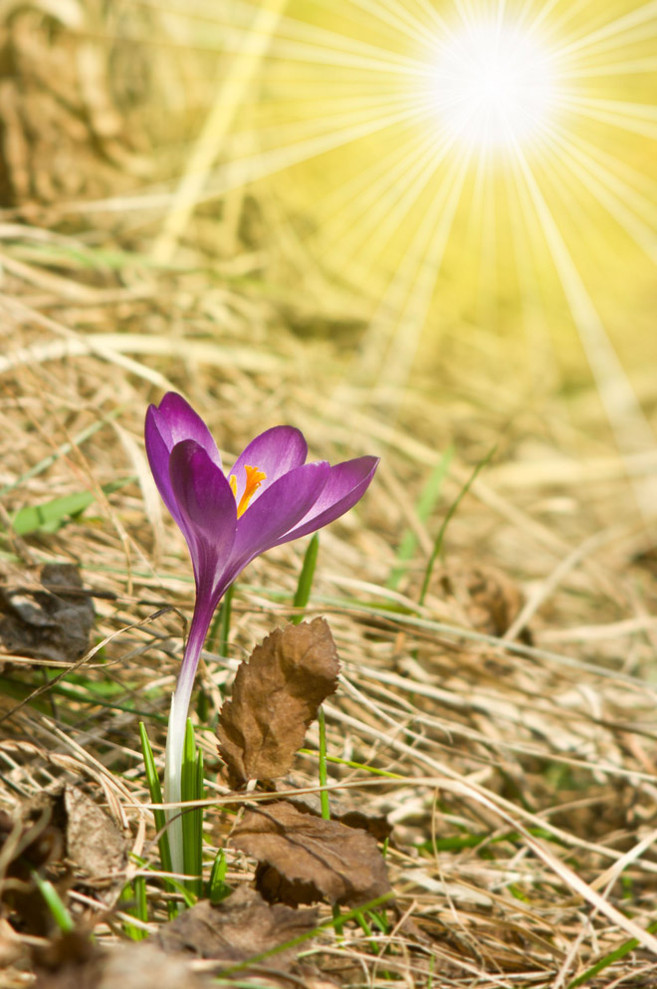
Marist Vocation Ministry
Prayer Guide

CALLED TO BE A
LIFE-GIVING LIGHT

“‘Let there be light’; and there was light… And God saw that the light was good.”
Genesis 1: 3-4

Introduction:
In the midst of growing darkness in the world, let there be light!
And there was light through Jesus who enlightens the world and called us to be a light too… “You are the light of the world. A city set on a hill cannot be hidden (Mt. 5:14).” Those who receive Christ in their life receive light and are called to enlighten the world in varied ways. There are homes of light that this little light is taken cared so it will grow and shine brightly giving warmth and life into the world.
Opening Song: https://www.youtube.com/watch?v=Sgm9lkTNQmc

You are Mine by David Haas
I will come to you in the silence
I will lift you from all your fear
You will hear My voice
I claim you as My choice
Be still, and know I am near
I am hope for all who are hopeless
I am eyes for all who long to see
In the shadows of the night,
I will be your light
Come and rest in Me
Do not be afraid, I am with you
I have called you each by name
Come and follow Me
I will bring you home
I love you and you are mine
I am strength for all the despairing
Healing for the ones who dwell in shame
All the blind will see, the lame will all run free
And all will know My name
Do not be afraid, I am with you
I have called you each by name
Come and follow Me
I will bring you home
I love you and you are mine
I am the Word that leads all to freedom
I am the peace the world cannot give
I will call your name, embracing all your pain
Stand up, now, walk, and live
Do not be afraid, I am with you
I have called you each by name
Come and follow Me
I will bring you home
I love you and you are mine
Do not be afraid, I am with you
I have called you each by name
Come and follow Me
I will bring you home
I love you and you are mine

Opening prayer: Gracious loving Father, the whole creation praises you!
Every living thing you have created with a purpose.
In our journey filled with uncertainties and complexities,
Help us know our place here on earth.
Make our ears be attentive to your gentle voice speaking within
To discover your divine will for us.
This we pray through Christ our Lord. Amen.
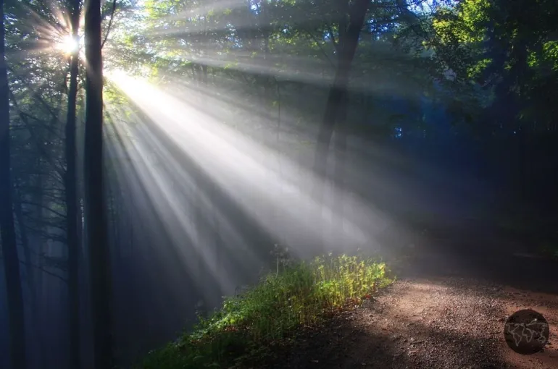

- Guiding Light
Reading: Matthew 2:1-12 ‘The Visit of the Wise Men’

Moment of Silence

Reflection:
Like the Magi, countless people, in our own day, have a “restless heart” which continues to seek without finding sure answers – it is the restlessness of the Holy Spirit that stirs in hearts. They too are looking for a star to show them the path to Bethlehem.

How many stars there are in the sky! And yet the Magi followed a new and different star, which for them shone all the more brightly. They had long peered into the great book of the heavens, seeking an answer to their questions – they had restless hearts –, and at long last the light appeared. That star changed them. It made them leave their daily concerns behind and set out immediately on a journey. They listened to a voice deep within, which led them to follow that light. It was the voice of the Holy Spirit, who works in all people. The star guided them, until they found the King of the Jews in a humble dwelling in Bethlehem.

Questions for Reflection:
- Who are the people in my life who guide me to know Jesus in my life?
- What are the changes in my life as I encounter Jesus?
Prayer: Lord Jesus, we thank you for the guiding light that leads us see your face
For our heart is restless until it finds rest in you.
Renew us O Lord as we encounter you.
Let us be receptive to your gentle voice and
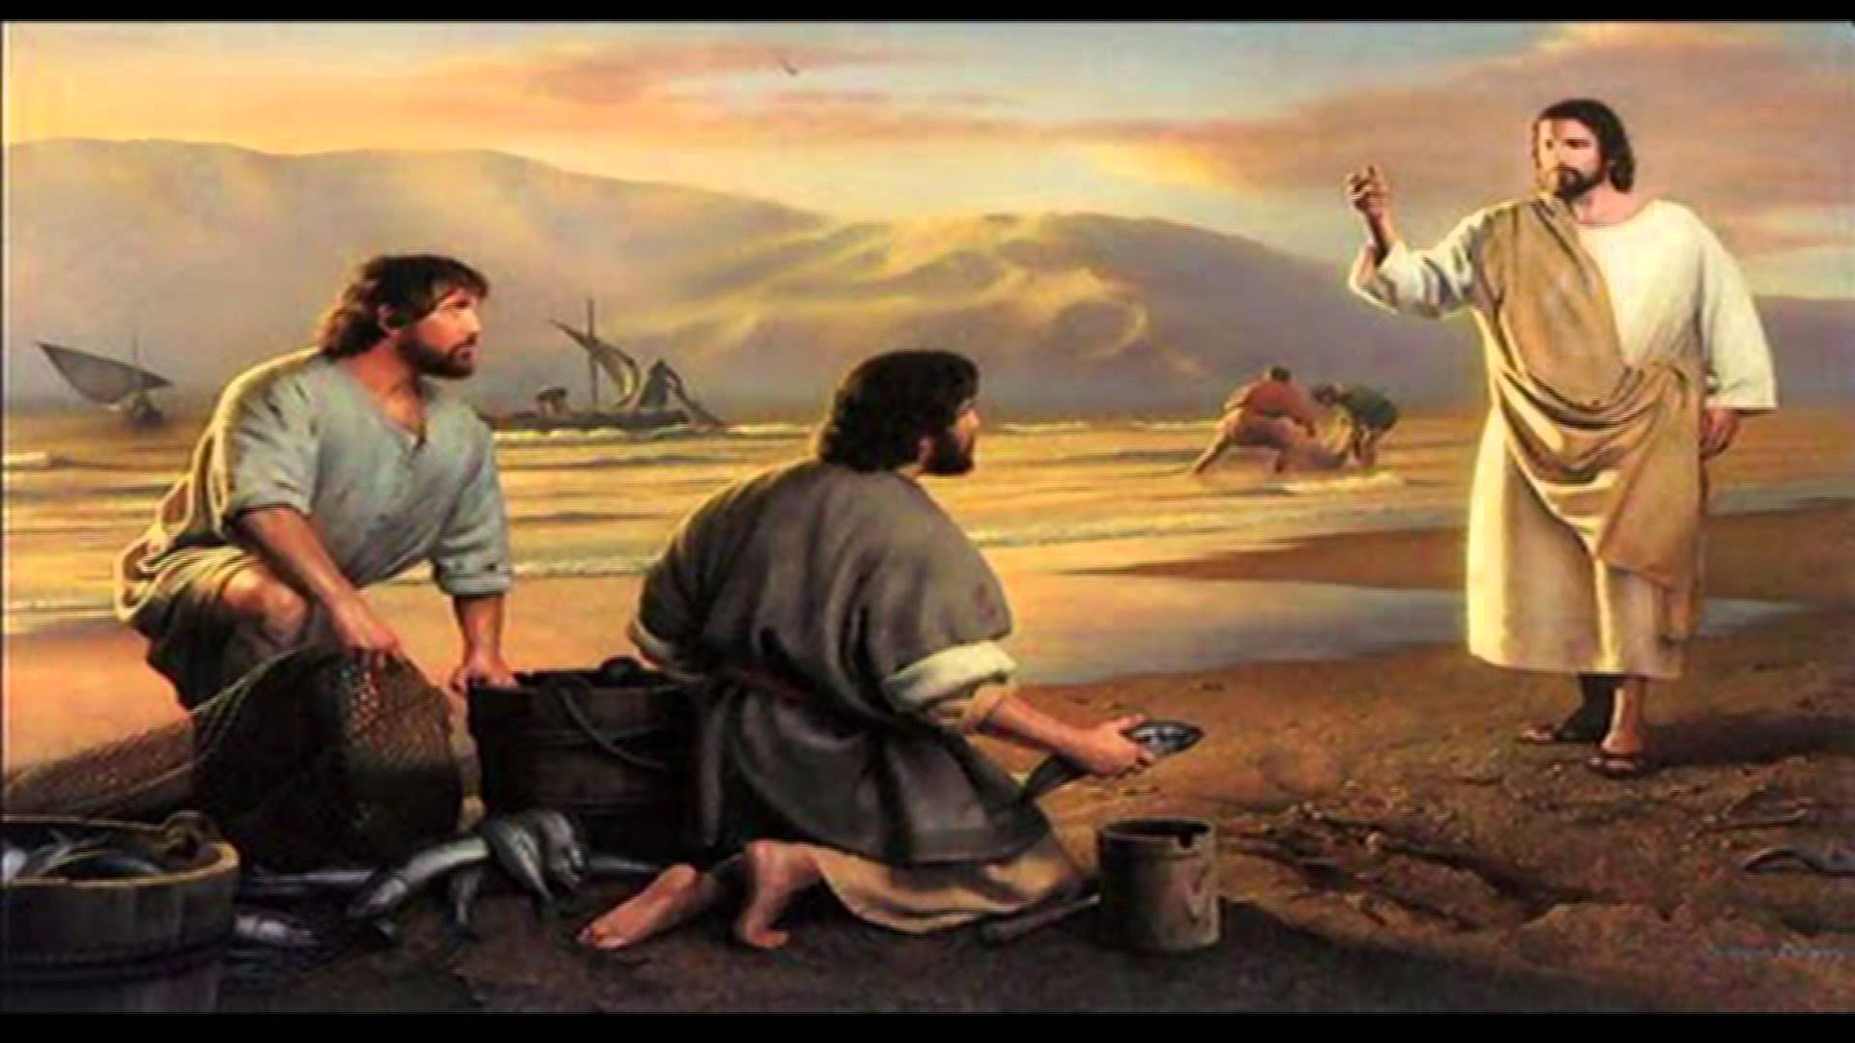
Make us a guiding light that points out a pathway towards you. Amen.

- Called to Become Light of the World
Reading: Matthew 4: 18-23; 5: 14-16 ‘Jesus Calls the First Disciples and to be Light of the World’
Moment of Silence
Questions for Reflection:
- How do I respond to the call of God to follow Him?
- How can I become a light to the world?

Reflection: Each of us is called by Christ to follow him that he may be able to teach us his ways and to respond to his call to become the light of the world. Mary the first disciple of Jesus is the quintessence of a perfect disciple who was first to be evangelised. “In the heart of the Church, Mary shines forth. Today, (this young woman) Mary is the Mother who watches over us, her children, on our journey through life, often weary and in need, anxious that the light of hope not fail. For that is our desire: that the light of hope never fail…”
Prayer:
Lord Jesus, grant us the grace to follow you unreservedly.
Like Mary our mother, may our heart so free and full of God
And that the light of God could be seen,
a light streaming out from within. Amen
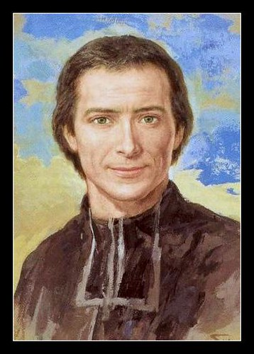
- Marcellin, a Man of Light and a Builder of ‘Homes of Light’
From the circular letter of Bro. Ernesto Sanchez Barba, fms
entitled Homes of Light: Caring for Life. Generating New Life

We could envisage the whole of Marcellin Champagnat’s life as a light shining in the midst of the dark circumstances of his times. A light shining in the midst of young people to whom he gave priority and preferential consideration and attention when he founded the Institute and set about his evangelizing ministry. A light in the midst of his brothers, with whom he formed a close-knit community, trying to create, from the very beginning, homes of light. A light among his fellow priests, showing the motherly face of the Church, wearing an apron, rolling up his sleeves…

There is a symbolic story that Br Jean Baptiste tells about Marcellin Champagnat as a new-born baby He says that Marcellin’s mother, “several times, on approaching the cradle where baby Marcellin was lying, noticed a kind of luminous flame which seemed to issue from the child’s chest”.11 I want to stay with the idea that the author puts forward by referring to a “luminous flame”, without going into the historicity of the event, but noting, rather, the strong symbolism that is conveyed. Marcellin was a much-loved child, brought up in a home in which the presence and influence of his parents, his aunt, his brothers and sisters had a marked effect on his life. This was the home where the foundations
were laid for him to discover his call to be a light for the world (cf Mt 5: 14), to be that luminous flame that young people, the brothers, and so many other people had the occasion to experience on meeting Champagnat. His life radiated life and this luminous flame continues to burn amongst us

At the beginning of his life, when the symbol of a luminous flame was mentioned, he had a loving, pious mother at his side, and he was embraced in the warmth of the family home. During his lifetime, in all its difficulties and problems, he discovered the constant luminous flame of Mary in his life. In his final moments, there was a lit lamp which was going out before his eyes, while the brothers were singing the Salve, forming their home around Mary. It was a Saturday, the day dedicated to our Good Mother.

This light accompanied him all through life. He lived with trust. He did not doubt for an instant that his life and mission were the work of God, the work of Mary. He never put himself forward as the leading actor, but in all things, gave glory and praise to the Lord, seeing himself as the Lord’s servant. He always lived under the motherly protection of Mary and often had recourse to her.

This life gave him a spirit of daring. He was always attentive to discern the voice of God in the events
of life and in his personal prayer. His boldness made him open and flexible to develop new responses without getting bogged down in pre-determined schemes. He gave himself to the education and evangelization of youth, giving priority attention to the most abandoned. He did all this while building up a spirit of brotherhood, forming homes of light. He had the intuition that the witness of a group is always more powerful than that of an individual. We Marists of Champagnat have these and other characteristics that Marcellin gave us in our DNA. They continue to light up our path today.

Moment of Silence

Questions for Reflection:

- What is home for me?
- In your life, cite some places, or experiences that you feel being at ‘homes of light’.
- What kind of light do I want to be?

Prayer: Lord Jesus, you have commanded us to be light of the world. Your servant St. Marcellin Champagnat responded to your call and was a testimony of your light. Marcellin’s flame that was burning for love to care for young people to draw them close to you had attracted other brothers to be a servant in this special call. The light that he had received has been continually forming ‘homes of light’ caring for life and generating new life. May the flame that you entrusted to Marcellin passed on to his brothers may shine forth brightly. That many young men will become attracted to the call of education and evangelization of youth and loving service to the most abandoned. The harvest is great but the laborers are few. Send more workers to your vineyard to help in the work of salvation. Grant us the courage Lord to show the light that is kept hidden that all may see your good works and give glory to the Father. Amen

- MARIST BROTHERS INSTITUTE as “Homes of Light”

Video Presentation about Marist Brothers: https://www.youtube.com/watch?v=KoDbcljp5CI

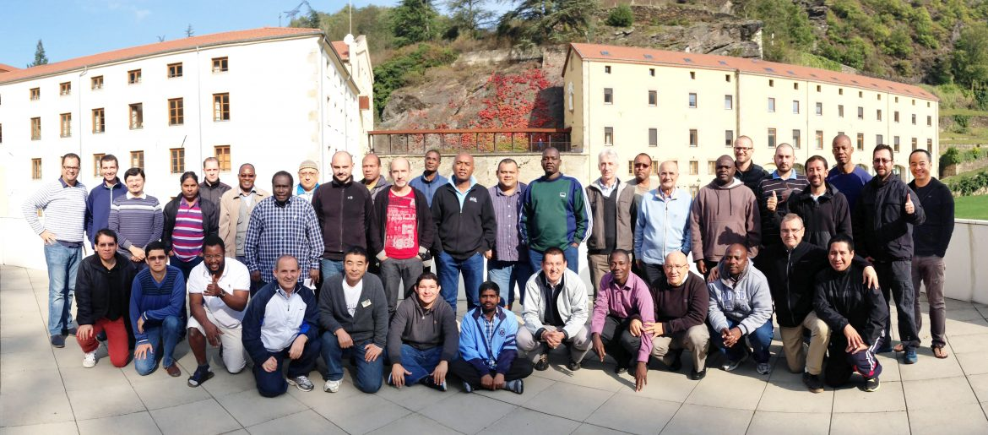

- Presentation of the History, Charisms, Formation and Missionary Activities of Marist Brothers Community
Intercessory Prayer

Loving Mother, your name engraved into the hearts of your Marist children.
How blessed are they that their lives are entrusted by Jesus to your motherly care. You have been their constant companion and model on how to care for young people and to live as brothers and sisters in the community in family spirit with tenderness, warmth, and affection. Draw them ever close to your Son Jesus that they will be more faithful witnesses of the light of Christ into the world filled with darkness. May you touch the hearts of young people Mother Mary to respond to the call of God in order for them to find meaning in their existence, experience life in its fullness and joy in his presence. Unite us that we may be one as a family journeying together towards the Kingdom of God where God the Father, Son and Holy Spirit reign forever and ever. Amen.

Notre Dame, pray for us.
St. Marcellin pray for us.

Closing Song: Shine Jesus Shine https://www.youtube.com/watch?v=jmDTi9rgYYw or any Christian songs about Christ being light of the world.

Pope Francis' Homily for Epiphany Celebration; Angelus Address, January 6, 2016. https://slmedia.org/blog/pope-francis-homily-for-epiphany-celebration-angelus-address
Ibid, n 48

