**Make me a heart of clay,**

**breaks the heart of stone,**

**give it all the twists and turns it takes,**

**but do it your way.**

**Give me a simple heart,**

**make me a heart like yours,**

**use any shape you want,**

**but make it just like yours.**

**As you wish, sir,**

**How do you want it to be?**

**Shape it Jesus,**

**do it your way.**

**May I have your patience, your love,**

**that I may have your will,**

**that I may have your freedom, that peace with God may reign,**

**that I may have what I lack, that I may have more than what I do not have,**

**make me a heart of clay, that's all I want.**

**May I have your simplicity always so full of light,**

**forgive as you forgive, look how well you do it,**

**make me a child's heart, a clean and pure heart,**

**turn it over with your hands**

**and make me a heart like yours.**

**YEAR OF VOCATIONS**

**HEART OF CLAY**

**(TAPHERS)**

**WELCOME**

**1.-**

WHAT IS IT THAT MAINTAINS AND SUSTAINS MY VOCATION?

Welcome, in this year that we celebrate vocations, especially for us Marists, we begin our moment, reflecting interiorly on our "YES", having felt moulded by the Lord.

**SONG**

**2.-**

SONG: "CORAZÓN DE BARRO" (HEART OF MUD)

**3.-**

**ACTIVITY**

Feeling that our heart is made of clay, that it was moulded by the hands of the Lord, we discover in our beginnings, remembering that vocational spark that ignited and awakened in me and generated a process in the journey of religious life...........

(hand out coloured plasticine to each person, as many as needed)

**He cut the rock, he made brothers by raising a house, a family of work and praise, by example he built fraternity.**

**But it was God, who lived in this man's body, who listened, smiled and gave strength to walk.**

**Because man without God**

**is not its own master.**

**For man without God knows defeat.**

**And the fact is that man without God cannot walk (2).**

**They fought him and disputed his idea of madness, discouraged his enthusiasm, and opposed him; he had no one to fight on his behalf.**

**But it was God, who supported this man's every step, who watched over and disproved the proud and charlatan.**

**He ran the mountains, tasted the fatigue and the taste of sweat.**

**The villager received his blessings, gave him his bed and he slept in the doorway.**

**But it was God**

**that illuminated the heart of this man,**

**and held out hope for the poor homeless...**

**4.-**

**PERSONAL TIME**

In a determined space, to invite each person to give shape with plasticine, to that dream that guided my vocation and has given me light.

**CUT THE ROCK**

**(KAIROI)**

**5.-**

**ISSUE**

Observing the shape, I have made of the plasticine, I see its colours, its features, its way of being and being, and I wonder:

Has it mutated, has it changed, is it another dream that sustains me to keep on walking?

**SHARE**

**6.-**

Celebrating the life of each one of us, we share our dreams, the way we perceive our walk as Marists in the style of Mary and Champagnat...

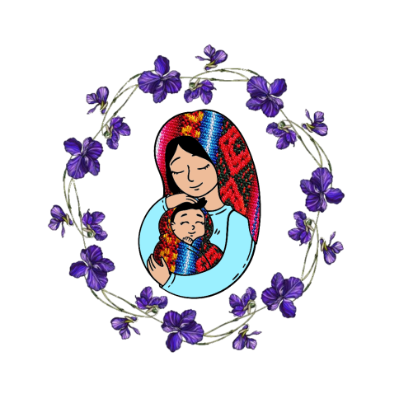

**SALVE REGINA.......**

**SONG**

**7.-**

SONG: "CUT THE ROCK".

**OUR FATHER.......**