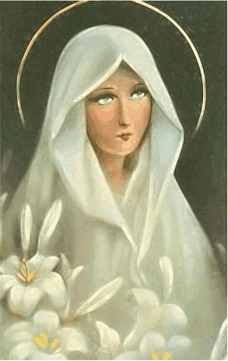

"Then I heard the voice of the Lord saying, "Whom shall I send? And who will go for us?" "Here am I," - I said - "send me.'' Isaiah 6:8.

2) Play/sing the song Salve Regina - Gregorian Chant, sung by the Benedictine monks.
Reference: https://www.youtube.com/watch?v=0ddLO5VT2jg

SALVE REGINA
Salve Regina, mater misericordiae:
Vita, dulcedo, et spes nostra, salve.
Ad te clamamus, exsules, filii Hevae.
Ad te suspiramus, gementes et flentes
In hac lacrimarum valle.
Eia ergo, Advocata nostra,
Illos tuos misericordes oculos
Ad nos converte.
Et Jesum, benedictum fructum ventris tui,
nobis, post hoc exsilium ostende.
O clemens! O pia!
O dulcis Virgo Maria!

This small excerpt from Marcellin Champagnat's Spiritual Testament, written on his deathbed to his closest brothers, emphasizes the care they should take with the gift they have received, by watching over their vocations.
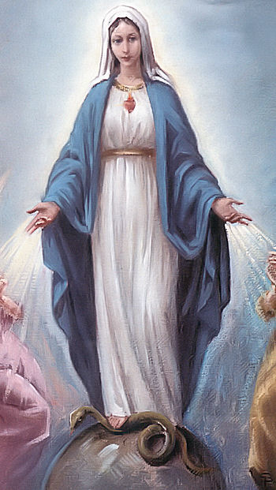
My dear brothers, be faithful to your vocation, love it, and persevere in it courageously. Keep yourselves in a great spirit of poverty and detachment. The daily observance of your holy rules preserves you from ever defaulting on the sacred vow that binds you to the most beautiful and most delicate of virtues. To live as a good religious requires sacrifice; but grace makes everything easier. Jesus and Mary will help you; besides, life is very short and eternity will never end. Oh, how consoling it is, when you present yourself before God, to remember that you have lived under the auspices of Mary in your Society! May this good Mother preserve, multiply and sanctify you!
The grace of our Lord Jesus Christ, the love of God, and the communication of the Holy Spirit be with you always! I leave you all with confidence in the sacred hearts of Jesus and Mary, hoping that we may all be reunited together in blessed eternity. Such is my last express wish, for the glory of Jesus and Mary.
(Also to the collaborators he expresses his affection and care for their lives and vocations):
...So, dear Brother, may God himself bless us all and we will be happy. I know how hard you work to attend to everything. Once again, may God spread his blessings, and everything will work out. Tell your dear friend, tell your dear fellow-workers how dear they are to me and how much I love them in Jesus and Mary: take great care of their health... (Letter, 19th January 1836 - CIRCULAR to the Brothers - Letters, p. 240).
Reflection: Try to feel what the words of Father Champagnat elicit in me, in the last moments of his life. How have I lived my vocation? What can his words tell me today? What could he want to tell me today? (5 minutes for meditation). NOTE: You can give the group material to write down if they want.
The poem by Pablo Neruda: (Note: in this poem, the word "Matilde" - for which the author writes - has been replaced by "Madre", referring to the Good Mother Mary).

I Ask for Silence

NOW leave me alone.
Now get used to it without me.
I'm going to close my eyes
And I only want five things,
five favorite roots.
One is endless love.
The second is to see autumn.
I can't be without the leaves
flying and coming back to the earth.
The third is the severe winter,
the rain I loved, the caress
of fire in the wild cold.
Fourth is the summer
round as a watermelon.
The fifth thing is your eyes,
My mother, beloved,
I don't want to sleep without your eyes,
I don't want to be without you looking at me:
I change the spring
for you to keep looking at me.
Friends, that's how much I want.
It's almost nothing and almost everything.
Now if you want to leave.
I've lived so long that one day
you'll have to forget me by force,
wiping me off the slate:
my heart was endless.
But because I ask for silence
don't think I'm going to die:
the opposite happens to me:
it happens that I am going to live.
It happens that I am and that I continue.
It will not be, then, but inside
of me will grow grains,
first the grains that break
the earth to see the light,
but mother earth is dark:
and within me I am dark:
I am like a well in whose waters
the night leaves its stars
and goes on alone through the field.
It is that I have lived so much
that I want to live so much more.
I have never felt so sonorous,
I've never had so many kisses.
Now, as always, it is early.
The light flies with its bees.
Leave me alone with the day.
I ask permission to be born.

5) In this poem the author says goodbye, but with the hope for what is to come and the joy of knowing all he has left for those who will remain. We can read the poem as if it were written by ourselves, or by Father Champagnat, when we meet Mary and Jesus Christ, after finishing our works in this world. Remembering the Lord's words: "I am the vine, you are the branches. He who remains in me, and I in him, the same will bear much fruit; for without me you can accomplish no work... You did not choose me; rather, I chose you and appointed you to go and bear fruit and fruit that will last."

Reflect: What poem will I leave to humanity? What fruits will I leave to my brothers and sisters? Am I writing the story of my life the way I want to? What can I do, today, to live my vocation with fullness? (10 minutes to take up the texts, think and write down). OBS: give the group material to write down.

6) Moment of sharing: Would you like to share with the group something that touched me, caught my attention, or could contribute to this moment?

7) Play/sing the song:

Annunciation - Alceu Valença

In the light haze of passions that come from within
You come to play in my backyard
On your horse, bare-chested, hair in the wind
And the sun burning our clothes on the clothesline
In the light mist of passions that come from inside
You come to play in my backyard
On your horse, bare-chested, hair in the wind
And the sun hanging our clothes on the clothesline
You come, you come
I already hear your signs
You'll come, you'll come
I already hear your signs
The angel's voice whispered in my ear
I don't doubt, I already hear your signs
That you would come
on a Sunday morning
I announce you through the bells of the cathedrals
You're coming, you're coming
I already hear your signs
You are coming, you are coming
I already hear your signs
In the light haze of passions that come from within
You're coming to play in my backyard
On your horse, bare-chested, hair in the wind
And the sun hanging our clothes on the clothesline
You come, you come
I already hear your signs
You'll come, you'll come
I already hear your signs
The angel's voice whispered in my ear
I don't doubt, I already hear your signs
That you would come on a Sunday morning
I announce you through the bells of the cathedrals
You're coming, you're coming
I already hear your signs
You will come, you will come
I already hear your signs

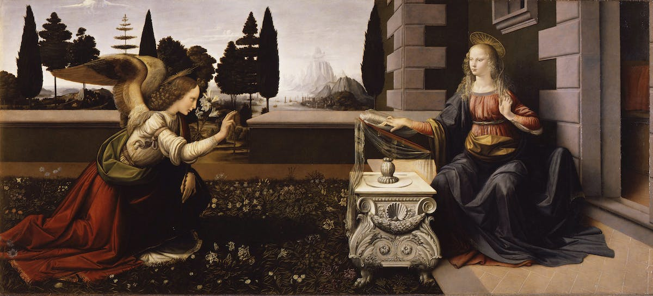
Reference: https://www.youtube.com/watch?v=PrdBUorYboU

