Vocational Prayer Come and See

Hymn listened: I will follow you
I will follow you wherever you take me, without going ahead without forcing my way, wisely ignorant, I will go where I do not know, with my heart in you I will follow you (Composer: Alejandro Labajos, sj).

Psalm 119
Antiphon (sung): Lamp is your Word for my steps, light on my path (2). Light, your Word is light (2) (Aim Karem).

Let your love come to me, O Lord, your salvation, according to your promise! I will answer him who insults me, for I trust in your word.
Do not take the word of truth out of my mouth, for I trust in your judgments.
I will unceasingly observe your law forever and ever.

I will walk in freedom, for I will seek your precepts.
Of your teachings I will speak before kings, and I will not be ashamed.
And I will delight myself in your commandments, which I love dearly.
I stretch out my hands toward your commandments, I meditate on your precepts.

I keep my steps far from every evil way, that I may keep your word. How sweet are your promises to my taste, sweeter than honey to my mouth! Your precepts have made me wise; therefore I hate every false path.
Thy word is a lamp unto my feet and a light unto my path. I have sworn, and I will keep it, to keep your righteous judgments. I am afflicted exceedingly, O Lord, give me life according to your word. Accept the vows of my mouth, O Lord, and teach me thy judgments. My soul is in my hands without ceasing, but I do not forget your law. The wicked lay a snare for me, but I do not turn aside from your precepts. Your teachings are my heritage forever; they are the joy of my heart. I incline my heart to practice your precepts; they are my reward forever.

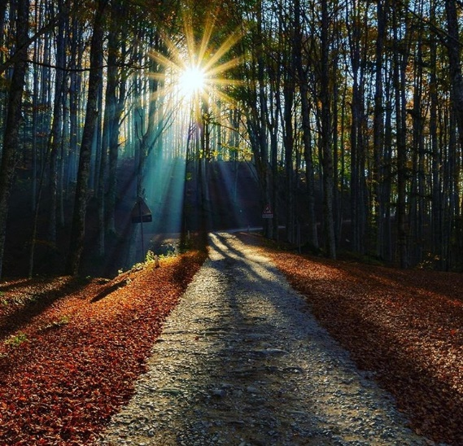
Antiphon: Your Word is a lamp to my feet, a light to my path (2). Light, your Word is light (2).

(Expression of echoes or recreations from our own vocational experience).
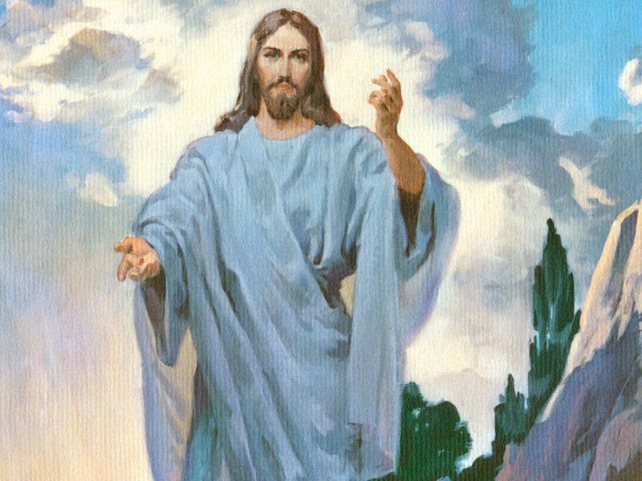

A reading from the Gospel of John (1:35-39). The next day, John was there again with two of his disciples. Noticing Jesus passing by, he says, "Behold, the Lamb of God!" The two disciples heard him speak thus and followed Jesus. Jesus turned, and seeing them following him says to them, "What are you looking for?" They answered him, "Rabbi - which means, "Teacher" - where do you live?" He answered them, "Come and see." So they went and saw where he lived and stayed with him that day. It was about the tenth hour.

Where you go, Marist Brothers Rule of Life #1:
BROTHER, set out and listen to Jesus who says to each one of us "Come and see" (Jn 1:39). Your call to fraternity is a mystery. Accept it as a gift. Live each day with an itinerant attitude, and you will discover that the road transforms your way of seeing and understanding. Stay, live with the Lord, let yourself be accompanied by the Master and, like those first disciples, never forget the moment when Jesus touched your heart and awakened your most authentic and profound identity. His first disciples discovered this "Come and see" as a genuine call from the Master. In response they "went and saw where he lived and stayed with him that day. It was about four o'clock in the afternoon" (Jn 1:39).

(Time of silence to interiorize the message of the Gospel and the Rule of Life)

(Spontaneous vocational requests).

Our Father.

Closing prayer: Lord, continue to call us.
Lord Jesus, you who have called those whom you have loved, call many young people to work with you. Do not tire, Lord, of calling us because every time we listen to you, a drop of love falls into our hearts. Bless all the young people of the world and grant that, like Mary, we may always know how to respond to you: "May it be done to me according to your Word".

Salve.

