Called and Chosen

Invocation of the Light:

Glory to God who has shown us the light!
R: Lead us from darkness to light
Lead us from sadness to joy
R: Lead us from death to new life
Glory to God who has shown us the light.
In the name of the Father …
R: Source of all Being
and of the Son …
R: Compassionate One
and of the Holy Spirit …
R: Amen.

Gathering Hymn: You are Mine (David Haas)

I will come to you in the silence.
I will lift you from all your fear.
You will hear my voice,
I claim you as my choice, be still and know I am here.

I am hope for all who are hopeless.
I am eyes for all who long to see.
In the shadows of the night,
I will be your light, Come, and rest in me.

Do not be afraid, I am with you.
I have called you each by name.
Come and follow me, I will bring you home;
I love you and you are mine.

I am strength for all the despairing.
Healing for the ones who dwell in shame.
All the blind will see,
The lame will all run free, and all will know my name.

Opening Prayer:

Lord, you call us not to be afraid, and to hear Your voice, as Marists together!
Knowing our weaknesses and flaws, we also know that You call us beyond these,
to learn once more how to follow you, as Mary did.
May the image of Your Son, Jesus, be continually formed within us, Amen.

Story #1: “Michelangelo and the rejected block of marble”

One day the famous artist Michelangelo was walking down a street. As he walked along, he came across a block of marble lying on the road. The marble was in front of the house of another artist. Michelangelo, who knew the artist, inquired whether the marble belonged to him. The artist said ‘yes’, and also added that he had rejected the marble, since it had a flaw. Michelangelo asked the artist whether he could have the block of rejected marble. The artist gladly agreed to his request.

Michelangelo had the marble brought into his studio. He saw the same flaws and cracks as did the other artist. But he saw beyond the defect in the marble. He saw the block as a challenge to his artistic skills. In a short while the master sculptor was chiseling away at the marble. He worked around the flaw and continued to hammer away at the block. As the days went by a beautiful figure of a man emerged from the rejected marble. This figure is considered to be one of the great art treasures of the world: the figure is “David”. It would never have been so, if that flawed marble had not caught the creative and imaginative eye of the great Michelangelo.

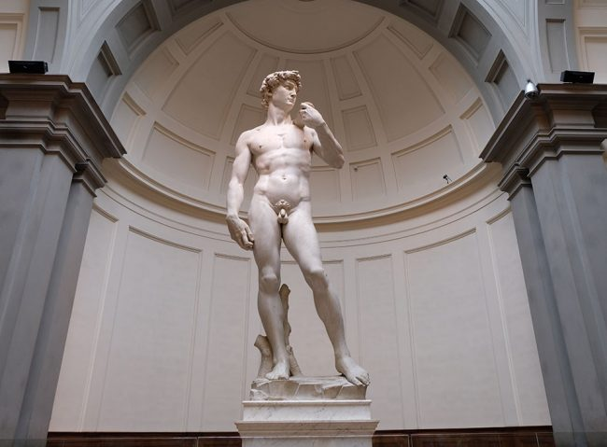

Reflection 1:

God does not make ‘junk’. All of us have something to offer, something to contribute to humanity. Most of the time we can be worrying about our flaws and weaknesses, so we can often lose sight of the tremendous good and talent that lies hidden within us. The marble in the story was rejected because of the flaw that prevented it from being used by the original sculptor for a particular purpose. But Michelangelo broke away from this limiting frame of reference. He thought out a new way of using the marble. The result was a masterpiece.
For ourselves, as Marists, what might this little ‘parable’ say to our lives in this present moment? We are invited, brothers and laity together, to reflect on our respective vocation stories and come to a reappreciation of our Marist call. Do I sometimes feel like that rejected piece of marble, not quite good enough anymore to bring about a ‘new creation’?
Who are those, like Michelangelo, who can see hidden beauty and potential within me?
Perhaps I am called to be a ‘Michelangelo’ for someone else who senses themselves as a bit of ‘flawed marble’? [pause]
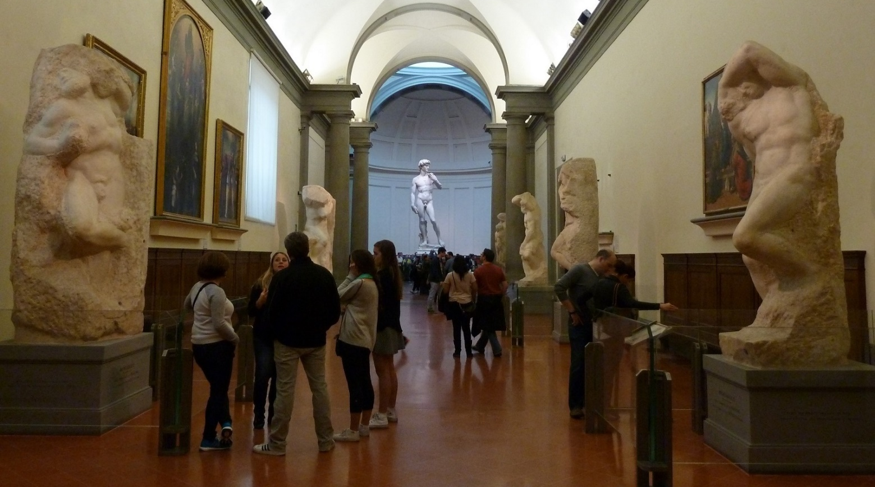

Story #2: Hidden Life: a Marist Reflection (Craig Larkin SM)

In their haste to reach Michelangelo’s statue of David, tourists in Florence are often inclined to
overlook the unfinished sculptures in the hallways leading to the room where “David” stands.
These pieces of sculpture have been called “The Prisoners”, and they reveal what can happen to an ordinary piece of stone when the craftsmanship of a genius draws from inside it a perfection and form that others would never have thought possible.

If a human genius can look at a piece of stone and see possibilities that others cannot see, what possibilities might God see in human beings? What “prisoner” inside each of us unlikely people is waiting to be released? And what might happen if people allowed Mary – often referred to by the Scriptural title of “wisdom” and “artisan”- to shape and form and draw forth from the depths of their being a particular image of the disciple of Jesus? [pause]

Reflection 2:

In this gallery in Florence, we not only have the David statue emanating from a flawed block of marble, but we also have these not-quite-right ‘prisoner’ statues. Perhaps we can view these as ‘a work in progress’ … a bit like ourselves. How is God shaping me in this present time? What parts of me might need chiselling away so that the hidden beauty of my continually emerging Marist vocation might see the light of day? [pause]

Gospel: Mark 8:23-25

He took the blind man by the hand and led him out of the village; and when he had put saliva on his eyes and laid his hands on him, he asked him, ‘Can you see anything?’ And the man looked up and said, ‘I can see people, but they look like trees, walking.’ Then Jesus laid his hands on his eyes again; and he looked intently, and his sight was restored, and he saw everything clearly.

Intercessions:

Leader: Perhaps I’m still a bit like a ‘prisoner’ statue. Or maybe my vision is only partial and needs further healing from the Lord? Possibly the Lord has surprises still in-store for us? You may wish to share a prayer, maybe around one of these themes:

- The beauty hidden beneath our flaws …

- Our call to let the Lord form us as Marists anew …

- With further marble chiselled away, how might I come to a reappreciation of my vocation? …

- What ‘flaws’ in ourselves, our community, or our church need reforming? …

- What particular image of a disciple might Mary desire in her Marists of Champagnat? …

‘Our Father’ (alternate):

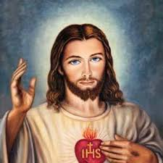
Holy One, in Heavenly fullness,
R: Glorious Your name through all creation!

As you provide for our needs today,
R: may we hunger to see the whole world fed.

In the hurts we absorb from one another, forgive us.
R: In times of testing and trial, strengthen us.

Let us not seek revenge, but reconciliation; delighting not in victory, but justice.
R: And from the grip of all that is evil, free us.

May our future actions grow from here!
R: For the glory of Your Reign, Amen.

Final Prayer: (from Pope John XXIII)

Consult not your fears but your hopes and your dreams.
Think not about your frustrations but your God-given unfulfilled potential.
Concern yourself not with what you have tried and failed but with what is still possible to do.
Live lives that incarnate the Heart and the Love of Jesus.
We make this prayer in Jesus’ name, Amen.

Hymn: “Blessing from the Book of Numbers” (Michael Herry fms) [link below*]

May the Lord bless you and keep you.
May his face shine light upon you.
May the Lord be gracious to you.
May the Lord give you his peace.

May the Lord bless you,
May the Lord keep you,
May the Lord give you his peace.

May his gentle hand now guide you.
May you know his name forever.
May his wing rest o’er and protect you.
May the Lord give you his peace.

May your heart be rest for his spirit.
May you see your children’s children.
May you praise the Lord forever.
May the Lord give you his peace.

* “Blessing from the Book of Numbers” Download MP3 from this link: https://static1.squarespace.com/static/52422a6fe4b06209130d02bd/5521fb67e4b0e0673a965b42/5521fd8de4b0abe69be74a7c/1428290957917/02+Blessing+From+The+Book+Of+Numbers.m4a

