[NOTE: for this prayer use a central symbol of some leaves. Or perhaps this prayer can be done outside!]

“Chat with a Leaf” … our Marist vocation to build a ‘Common Home’

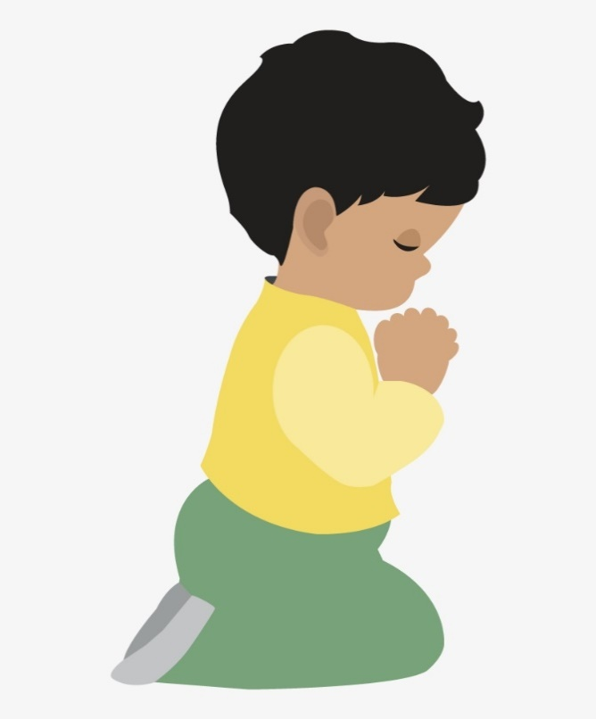
Invocation of the Light:

As we gather, let us centre ourselves in the presence of God and one another. (pause)

Glory to God who has shown us the light!
R: Lead us from darkness to light
Lead us from sadness to joy
R: Lead us from death to new life
Glory to God who has shown us the light
in the name of the Father
R: Source of all Being
and of the Son …
R: Compassionate One
and of the Holy Spirit …
R: Amen

Gathering Hymn:

[in Latin www.youtube.com/watch?v=zm7cYvKVkKg]

Confitemini Domino, quoniam bonus. Confitemini Domino, alleluia.

[or in English www.youtube.com/watch?v=to01d0ejx7c]

Come and fill our hearts with your peace. You alone O God are holy.
Come and fill our hearts with your peace. Alleluia.

Opening Prayer:

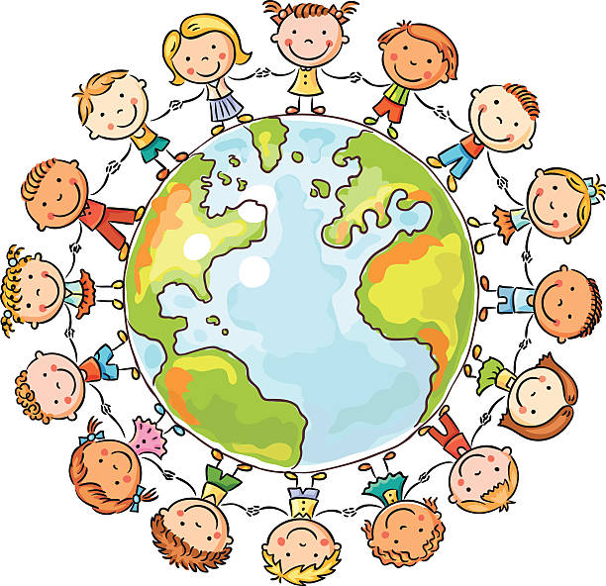
Introduction … We are Marists, Brothers and Lay, amidst a world that is continually being created and shaped through God’s and our continued efforts. Let us listen and wait for God’s inspiration today …

And Let us Pray … Perhaps You, Lord, have a word of peace for us, and a word, that speaks to our longing and passion, a word that encourages us to ask the deeper questions: “Who am I?” “Who are we?” “How are we to know where You are leading us?” “And what does it mean to be a Marist in our world today?”

Convert us anew, Lord, that with the fervour we had when we first discovered our Marist vocation, we may work for the good of our Common Home. We make this prayer, in Jesus’ name, AMEN.

Reflection #1: FINDING GOD IN A LEAF: THE MYSTICISM OF LAUDATO SI' by Brian Grogan, p.15 (for three voices: Narrator, All of us, Leaf)

N: Chat with a Leaf! Try engaging with an older leaf! The Pope says that ‘nature cries out to us’ so let’s listen to that voice! The dialogue might run as follows:
All: ‘Good day! Please tell me your story’.
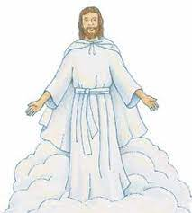
L: ‘Well, that big tree beside us is my parent and it gave birth to me this spring. It’s been a good life up there: I don’t think I ever harmed anyone, and with my 50,000 siblings I helped your species by absorbing CO2 and providing oxygen. A little while back my parent had to withdraw support of me to conserve itself for winter. So here I am, cracked and crumbling.’
All: ‘And what next?’
L: ‘Well, like yourself, I’ll return to dust and become part of something else, a daffodil, perhaps! Receiving and giving back is the rhythm of things. We trees go back some 335 million years – a bit longer than humans, I may say. Someone of your species has said that trees are God’s first temples. Not bad! Of course, we all go back to the beginning, so we’re the same deep down … but your species destroys so many of us, despite the fact that trees are the earth’s lungs, and we could eat up enough CO2 to save our common home. Can you do anything to help?’ (pause)
…………………………………………………………………………….
Reflection #2: (Comment, by Brian Grogan)
I find that this way of relating to nature offsets my instinct to see materials things simply as objects. The universe unfolds in God, who fills it completely. Hence, there is a mystical meaning to be found in a leaf, in a mountain trail, in a dew drop, in a poor person’s face. The ideal is not only to pass from the exterior to the interior to discover the action of God in the soul, but also ‘to discover God in all things’. [Pope Francis, Laudato Si’ #233] (pause)
…………………………………………………………………………….

Reflection #3: (from “Homes of Light” by Br Ernesto)
God has given us the earth as a gift and as a task, to care for it and to answer for it; we do not own it. Integral ecology has its foundation in the fact that “everything in the world is connected” (LS 16). …There are numerous and constant calls of the Church to rouse our sense of care for our common home. Yet, professional studies on the topic of ecology keep pointing to the growing urgency of collective action, or else we will continue to suffer the consequences and our legacy to future generations will be an uninhabitable planet. …
The XXII General Chapter invited us to … create “an integral ecological awareness in all our communities and different ministries and developing policies at all levels of the Institute that strengthen our commitment to the care of our common home.” …
Each of our communities and families …can be an active laboratory for the care of our great common home. We start with small, concrete actions on a daily basis, and at the same time assess and improve our structures and the way we operate. (pause)
…………………………………………………………………………….

Intercessions / Shared Reflections:

L: Following Laudato Si’ and the COP26 “UN Climate Change Conference” in 2021, our Marist vocation is to create “an integral ecological awareness in all our communities and different ministries”, that we might develop “policies at all levels of the Institute that strengthen our commitment to the care of our common home.” Remembering the fervour, we had when we first discovered our Marist vocation, may this call invigorate us anew, we pray: Kyrie, Kyrie, Eleison (sung or spoken)

And for what else shall we pray?

‘Our Father’

or ‘Alternate Our Father’:

O Glorious One, You shine both within and beyond all!
Feed us with the fullness of life, enough bread and wisdom for today.
Untie the knots of failure that hold us back,
and help us release the restraints drawn by others, binding us all.
From trials too great to endure, spare us.
From our fractured and scattered lives,
free us and bring us an awareness of Your abiding Presence.

For from You arises every Vision, Power and Song,
gathering us and leading us to all Eternity, Amen.

Final Prayer:

When evil darkens our world, give us light.
When despair numbs our souls, give us hope.
When we stumble and fall, lift us up.
When doubts assail us, give us faith.
When nothing seems sure, give us trust.
When ideals fade, give us vision.
When we lose our way, be our guide,
that we may find serenity in Your presence,
and purpose in doing Your will, forever and ever, Amen.

And like the gentle falling of leaves, continue to bless us, Lord,
in the name of the Father, and of the Son, and of the Holy Spirit, Amen.
Mary our Good Mother … pray for us.
St Marcellin Champagnat and the First Brothers … pray for us.
And may we always remember … to pray for one another.

