That our Marist Vocation be a blessing for the world!

Greeting:
The peace of Christ be with you
… and with all those we love.
In this moment we take time to stop
… to listen to Your Word in our life.
Our lives are a field planted with purpose
… it is the holy ground of God.
Our feet tread this ground with reverence
… in the mystery of God’s grace.

And so we pray
in the name of the Father … R: The Great Gardener of Life
and of the Son … R: Who rejoices as he tils the soil
and of the Holy Spirit … R: Who with love brings forth the rain, Amen.

Introduction:
Maybe our call to rediscover our original passion, a reappreciation of our vocation as Marists, is to see where the Spirit is calling us forward in our world, and respond there. The following poem states that “the world is breaking. How could it not? What was meant as garden needs its gardeners” to be again a blessing on the earth. As Marists, may we be a blessing, may we ‘dream dreams and see visions’ of our vocation rising once more in the heart of the world.

Let us take a section, around the room, after which we will pause to echo a word or phrase. …

Theme Poem: “The garden is burning” by Bro Richard Hendrick
[Leaven Magazine, October 2021, p.21]

For a long time now
a fire has been burning in my mind
a flood has rolled across my heart
an earthquake rumbles in my soul.
I am afraid it is breaking,
this world of ours, how could it not?
It bears so much weight
the weight of sadness,
the weight of fear,
the weight of pain.

Last week in Greece
a two-thousand-year-old Olive Tree, an elder,
ancient and wise in ways we cannot even begin to know,
burned, as people fled the lands
that fed them and us for ages untold.
The trees don’t get to leave.

Here in Ireland we smile
and take pictures of a Walrus,
a prince of the cold kingdom,
now an exile, lost, wandering, alone,
iceless, friendless, bewildered by boats.

In Siberia, the tundra burns and mammoth
bones have their slumbering rest disturbed
long thought safe and sleeping by the
peoples who live and love upon the frosted lands.

In Afghanistan, a wordless groan erupts,
the pain of a tortured soul,
the ache of a land so long in agony
its voice is near a death rattle
despair of a people fearing a veil being drawn over their faces,
a stifling of song, an ending of hope, a blanket of hate, and loss,
and loss, and loss, and betrayal.

In Haiti, earthquakes again.
In Lebanon, explosions again.
In America, fires again.
In Turkey, floods again.
My litany is nowhere near complete…

Lord have mercy.
The world is breaking.
How could it not?
What was meant as garden
needs its gardeners,
needs us to be Adams, gardeners, again;
needs us to be Eves, mothers of life, again;
that was the original blessing after all;
to grow, to steward, to bring forth life,
to bless, to give thanks, to guard and keep
all that lives, all that breathes, all that is.

So what must I do?
What can you do?
Be a gardener.
Now, right where you are.
Dig. Dig deep within,
Dig over the hard soil of the heart that cannot bear to hear anymore
and let it breathe again original blessing.

Plant seeds of kindness.
Plant seeds of compassion.
Plant seeds of love.
Water it with your tears for all beings who suffer.
Grow a harvest of tenderness for those who suffer
Grow flowers of welcome for the lost and the lonely
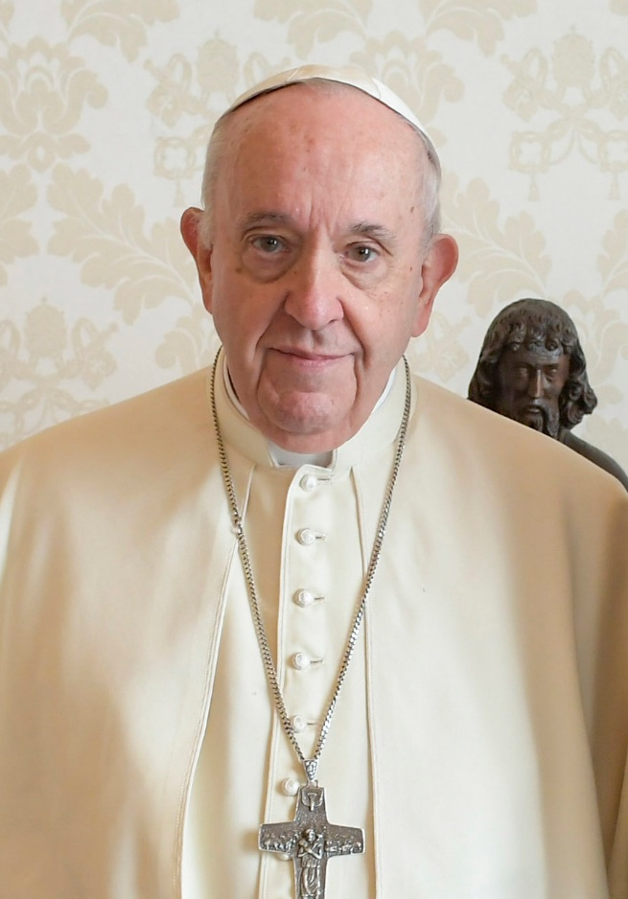
Grow the fruit of peace in yourself and offer it
to all beings to eat.

Act with reverence for all that is,
for all that is, is holy.
Allow that little plot of life
and earth around you to heal.
It will spread.
Remember we are all sons of Adam
Remember we are all daughters of Eve
Hear again the song of sister Mother Earth
Sing again the hymn of creation
Be again, blessing
Be again, the gardener,
Be at last the steward.
Be.
(Pause for reflection)

Response:

Let us take a moment to echo a word or phrase that strikes us …

Reflection: “Towards an ever wider we” by Pope Francis

This is the ideal of the new Jerusalem, where all peoples are united in peace and harmony, celebrating the goodness of God and the wonders of creation. To achieve this ideal, however, we must make every effort to break down the walls that separate us and, in acknowledging our profound interconnection, build bridges that foster a culture of encounter. … The prophet Joel predicted that the messianic future would be a time of dreams and visions inspired by the Spirit: “I will pour out my spirit on all flesh; your sons and your daughters shall prophesy, your old men shall dream dreams, and your young men shall see visions” (Joel 2:28). We are called to dream together, fearlessly, as a single human family, as companions on the same journey, as sons and daughters of the same earth that is our common home, sisters and brothers all. [Message of His Holiness Pope Francis, for the 107th World Day of Migrants and Refugees 2021].

(Pause for reflection)

Litany Response:

Dreams come and go in our lives, for more die than come to reality.
Lord have mercy. Lord have mercy.
What is it in us that allows us to let go of visions that could create a new and beautiful world?
Christ have mercy. Christ have mercy.
Why do we so easily give in to barriers? Why do we let ourselves conform and be satisfied with what is? Lord have mercy. Lord have mercy.
Pope Francis, opening the Synod on Synodality, remarked: "That expression – 'We have always done it that way' – is poison for the life of the Church."
May we listen to the possibility of new ways, creating a common home for all.
Blessed by God forever!
What a precious feeling to be supported, to have others say “you can do it … we can do it together!”
Blessed by God forever!
Nothing is beyond our reach if we reach out together. If we reach out with all the confidence we have… If we are willing to persevere even in difficult times and if we rejoice with every small step forward.
Blessed by God forever!
Nothing is impossible if we put aside our careful ways, if we build our dreams with faith – faith in ourselves, faith in each other, and above all, faith in our God with whom all things are possible.
Blessed by God forever!
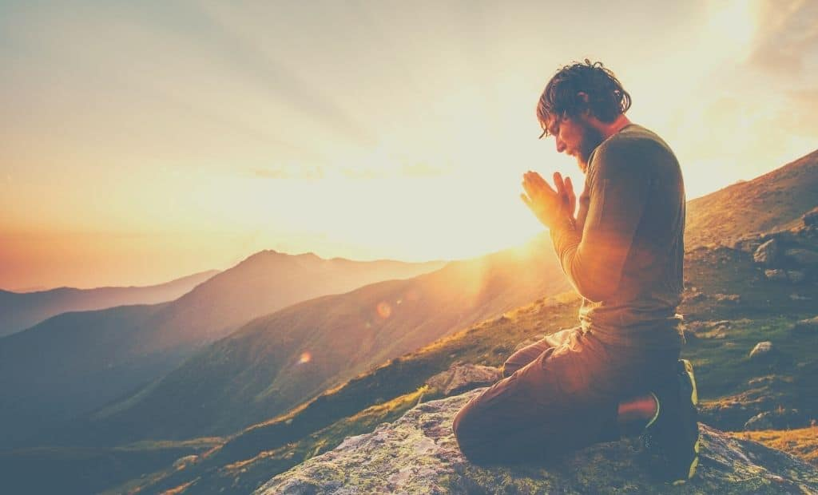
Reaching out to a dream can be risky. It can involve hardships that our imagination never knew. Our comfortableness can so easily be disturbed. But, what beauty can be experienced if we accept the challenge of a dream!
Blessed by God forever!

Shared Prayer / Our Father:

Final Prayer:

Our hands are called to bring life to all
… God’s hands for the world.
Our feet yearn to walk the path You call us to
… God’s feet for the world.
Our hearts yearn to experience fire and love
… God’s heart for the world.
Our lives, our vocation, our passion is reconfirmed, that we be a blessing, just as Mary, Marcellin and our First Brothers were a blessing to the world of marginalised young people. Through them, continually bless us, Lord, inspire us, and lead us forward in faith and hope
… through Christ our brother and Lord, Amen.

Final Hymn: “One heart, one mind” (David Haas) [download from www.youtube.com/watch?v=odm6UvbDDps]
Please join in the chorus as you pick up the tune …

May we be of one heart, one mind,
giving our lives for each other.
All that we are, we hold in common
by the grace of the Lord.
May there be no one among us who is in need or alone.
May we be of one heart, one mind.

- Grounded in hope, strong by faith, filled with joy, led in peace …
Blest by God, one in the Body of Christ!

- Courage lived, wisdom shared, mercy shown, truth be told …
Blest by God, one in the Body of Christ!

- Wonders and signs, day by day, one in love, offering praise …
Blest by God, one in the Body of Christ!

