Our Apron of Service, as sisters and brothers in Christ

Invocation of the Light:

Glory to God who has shown us the light!
Lead us from darkness to light.
Beyond selfishness to be the people we were born to be.
Serving You with joyful praise!
Glory to God who has shown us the light.
In the name of the Father, and of the Son, and of the Holy Spirit, Amen.

Hymn: As Mary Did (Michael Herry fms) Download from:
https://static1.squarespace.com/static/52422a6fe4b06209130d02bd/53f2d78de4b010bb9e73f29c/56fcde2aab48de8601f34178/1459412562534/07+As+Mary+Did.m4a

To follow Christ as Mary did, this now the pearl we seek together.
You call us forth to be your people, your living Word made flesh today.

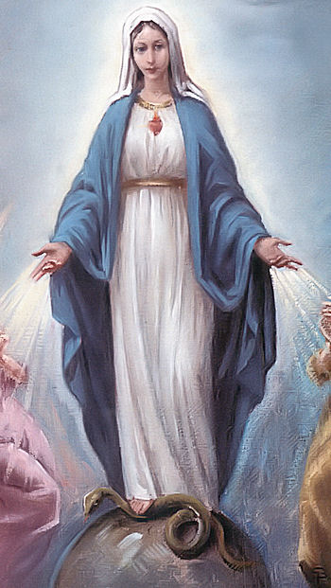
1. May the blessing of Mary's unwavering faith be upon us.
May her spirit of prayer live in our hearts and lives.

2. May the blessing of Mary's loving service be upon us.
May her spirit of praise be on our lips and in our hearts.

3. May the blessing of Mary's union with Jesus be upon us.
May her courage and patience find a home in our lives.

4. May the blessing of Mary's mercy and justice be upon us.
May we work with her spirit to heal our broken world.

Introduction:

The symbol of the apron is a fitting one for Marists. Be it Mary’s loving service; or the service of Marcellin with apron gathered at his waist, trowel in hand, sweat on his brow; and of course Jesus, wearing the only vestment mentioned in John’s gospel, the towel wrapped around his waist as he washed the disciples’ feet. Perhaps you have a story of when you felt particularly of service to another, maybe to a young person in need. What fire of the Spirit did this person spark in you, as you sensed “Yes! This is my vocation, this is my Marist call. To be the Lord’s servant here and now.” As we continue on our journey, following Christ as Mary did, may we put on Jesus’ towel, the apron of service that we were originally called from our birth to wear.

Reflection 1: by Parker Palmer (‘Let Your Life Speak’ p.10)

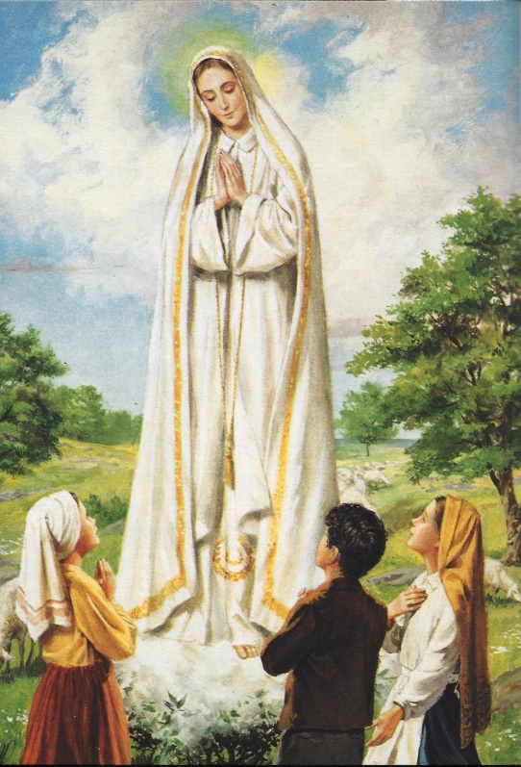
Discovering vocation does not mean scrambling toward some prize just beyond my reach but accepting the treasure of true self I already possess. Vocation does not come from a voice ‘out there’ calling me to become something I am not. It comes from a voice ‘in here’ calling me to be the person I was born to be, to fulfill the original selfhood given me at birth by God. (pause)

Reflection 2:

The following is from “Wherever you go, the Rule of Life for the Marist Brothers”. It refers to ‘brotherhood’ and the ‘apron of brotherhood’, which can easily be understood as an ‘apron’ for all Marists, as sisters and brothers together, all called to service.

[70] Your chief contribution to the life of the Church
is to be on mission as brother.
Your vocation itself is a ministry within the Church;
a reminder to the wider community
about the importance of fraternity
and our fundamental call to be
a community of brothers and sisters in service (diakonia).
At the banquet in the Reign of God,
a brother takes his place as one who serves the table,
caring especially for those thought to be most insignificant.
By putting on the apron of brotherhood,
your specific vestment in the liturgy of life,
you join your service to the mission of God. (pause)

Reading: Luke 12:36-38

Jesus said to his disciples: ‘See that you are dressed for action and have your lamps lit. Be like those waiting for their master to return from the wedding feast, ready to open the door as soon as he comes and knocks. Happy those servants whom the master finds awake when he comes. I tell you solemnly, he will put on an apron, sit them down at table and wait on them. It may be in the second watch he comes, or in the third, but happy those servants if he finds them ready.’ (pause)

Intercessions / Reflections / Our Father:

Perhaps these reflections on service and wearing aprons have sparked a memory for you, a story, or a prayer that you would like to share …

Final Prayer:

Jesus’ Kingdom banquet is realised today by the prayer and ministry of his disciples.
May Your Reign be enlivened in our hearts and in our world.
Perhaps many times in the past the apron of loving service has been worn by ourselves or by others who have ministered to us.
We give thanks for those times when the ‘Master’ has put on his apron to lovingly serve us.
We pray particularly that those young men and women who work more closely with us, might answer the Lord’s call in their lives.
May our invitation for these to join our Marist way of life bear fruit.
It is a great gift to be a Marist in our world today.
With Jesus, Mary, and Champagnat, we give You thanks!
In the name of the Father, and of the Son, and of the Holy Spirit, Amen.

