National Vocations Awareness Week, 2004
St Marcellin’s and our “long journey into the heart of God”

Invocation of the Light:
L: Glory be to God who has shown us the light!
R: Lead us from darkness to light,
L: Lead us from sadness to joy,
R: Lead us from death to immortality.
L: Glory be to God who has shown us the light!

Opening Hymn: (choose one of the following)

Where Two or Three are Gathered (track #3, ‘Song of the Pilgrim’, by Michael Herry fms)

Where two or three are gathered in my name
know I am with you, I am with you.
Where two or three are gathered in my name know I am there to be with you.
Give us hearts renewed (track #7, from ‘Sing Spirit Sing Life’, by Michael Herry fms)

Give us hearts renewed in love O Lord
turn us back to walk with you.
Through your saving power redeem us,
in your love, our lives renew.

Opening Reflection:
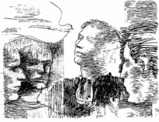
St Marcellin was a man who “was seized by the love that Jesus and Mary had for him and for others”. Henry Nouwen stated that “our prayer lives, lived as faithful response to the presence of the Spirit within us, may open a window on our emotions, feelings, and passions and give us some indication of how to put them into the service of our long journey into the heart of God.” (“Bread For The Journey”. Harper Collins, 1997)

Above all else, perhaps Marcellin’s vocation, and ours, is a “long journey” of listening to the voice of the Spirit, leading us through our lives of prayer, service, presence, and efforts in the areas of evangelisation and solidarity, “into the heart of God”.

And it is this journey, faithfully lived, which can be inviting to younger people. We say with our lives “this is a place for me, a place which leads me to freedom, perhaps this is a place for you?”

In this “National Vocations Awareness Week” we take a moment to give thanks for our own vocational journey, and wonder together what might be the new place that our gracious God is leading us to …

(pause for reflection)

Psalm Response:

Ant. We call upon your name, O God

O God, you are my god, I long for you;
my soul thirsts for you;
My body seeks for you
as in a dry and weary land without water.

So I have looked upon you in the sanctuary,
beholding your power and your glory.

For your constant love is better than life.
My lips will sing you praises.
So I will bless you as long as I live;
I will lift up my hands
and call on your name.

My soul feasts on you
and my mouth praises you,
as I think of you upon my bed,
and meditate on you
in the watches of the night;
for you have been my help

In the shadow of your wings
I sing for joy.
My soul clings to you;
your hand upholds me.

Glory be…

Ant. We call upon your name, O God

Matthew 13:44-46

The Kingdom of heaven is like this. A man happens to find a treasure hidden in the ground. He covers it up again and is so happy that he goes and sells everything he has and then goes back and buys that piece of land. Also, the Kingdom of heaven is like this. A man is looking for fine pearls, and when he finds one that is unusually fine, he goes and sells everything that he has, and buys that pearl.
(pause for reflection)

Intercessions:

Lord Jesus, let the love of the Spirit be in us:
- We consecrate our hearts journey to you
Help all Christians to answer your call
- May they be a light to the world
Bless all Marist communities in our Oceania Region
- enrich us into a deeper living of Marcellin’s Spirituality
In solidarity we pray for those who suffer, comfort them through your grace
- and through those called to respond to the needs of our struggling world
And for what else shall we pray? …

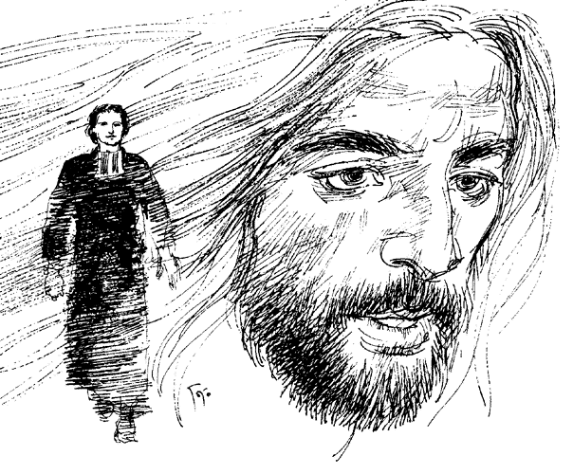
Our Father

Final Prayer:

God of heaven and earth,
through Jesus you have been revealed to us as one like
a motherly Father,
by the Word made in our flesh,
in the embrace of the Holy Spirit.
May you be blessed for opening to us the secret of your inmost heart
and for inviting us and all those you call
to enter it in the glory where you reign
for ever and ever. AMEN

